General Considerations and Goals
For Linux platforms software building from source distributions has been simplified and improved in the past through evolving tools like autoconf and automake.
Under Microsoft platforms developers normally are used to manage their software through powerfull but less transparent IDE’s like Visual Studio or Borland C++-Builder.
These concepts are usefull when applied by experienced programmers in the specific area, but they are really to complex and expensive for programmers that focus on application programming for platform independent applications.
The idea behind this project is to support application programmers with a view on software build management that concentrates on the parts that are vital for building applications.
The following list holds the questions, that an application programmer copes with:
- How can we easily and reliable integrate third party software components into applications?
- Which files are incorporated to build applications (application specific files as well as third party or system specific files)?
- How can we prevent specifiying all from scratch when changing to a new application project?
- How can we easily reuse build descriptions?
- How can we reduce the complexity of build configurations?
- Are there possibilities to check build configurations for correctness (avoiding time consuming build processes that end up in build failures)?
- Is there a possibility to represent build configurations in a wayr that easily support problem analysis (f. e. graphic support)?
These questions are central points of the motivation to develop autobuild.

Build description
- Minimality
The descrption for build configurations is minimal meaning that there are no redundancies when describing specific build configurations and projects.
- Flexibility
The description of configurations should be fexible enough to integrate specific build configurations and tools.
- Transparency
All generated code (make files) should be clear for inspection to find problems and errors in the build process.

Model

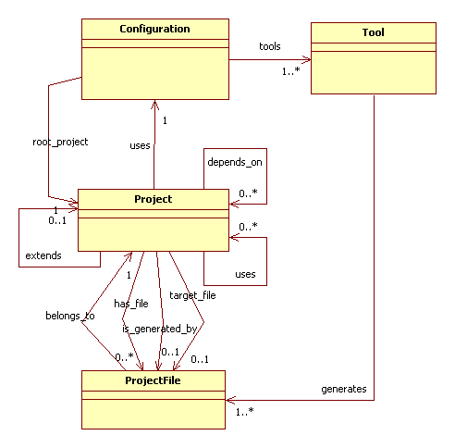
The used model covers two concepts:
- Project view
All descriptions that consern the concrete project.
- Configuration view
All descriptions that concern the target system and the toolchain that should be used.
Both concepts can be used in arbitrary combinations.
The following tables describe a concrete project with example projects and configurations. The Configuration view refers to concrete tools that definitely will make the real build work. Every tool can be described in an additional description file to ease the integration of additional tools.

Project | Target | uses
Toolchain | resources
Omniorb | resources | toolchain
Ecl | static library | toolchain
Styx | static library | toolchain
Ccs | static library | Ecl
 |  | styx
 |  | omniorb
guiframework | static library | ccs
Shexplorer | executable | guiframework
Scons | executable | ccs
…

Configuration | Toolchain | Target System
Win32_vs6_debug | Visual Studio 6 | Win32
Win32_mingw_debug | MinGW | Win32
linux_gnu_release | GNU | Linux
…

Tool | Source File | Command | Targets Files
cpp | *.cpp,*.cc | g++ … | *.o
c | *.c | gcc … | *.o
uic | *.ui | uic … | *.h,*.cpp
moc | *.h | moc … | moc_*.cpp
…

Implementation
The implementation of the build system expects a the description of the project in one description file an the description of the configuration in another description file. The build process references a project description and a configuration description.
The language for the description of projects and configurations is very simple and easy to use. A description file contains a sequence of directives. A directive can occur more than one time within a description file.
A directive covers exactly one line and starts with a “.” In the first column. Configuration descriptions and configuration descriptions have different sets of valid directives.

Configuration description

.compiler <text>
A key for the used compiler.

.system <text>
A key for the intended target system.

.toolchain <text>
A key for the tool chain to use.

.c_option <text>
Additional configuration specific option supplied to c and c++ compilers.

.link_option <text>
Additional configuration specific option supplied to the linker.

.cpp <text>
Reference to the generic c++-Compiler description.

.c <text>
Reference to the generic c++-Compiler description.

.cidl <text>
Reference to the generic CORBA – IDL -Compiler description.

.midl <text>
Reference to the generic COM – IDL -Compiler description.

.pp <text>
Reference to the generic General Purpose Preprocessor description.

.uic <text>
Reference to the generic Qt User Interface Compiler description.

.moc <text>
Reference to the generic Qt Meta Object Compiler description.

.parsgen <text>
Reference to the generic Parser Generator description.

.lib <text>
Reference to the generic Librarian description.

.link <text>
Reference to the generic Linker description.

.slink <text>
Reference to the generic Shared Object Linker description.

.asm <text>
Reference to the generic Assembler description.

Project description

.name <text>
Project name (should not contain blanks or any special characters). Determines the name of the target file that will be generated when building the project.

.uses <text>

.depends_on <text>

.extends <text>
Dependency specifications, describe dependencies with other projects.

.target <text>
This directive determines the type of target to be generated. The specification is bound to following values:
- resources
resources from third party components like libraries and shared libraries
- static library
a static code library that can be linked to applications or shared libraries
- shared library
a shared library that can be dynamically linked to applications and other shared libraries
- executable
an executable application

Usage

.include <text>
Include path that must be specified by projects that use tis project.

.lib <text>
Library to be used when used by other projects.

.lib_path <text>
Path to libaries supplied by this project

.include <text>
Include path that must be specified by projects that use tis project.

Source File List

.skip_dir <text>
Ignore this directory when creating the source file list of this project.

.skip_file <text>
Ignore this file when creating the source file list of this project.

.path <text>
Include all files of this path and its subdirectories when creating the source file list.

.path_nr <text>
Include all files of this path when creating the source file list, but ignore subdirectories of this path (nr means non recursive).

.src_file <text>
Include exactly this file when creating the source file list.

Tool description

.name <text>
Tool name.

.description <text>
Additional description.

.command_line <text>
The command line to be specified when building.

.target <text>
Specification of a target file that will be created by the tool.+

Using abuild

