IQT-Mosaic Data Conversion
Documentation

Version 1.0, 24. May 2006
Project: FM05A02
Author: Peter Ritzmann
File: LegacyConverison.doc
Status: Draft
Copyright © 2006 by
2i Industrial Informatics GmbH
Wirthstraße 7a
D-79110 Freiburg
Tel. +49 (0) 761 / 45205-0
Fax +49 (0) 761 / 45205-90
E-Mail info@2igmbh.de
www.2igmbh.de

1 General 3
2 Conceptual Considerations 4
2.1 Source concepts 4
2.2 Transformation Process Structure 4
3 Implementation 6
3.1 Abstract IQT dataset 7
3.2 Situation specific Transformation handlers and data 7
3.3 Check mechanisms 7
3.4 Application integration 7
4 Transformation System Components 8
4.1 IQT dataset Parser 8
4.2 Transformation Handler 8
4.3 User Interface 8
4.4 Transformation extensions 8
5 Realization 9
5.1 IQT abstract dataset classes 9
cFMFatFile class 9
cHeader class 9
cSubfile class 9
cHeatGroup class 9
cHeatZone class 9
cRegister class 10
cTextVar class 10
cHeatText class 10
cProcessGraphic class 10
cEM17Data class 10
5.2 Mosaic data Models 10
5.3 Transformation Handler 11
6 Dataset Viewer 13

General
This specification treats conversion of IQT datasets into Mosaic datasets.
IQT datasets are stored in a binary representation structured by a couple of subfiles. Every subfile contains data directed to specific areas like tool data, machine setup, process graphics setup, automation data (robot, free programmable cores).
All of the data within an IQT dataset should be transformed and converted to the ASCII representation of Mosaic datasets if possible.
For this purpose the following tasks have been identified, that must be handled by the transformation process:
- Conversion of the register based (integer) representation of IQT data items identified by “register numbers” into the strictly typed representation of Mosaic data items identified by variable names.
- Conversion of IQT data groups with a specific layout (heating data, process graphics).
- Semantic conversion of IQT data items based on application specific versions of the datasets.
- Handling of registers that are shared by different IQT application programs (special programs).
Some coarse format information can be obtained by the classification into numerical (registers and bits) and text (text) data within an IQT dataset. More format specific information like data type or precision only comes into existence with the interpretation of the application that uses the data (in this case the IQT).
Though conversions between IQT register items and Mosaic variables seem to be easy and straightforward, the transformation process must be extendable with mechanisms to add missing format and semantic information. These extensions are item not type based and therefore should be applicable to every register, bit or text stored in an IQT data set.

Conceptual Considerations

Source concepts
- header data
- bde setup
- process protocol setup
- process graphics setup
- automation setup
remak robot data
wittmann robot data (EUROMAP 17)
- text and compressed text
- free programmable cores
- free configurable pages
- heating data
- special registers (IQSON… and similar)

Transformation Process Structure
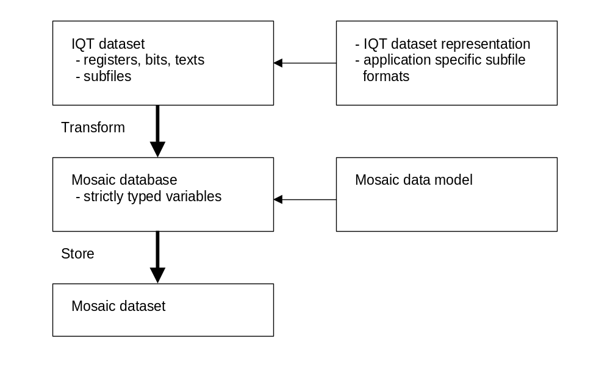
Fig. 2-1 Main transformation steps
The two main transformation steps are shown in Figure 2-1. The first transformation step (Transform) must be implemented, the second transformation step (Store) already exists as part of the Mosaic dataset management facilities.

Implementation
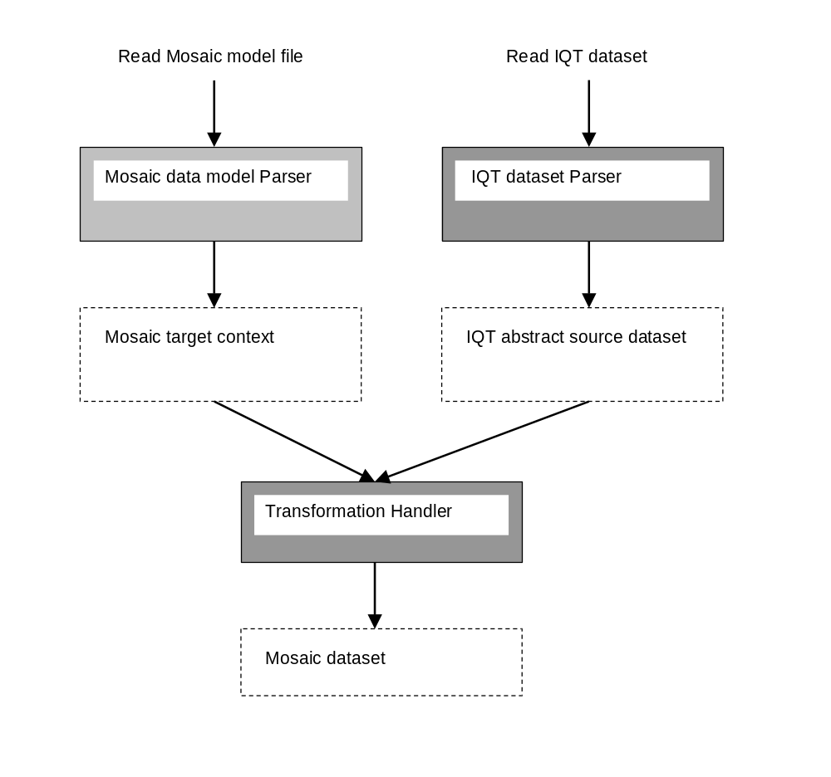
Fig. 2-2 Transformation process implementation

The implementation of the transformation process is guarded by two abstract representations of the models to be transformed. The target Mosaic model is represented by the Mosaic context known within Mosaic application programming, the source model is represented by a new class abstract IQT dataset that enables full access to IQT datasets, subfiles registers, bits and texts.
The transformation process can be extended by specific transformation handlers that are called in a specific situation of the transformation process. For different situations different handlers can be registered with the transformation process. Every call of a handler is supplied with references to the source and target model and situation specific references to source data constructs (for example a heat data specific class reference or a process graphic specific class reference).

Abstract IQT dataset
The abstract IQT dataset is a class that offers methods to retrieve IQT dataset informations:
- header informations
- heating data
- register data
- text
- process graphics data

Situation specific Transformation handlers and data
- register handler
- bit handler
- text handler
- graphics data handler
- heat data handler
These specific data handlers are subsequently referred to as data handlers.

Check mechanisms
The preferred checking instance for the validity of datasets and plausibility of data is the Mosaic application itself. The validity of a dataset must be computed by the concrete and machine specific Mosaic operator station when a Mosaic dataset is read by the Mosaic application. Because of missing machine specific data, no exact validity and plausibility checks are possible when converting IQT datasets.

Application integration
A straightforward integration could be the integration of the transformation functionality directly into the mosaic application. Otherwise a Shacira based application would be the preferred integration level. In both cases the user interface has to be specified.

Transformation System Components
All system Components are C++ objects or applications that require the base framework Shacira.

IQT dataset Parser
The IQT dataset parser is a C++ object that reads and interprets IQT datasets. The parser Generates the abstract IQT dataset object, which is used as input for the transformation handler.

Transformation Handler
The transformation handler calls the different data handlers controlled by the abstract IQT dataset object.

User Interface
The user interface is either one or more Mosaic pages or a standalone Shacira based application.

Transformation extensions
Transformation extensions are the application specific code parts, that handle concrete Machines on the source and the target side of the transformation.

Realization
The system is realized as a couple of C++ classes that depend on the Shacira base system (Version 1.3.2 or higher).

IQT abstract dataset classes
An abstract IQT dataset consists of a couple of classes. Objects of those classes are hosted by the dataset root object of type cFMFatFile.

cFMFatFile class
The cFMFatFile class represents the abstract IQT dataset root and can be instantiated by supplying the file name of a potential IQT dataset file:

cFMFatFile fat_file(“material.001”);

The boolean method cFMFatFile::Parse() parses the supplied file and returns true if a valid IQT dataset can be verified. After successful parsing, the cFMFatFile object enables querying all the the information that represent the IQT dataset.

cHeader class
The class cHeader contains all informations of the IQT dataset header (machine type, tool number, aggregat specific data for all aggregates, …).

cSubfile class
The class cSubfile contains all informations with respect to a IQT dataset subfile (subfile id, subfile length, subfile raw data, …). An abstract IQT dataset contains more than one cSubfile objects that can be retrieved using the method cFMFatFile::SubFiles(…).
All data of an IQT dataset is located within a specific subfile of the dataset. Th subsequent described components of an IQT dataset can be retrieved on a subfile object.

cHeatGroup class
The class cHeatGroup contains information about a specific heating group like barrel, tool or oil heating. cHeatGroup contains a couple of cHeatZone objects. cHeatZone objects permit access to heating data of a specific heating zone.
cHeatGroup objects can be retrieved from a cSubfile object with the method cSubFile::HeatGroupMap(…).

cHeatZone class
An object of class cHeatZone carries data of the associated heating zone of a machine and is identified by the zone id and the unit id. The unit id identifies the specific unit, for example the number of the aggregat the zone is associated if the zone belongs to the barrel heatgroup.
Heating data, that comes with the heat zone is the set value and the 4 tolerance values.

cRegister class
The cRegister classes refer to so called IQT or ISCOS registers of an IQT based machine. A register is a numeric variable with 1, 10 or 20 values. The data type is a 16 bit integer or a 32 bit integer. A register is identified by a unique id that is often called register number.
cRegister class objects also represent IQT bits.
A cSubfile object can contain an arbitrary number of cRegister objects. They can be retrieved using the method cSubfile::RegisterMap(…).

cTextVar class
The cTextVar class contains IQT text variable informations. A cTextVar object can be identified by a unique id called text id. Data of structured text variable are subsumed to one continuos text.
A cSubfile object can contain an arbitrary number of cTextVar objects. They can be retrieved using the method cSubfile::TextVarMap(…).

cHeatText class

cProcessGraphic class
The cProcessGraphic class holds the process graphic informations of an IQT dataset (setup, set curves …).

cEM17Data class
The cEM17Data class holds a data block that contains EUROMAP 17 data. The EUROMAP 17 format is used to store Wittmann robot data.

Mosaic data Models
The transformation destination must be a valid Mosaic context object of type cContext.
A valid context is represented by the local context of a running Mosaic application. For remote transformations, it is also possible to load a valid context from an existing data model description.
Another valid context is a remote context of a machine accessible via network.
The third and most simple case is to use a stored tool dataset of an arbitrary Mosaic machine as destination data model.
Compared with the startup data model of the same machine this models have the advantage to represent dynamically generated variable information (for example heating variables).

Transformation Handler
A transformation handler is a class that combines an abstract IQT dataset object with a valid Mosaic context object.
Execution of the method cTransformationObject::Process() calls the virtual methods of the transformation handler for every component of the abstract IQT dataset.
Every virtual method call of the transformation handler call supplies supplies a pointer to the header of the dataset and a pointer to the subfile containing the associated component:

virtual BOOL_T HandleHeader(cHeader * header);

This is the first virtual method called when processing an abstract IQT dataset.

virtual BOOL_T HandleRegister(cHeader * header, cSubfile * subfile,
cRegister * reg);

This is the first virtual method called when processing an abstract IQT dataset.

virtual BOOL_T HandleTextVar(cHeader * header, cSubfile * subfile,
cTextVar * textvar);

This method is called for every text variable object of the abstract IQT dataset.

virtual BOOL_T HandleHeatZone(cHeader * header, cSubfile * subfile,
cHeatGroup * heatgroup, cHeatZone * heatzone);

This method is called for every heat zone object of the abstract IQT dataset, heatgroup is a pointer to the heat group that is associated with the heat zone.

virtual BOOL_T HandleHeatText(cHeader * header, cSubfile * subfile,
cHeatGroup * heatgroup, cHeatText * heattext);

This method is called for every heat text object of the abstract IQT dataset, heatgroup is a pointer to the heat group that is associated with the heat text.

virtual BOOL_T HandleProcessGraphic(cHeader * header, cSubfile * subfile,
cProcessGraphic * processgraphic);

This method is called when process graphic data is stored in the IQT dataset.
virtual BOOL_T HandleEM17Data(cHeader * header, cSubfile * subfile,
cEM17Data *em17_data);

This method is called when an EUROMAP 17 data block is stored in the IQT dataset.
The base cTransformationHandler class must be reimplemented to form a concrete transformation process.

Dataset Viewer
The Dataset Viewer application is a prototypic implementation of the transformation process that should serve as demonstration for the usage of the classes and perhaps as starting point for more complete and concrete transformations.
The reimplemented cTransformationHandler class is cFMTestHandler. CFMTestHandler transforms parts of the file header, heating data and some specific registers.

After system startup the default template file “default.tpl” is loaded. Other template files can be loaded using the button select template.
To load an IQT tool dataset the button “select file” must be clicked. When loading of an IQT dataset succeeds, a Mosaic dataset is written to the file dataset.mld if writing to the startup directory of the application is permitted.
The abstract IQT dataset is viewed. Subfiles can be inspected by double clicking the hierarchical nodes of the file tree.

