# **CVI620/DPS920- Lab 3**

# **Creating images and accessing pixels**

| Total Mark: | 10 marks (2.5% of the total course grade)   * 5 out of 10: Blackboard submission (Due: End of week 1) * 5 out of 10: Lab demo (Due: During lab of week 2) |
| --- | --- |
| Submission file(s): | * Lab03.cpp * Lab03_20W.docx |

Please work in **groups** to complete this lab. This lab is worth 2.5% of the total course grade and will be evaluated through your written submission, as well as the lab demo. During the lab demo, group members are *randomly* selected to explain the submitted solution. Group members not present during the lab demo will lose the demo mark.

Please submit the submission file(s) through Blackboard. Only one person must submit for the group.

## **Part I: Creating images and accessing pixels**

1. Start a new OpenCV project and name it Lab03. Add the debug property sheet as in Lab 2.
2. Write a code to do the following items:
   1. Create a black image of size 480 x 640 and display it.
   2. In a loop,
      1. Ask the user for top left (x1, y1) and bottom right (x2, y2) coordinates of a rectangle. Check if these coordinates are within image size limits. If not, ask again until valid numbers are entered.
      2. Ask for a letter specifying one of the following colors

* k: black
* w: white
* r: red
* g: green
* b: blue
* c: cyan
* y: yellow
* m: magenta
* x: a random color
  + 1. Color the specified rectangle area in the image with the specified color by accessing the image pixels.
    2. Define a ‘Rect’ object and set the members with the coordinates given by the user in step (i). Then use the member functions to print the area, width, and height of the rectangle. Check the values. Are they correct?
    3. Ask for the coordinates of a point (px, py). Then use the member functions of above Rect object to print if this point is inside of the rectangle or not.
    4. Ask if the user wants to continue. If not, save the created image as Lab03.jpg and exit the loop.

1. Run the code and create an image with a few colored rectangles, including a random color one. Take a screenshot of the output window and paste here.

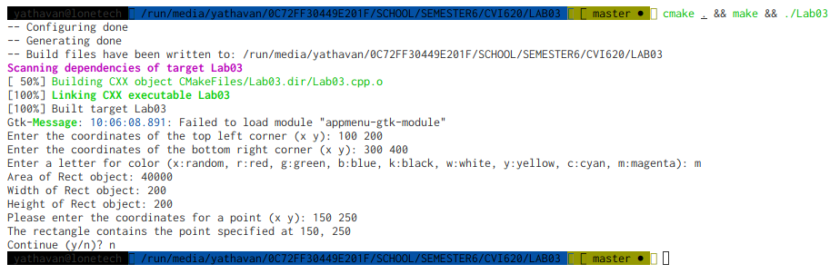

1. Paste the created image (Lab03.jpg) here.

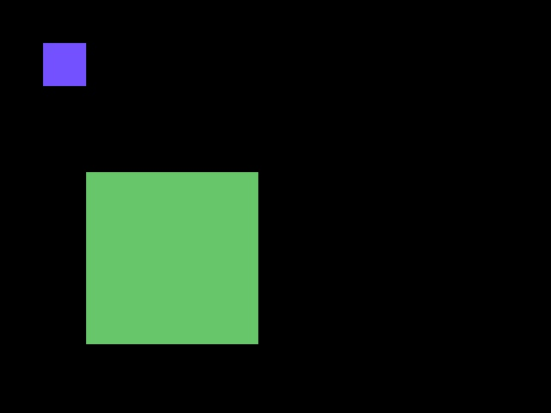

1. Add this declaration to your file:

We, ------------ (mention your names), declare that the attached assignment is our own work in accordance with the Seneca Academic Policy. We have not copied any part of this assignment, manually or electronically, from any other source including web sites, unless specified as references. We have not distributed our work to other students.

1. Specify what each member has done towards the completion of this work:

|  | Name | Task(s) |
| --- | --- | --- |
| 1 | Yathavan Parameshwaran | Lab3.cpp coding of user input, coloring, and . |
| 2 | Gabriella Ko | Calculating area/width/height |
| 3 | Patrick O'reilly | Contains point coding + saving image. |