**MAP524 Project Checkpoint #2**

By: Yathavan Parameshwaran

Date: November 18, 2019

The app I am planning on making is a simple wedding planner application. The app will consist of 5 views:

1. Landing page (the main menu)
2. A todo list for the user to check off items
3. Budget tracker for the catering and venue. It will display amount remaining as each item is added
4. Meal planner
5. Venue finder (using Google Maps API)

The todo list will be done using a ListView as we learned in assignment 3. It will allow the user to add things such as “buy flowers” or “get suit dry cleaned”. And it will allow the user to check things off and delete them if they wish.

The budget tracker is built to handle expenses such as venue costs, catering costs, photography costs, etc. It will allow the user to add the activity, choose the category (from a preset list), and pick an amount. It will display the amount left or exceeded at the bottom of the screen. The features “meal planner” and “venue finder” ties into this app. As the meal options and venue options you choose will get added to the list and calculated as part of the budget.

The meal planner does exactly what is sounds like: plan the meals. The user can select an appetizer, entree, dessert, and beverage from a series of menus, and once completed, will receive a formatted menu with the options for the guests to choose.

The venue finder will utilize the Google Maps API to find wedding venues close to your current location. Once you pick a venue, it will get saved to your preferences.

This app will use SQLite database to save your preferences and choices that you have selected during your use of this application. Once you have used all the features of the app, you will have the chance to see all your options and choices in one screen to print out and give to your wedding venue planner.

User Interface Mockups

1 – Main menu

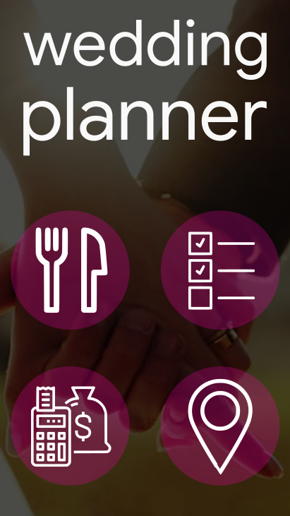

2 – Meal planner

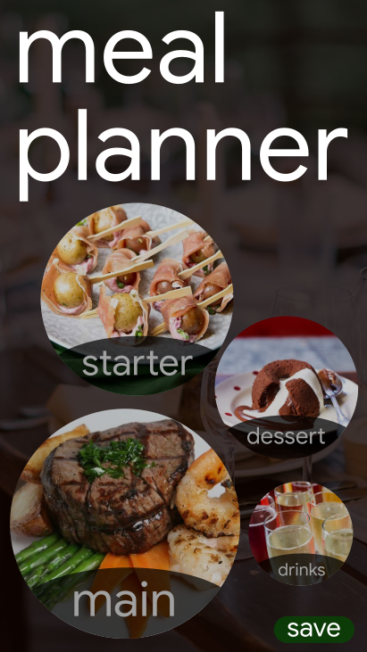

3 – Budget manager

