Machine Learning Exam SoftUni 2018

Radoslav Ivanov

Classifications of Red Wines

I have decided to make 2 classifications of Red Wines, the first classification is divided into “good” or “not good” quality (RedWineClassification2.ipynb), the second classification is divided into "good", "average" or "not good" quality (RedWineClassification3.ipynb).

Please, review both notebooks.

# RedWineClassification2:

## Conclusion

After performing tests on Decision Tree, Random Forest, Linear SVM and Gaussian SVM in the classification of Red Wines, it can be concluded that the best performer of the above mentioned is the Random Forest. Please, check below the respective results for all of the algorithms. The best score is 0.92 from Random Forest.

Decision tree: 0.89375

Random forest: 0.9145833333333333

Linear SVM: 0.8854166666666666

Gaussian SVM: 0.88125

## Random forest ROC Curve:

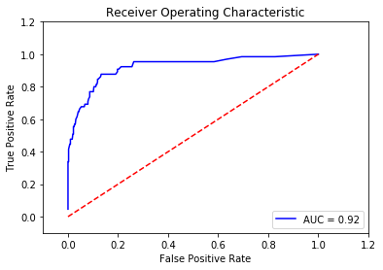

## Confusion matrix

array([[406, 9],

[32, 33]], dtype=int64)

# RedWineClassification2:

## Conclusion

## After performing tests on Decision Tree, Random Forest, Linear SVM and Gaussian SVM in the classification of Red Wines, it can be concluded that the best performer of the above mentioned is the Random Forest. Please, check below the respective results for all of the algorithms. The best score is 0.86 from Random Forest.

## Decision tree: 0.8291666666666667

## Random forest: 0.8625

## Linear SVM: 0.8333333333333334

## Gaussian SVM: 0.8520833333333333

## Confusion matrix

array([[ 0, 18, 1],

[ 1, 382, 13],

[ 0, 33, 32]], dtype=int64)