hw5_erhs535_erh
Eliud R. Rivas Hernandez

Introduction
This analysis examines the spatial distribution of homicides in Baltimore, MD using data from the Washington Post’s comprehensive investigation of unsolved homicides in major U.S. cities. The analysis uses the sf framework for spatial analysis and tigris to provide geographic context through census tract boundaries.

Questions of Interest:
- How are homicides spatially distributed across Baltimore?
- Are there geographic differences between solved and unsolved homicides?
- Do different racial groups experience homicides in different geographic areas?

Load required packages:
library(tidyverse)
library(sf)
library(tigris)
library(forcats)
library(viridis)
library(scales)

Data Loading and Preparation

Read Homicide Data
# Read the Washington Post homicide data
homicides <- read_csv("data/homicide-data.csv")
# Display structure
glimpse(homicides)
## Rows: 52,179
## Columns: 12
## $ uid <chr> "Alb-000001", "Alb-000002", "Alb-000003", "Alb-000004", …
## $ reported_date <dbl> 20100504, 20100216, 20100601, 20100101, 20100102, 201001…
## $ victim_last <chr> "GARCIA", "MONTOYA", "SATTERFIELD", "MENDIOLA", "MULA", …
## $ victim_first <chr> "JUAN", "CAMERON", "VIVIANA", "CARLOS", "VIVIAN", "GERAL…
## $ victim_race <chr> "Hispanic", "Hispanic", "White", "Hispanic", "White", "W…
## $ victim_age <chr> "78", "17", "15", "32", "72", "91", "52", "52", "56", "4…
## $ victim_sex <chr> "Male", "Male", "Female", "Male", "Female", "Female", "M…
## $ city <chr> "Albuquerque", "Albuquerque", "Albuquerque", "Albuquerqu…
## $ state <chr> "NM", "NM", "NM", "NM", "NM", "NM", "NM", "NM", "NM", "N…
## $ lat <dbl> 35.09579, 35.05681, 35.08609, 35.07849, 35.13036, 35.151…
## $ lon <dbl> -106.5386, -106.7153, -106.6956, -106.5561, -106.5810, -…
## $ disposition <chr> "Closed without arrest", "Closed by arrest", "Closed wit…

Filter to Baltimore and Prepare Variables
# Filter to Baltimore, MD
baltimore <- homicides %>%
filter(city == "Baltimore", state == "MD") %>%
# Create solved/unsolved variable
mutate(
case_status = case_when(
disposition == "Closed by arrest" ~ "Solved",
disposition %in% c("Closed without arrest", "Open/No arrest") ~ "Unsolved"
),
# Clean race variable
victim_race = str_to_title(victim_race),
victim_race = case_when(
victim_race == "Unknown" ~ NA_character_,
TRUE ~ victim_race
)
) %>%
# Remove cases with missing coordinates or race
filter(!is.na(lat), !is.na(lon), !is.na(victim_race))
# Display summary
cat("Total homicides in Baltimore:", nrow(baltimore), "\n")
## Total homicides in Baltimore: 2827
cat("Solved:", sum(baltimore$case_status == "Solved"), "\n")
## Solved: 1002
cat("Unsolved:", sum(baltimore$case_status == "Unsolved"), "\n")
## Unsolved: 1825

Identify Top 3 Race Groups
# Count homicides by race
race_counts <- baltimore %>%
count(victim_race, sort = TRUE)
print(race_counts)
## # A tibble: 5 × 2
## victim_race n
## <chr> <int>
## 1 Black 2596
## 2 White 157
## 3 Hispanic 57
## 4 Asian 11
## 5 Other 6
# Use fct_lump to keep top 3 races
baltimore <- baltimore %>%
mutate(
victim_race_grouped = fct_lump(victim_race, n = 3, other_level = "Other")
)
# Display grouped race distribution
baltimore %>%
count(victim_race_grouped, sort = TRUE) %>%
knitr::kable(caption = "Distribution of Homicides by Race Group")
Distribution of Homicides by Race Group
victim_race_grouped | n
Black | 2596
White | 157
Hispanic | 57
Other | 17

Spatial Data Preparation

Convert Homicides to SF Object
# Convert to sf object using WGS84 (EPSG:4326)
baltimore_sf <- baltimore %>%
st_as_sf(coords = c("lon", "lat"), crs = 4326)
# Display spatial summary
cat("Coordinate Reference System:\n")
## Coordinate Reference System:
print(st_crs(baltimore_sf))
## Coordinate Reference System:
## User input: EPSG:4326
## wkt:
## GEOGCRS["WGS 84",
## ENSEMBLE["World Geodetic System 1984 ensemble",
## MEMBER["World Geodetic System 1984 (Transit)"],
## MEMBER["World Geodetic System 1984 (G730)"],
## MEMBER["World Geodetic System 1984 (G873)"],
## MEMBER["World Geodetic System 1984 (G1150)"],
## MEMBER["World Geodetic System 1984 (G1674)"],
## MEMBER["World Geodetic System 1984 (G1762)"],
## MEMBER["World Geodetic System 1984 (G2139)"],
## MEMBER["World Geodetic System 1984 (G2296)"],
## ELLIPSOID["WGS 84",6378137,298.257223563,
## LENGTHUNIT["metre",1]],
## ENSEMBLEACCURACY[2.0]],
## PRIMEM["Greenwich",0,
## ANGLEUNIT["degree",0.0174532925199433]],
## CS[ellipsoidal,2],
## AXIS["geodetic latitude (Lat)",north,
## ORDER[1],
## ANGLEUNIT["degree",0.0174532925199433]],
## AXIS["geodetic longitude (Lon)",east,
## ORDER[2],
## ANGLEUNIT["degree",0.0174532925199433]],
## USAGE[
## SCOPE["Horizontal component of 3D system."],
## AREA["World."],
## BBOX[-90,-180,90,180]],
## ID["EPSG",4326]]

Download Census Tract Boundaries
# Download Baltimore City census tracts
# Baltimore City is FIPS code 24510
baltimore_tracts <- tracts(state = "MD", county = "Baltimore city", year = 2020)
## | | | 0% | | | 1% | |= | 1% | |= | 2% | |== | 2% | |== | 3% | |== | 4% | |=== | 4% | |=== | 5% | |==== | 5% | |==== | 6% | |===== | 7% | |===== | 8% | |====== | 8% | |====== | 9% | |======= | 9% | |======= | 10% | |======= | 11% | |======== | 11% | |======== | 12% | |========= | 12% | |========= | 13% | |========== | 14% | |========== | 15% | |=========== | 15% | |=========== | 16% | |============ | 17% | |============ | 18% | |============= | 18% | |============= | 19% | |============== | 20% | |============== | 21% | |=============== | 21% | |=============== | 22% | |================ | 22% | |================ | 23% | |================= | 24% | |================= | 25% | |================== | 25% | |================== | 26% | |=================== | 26% | |=================== | 27% | |=================== | 28% | |==================== | 28% | |==================== | 29% | |===================== | 29% | |===================== | 30% | |====================== | 31% | |====================== | 32% | |======================= | 32% | |======================= | 33% | |======================== | 34% | |======================== | 35% | |========================= | 35% | |========================= | 36% | |========================== | 37% | |========================== | 38% | |=========================== | 38% | |=========================== | 39% | |============================ | 39% | |============================ | 40% | |============================ | 41% | |============================= | 41% | |============================= | 42% | |============================== | 42% | |============================== | 43% | |=============================== | 44% | |=============================== | 45% | |================================ | 45% | |================================ | 46% | |================================= | 47% | |================================= | 48% | |================================== | 48% | |================================== | 49% | |=================================== | 49% | |=================================== | 50% | |=================================== | 51% | |==================================== | 51% | |==================================== | 52% | |===================================== | 52% | |===================================== | 53% | |====================================== | 54% | |====================================== | 55% | |======================================= | 55% | |======================================= | 56% | |======================================== | 57% | |======================================== | 58% | |========================================= | 58% | |========================================= | 59% | |========================================== | 60% | |========================================== | 61% | |=========================================== | 61% | |=========================================== | 62% | |============================================ | 62% | |============================================ | 63% | |============================================ | 64% | |============================================= | 64% | |============================================= | 65% | |============================================== | 65% | |============================================== | 66% | |=============================================== | 66% | |=============================================== | 67% | |=============================================== | 68% | |================================================ | 68% | |================================================ | 69% | |================================================= | 69% | |================================================= | 70% | |================================================== | 71% | |================================================== | 72% | |=================================================== | 72% | |=================================================== | 73% | |==================================================== | 74% | |==================================================== | 75% | |===================================================== | 75% | |===================================================== | 76% | |====================================================== | 77% | |====================================================== | 78% | |======================================================= | 78% | |======================================================= | 79% | |======================================================== | 79% | |======================================================== | 80% | |======================================================== | 81% | |========================================================= | 81% | |========================================================= | 82% | |========================================================== | 82% | |========================================================== | 83% | |=========================================================== | 84% | |=========================================================== | 85% | |============================================================ | 85% | |============================================================ | 86% | |============================================================= | 87% | |============================================================= | 88% | |============================================================== | 88% | |============================================================== | 89% | |=============================================================== | 89% | |=============================================================== | 90% | |=============================================================== | 91% | |================================================================ | 91% | |================================================================ | 92% | |================================================================= | 92% | |================================================================= | 93% | |================================================================== | 94% | |================================================================== | 95% | |=================================================================== | 95% | |=================================================================== | 96% | |==================================================================== | 97% | |==================================================================== | 98% | |===================================================================== | 98% | |===================================================================== | 99% | |======================================================================| 100%
# Transform to same CRS as homicide data
baltimore_tracts <- baltimore_tracts %>%
st_transform(crs = 4326)
# Display tract information
cat("Number of census tracts:", nrow(baltimore_tracts), "\n")
## Number of census tracts: 199

Verify Spatial Alignment
# Check if homicide points fall within tract boundaries
baltimore_bbox <- st_bbox(baltimore_sf)
tracts_bbox <- st_bbox(baltimore_tracts)
cat("Homicide data bounding box:\n")
## Homicide data bounding box:
print(baltimore_bbox)
## xmin ymin xmax ymax
## -76.71102 39.22270 -76.53094 39.37192
cat("\nCensus tracts bounding box:\n")
##
## Census tracts bounding box:
print(tracts_bbox)
## xmin ymin xmax ymax
## -76.71152 39.19721 -76.52945 39.37221
# Verify points are within tracts
points_in_tracts <- st_within(baltimore_sf, baltimore_tracts, sparse = FALSE) %>%
rowSums()
cat("\nPoints within tract boundaries:", sum(points_in_tracts > 0), "of", nrow(baltimore_sf), "\n")
##
## Points within tract boundaries: 2827 of 2827

Spatial Visualization

Create Map with Facets
# Create the main visualization
ggplot() +
# Add census tract boundaries
geom_sf(data = baltimore_tracts,
fill = "gray95",
color = "gray70",
size = 0.2) +
# Add homicide points
geom_sf(data = baltimore_sf,
aes(color = victim_race_grouped),
size = 1.5,
alpha = 0.6) +
# Facet by case status
facet_wrap(~case_status, ncol = 2) +
# Color scheme
scale_color_viridis_d(option = "plasma",
name = "Victim Race",
end = 0.9) +
# Labels and theme
labs(
title = "Spatial Distribution of Homicides in Baltimore, MD (2007-2017)",
subtitle = "Comparing Solved and Unsolved Cases by Victim Race",
caption = "Data: Washington Post | Boundaries: U.S. Census Bureau (2020 Census Tracts)",
x = NULL,
y = NULL
) +
theme_minimal(base_size = 12) +
theme(
plot.title = element_text(face = "bold", size = 16),
plot.subtitle = element_text(size = 12, color = "gray30"),
strip.text = element_text(face = "bold", size = 14),
strip.background = element_rect(fill = "gray90", color = NA),
legend.position = "bottom",
legend.title = element_text(face = "bold"),
panel.grid.major = element_line(color = "gray80", size = 0.2),
axis.text = element_text(size = 8)
)
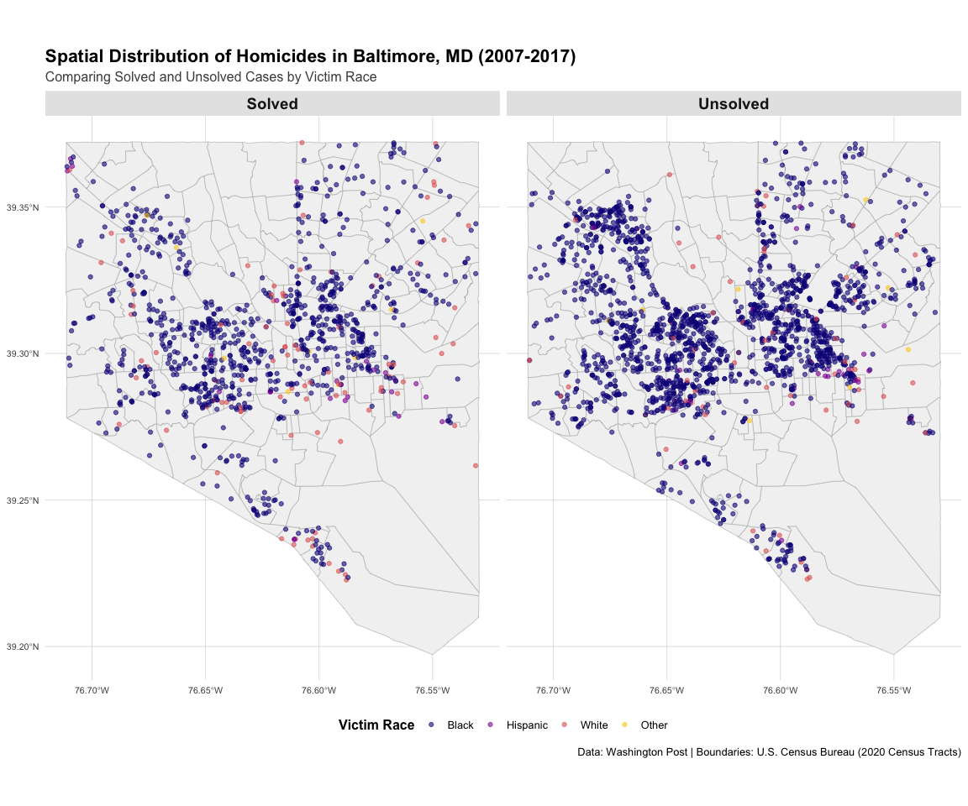

Statistical Summary

Homicides by Race and Case Status
# Create summary table
summary_table <- baltimore %>%
count(case_status, victim_race_grouped) %>%
pivot_wider(names_from = case_status, values_from = n, values_fill = 0) %>%
mutate(
Total = Solved + Unsolved,
Percent_Unsolved = round(100 * Unsolved / Total, 1)
) %>%
arrange(desc(Total))
summary_table %>%
knitr::kable(
caption = "Homicide Cases by Victim Race and Case Status",
col.names = c("Victim Race", "Solved", "Unsolved", "Total", "% Unsolved")
)
Homicide Cases by Victim Race and Case Status
Victim Race | Solved | Unsolved | Total | % Unsolved
Black | 876 | 1720 | 2596 | 66.3
White | 90 | 67 | 157 | 42.7
Hispanic | 27 | 30 | 57 | 52.6
Other | 9 | 8 | 17 | 47.1

Spatial Clustering Analysis
# Calculate distances between points for each group
baltimore_by_status <- baltimore_sf %>%
group_by(case_status) %>%
summarize(
count = n(),
.groups = "drop"
)
# Calculate centroids for each race group and case status
centroids <- baltimore_sf %>%
group_by(case_status, victim_race_grouped) %>%
summarize(
count = n(),
geometry = st_union(geometry),
.groups = "drop"
) %>%
st_centroid()
print(centroids)
## Simple feature collection with 8 features and 3 fields
## Geometry type: POINT
## Dimension: XY
## Bounding box: xmin: -76.62836 ymin: 39.29647 xmax: -76.59959 ymax: 39.31304
## Geodetic CRS: WGS 84
## # A tibble: 8 × 4
## case_status victim_race_grouped count geometry
## * <chr> <fct> <int> <POINT [°]>
## 1 Solved Black 876 (-76.62494 39.30763)
## 2 Solved Hispanic 27 (-76.6039 39.30001)
## 3 Solved White 90 (-76.60906 39.29647)
## 4 Solved Other 9 (-76.61073 39.31304)
## 5 Unsolved Black 1720 (-76.62836 39.30931)
## 6 Unsolved Hispanic 30 (-76.60313 39.29989)
## 7 Unsolved White 67 (-76.60769 39.29849)
## 8 Unsolved Other 8 (-76.59959 39.31121)

Key Findings

Geographic Patterns
# Calculate key statistics for findings
total_homicides <- nrow(baltimore)
unsolved_rate <- round(100 * sum(baltimore$case_status == "Unsolved") / total_homicides, 1)
top_race <- baltimore %>%
count(victim_race_grouped, sort = TRUE) %>%
slice(1) %>%
pull(victim_race_grouped) %>%
as.character()
top_race_pct <- round(100 * max(table(baltimore$victim_race_grouped)) / total_homicides, 1)
Based on the spatial analysis of 2827 homicides in Baltimore from 2007-2017:
- High Unsolved Rate: Approximately 64.6% of homicides remain unsolved, indicating significant challenges in case clearance.
- Racial Disparities: Black victims represent 91.8% of all homicides, showing substantial racial disparities in victimization.
- Spatial Distribution: Homicides are not randomly distributed but show clear clustering in specific census tracts, suggesting concentrated areas of violence.
- Solved vs. Unsolved Geography: The spatial patterns of solved and unsolved cases show both similarities and differences, with some areas having particularly low clearance rates.

