2
1
3
4
5
6
B
A
*
0
#
D
7
8
9
C
Keypad
7 6 5 4 3 2 1 0
Outputs from ES308 Rabbit Board
Inputs to ES308 Rabbit Board

Pins on keypad
1
0
2
3
7
6
5
4
Enclosure 12

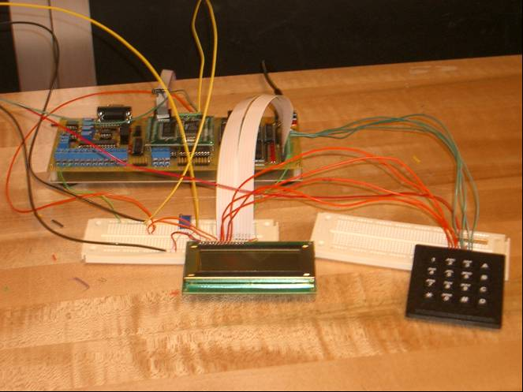\
Input connections to the ES308 board
Input connections to the keypad (pins 3-0)
Output pins on ES308 board, goes to both LCD Display and Keypad
Output pins to Keypad, shared with LCD Display (pins 7-4)
The way the keypad works is a output wire is set low while the other three are still set high (+5Volts for high, +0 volts for low). This will send voltage through that one horizontal line that is low (that is set by the ES308 board therefore known). If a key is pressed down the input wire for that pin will then set itself low while the others are still high. If nothing was pressed all four wires will stay at high.
For example:
- Set wire #4 to 0 volts, wires #5,#6,and #7 to 5 volts (look at bottom line of keypad) Binary: 1110 Hex: D
- Read in wires #0,#1,#2, and #3.
- Wire #3 is low, all others are high Binary: 0111 Hex: 7
- Because the bottom line was being looked at (wire #4 low) and the 3rd wire was low, it was the * key that was selected.
Enclosure 12

