|  |
| --- |
| **Title** |

A Meta-Analysis of the Influence of Climate, Time-Since-Fire and Burn Extent on Stream Biogeochemical Responses to Wildfire

|  |
| --- |
| **Summary** |

This data package is associated with the publication “A Meta-Analysis of the Influence of Climate, Time-Since-Fire and Burn Extent on Stream Biogeochemical Responses to Wildfire” submitted to ***GEOPHYSICAL RESEARCH LETTERS (CAVAIANI ET AL., 2024).*** This study uses meta-analytical techniques to evaluate the effect of wildfire on in-stream responses in burned and unburned watersheds. The study aims to provide additional insight into the range of responses and net influences that wildfires have on hydrobiogeochemistry across broad spatial scales, burn extents, and the longevity of change of water quality. Furthermore, we want to investigate the variability of wildfire responses within and across studies to disentangle the mechanisms that contribute to fire responses. This study compiles data and metadata from 18 total publications that includes 1) surface water geochemistry data (dissolved organic carbon; nitrate), 2) climate classifications, 3) year of the wildfire, 4) the time lag between when the fire occurred and when the sampling occurred, and 5) study design of the publication. In total, this meta-analysis draws data from 18 publications spanning 8 climate guilds, 3 biomes, 62 watersheds, and 20 unique wildfires.

|  |
| --- |
| **Brief Overview of Methods** |

We performed a systematic literature search in September 2023 on Scopus and Web of Science using keywords: “wildfire” OR “fire” AND “dissolved organic carbon” OR “nitrate” AND “concentration” AND “export” OR “discharge” OR “stream” OR “river” OR “creek” OR “watershed” to generate a list of peer-reviewed papers reporting the effects of fire on dissolved organic carbon and nitrate in burned versus unburned watersheds. From the initial list of publications, we only retained studies matching all five of the following criteria: 1) the burn was a wildfire, 2) paired watershed study design encompassing both burned and unburned reference sites, 3) data where either DOC or nitrate was reported, 4) data were reported as time-series which allowed us to interpret seasonal variability in concentrations, and 5) located within North America. The dataset also includes a summary file that consists of site level metadata, climate characteristics and the effect size calculated for each site included in the study. Due to the lack of accessible data across publications, we generated a pseudo yield metric to facilitate intercomparisons across watersheds of different sizes. To analyze the proportional difference between burned and unburned in-stream solute concentrations, we calculated the effect size statistical metric. Effect sizes were converted to percent differences. Mixed-effects models were used to determine the significance of climate, time-since-fire, and burn extent response to fire. All scripts are in R and the associated data can be found at this data repository: <https://github.com/river-corridors-sfa/rc_sfa-rc-3-wenas-meta>.

|  |
| --- |
| **Critical Details** |

1 – Map of the continuous United States (CONUS) with each point representing a unique fire that was studied. The size represents how many watersheds were monitored associated with each wildfire. In total, 62 watersheds are represented in 18 publications.



2 – Table of each publication that was included and the characteristics of the selected sites.

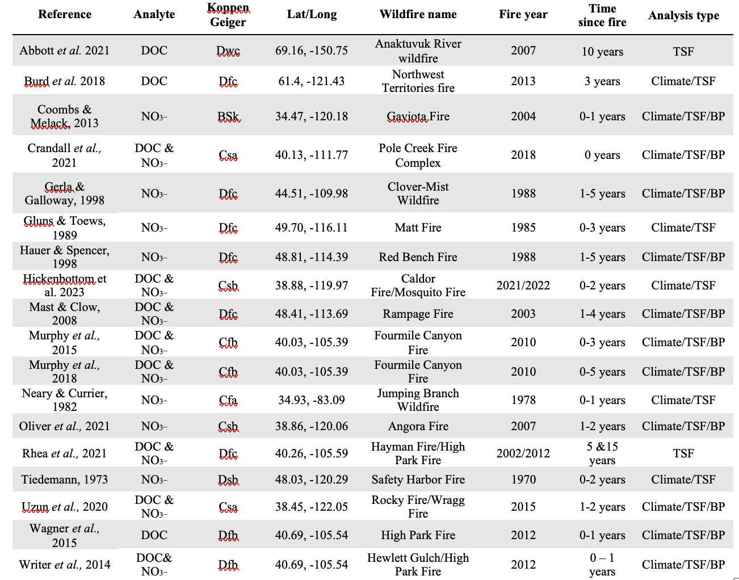

|  |
| --- |
| **Data Package Structure** |

This data package contains 4 primary folders that include the following: 1) inputs, 2) Output for analysis, 3) initial plots, and 4) r scripts. The package contains a single flmd file. The input folder, folder 1, contains a list of the output from the formal web search and why each publication was excluded. It also includes a site-level metadata for all the publications included in the final analysis. The output for analysis folder, folder 2, contains individual data dictionaries, appended as _dd.csv, to define and provide descriptors of column/row headers. This package contains the following file types: csv, pdf, jpeg.

|  |
| --- |
| **Acknowledgements and Citations** |

This research was supported by the U.S. Department of Energy (DOE) Office of Science, Biological and Environmental Research (BER) Program, Environmental System Science (ESS) Program (<https://ess.science.energy.gov/>) through the Pacific Northwest National Laboratory (PNNL) River Corridor Science Focus Area (SFA). PNNL is operated by Battelle Memorial Institute for the DOE under Contract No. DE-AC05-76RL01830.

|  |
| --- |
| **Contact** |

Allison Myers-Pigg, allison.myers-pigg@pnnl.gov

|  |
| --- |
| **Change History** |

|  |  |  |
| --- | --- | --- |
| Version 1 | March 2024 | Original data package publication |