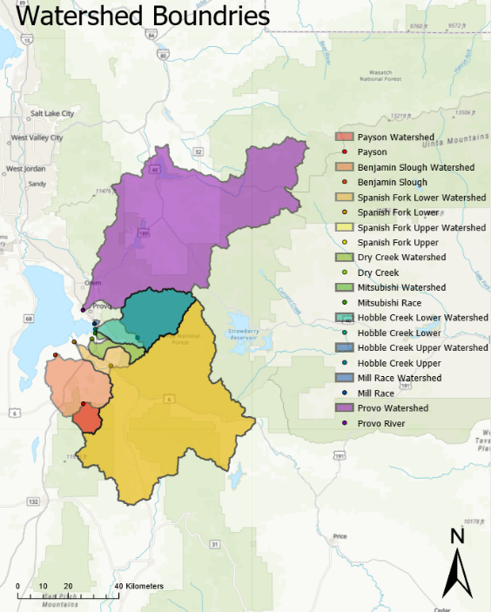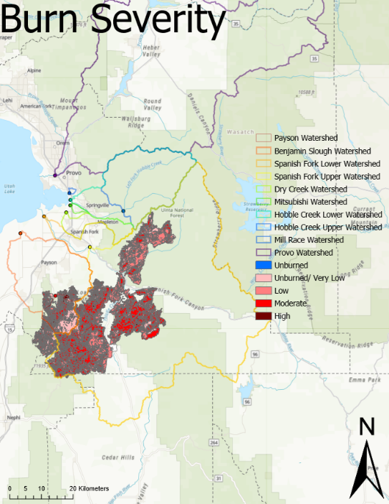

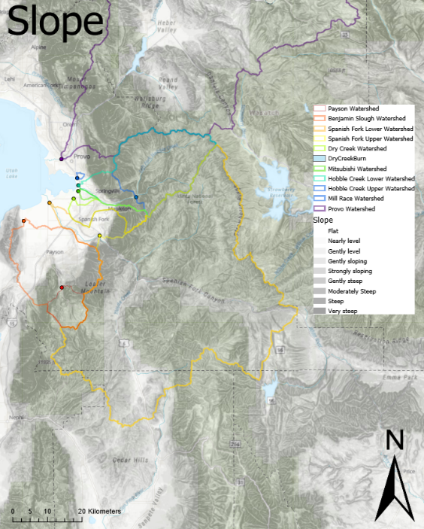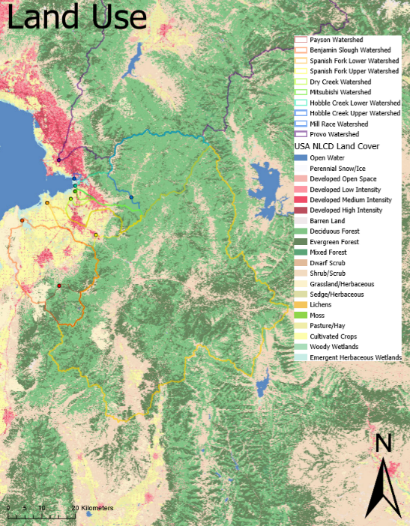

**Figure S1.** Detailed maps of the study watersheds, burn scar severity, topography, and land use. We created the maps with ArcGIS Pro (ESRI) using open source basemap layers from the global GIS user community (the USGS National Map and Earth Resources Observation and Science Center).