# Severe western Canadian wildfire affects water quality even at large basin scales

*Emmerton, C.A., Cooke, C.A., Hustins, S., Silins, U., Emelko, M.B., Lewis, T., Kruk, M.K., Taube, N., Zhu, D., Jackson, B., Stone, M., Kerr, J.G., Orwin, J.F.*

# Supplementary material

## Wildfire commencement and burned area

Driven by a strong El Niño event from 2014 to 2016, precipitation and soil moisture conditions were drier than normal in the lower Athabasca region leading up to the wildfire (1,2). Between October 2015 and April 2016, total precipitation was 22% below normal and mean air temperature was 3.2°C warmer than normal (3). Snow depth across the region was the lowest in the previous 10 years and snow was absent two weeks earlier than normal (1). These mild and dry conditions reduced regional runoff and drove substantial river flow deficits in the region (Figure 2, main manuscript). The Athabasca (downstream of Fort McMurray), Clearwater (at Draper), and Hangingstone (at Fort McMurray) rivers, in particular, were discharging water at as low as the 20th percentiles of their daily historic flows in April (4).

Fire perimeters and burn intensities were delineated using Landsat 8-Sentinel 2 surface reflectance data (5). The extent and severity of the May 2016 Fort McMurray (Horse River) wildfire was quantified using pre- and post-burn Normalized Burn Ratios (NBR):

where NIR is reflected near infrared radiation (~785-900 nm) and SWIR is reflected shortwave infrared radiation (1,565-2,294 nm). Burn severity index (∆NBR) was then calculated as pre-fire NBR less post-fire NBR using a classification scheme of no change (∆NBR<0.10), low severity burn (∆NBR=0.10-1.25), moderate severity burn (∆NBR=1.25-2.25) and high severity burn (∆NBR>2.25). The Fort McMurray wildfire was characterized by a well-defined burn perimeter with the majority of burn severity values classified as high (40%), followed by moderate (26%), no change (20%), and low severity (11%) (Figure 1, main manuscript). The balance of the burned area in the satellite imagery was surface water (1%) or was contaminated by clouds (2%).

## Post-fire precipitation events

Following the fire, the first precipitation event greater than 10 mm in the region occurred in late May 2016 in the Clearwater and Hangingstone watersheds and contributed to river flow increases toward historically normal levels (Figure 2, main manuscript). The second precipitation event occurred on June 9th and delivered 20 to 59 mm of precipitation across multiple meteorological stations, resulting in notable increases in flow in all monitored rivers. The third precipitation event of note was very intense in the Fort McMurray area with 84 mm falling on July 31, 2016. This rainfall, however, was an extremely localized event at the mouths of the Clearwater and Hangingstone rivers and therefore only somewhat affected flow at local hydrometric stations.

## Pre- and post-fire river hydrology

Methodology: The hydrologic response of impacted rivers before and after the wildfire were also evaluated using one event-specific and two annual metrics of river hydrology. First, we quantified basin lag times during precipitation events at two impacted monitoring stations before (2010–2016) and after (2016–18) the fire using hourly rainfall and flow data. Basin lag times in the Clearwater and Hangingstone river watersheds were calculated as the difference in time between the centroid of a storm’s rainfall accumulation (≥10 mm at nearby stations) and the subsequent peak flow in each river at its impacted hydrometric station (6). Second, pre- and post-fire regressions of flow data between an upstream (unburned before and after the fire) and downstream (unburned before, burned after the fire) station within the Athabasca (N 54.7223; W -113.2884) and Hangingstone (N 56.2687; W -111.4887) rivers were compared. Finally, annual flow duration curves before and after the wildfire were constructed using hourly data from impacted flow stations monitoring the Athabasca, Clearwater, and Hangingstone rivers. Median flows were calculated each year across 5% flow exceedance intervals and were ranked to assess changes in the 2016 post-fire flow duration curve shape relative to pre-fire data.

Results: Flow metrics showed few differences before to after the wildfire. Basin lag and precipitation rate regressions in the burned Clearwater and Hangingstone watersheds suggested little evidence of shortened basin lag times post-fire (Figure S3). Regressions between upstream (unburned) and downstream (burned) Athabasca River stations showed similar slopes and variabilities before and after the fire (Figure S4) with no post-fire outliers relative to historic data. Similar patterns were observed in the Hangingstone River (Figure S4). Post-fire flow duration curves from the impacted Athabasca, Clearwater, and Hangingstone rivers were typical in magnitude and shape compared to their pre-fire years, except at the lowest end of flows when 2016 ranked in the upper quartile of all years, particularly at the Hangingstone and Athabasca rivers (Figure S5).

# Tables

**Table S1** Water quantity and quality monitoring preceding and proceeding the May 2016 Fort McMurray wildfire in the lower Athabasca region of northeastern Alberta, Canada.

|  |  |  |
| --- | --- | --- |
| **Sampling site** | **Frequency** | **Record** |
|  |  |  |
| *Meteorology* |  |  |
| Fort McMurray A | Hourly, Daily | 2010-2016 |
| Bovine | Daily | 2016 |
|  |  |  |
| *River flow* |  |  |
| Athabasca R. u/s FMM* | Hourly, Daily | 1958-2016 |
| Clearwater R. at Draper | Hourly, Daily | 1967-2016 |
| Hangingstone R. at FMM | Hourly, Daily | 1965-2016 |
| Athabasca R. at Athabasca | Daily | 1957-2016 |
| Hangingstone R. at North Star | Daily | 2002-2016 |
| Ells R. at CNRL Bridge | Daily | 2010-2016 |
| Firebag R. near the mouth | Daily | 1971-2016 |
| Mackay R. near Fort Mackay | Daily | 1972-2016 |
| Calumet R. near the mouth | Daily | 2010-2016 |
| Christina R. near the mouth** | Daily | 1966-2016 |
| High Hills R. near the mouth | Daily | 2012-2016 |
|  |  |  |
| *Water quality* |  |  |
| Athabasca R.  u/s of Fort McMurray  (burned) | 15-minute (sonde)  Daily (autosampler)  Weekly (grab)  Monthly (grab)  Historic (grab) | 18-May to 17-Oct 2016  24-May to 30-Aug 2016  11-May to 30-Aug 2016  19-Sep 2016 to 11-Dec 2016  2004-2016 |
|  |  |  |
| Athabasca R.  d/s of Fort McMurray (LB/RB)  (burned) | 15-minute (sonde) | 18-May to 18-Oct 2016 |
|  |  |  |
| Clearwater R.  near the mouth  (burned) | 15-minute (sonde)  Daily (autosampler)  Weekly (grab)  Historic (grab) | 18-May to 17-Oct 2016  24-May to 31-Aug 2016  24-May to 31-Aug 2016; 5-Apr to 13-Jun 2016  2001-2015 |
|  |  |  |
| Hangingstone R.  at Fort McMurray  (burned) | 15-minute (sonde)  Daily (autosampler)  Weekly (grab)  Historic (grab) | 18-May to 17-Oct 2016  24-May to 30-Aug 2016  11-May to 30-Aug 2016; 5-Apr to 14-Jun 2016  2004-2016 |
|  |  |  |
| Athabasca R.  at Grand Rapids  (unburned)*** | 15-minute (sonde)  Daily (autosampler)  Weekly (grab) | 5-July to 20-October 2016  22-Jun to 27-Aug 2016  18-May, 28-Jun to 30-Aug 2016 |
|  |  |  |
| Ells R. at EL2; Firebag R. at FI1; Mackay R. at MA1; Calumet R. at CA1  (unburned) | Monthly (grab) | 12-Jun to 22-Sep 2015  14-Jun to 21-Sep 2016 |
|  |  |  |
| Christina R. at CH1; High Hills R. at HHR1  (burned) | Monthly (grab) | 16-Jun to 16-Sep 2015  21-Jun to 21-Sep 2016 |

FMM: Fort McMurray; *flow quantified by difference between Athabasca River downstream of Fort McMurray and Clearwater River at Draper Water Survey of Canada stations.**flow quantified by difference between Clearwater River above Christina River and Clearwater River at Draper. ***flow quantified by scaling runoff at the Athabasca River at Athabasca station to this station’s drainage area.

**Table S2** Spearman correlations of river flow (Q), turbidity (T), specific conductivity (C), and pH (P) with several total physical, ion, nutrient and metals concentrations exhibiting particle-bound and dissolved behavior (see Results in main manuscript) in frequently monitored river stations in 2016 after the Fort McMurray wildfire. Significant correlations (α=0.05) denoted by either a positive (+) or negative (–) association symbols. (t)=total analysis.

|  |  |  |  |  |  |  |  |  |  |  |  |  |  |  |  |  |  |
| --- | --- | --- | --- | --- | --- | --- | --- | --- | --- | --- | --- | --- | --- | --- | --- | --- | --- |
| **Group** | **Analyte** | **Athabasca R.**  **at Grand Rapids** | | | | **Athabasca R.**  **u/s Fort McMurray** | | | | **Clearwater R.**  **at Draper** | | | | **Hangingstone R.**  **at Fort McMurray** | | | |
|  |  | **Q** | **T** | **C** | **P** | **Q** | **T** | **C** | **P** | **Q** | **T** | **C** | **P** | **Q** | **T** | **C** | **P** |
|  |  |  |  |  |  |  |  |  |  |  |  |  |  |  |  |  |  |
| **Particle-bound type** | |  |  |  |  |  |  |  |  |  |  |  |  |  |  |  |  |
| Sediment | TSS | + | + | ─ | ─ | + | + | ─ | ─ | + | + |  | ─ | + | + |  | ─ |
| Ions | t-K | + | + | ─ | ─ | + | + | ─ | ─ |  | + |  |  |  |  |  |  |
| Nutrients | TOC | + | + | ─ | ─ | + | + | ─ | ─ | + | + |  | ─ |  |  |  |  |
| Nutrients | TKN | + | + | ─ | ─ | + | + | ─ | ─ | + | + |  | ─ | + | + |  | ─ |
| Nutrients | TP | + | + | ─ | ─ | + | + | ─ | ─ | + | + |  |  | + | + | ─ | ─ |
| Metals | t-Ag |  |  |  |  | + | + | ─ | ─ | + | + |  |  | + | + |  | ─ |
| Metals | t-Al | + | + | ─ |  | + | + | ─ | ─ | + | + |  |  | + | + |  | ─ |
| Metals | t-As | + | + |  | ─ | + | + | ─ | ─ | + | + |  | ─ | + | + |  | ─ |
| Metals | t-Ba | + | + | ─ |  | + | + |  | ─ | + | + |  | ─ | + | + |  |  |
| Metals | t-Be | + | + | ─ | ─ | + | + | ─ | ─ | + | + |  |  | + | + |  | ─ |
| Metals | t-Bi | + | + | ─ |  | + | + | ─ | ─ |  | + |  |  | + | + |  |  |
| Metals | t-Cd | + | + | ─ |  | + | + | ─ | ─ | + | + |  |  | + | + |  |  |
| Metals | t-Co | + | + | ─ | ─ | + | + | ─ | ─ | + | + |  | ─ | + | + |  | ─ |
| Metals | t-Cr | + | + | ─ |  | + | + | ─ | ─ | + | + |  |  | + | + |  | ─ |
| Metals | t-Cu | + | + | ─ | ─ | + | + | ─ | ─ | + | + |  |  | + | + |  | ─ |
| Metals | t-Fe | + | + | ─ | ─ | + | + | ─ | ─ | + | + |  |  | + | + |  | ─ |
| Metals | t-Li |  |  |  |  | + | + |  | ─ |  | + |  |  | ─ |  | + | + |
| Metals | t-Mn | + | + | ─ | ─ | + | + | ─ | ─ | + | + | ─ | ─ | + | + | ─ | ─ |
| Metals | t-Ni | + | + | ─ | ─ | + | + | ─ | ─ | + | + |  | ─ | + | + | ─ | ─ |
| Metals | t-Pb | + | + | ─ | ─ | + | + | ─ | ─ | + | + |  |  | + | + | ─ | ─ |
| Metals | t-Sb |  |  |  |  | + | + | ─ | ─ | + | + |  |  |  | + |  |  |
| Metals | t-Sn |  |  |  |  |  |  |  |  |  |  |  |  |  |  |  |  |
| Metals | t-Th | + | + | ─ | ─ | + | + | ─ | ─ | + | + |  |  | + | + |  | ─ |
| Metals | t-Ti | + | + | ─ |  | + | + |  | ─ | + | + |  | ─ | + | + |  | ─ |
| Metals | t-Tl |  | + | ─ |  | + | + | ─ | ─ |  | + |  |  | + | + | ─ | ─ |
| Metals | t-U | + | + |  |  | + | + |  | ─ | + | + |  |  |  |  |  |  |
| Metals | t-V | + | + | ─ |  | + | + | ─ | ─ | + | + |  | ─ | + | + |  | ─ |
| Metals | t-Zn | + | + | ─ | ─ | + | + | ─ | ─ | + | + |  |  | + | + |  | ─ |
|  |  |  |  |  |  |  |  |  |  |  |  |  |  |  |  |  |  |
| **Dissolved type** | |  |  |  |  |  |  |  |  |  |  |  |  |  |  |  |  |
| Ions | t-Na |  |  |  |  |  |  |  |  | ─ | ─ | + | + | ─ | ─ | + | + |
| Ions | t-Mg |  | ─ | + | + |  |  |  |  |  |  |  |  |  |  | + | + |
| Ions | t-Ca |  | ─ | + | + | ─ | ─ | + | + |  |  | + |  | ─ |  | + | + |
| Ions | t-Cl |  |  |  |  |  |  |  |  |  |  | + | + | ─ |  | + | + |
| Metals | t-B |  |  |  |  |  |  |  |  |  |  |  |  | ─ | ─ | + | + |
| Metals | t-Mo | ─ | ─ | + | + | ─ | ─ | + | + |  |  |  |  | ─ | ─ | + | + |
| Metals | t-Se |  |  |  |  | ─ | ─ | + | + |  |  |  |  |  |  |  |  |
| Metals | t-Sr |  |  | + | + | ─ | ─ | + | + |  |  | + |  | ─ |  | + | + |

**Table S3** Ordination axis variation and species scores of an unconstrained Principal Components Analysis (PCA) of river water quantity and quality data following the May 2016 Fort McMurray wildfire. Axes with positive associations between conductivity and turbidity (PC3), in the absence of discharge changes, were considered to reflect fire-impacted water quality. **indicates main water quality stations.

|  |  |  |  |  |  |  |  |
| --- | --- | --- | --- | --- | --- | --- | --- |
| **PCA Axis and parameters** | **Burned** | | | | |  | **Unburned** |
| **Atha. R.**  **u/s of Fort McMurray (LB)\*\*** | **Atha. R.**  **d/s of Fort McMurray (LB)** | **Atha. R.**  **d/s of Fort McMurray (RB)** | **Clearwater R.**  **at Draper\*\*** | **Hang. R.**  **at Fort McMurray\*\*** |  | **Atha. R.**  **at Grand Rapids\*\*** |
|  |  |  |  |  |  |  |  |
| PC1 variation (%) | 59 | 48 | 44 | 48 | 53 |  | 51 |
| River discharge | 0.91 | 0.88 | -0.24 | 0.75 | 0.76 |  | 0.90 |
| Conductivity | -0.86 | -0.77 | -0.72 | -0.85 | -0.79 |  | -0.58 |
| Turbidity | 0.74 | 0.83 | -0.17 | 0.29 | 0.35 |  | 0.73 |
| pH | -0.81 | -0.85 | -0.69 | -0.69 | -0.83 |  | -0.51 |
| Dissolved O2 | -0.70 | 0.13 | 0.86 | 0.66 | 0.71 |  | -0.72 |
| Water temperature | 0.57 | -0.33 | -0.91 | -0.76 | -0.81 |  | 0.59 |
|  |  |  |  |  |  |  |  |
| PC2 variation (%) | 26 | 31 | 28 | 27 | 23 |  | 37 |
| River discharge | 0.17 | -0.21 | 0.85 | 0.56 | 0.40 |  | -0.12 |
| Conductivity | -0.09 | 0.21 | -0.52 | -0.18 | -0.21 |  | -0.55 |
| Turbidity | 0.42 | -0.05 | 0.35 | 0.58 | 0.65 |  | 0.46 |
| pH | -0.48 | 0.04 | -0.61 | -0.27 | -0.24 |  | -0.76 |
| Dissolved O2 | 0.69 | 0.97 | -0.39 | -0.71 | -0.65 |  | 0.67 |
| Water temperature | -0.81 | -0.92 | 0.22 | 0.60 | 0.53 |  | -0.78 |
|  |  |  |  |  |  |  |  |
| PC3 variation (%) | 8 | 10 | 17 | 15 | 12 |  | 7 |
| River discharge | 0.06 | -0.04 | 0.08 | -0.02 | -0.09 |  | 0.21 |
| Conductivity | 0.46 | 0.58 | 0.31 | 0.37 | 0.42 |  | 0.57 |
| Turbidity | 0.49 | 0.49 | 0.89 | 0.75 | 0.66 |  | 0.36 |
| pH | 0.14 | -0.12 | 0.10 | 0.30 | 0.19 |  | -0.02 |
| Dissolved O2 | -0.09 | -0.05 | 0.25 | 0.20 | 0.22 |  | 0.07 |
| Water temperature | 0.05 | 0.05 | -0.27 | -0.23 | -0.21 |  | -0.14 |

**Table S4** Percentage of post-fire and historic water samples exceeding Canadian surface water quality guidelines (7) in rivers (# samples) draining unburned (U) and burned (B) watersheds. **Bold** type indicates an increase in the frequency of guideline exceedances relative to control sites and historic records, if available.

|  |  |  |  |  |  |  |  |
| --- | --- | --- | --- | --- | --- | --- | --- |
|  | **Atha .R.**  **at Grand Rapids**  ***2016*** | **Atha. R.**  **u/s Fort McMurray *Historic*** | **Atha. R.**  **u/s Fort McMurray *2016*** | **Clear. R.**  **at Draper**  ***Historic*** | **Clear. R.**  **at Draper**  ***2016*** | **Hang. R.**  **at Fort McMurray *Historic*** | **Hang. R.**  **at Fort McMurray *2016*** |
|  | **U (11)** | **U (83)** | **B(20)** | **U (88)** | **B (17)** | **U (39)** | **B (24)** |
|  |  |  |  |  |  |  |  |
| *Particle-bound* | |  |  |  |  |  |  |
| t-Ag | 0 | 0 | 0 | 2 | 0 | 0 | 0 |
| t-Al | 100 | 41 | 91 | 90 | 80 | 87 | 69 |
| t-As | 0 | 0 | 0 | 0 | 0 | 0 | 0 |
| t-B | 0 | 0 | 0 | 0 | 0 | 0 | 0 |
| t-Cd | 9 | 8 | **18** | 4 | **5** | 8 | 8 |
| t-Cu | 45 | 17 | 36 | 20 | **35** | 10 | **27** |
| t-Fe | 100 | 34 | 91 | 97 | 85 | 100 | 92 |
| t-Pb | 0 | 0 | **18** | 0 | **15** | 0 | **4** |
| t-Ni | 0 | 0 | 0 | 0 | 0 | 0 | 0 |
| t-Th | 0 | 0 | 0 | 0 | 0 | 0 | 0 |
| t-U | 0 | 0 | 0 | 0 | 0 | 0 | 0 |
| t-Zn | 55 | 19 | 36 | 30 | 30 | 21 | **27** |
|  |  |  |  |  |  |  |  |
| *Dissolved* | |  |  |  |  |  |  |
| t-Cl | 0 | 0 | 0 | 0 | 0 | 0 | 0 |
| t-Mo | 0 | 0 | 0 | 0 | 0 | 0 | 0 |
| t-Se | 0 | 1 | 0 | 2 | 0 | 0 | 0 |

# Figures

|  |  |
| --- | --- |
| **a.** | **b.** |
|  |  |

**Figure S1** a. Map of selected historical river water quantity and quality stations operating within unburned and burned watersheds in the lower Athabasca region. b. Repeated measures ANOVA of total suspended sediment (upper) and total calcium (lower) yields from four unburned rivers (Firebag, Ells, Calumet, Mackay; grey circles) and four impacted rivers (Clearwater, Hangingstone, Christina, High Hills; triangles) in 2015 (pre-fire) and 2016 (post-fire; crosses).

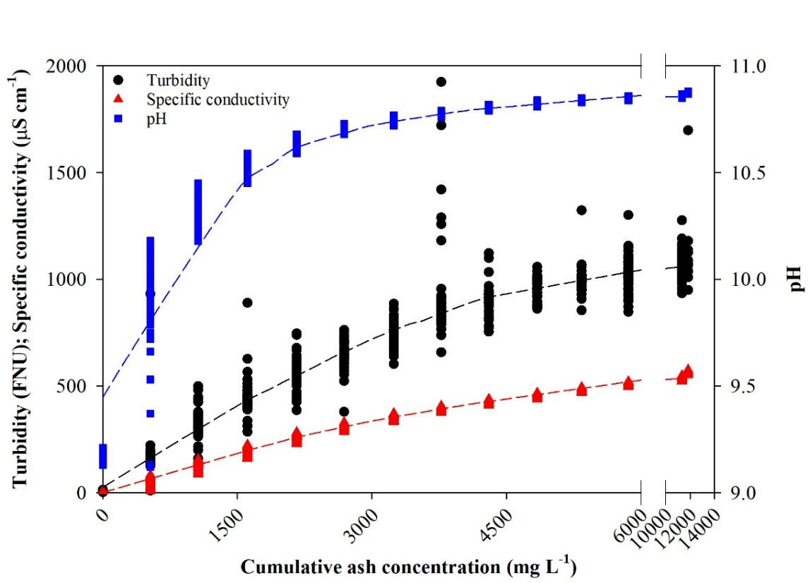

**Figure S2** Results from a laboratory mixing experiment of Fort McMurray wildfire ash (from the Clearwater River watershed) added to water while monitoring general water chemistry using a multi-probe sonde. Dashed lines are loess smoother fits of the experimental data.

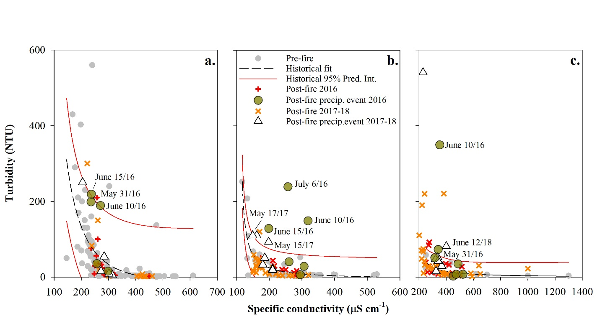

**Figure S3** Historic and post-fire measured turbidity and specific conductivity relationships from burned (a.) Athabasca River upstream of Fort McMurray; (b.) Clearwater River at Draper; and (c.) Hangingstone River at Fort McMurray sites. 95% prediction intervals on historic data are also shown.

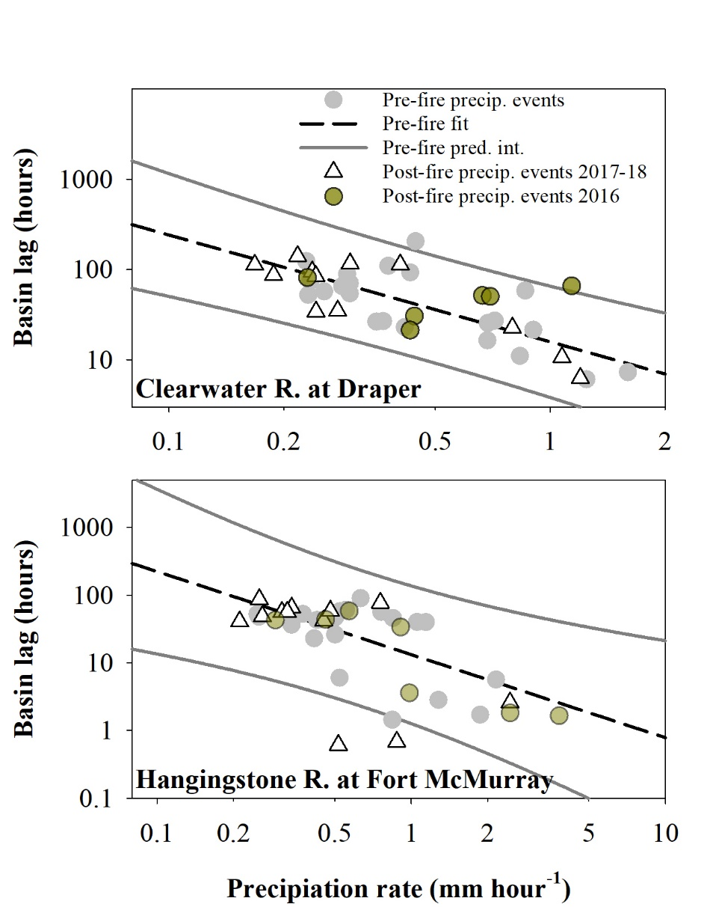

**Figure S4** Log transformed precipitation rate and basin lag time (see supplementary information above) scatterplots for individual storm events monitored before (2010-2016) and after the 2016 Fort McMurray wildfire in the watersheds of the burned Clearwater and Hangingstone rivers. Fit lines accompany 95% prediction intervals for historic data.

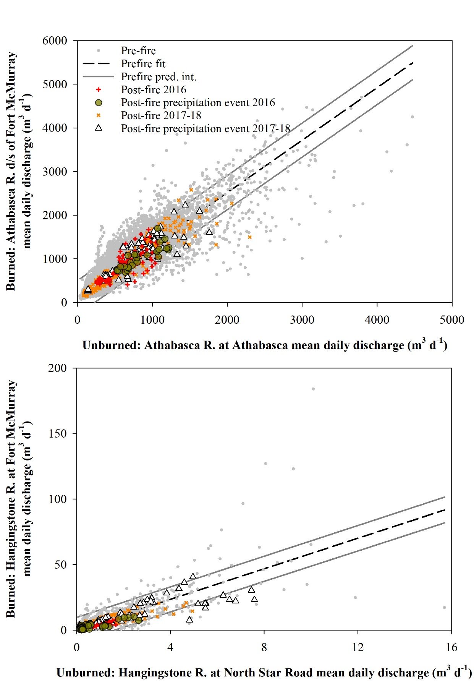

**Figure S5** River flow associations between stations draining unburned and burned portions of the Athabasca (upper panel) and Hangingstone (lower panel) rivers before and after the 2016 Fort McMurray wildfire. Fit lines accompany 95% prediction intervals for historic data.

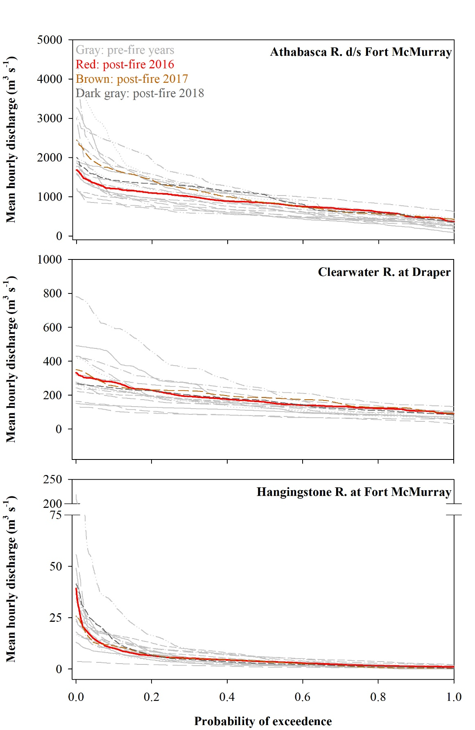

**Figure S6** Mean hourly flow duration curves of hydrometric stations of the Athabasca, Clearwater and Hangingstone rivers before and after the 2016 Fort McMurray wildfire.

# References

1. Alberta Agriculture. (2018) Alberta Climate Information Service. Available at: http://agriculture.alberta.ca/acis/ [Accessed Januray, 2018].

2. Elmes MC, Thompson DK, Sherwood JH, Price JS (2018) Hydrometeorological conditions preceding wildfire, and the subsequent burning of a fen watershed in Fort McMurray, Alberta, Canada. *Nat Hazards Earth Syst Sci* 18(1):157–170.

3. Environment and Climate Change Canada (2018) Historical weather data. Available at: http://climate.weather.gc.ca/ [Accessed August 20, 2009].

4. Water Survey of Canada (2018) Archived hydrometric data. Available at: http://www.wateroffice.ec.gc.ca/ [Accessed June 1, 2018].

5. Claverie M, et al. (2018) The Harmonized Landsat and Sentinel-2 surface reflectance data set. *Remote Sens Environ*. *Remote Sensing of* Environment 219: 145-161.

6. Marchi, L., Borga, M., Preciso, E., Gaume, E., 2010. Characterisation of selected extreme flash floods in Europe and implications for flood risk management. J. Hydrol. 394, 118–133. https://doi.org/10.1016/j.jhydrol.2010.07.017.

7. CCME. 2017. Canadian Environmental Quality Guidelines Summary Table. http://st-ts.ccme.ca/. (Accessed Jan. 2019).