**Supporting information (SI)**

**Two-years of post-wildfire impacts on dissolved organic matter, nitrogen, and precursors of disinfection by-products in California stream waters**

Habibullah Uzun1,Randy A. Dahlgren2, Christopher Olivares3,Cagri Utku Erdem4,Tanju Karanfil4, and Alex T. Chow 4,5

1Department of Environmental Engineering, Marmara University, Istanbul 34722, Turkey

2Department of Land, Air and Water Resources, University of California, Davis, California 95616, United States

3Civil and Environmental Engineering, University of California, Berkeley, California 94720, United States

4Department of Environmental Engineering and Earth Sciences, Clemson University, Anderson, South Carolina 29625, United States

5Biogeochemistry & Environmental Quality Research Group, Clemson University, Georgetown, South Carolina 29442, United States

* Corresponding author:

**Alex T. Chow**

Biogeochemistry & Environmental Quality Research Group, Clemson University, SC

PO Box 596, Georgetown, SC 29442

Email: achow@clemson.edu

Phone: 843-546-1013 x 232

**Analytical Methods**

***General water quality parameters.*** Methods used to analyze general water quality constituents, including dissolved organic carbon (DOC), dissolved nitrogen (DN), ammonia (NH4+-N), nitrate (NO3-), nitrite (NO2-), dissolved organic nitrogen (DON), and bromide (Br-), can be found elsewhere (Uzun, et al., 2016; Ruecker et al., 2017). pH was measured with a VWR Symphony pH meter. UV absorbance was measured with a Varian Carry 50 with SM 5910 method. Turbidity and apparent color were measured with Hach 2100 IS laboratory turbidity meter and DR 900 Colorimeter following Hach Method 8025 (if necessary, samples were diluted with distilled deionized water [DDW], and the results were corrected accordingly), respectively. Free chlorine (Cl2) and chloramine (as Cl2) concentrations were determined following Standard Method 4500-Cl (APHA/AWWA/WEF, 2012). Total suspended solids (TSS) measurements were performed (with un-filtered samples [50-250 ml]) following Standard Method 2540 D. DOC and DN were measured using a TOC-VCHS, Shimadzu Corp. following Standard Method 5310B and high-temperature combustion methods, respectively. Concentrations of NO3-, NO2- and Br- were quantified by ion chromatograph (ICS-2100, Dionex Corp.) (Table S1). DON values were calculated as: DON = DN – (NO2--N + NO3--N + NH4-N). It has been reported that when the concentrations of total inorganic nitrogen are higher than 60% of DN values, DON values become less reliable (Lee and Westerhoff, 2005). Therefore, only DON values for DON/DN ≥40% were reported.

***DOM characterization.*** Before analysis, water samples were filtered through a membrane filter (Pall Supor, ~0.45 µm), and the samples were diluted with DDW, if necessary. DOM was characterized by UV-Vis spectrophotometry (Shimadzu UV-1800) and specific ultraviolet absorbance SUVA254 (UV254/DOC [L/mg-m])(Lee and Westerhoff, 2005) ratios were calculated. 3D spectrofluorometry [measured with Shimadzu Spectrofluorometer RF5301]) was used to determine the humification index (HIX), an indicator of the humic content (Ruecker et al., 2017). Additionally, to provide further insights into the molecular structure of organic matter, 3D scans were divided into five operationally defined regions (I: tyrosine-like; II: tryptophan-like; III: fulvic acid-like; IV: soluble microbial byproduct-like; and V: humic acid-like) as described in previous studies (Chen et al., 2003; Ruecker et al., 2017; Zhou et al., 2013)

***Disinfection by-products (DBPs) measurements*.** Chloral hydrate (CH) (2,2,2-trichloroethane-1,1-diol), trihalomethanes (THMs) (trichloro-, dichlorobromo-, dibromochloro- and tribromomethane), and haloaceticacidc (HAAs) (chloro-, bromo-, dichloro-, bromochloro-, trichloro-, dibromo-, bromodichloro-, dibromochloro-, and tribromo acetic acid) were extracted and analyzed following USEPA Methods 551.1, and 552.2, respectively. The minimum reporting limits (MRLs) for all the DBP species are presented in Table S1.

Commercially available certified reference standards (~2000 µg/ml) were purchased from Sigma Aldrich, and diluted primary stock (DPS) (104 µg/L) solutions were prepared in methyl *tert*-butyl ether (MTBE) from concentrated reference standards. Calibration standards were prepared (1, 5, 10, 25, 50, 100, 200, 500, and 1000 µg/L) using a PDS solution following the same extraction method applied to standard samples.

A 20 ml volume of sample was transferred to a pre-washed glass extraction vial to determine THMs and CH, and 8 ml of methyl MtBE with 50 μg/L of 1,2-dichloropropane used as an internal standard. Then, 8.5 g of reagent grade oven-dried (~24 hrs) sodium sulfate was added to the extraction vial. Extraction vials were closed tightly, laid horizontally on a shaker table, and shaken at ~300 rpm for 15 minutes. After shaking, the vials were allowed to settle for at least 15 minutes. One ml of the upper layer of MtBE was transferred into gas chromatography (GC) vials for subsequent GC analyses.

A 40 ml volume of each sample was transferred to pre-washed glass extraction vials to determine HAAs and acidified with 2 ml of concentrated sulfuric acid. Then 8.0 g of sodium chloride was added to the extraction vials. After cooling, 4 ml of MTBE with 200 μg/L of 1,2-dichloropropane as an internal standard was added. Vials were closed tightly, laid horizontally on a shaker table, and shaken at 300 rpm for 15 minutes. After shaking, the vials were allowed to settle for at least 10 minutes. About 2.5 ml of the upper layer of MtBE was transferred into a pre-washed glass vial. Then, 1 ml of 10% acidic methanol was added into each vial, and the samples were kept in 50 oC (2 hrs) for the methylation process. Finally, the pH of the samples was increased, the reaction was quenched with 4 ml of saturated bicarbonate, and 1 ml of the upper layer was transferred into GC vials for subsequent GC analyses. Finally, samples were analyzed with Agilent 6890 GC-ECD (autosampler equipped with Phenomenex ZB-1 column [30m×0.25mm×1μm]). For quantification of volatile (THMs and CH) and non-volatile (HAAs) DBPs with GC-ECD, quantification methods followed USEPA methods 551.1, and 552.2, respectively.

NDMA was extracted and analyzed following USEPA Method 521. The MRL for NDMA is presented in Table S1 (2 ng/L). EPA 521 nitrosamine mix (2000 µg/ml of each component, 98.6-99.9%) in methanol, nitrosamine calibration mix of N-nitrosodimethylamine-d6 (NDMA-d6, 98%) as a surrogate and N-nitrosodi-n-propylamine-d14 (NDPA-d14, 99%) as an internal standard (1000 µg/ml of each in dichloromethane [DCM]) were purchased from Sigma Aldrich and Restek and used to prepare PDS (500 µg/L). Typical calibration curves consisted of eleven points (1, 3, 5, 10, 25, 35.7, 50, 100, 150, 200 and 400 ng/L). After quenching, 40 ng/L NDMA-d6 was spiked to the samples as a surrogate before extraction. Laboratory quality control blanks (10 ng/L and 50 ng/L NDMA spiked samples in DDW) were extracted simultaneously with each batch of samples. Samples were passed through solid-phase extraction (SPE) cartridges (pre-packed with 2 g of coconut charcoal) purchased from United Chemical Technologies (UCT). Before sample extraction, cartridges were pre-conditioned with DCM, methanol, and distilled/deionized water (DDW). After solid-phase extraction, cartridges were dried with air and eluted with DCM. Eluted samples were passed through column reagent grade oven-dried (~24 hrs) 6 g of sodium sulfate and concentrated to 1 ml under high purity nitrogen gas. Then the extracts were spiked with NDPA-d14 as an internal standard (40 ng/L) and analyzed using an Agilent 7000C GC/MS/MS equipped with DB1701 (30 m × 0.25 mm × 1 µm) column under the electron ionization mode.

**Table S1.** Summary of analytical methods, equipment use, and minimum reporting levels

|  |  |  |  |  |  |
| --- | --- | --- | --- | --- | --- |
| **Parameter** | **Unit** | **Measurement Method** | **Equipment** | **Minimum Reporting Level or Accuracy** | |
| Dissolved organic carbon  (DOC)b | (mg-C/L) | SMc 5310B | TOC-VCHS, Shimadzu Corp. | | 0.1 |
| Dissolved nitrogen  (DN) | (mg-N/L) | High Temp. Combustion | Shimadzu TOC-VCHS & TNM-1 | | 0.1 |
| UV absorbanced | - | SM 5910 | Varian Carry 50 | | ±0.004 |
| Brˉ,  NO3ˉ,  NO2ˉ | (µg/L) | USEPA Method 300 | ICS 2100, Dionex Corp. | | 10,  15,  20 |
| pH | - | SM 4500-H+ | VWR Symphony | | ±0.01e |
| NH3/NH4+ | (mg/L) | Salicylate Method | HACH Test Kit | | 0.02 |
| THMsf | (µg/L) | USEPA Method 551.1 | Agilent 6890 GC/ECD | | 1.0 |
| HAAsg | (µg/L) | USEPA Method 552.2 | Agilent 6890 GC/ECD | | 1.0 |
| NDMAh | (ng/L) | USEPA Method 521 | Agilent 7000C GC/MS/MS | | 2.0 |
| Residual  free/combined chlorine | (mg/L) | SM 4500-Cl F | N/Ai | | 0.05 |

a: as reported by the manufacturer. b: reagent grade potassium hydrogen phthalate was used to prepare external standards. Precision ranged from 0.05 to 0.15 mg/L. c: standard methods. d: measured at wavelengths of 254 nm using a 1 cm cell. e: Accuracy (pH units). f: MTBE solvent extraction followed by GC-ECD analysis, a detailed description of the THM method is provided in Uzun et al. (2016). h: Solid-phase extraction followed by GS/MS/MS analysis. i: Not applicable.

**Table S2.** Linear correlations for TSS vs. turbidity and apparent color values in samples from the first (2016) and second (2016-2017) rainy seasons post-wildfire.

|  |  |  |  |  |  |
| --- | --- | --- | --- | --- | --- |
|  |  | 1st rainy season*  (2016) | | 2nd rainy season*  (2016-2017) | |
|  |  | Turbidity | Apparent color | Turbidity | Apparent color |
| Reference | TSS vs. | 0.99 | 0.99 | 0.69 | 0.61 |
| Rocky Fire | 0.96 | 0.90 | 0.32 | 0.26 |
| Wragg Fire | 0.95 | 0.95 | 0.69 | 0.35 |

We defined (0.5 ≤ R2 ≤ 0.7) as a moderate positive relationship and R2 ≥ 0.7 as a strong positive linear relationship (Rumsey, 2015). *Rainy season indicates period with surface runoff generated through intermittent streams.

**Table S3.** Percent changes of dissolved and suspended solids for the first (2016) and second (2016-2017) rainy seasons after wildfires.

|  |  |  |  |  |
| --- | --- | --- | --- | --- |
|  | 1st rainy season*  (2016) | | 2nd rain season*  (2016-2017) | |
|  | TDS/TS  (%) | TSS/TS  (%) | TDS/TS  (%) | TSS/TS  (%) |
| Reference | 73 | 27 | 24 | 76 |
| Rocky Fire | 24 | 76 | 43 | 57 |
| Wragg Fire | 10 | 90 | 37 | 63 |

* Rainy season indicates period with surface runoff generated through intermittent streams.

**Table S4.** Linear correlations for DBP FPs vs. DOC for the first (2016) and second (2016-2017) rainy seasons after wildfires.

|  |  |  |  |  |  |  |
| --- | --- | --- | --- | --- | --- | --- |
|  | 1st rainy season*  (2016) | | | 2nd rainy season*  (2016) | | |
|  | THM FP | HAA FP | CH FP | THMFP | HAA FP | CH FP |
| Reference | 0.75 | 0.78 | 0.87 | 0.93 | 0.76 | 0.60 |
| Rocky Fire | 0.80 | 0.88 | 0.62 | 0.91 | 0.75 | 0.65 |
| Wragg Fire | 0.92 | 0.96 | 0.90 | 0.92 | 0.87 | 0.56 |

We defined (0.5 ≤ R2 ≤ 0.7) as a moderate positive relationship and R2 ≥ 0.7 as a strong positive linear relationship (Rumsey, 2015). * Rainy season indicates period with surface runoff generated through intermittent streams.

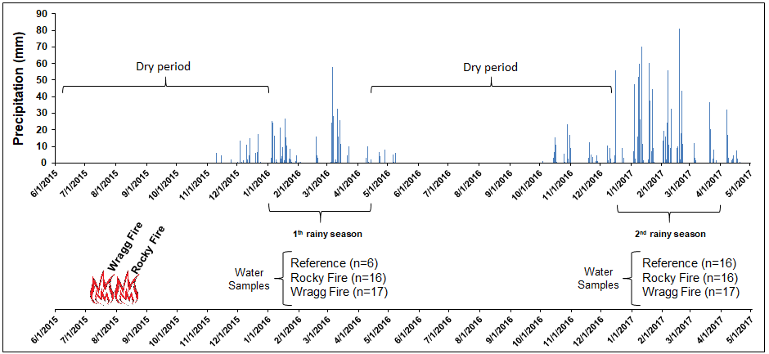

**Figure S1.** Precipitation (mm) and time chart for Fires and sample collection from watersheds. Dry period: indicates that the area did not receive enough water to generate streamflow. n: number of samples collected for the particular rainy season. According to Berryessa Dam rainfall records (DWR [Department of Water Resources], 2017) located adjacent to the Wragg Fire watershed, during 2016 (Jan. 5 and Apr. 10, 2016) and 2016-17 (Dec. 15, 2016, and March 31, 2017) water seasons the area received ~431 mm and ~1029 mm total precipitation, respectively.

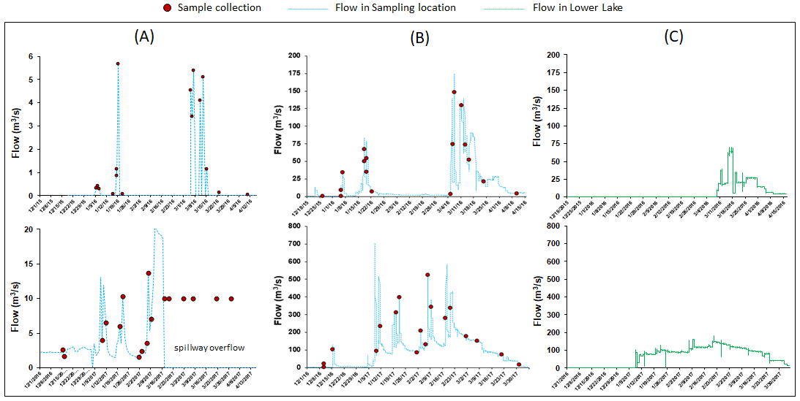

**Figure S2.** Sample collection and Flow (m3/s) conditions in sampling locations: Wragg Fire (A) Rocky Fire (B), and Lower Lake (C). Grab samples were collected from a well-mixed stream section for selected storm event and base flow conditions (United States Geological Survey [USGS] data for Wragg Fire sampling location [station no: 11451800], Rocky Fire sampling location [station no: 11451800] and lower Clear lake [station no: 11451800] were used to generate flow charts).

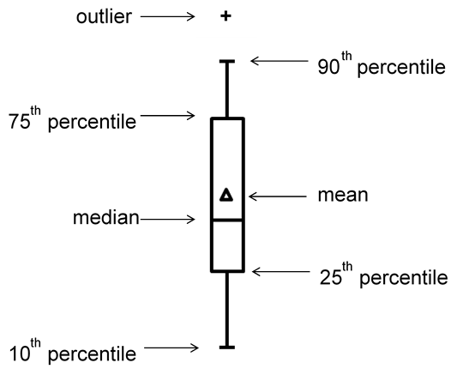

**Figure S3.** Legend for the box-and-whisker plot

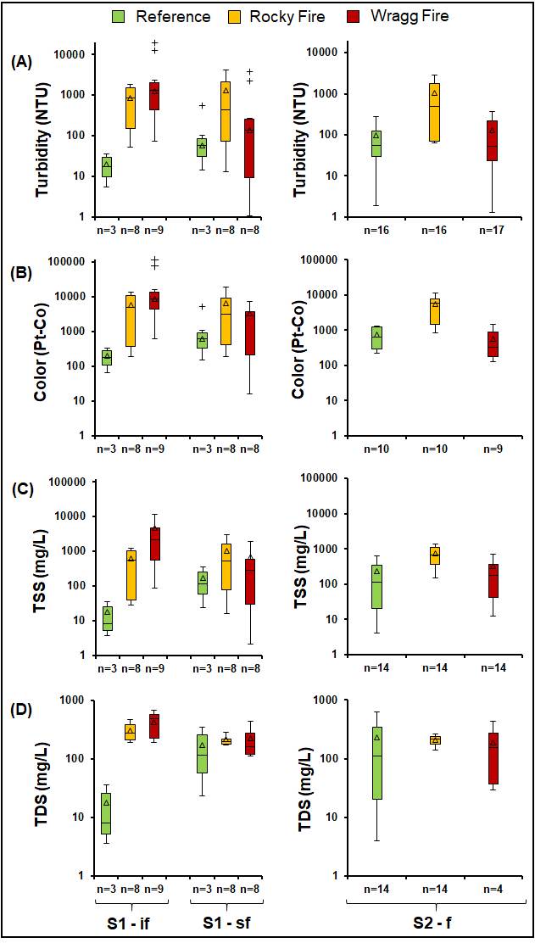

**Figure S4.** Concentrations of solid-related water quality parameters in reference, Rocky Fire, and Wragg Fire samples for S1–if, S1–sf, and S2–f. Turbidity (A), apparent color (B), TSS (C), and TDS (D). n: number of samples. S1-if and S1–sf defines samples collected during the initial (Jan. 5-22, 2016) and subsequent flushes (Mar. 5 – Apr. 10, 2016) for the first rainy season, respectively. S2–f defines all samples collected during the second rainy season (Dec. 15, 2016 – Mar. 31, 2017).

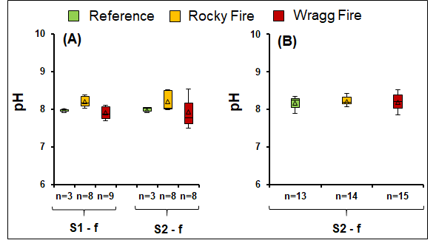

**Figure S5.** Stream water pHfor S1–if, S1–sf, and S2–f. n: number of samples. S1-if and S1–sf define samples collected during the initial (Jan. 5-22, 2016) and subsequent flushes (Mar. 5 – Apr. 10, 2016) for the first rainy season, respectively. S2–f defines all samples collected during the second rainy season (Dec. 15, 2016 – Mar. 31, 2017).

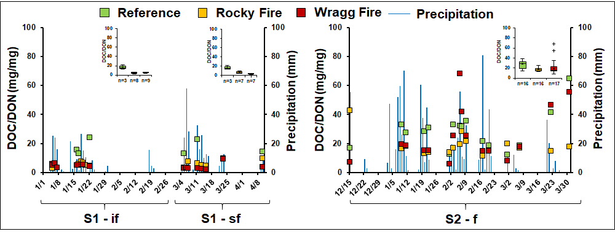

**Figure S6.** Trends forDON/DOC ratio in Reference, Rocky, and Wragg Fire samples for Y1–if, Y1–sf, and Y2–f. n: number of samples. S1-if and S1–sf define samples collected during the initial (Jan. 5-22, 2016) and subsequent flushes (Mar. 5 – Apr. 10, 2016) for the first rainy season, respectively. S2–f defines all samples collected during the second rainy season (Dec. 15, 2016 – Mar. 31, 2017).

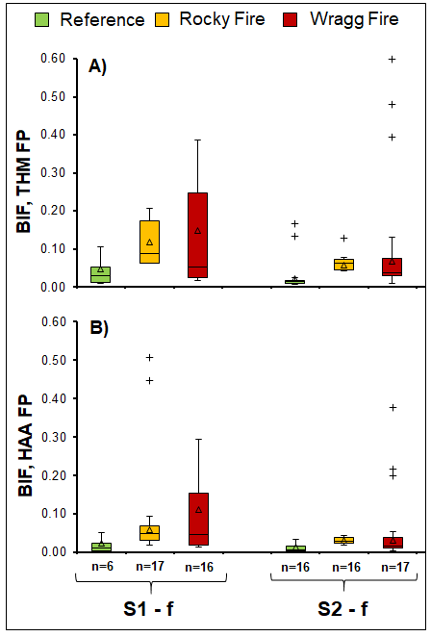

**Figure S7.** Bromine incorporation factors (BIF) in reference, Rocky Fire, and Wragg Fire samples for S1–f and S2–f. THM FPs (A), and HAA FPs (B). n: number of samples. S1-f defines samples collected during the first rainy season (Jan. 5 – Apr. 10, 2016), and S2–f defines all samples collected during the second rainy season (Dec. 15, 2016 – Mar. 31, 2017).

**References**

APHA/AWWA/WEF, 2012. Standard Methods for the Examination of Water and Wastewater. Stand. Methods 541. https://doi.org/ISBN 9780875532356

Chen, W., Westerhoff, P., Leenheer, J.A., Booksh, K., 2003. Fluorescence Excitation-Emission Matrix Regional Integration to Quantify Spectra for Dissolved Organic Matter. Environ. Sci. Technol. 37, 5701–5710. https://doi.org/10.1021/es034354c

DWR (Department of Water Resources). 2017. California Data Exchange Center. Accessed (8/21/ 2019), from BERRYESSA (BER): http://cdec.water.ca.gov/dynamicapp/QueryDaily?s=BER

Habibullah Uzun, Daekyun Kim, Wilson Beita-Sandi, Mahmut Selim Ersan, and T., Petry, K. and C., Uzun, H., 2016. Seasonal Changes of NDMA Formation Potential and its Removal During Water Treatment. Water Research Foundation, Denver, CO.

Lee, W., Westerhoff, P., 2005. Dissolved organic nitrogen measurement using dialysis pretreatment. Environ. Sci. Technol. 39, 879–884. https://doi.org/10.1021/es048818y

Ruecker, A., Uzun, H., Karanfil, T., Tsui, M.T.K., Chow, A.T., 2017. Disinfection byproduct precursor dynamics and water treatability during an extreme flooding event in a coastal blackwater river in the southeastern United States. Chemosphere 188, 90–98. https://doi.org/10.1016/j.chemosphere.2017.08.122

Rumsey, D.J., 2015. How to Interpret a Correlation Coefficient r, Statistics For Dummies, 2nd Edition.

Zhou, J., Wang, J.-J., Baudon, A., Chow, A.T., 2013. Improved fluorescence excitation-emission matrix regional integration to quantify spectra for fluorescent dissolved organic matter. J. Environ. Qual. 42, 925–930.