Drinking water treatment response following a Colorado wildfire
Supplementary Material

Amanda K. Hohner¹, Kaelin Cawley¹, Jill Oropeza², R. Scott Summers¹, and Fernando L. Rosario-Ortiz^{1,*}

¹ Department of Civil, Environmental and Architectural Engineering, University of Colorado, Boulder, CO 80309, USA
² City of Fort Collins Utilities, Fort Collins, CO 80521, USA
*Corresponding Author: Fernando.rosario@colorado.edu
The supplementary material contains pre- and post-fire water quality data for two additional sites within the CLP watershed, including the South Fork drainage. A statistical analysis comparing the water quality along the mainstem CLP River and South Fork is presented to address the selection of sampling sites for the study. The results from a two-way fixed effects regression analysis of the pre-and post-fire water quality data set for the CLP River mainstem and South Fork are presented and discussed. Additional historical water quality data (2000 – 2007) are included, and a brief review of the potential confounding effects of the mountain pine beetle (MPB) infestation on water quality. Post-fire DBP formation (concentrations), bromine substitution factors, and treated water parameters are also included. A hydrograph of the CLP River for pre- and post-fire years is presented and 2013 post-fire seasonal water quality concentrations are included. Further detail is given regarding iron interference with the DOM optical properties analyzed (SUVA₂₅₄ and fluorescence index (FI)).
Contents: Tables and Figures
Table S1. Pre-fire (2008 – 2011) water quality levels for three sites along the mainstem CLP River (PNF, PSF, PBR) and one location along the South Fork Poudre River (SFM). PNF = water intake; PBR = reference site.

Table S2. Pairwise comparison of PNF and SFM water quality differences (PNF – SFM) before and after the wildfire.
Table S3. Pairwise comparison of PSF and PBR water quality differences (PSF – PBR) before and after the wildfire.
Table S4. Pairwise comparison of PNF and PSF water quality differences (PNF – PSF) before and after the wildfire.
Table S5. Regression model results for log-transformed water quality parameters in the CLP watershed, including the statistics for the %burned independent variable.
Table S6. Historical water quality for PNF, PSF, and SFM from 2000 – 2007. The PSF sampling location from 2000 – 2007 was located upstream of the confluence of the South Fork and CLP River.
Table S7. Drainage basin characteristics for the water intake and reference site.
Table S8. Analysis of post-fire DBP formation (μg/L) for the water intake and reference site. Bromine substitution factors (BSF) are also presented (Hua et al., 2006; Obolensky and Singer, 2005).
Table S9. Analysis of post-fire statistically significant (p < 0.05) treated water parameters for the water intake and reference site.
Figure S1. Drainage basin areas for the CLP monitoring sites. The burn area percentages are shown and included for PNF (water intake) and PSF (Poudre River below South Fork). PBR and SFM are located upstream of burned areas.

Figure S2. Pre-fire (2008 - 2011) turbidity, TP, TN, and TOC levels for PNF, PSF, and PBR sampling sites along the mainstem CLP River and SFM along the South Fork.
Figure S3. Paired differences in water quality (turbidity, TP, TN, TOC) between PNF and SFM. Pre-fire and post-fire differences are shown. A difference of zero suggests the water quality of the two sites is similar.
Figure S4. Paired differences in water quality (turbidity, TP, TN, TOC) between PSF and PBR. Pre-fire and post-fire differences are shown. A difference of zero suggests the water quality of the two sites is similar.
Figure S5. Paired differences in water quality (turbidity, TP, TN, TOC) between PNF and PSF. Pre-fire and post-fire differences are shown. A difference of zero suggests the water quality of the two sites is similar.
Figure S6. Historical water quality for PNF, PSF (above confluence), and SFM from 2000 – 2007.
Figure S7. MPB tree mortality in the CLP watershed as of 2010 (USDA, 2015).
Figure S8. Daily average streamflow hydrograph of the CLP River at the drinking water intake for 2008 – 2013, and 2013 only. A flood event occurred in September 2013, resulting in flows near 70 m³/s.

Figure S9. Post-fire 2013 turbidity, TP, TN, and TOC seasonal trends for the water intake and reference site. Post-rainstorm samples (collected from the water intake) are plotted on the right-hand axis and are intended for comparison to the water intake. The streamflow hydrograph for the water intake is also shown (gray line). The peak of snowmelt occurred in early June (max flow = 51 m³/s) and a flood event occurred in early September (max flow = 69 m³/s).
Spatial water quality comparison for additional sites in the CLP watershed

Pre- and post-fire water quality data were collected for two additional locations within the CLP watershed including: 1) a site along the South Fork (SFM) upstream of areas burned in the wildfire and 2) along the CLP River mainstem, immediately downstream of the confluence with the South Fork (PSF) (Figure S1). PSF is located within the High Park fire burn area, and approximately 6.1% of the drainage area for PSF was burned, while 16.0% of the drainage for the water intake sampling site (PNF) was burned. To characterize the influence of the South Fork drainage on the CLP mainstem water quality before and after the wildfire, the two additional sites (SFM and PSF) were compared to the intake (PNF) and reference site (PBR).
An analysis of pre-fire data (2008 - 2011) indicated the water quality concentrations (turbidity, TP, TN, TOC) at all four sites (PNF, PSF, PBR, SFM) were not statistically different (p > 0.05) before the wildfire (Figure S2). Spatially, the pre-fire water quality of the four sites was found to be similar using Mood’s Median tests (Table S1), presented in Figure S2. It is important to note, SFM was sampled ~monthly during spring snowmelt while the other sites were sampled ~bi-weekly during snowmelt. The lower variability of the SFM site may be attributed to the lower sampling frequency. The paired data analysis in the following section addresses issues related to seasonal variability, by always comparing samples collected on the same date.

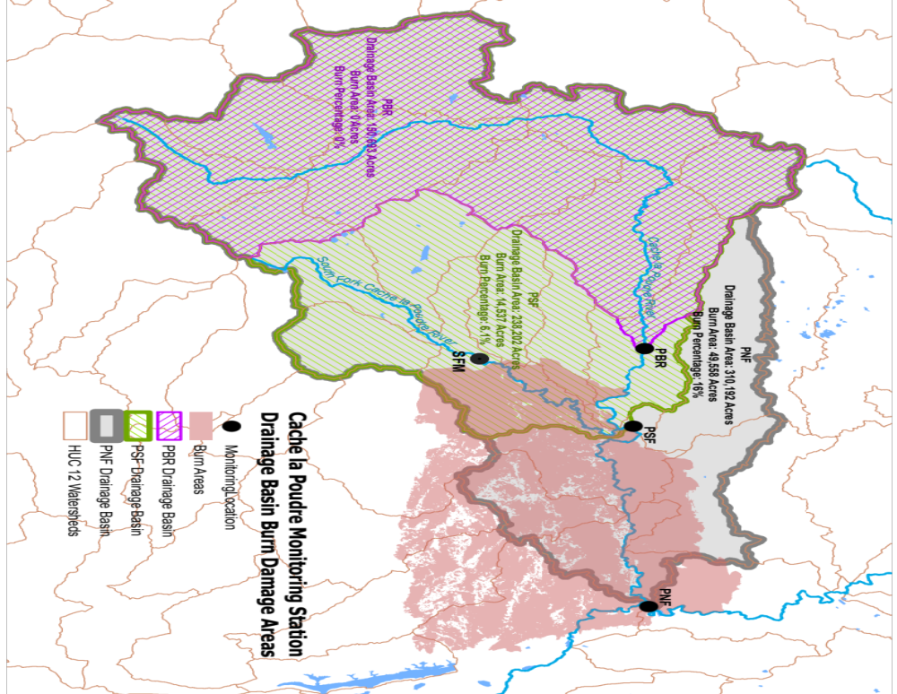
Figure S1. Drainage basin areas for the CLP monitoring sites. The burn area percentages are shown and included for PNF (water intake) and PSF (Poudre River below South Fork). PBR and SFM are located upstream of burned areas.

Table S1. Pre-fire (2008 – 2011) water quality levels for three sites along the mainstem CLP River (PNF, PSF, PBR) and one location along the South Fork of the CLP River (SFM). PNF = water intake; PBR = reference site.
Water Quality Parameter |  |  | Pre-fire (2008-2011)
 |  |  | PNF (intake) | PSF | PBR  (reference) |  | SFM |  | p value²
Turbidity  (ntu) |  | Mean  Median  SD  n | 3.6  1.4  4.5  41 | 2.6  1.4  2.9  41 | 2.2  1.1  2.4  41 |  | 2.3  1.9  1.4  26 |  | 0.57
TP  (mg_{P}/L) |  | Mean  Median  SD  n | 0.018  0.013  0.014  44 | 0.015  0.012  0.010  44 | 0.014  0.012  0.007  44 |  | 0.013  0.013  0.004  28 |  | 0.90
TN¹  (mg_{N}/L) |  | Mean  Median  SD  n | 0.29  0.25  0.20  20 | 0.26  0.20  0.23  20 | 0.27  0.24  0.18  20 |  | 0.23  0.18  0.19  14 |  | 0.42
TOC  (mg_{C}/L) |  | Mean  Median  SD  n | 4.8  3.5  2.8  43 | 4.8  3.7  2.7  43 | 4.8  3.9  2.7  43 |  | 4.4  3.4  2.3  27 |  | 0.50
1. TN data are only 2010 - 2011
2. Mood's Median comparison

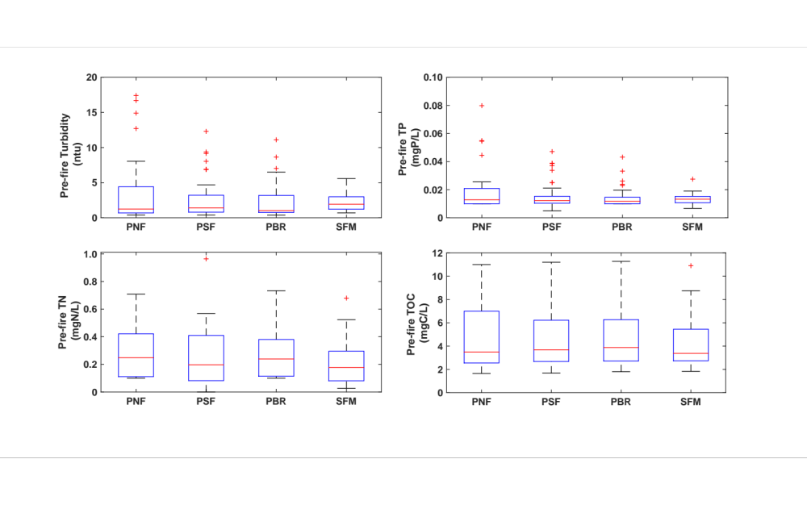
Figure S2. Pre-fire (2008 - 2011) turbidity, TP, TN, and TOC levels for PNF, PSF, and PBR sampling sites along the mainstem CLP River and SFM along the South Fork.

Additional paired comparisons of monitoring sites within the CLP watershed
To further investigate potential water quality differences between sampling sites before the wildfire, paired samples (by date) were compared using the statistical approach detailed in section 3.4 of the main text. In addition, a pre- to post-fire paired comparison of sites allows for understanding changes likely associated with the wildfire. Paired analysis was used because samples collected on the same date are not truly independent.
- PNF and SFM were compared to understand the influence of the South Fork drainage on downstream CLP River water quality pre- and post-fire. SFM is located upstream of the burned area and can potentially serve as a second reference site.
- PSF and PBR were compared to understand the contribution of the South Fork drainage between the water intake (PNF) and reference site (PBR). A rough approximation of the South Fork flow contribution to the CLP River mainstem at PNF is 13 - 34 %, varying seasonally.
- PNF and PSF were compared to understand the contribution of the fire-impacted area between the two sites. As noted previously, PNF drains a greater burned area (16.0%) than PSF (6.1%).
PNF and SFM comparison
The water quality of PNF and SFM were not statistically different for turbidity, TP, TN, and TOC (p > 0.05), suggesting the South Fork water quality and downstream CLP River water quality were similar prior to the wildfire. A pre- to post-fire paired comparison of PNF and SFM indicated turbidity, TP, and TN were statistically higher at PNF following the wildfire compared to SFM (located upstream of the burned area) (Table S2). Although the spatial difference (Δ) in TOC following the wildfire was greater than pre-fire, it was not statistically significant (p > 0.05), similar to the small increase in TOC spatial differences observed between the water intake and reference site (section 4.2; Table 1). Paired differences (Δ = PNF – SFM) before and after the wildfire are presented in Figure S3.
Table S5. Pairwise comparison of PNF and SFM water quality differences (PNF – SFM) before and after the wildfire.
Water Quality Parameter | Pre-Fire  (2008-2011) | Post-Fire  (2013) | p value
Water Quality Parameter | Median Δ  (PNF – SFM) | Median Δ  (PNF – SFM) | p value
Turbidity (ntu) | -0.2 | 2.8 | 0.01
TP (mg_{P}/L) | 0.001 | 0.008 | 0.04
TN (mg_{N}/L) | 0.01 | 0.17 | 0.04
TOC (mg_{C}/L) | 0.10 | 0.40 | 0.18
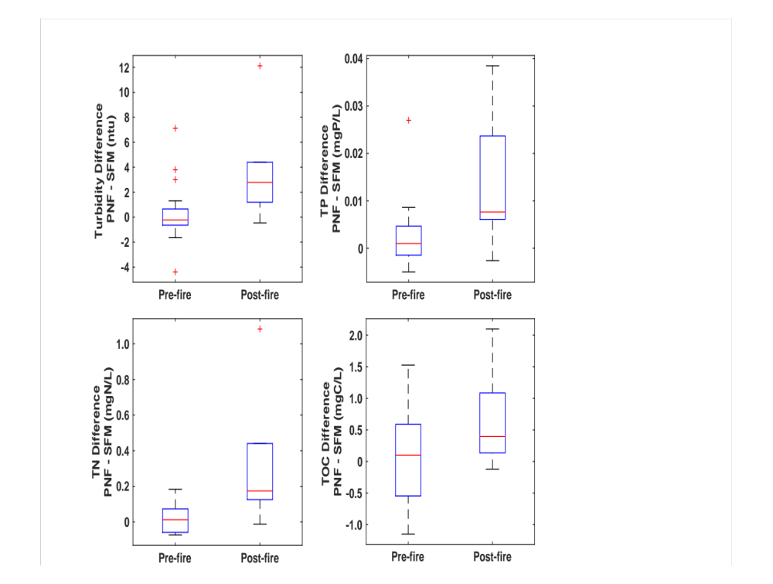
Figure S3. Paired differences in water quality (turbidity, TP, TN, TOC) between PNF and SFM. Pre-fire and post-fire differences are shown. A difference of zero suggests the water quality of the two sites is similar.
PSF and PBR comparison
Pairwise analysis of PSF and PBR indicated the water quality of the sites was not statistically different (p > 0.05) prior to the wildfire for turbidity, TP, TN, and TOC. The similarity in water quality upstream and downstream of the confluence of the South Fork and CLP River mainstem suggests that, prior to the wildfire, the contribution or dilution by the South Fork was not significant to the downstream water quality of the CLP River. These similarities validate PBR as a reference site for the mainstem CLP River. A pre- to post-fire paired comparison (Table S3) indicated following the wildfire spatial differences between PSF and PBR were statistically higher for turbidity, TP, and TOC. TN was not statistically different. Pairwise differences (PSF – PBR) before and after the wildfire are presented in Figure S4. Post-wildfire impacts are expected to be lower at PSF compared to the water intake (PNF) due to the smaller percentage of the drainage area burned.
Table S6. Pairwise comparison of PSF and PBR water quality differences (PSF –PBR) before and after the wildfire.
Water Quality Parameter | Pre-Fire (2008-2011) | Post-Fire (2013) | p value
Water Quality Parameter | Median Δ (PSF - PBR) | Median Δ (PSF - PBR) | p value
Turbidity (ntu) | 0.11 | 1.1 | 0.00
TP  (mg_{P}/L) | 0.000 | 0.003 | 0.02
TN  (mg_{N}/L) | -0.01 | -0.07 | 0.27
TOC  (mg_{C}/L) | -0.070 | 0.18 | 0.04

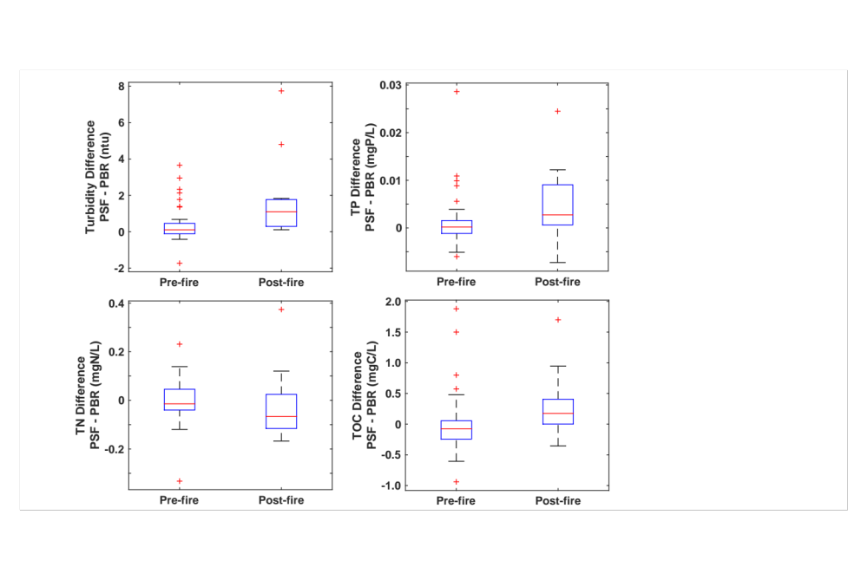
Figure S4. Paired differences in water quality (turbidity, TP, TN, TOC) between PSF and PBR. Pre-fire and post-fire differences are shown. A difference of zero suggests the water quality of the two sites is similar.
PNF and PSF comparison
Although PNF and PSF are both within the High Park fire burn area, a paired comparison allows for an understanding of the contribution of the wildfire between the two sites. PNF drains ~201 km² of burned area, (16.0% of respective drainage) whereas PSF drains ~59 km² burned area (6.1% of respective drainage). Prior to the wildfire, a paired comparison of the two sites indicated that turbidity and TP were statistically different (p < 0.05) between the two sites, which was also observed when PNF (water intake) and PBR (reference) pre-fire water quality concentrations were compared in the main text (section 4.1; Table 1). This suggests the differences observed between the water intake and reference site (upstream of South Fork confluence) were similar to those observed downstream of the South Fork confluence (PSF). Following the wildfire, a pre-to post-fire paired comparison indicated turbidity, TP, TN, and TOC were statistically different (p < 0.05), with concentrations consistently higher at PNF compared to PSF (Table S4; Figure S5).
Table S7. Pairwise comparison of PNF and PSF water quality differences (PNF – PSF) before and after the wildfire.
Water Quality Parameter | Pre-Fire  (2008-2011) | Post-Fire  (2013) | p value
Water Quality Parameter | Median Δ  (PNF - PSF) | Median Δ  (PNF - PSF) | p value
Turbidity (ntu) | 0.12 | 3.2 | < 0.001
TP  (mg_{P}/L) | 0.002 | 0.012 | < 0.001
TN  (mg_{N}/L) | 0.05 | 0.26 | 0.01
TOC (mg_{C}/L) | -0.07 | 0.11 | 0.01
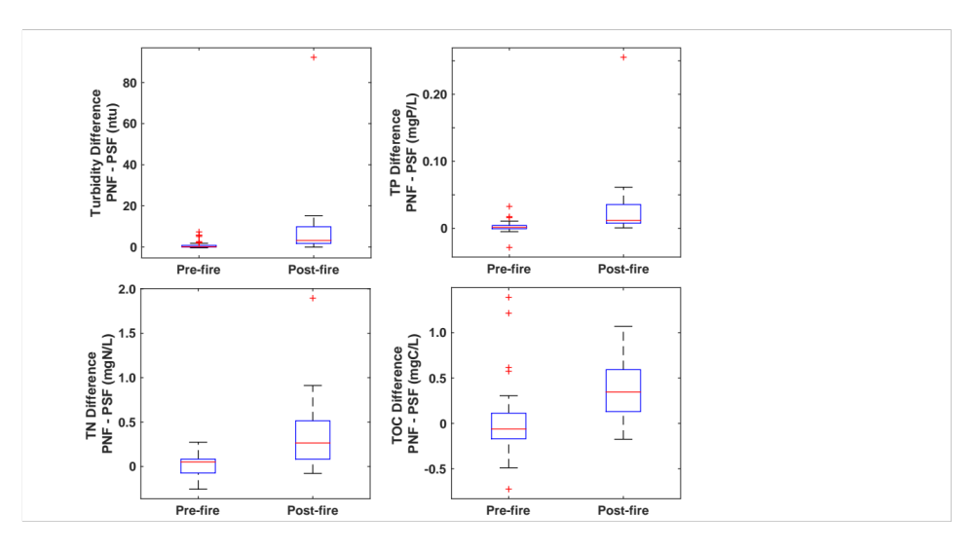
Figure S5. Paired differences in water quality (turbidity, TP, TN, TOC) between PNF and PSF. Pre-fire and post-fire differences are shown. A difference of zero suggests the water quality of the two sites is similar.

Two-way fixed effects water quality regression model
To further analyze the water quality of the CLP River mainstem and South Fork before and after the wildfire two-way fixed effects regression models were developed using pre- and post-fire water quality data for the four sampling sites (Figure S1): water intake (PNF), PSF, reference site (PBR), and SFM. SFM and the reference site are both located upstream of areas burned in the wildfire. The four water quality parameters of interest in the study were modeled as response variables: turbidity, TP, TN, and TOC.
The two-way fixed effects regression models account for time variant effects (i.e., seasonality, MPB epidemic) and time invariant effects (i.e., elevation of sampling sites). Sampling date (categorical variable) was included as the time variant fixed effect in the models. Every sampling date included in the models had water quality data from at least three sites, and commonly all four sites. Including sampling date as an independent variable in the model accounts for the unique conditions for each date sampled (e.g., snow pack conditions, recent precipitation, etc.) that likely influence the response variables. One of the main benefits of this approach is that it accounts for not only the known and measurable unique conditions for each date sampled, but it also accounts for the unknown and difficult to measure conditions that can influence the response variables, such as MPB pervasiveness. Similarly, sampling site ID (categorical variable) was used as the time invariant fixed effect in the models. Including sampling site as an independent variable accounts for the unique conditions at each site (e.g., %forest, slope, etc.) that may influence the response variables. One of the main benefits of this approach is that it accounts for not only the known and measurable unique conditions at each site, but it also accounts for the unknown and hard to measure conditions that can influence the response variables, such as micro-climates.
To investigate potential effects of the wildfire on the water quality variables, percent drainage area burned (%burned) for each sampling site was included as an independent variable. For the pre-fire data this variable is 0% for all sampling sites, because it is assumed all sites had experienced 0% burn. Prior to the Hewlett Gulch and High Park fires, the most recent fire in the CLP watershed was in 1994, and was relatively small compared to the 2012 fires. Post-fire the two upstream reference sites (PBR and SFM) had experienced 0%burned, PSF was 6.1% burned, and the intake (PNF) was 16% burned. The post-fire %burned variable for each respective sampling site is indicated in Figure S1. The water quality data were log transformed to normalize for the regression analysis.
The results of the regression analysis are shown in Table S5. The %burned variable was a significant term (p < 0.05) in all water quality regression models. The coefficient for the %burned variable represents the change in response variable (e.g., turbidity) for every % of drainage area burned. It is important to note that this change is the change attributed to the %burned for the specific conditions observed in 2013. The wildfire effect indicated by the coefficient for %burned is specific for this wildfire and watershed, and could vary depending on the streamflow and weather conditions observed in a specific watershed for a specific year. From the regression analysis, the considerable and statistically significant effect of the area burned on turbidity, TP, TN, and TOC concentrations of the CLP River is demonstrated (Table S5). For instance, the model indicates that the water intake experienced an increase in turbidity of 3.999*16%*logTurbidity. Similarly, the %burned coefficients are positive for all water quality parameter models of interest, indicating an increase in concentrations following the wildfire.

Table S5. Regression model results for log-transformed water quality parameters in the CLP watershed, including the statistics for the %burned independent variable.
Modeled Water Quality Parameter | Independent  Variable | Coefficient | Standard Error  Coefficient | t-value | p-value
Log Turbidity  (adj. R²=0.82) | %burned | 3.999 | 0.499 | 8.02 | 0.000
Log TP  (adj. R² =0.71) | %burned | 2.318 | 0.337 | 6.88 | 0.000
Log TN  (adj. R²= 0.53) | %burned | 1.909 | 0.809 | 2.36 | 0.021
Log TOC  (adj. R²=0.95) | %burned | 0.504 | 0.135 | 3.73 | 0.000

Historical CLP water quality (2000 – 2007)
In addition to the four years of pre-fire data (2008 - 2011) used in this study, water quality data were also collected from 2000 – 2007. The historical water quality data set includes concentrations measured for the PNF, PSF, and SFM sampling sites. It should be noted, from 2000 – 2007 PSF was sampled above the confluence of the South Fork with the mainstem CLP, which differs from the 2008 - 2013 data which was collected downstream of the confluence. Total suspended solids (TSS), TP, and TOC were not statistically different for PNF, PSF, and SFM (p > 0.05; Table S6). Figure S6 shows the variability in water quality at the sites from 2000 – 2007.

Table S6. Historical water quality for PNF, PSF, and SFM from 2000 – 2007. The PSF sampling location from 2000 – 2007 was located upstream of the confluence of the South Fork and CLP River.
Water Quality Parameter |  |  | Historical Water Quality (2000 – 2007)
 |  |  | PNF | PSF | SFM | p value¹
TSS  (mg/L) |  | Mean  Median  SD  n | 4.3  3.0  5.0  103 | 3.9  2.8  3.6  103 | 3.9  2.5  5.7  103 | 0.37
TP  (mg_{P}/L) |  | Mean  Median  SD  n | 0.011  0.009  0.008  101 | 0.011  0.009  0.008  101 | 0.012  0.010  0.006  101 | 0.14
TOC  (mg_{C}/L) |  | Mean  Median  SD  n | 4.2  3.3  2.2  100 | 4.1  3.3  2.1  100 | 4.1  3.4  2.1  100 | 0.85
1. Mood's Median test was used for determination of p values

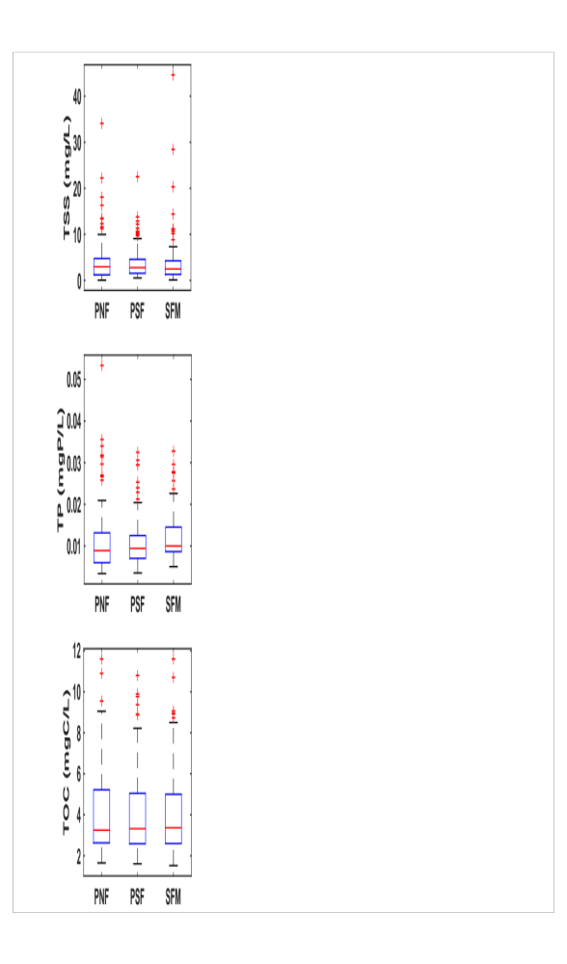
Figure S6. Historical water quality for PNF, PSF (above confluence), and SFM from 2000 – 2007.
Due to resource constraints, only PNF (water intake) and PBR (reference) sampling sites were selected for the main study focusing on drinking water treatment processes and DBP formation. Wildfire impacts are expected to be greatest at PNF and this location represents Fort Collins influent water quality. The analysis of SFM and PSF serves to further understand the post-fire changes in water quality and validate the study sampling design, including PBR as a reference site.
Drainage Basin Characteristics
Table S7 lists the characteristics for the water intake and reference site drainages. While the mean elevations and drainage areas differ, the pre-fire water quality of the two sites did not appear affected by these drainage differences. Downstream cumulative effects on water quality were not significant at the water intake compared to the reference site, with the exception of a small difference in turbidity as noted in the manuscript (section 4.1; Table 1).
Table S7. Drainage basin characteristics for the water intake and reference site.
Drainage  Characteristic | Water Intake  (PNF) | Reference  (PBR)
Drainage Area (km²) | 1255 | 610
Mean Elevation (km) | 2813 | 3078
Mean Annual Precipitation (mm) | 616 | 741
Mean Basin Slope (%) | 30.4 | 29.6

Mountain Pine Beetle effects on water quality
The mountain pine beetle (MPB) epidemic has infested significant portions of the CLP watershed (Figure S7) including areas draining to the water intake (PNF) and the reference site (PBR), as noted in sections 2.0 and 4.1 of the manuscript. The MPB attacks and kills healthy trees, which can influence the biogeochemical cycling in watersheds (reviewed in Mikkelson et al., 2013a) The effects of the MPB on water quality in some cases may be similar to those expected following wildfire, constituting a potentially confounding factor in this study. However, as discussed in Adams et al. (2011), the general characteristics of tree die-off are expected to be more similar to harvesting than wildfire (Adams et al., 2011). In contrast to high severity fires, tree die-off is likely not continuous across a watershed, occurs in phases, and does not consume the entire canopy. The changes to a watershed following wildfire are generally acute and more drastic, including charring of vegetation and soils.
A review of bark beetle infestation impacts suggests the water quality response cannot be generalized, varying between watersheds with sometimes conflicting findings (Mikkelson et al., 2013a). Research conducted in Colorado watersheds did not show a significant nitrate (Clow et al., 2011; Rhoades et al., 2013) or DOC (Clow et al., 2011) response. Further, the percent MPB-impacted basin area had minimal influence on nitrate and DOC concentrations compared to other basin characteristics (Clow et al., 2011). However, Clow et al. observed an increase in TP and TN, and Mikkelson et al. observed an increase in TOC (Mikkelson et al., 2013b). Clow et al. note the increase in TP and TN could be due to particulate nutrients. A direct measurement of particles levels (e.g., turbidity) has not been strongly related to MPB effects. A study of British Columbia watersheds noted the relationship between MPB and turbidity was not strong and turbidity showed low variability (Brown et al., 2011). Alternatively, high particulate concentrations are strongly associated with post-wildfire water quality responses as discussed in the introduction of the manuscript (section 1.0), and observed in this study.
While the MPB has been shown to increase TP, TN, and TOC in a few instances, potentially confounding wildfire effects observed in the CLP River, upstream areas draining to PNF, PSF, PBR, and SFM were affected by the MPB infestation (Figure S7). The substantial pre-fire data (2000 – 2011) serves to capture several stages of potential MPB effects on CLP River water quality for comparison to post-fire water quality. Further, historical water quality data do not indicate any temporal trends that would suggest MPB influence on water quality for this watershed. Importantly, the two unburned sites, PBR and SFM, drain areas affected by the MPB. Although the exact percent forest killed by MPB for the different sites is unknown (outside the scope of this study), it is clear from Figure S7 (USDA, 2015) that MPB mortality was well spread across the CLP watershed in 2010.
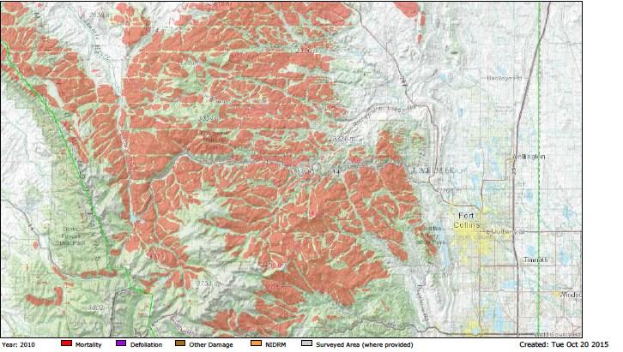
Figure S7. MPB tree mortality in the CLP watershed as of 2010 (USDA, 2015).
Post-fire seasonal source water quality

Post-fire seasonal trends for turbidity, TP, TN, and TOC are shown in Figure S9 for the water intake and reference site. Post-rainstorm samples for the water intake are included in Figure S9, but were not included in the calculation of the paired spatial differences. Post-rainstorm samples are discussed in the main text (section 4.6). In 2013, turbidity at the reference site was always less than 20 ntu, and highest during the rising and receding limbs of snowmelt (early May and late July) (Figure S9). The water intake and reference site showed similar seasonal trends for turbidity, but turbidity at the water intake was always higher than the reference, with substantially higher peak values (>100 ntu). The observed decrease in turbidity during snowmelt can likely be attributed to dilution of the particle load from upstream snowmelt. Water quality differences between the water intake and reference site were greatest from April- early May, whereas following spring snowmelt differences between sites were minimal, with the exception of the mid-July sample, which was collected several days after a rainstorm event (Figure S9). Snowmelt likely primarily occurred in areas unaffected by the wildfire and therefore the lack of a larger post-wildfire snowmelt response is not surprising.
Potential iron interference with optical properties
Explicit correction factors for iron interferences with optical properties were not applied due to the lack of concurrent iron data. However, available post-fire data were used to determine that the maximum total iron concentration observed at the water intake site during a rainstorm event (0.27 mg_{Fe}/L) would contribute less than 0.024 cm⁻¹ to the UV₂₅₄ (Weishaar et al., 2003). This is on average less than a 17% increase in UV₂₅₄ for the water intake data set (baseflow and snowmelt samples), representing the maximum estimated potential influence of iron on UV₂₅₄ for this study. It should be noted, iron levels of baseflow and snowmelt samples are expected to be much lower than following rainstorm events when metals are more readily mobilized, therefore the approach taken to account for optical interferences is conservative. Iron was also detected at the reference site (maximum = 0.23 mg_{Fe}/L), possibly interfering with those samples as well, independent of the wildfire.
Additionally, taking iron interferences into consideration for the fluorescence index (FI) the Fe:TOC ratio was determined. The maximum Fe:TOC ratio observed in post-fire samples was 0.03 mg_{Fe}/mg_{C} which could result in an increase of up to 0.04 FI units based on the laboratory study conducted by Poulin et al. (2014) under anoxic conditions (Poulin et al., 2014). As noted previously, iron concentrations were not measured concurrently with the samples used for fluorescence scans. The post-fire response observed in FI may be partially associated with iron interferences. However, in several instances the FI difference between sites (Δ) was as high as 0.09 units, which cannot exclusively be attributed to iron (Figure 4). In future post-fire monitoring studies it is suggested that metals are measured in conjunction with optical properties.

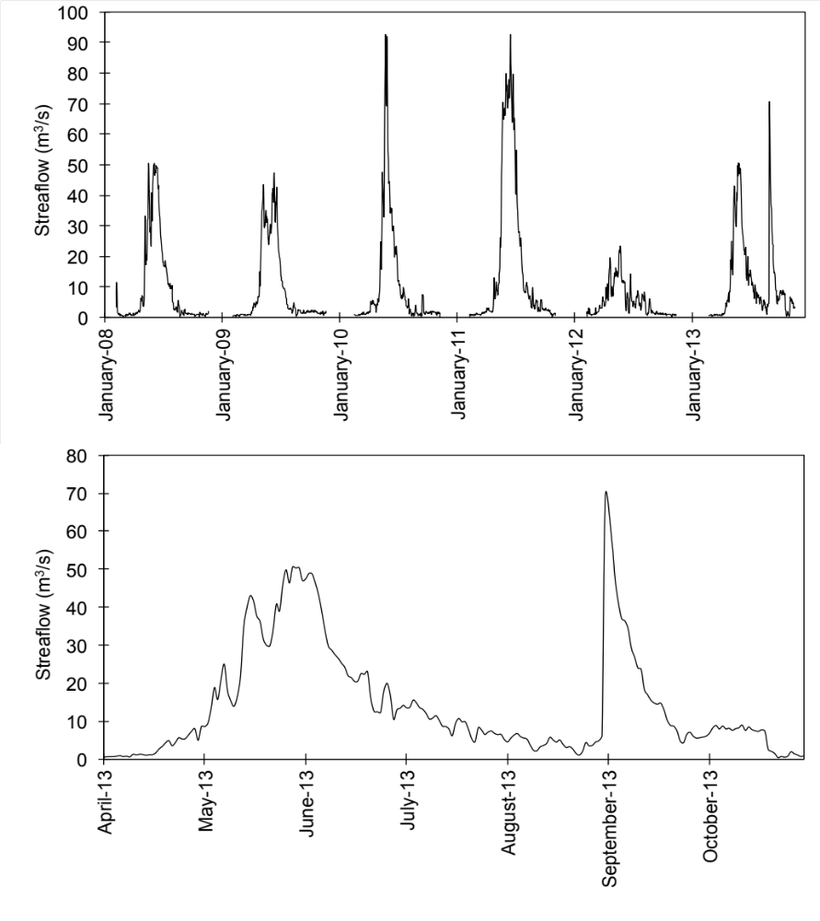
Figure S8. Daily average streamflow hydrograph of the CLP River at the drinking water intake for 2008 – 2013, and 2013 only. A flood event occurred in September 2013, resulting in flows near 70 m³/s.
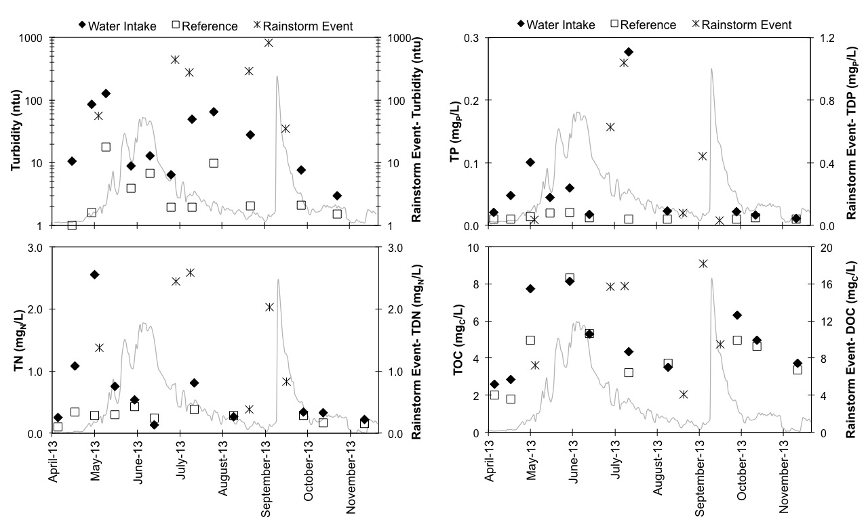
Figure S9. Post-fire 2013 turbidity, TP, TN, and TOC seasonal trends for the water intake and reference site. Post-rainstorm samples (collected from the water intake) are plotted on the right-hand axis and are intended for comparison to the water intake. The streamflow hydrograph for the water intake is also shown (gray line). The peak of snowmelt occurred in early June (max flow = 51 m³/s) and a flood event occurred in early September (max flow = 69 m³/s).

Table S8. Analysis of post-fire DBP formation (μg/L) for the water intake and reference site. Bromine substitution factors (BSF) are also presented (Hua et al., 2006; Obolensky and Singer, 2005).
DBP  Formation |  | Water Intake | Reference  Site | Δ^{1,2}  (intake – reference) | n | p value³
TTHM Formation  (μg/L) | Mean  Median  SD | 219.8  192.2  (113.3) | 217.3  178.2  (132.5) | 2.5  10.1  (30.3) | 12 | 0.04
TTHM BSF  (%) | Mean  Median  SD | 1.4  1.1  (1.1) | 1.1  1.1  (0.7) | 0.36  0.30  (0.60) | 12 | 0.15
HAA5  Formation  (μg/L) | Mean  Median  SD | 216.0  185.5  (120.7) | 209.9  160.4  (133.2) | 6.0  3.8  (42.1) | 12 | 0.67*
HAA5 BSF  (%) | Mean  Median  SD | 0.19  0.15  (0.17) | 0.18  0.13  (0.19) | 0.005  0.000  (0.057) | 12 | 1.00
HAN4  Formation  (μg/L) | Mean  Median  SD | 6.8  5.5  (2.5) | 5.7  4.7  (2.5) | 1.11  0.91  (0.97) | 12 | < 0.01*
HAN4 BSF  (%) | Mean  Median  SD | 1.9  1.2  (2.4) | 1.4  0.0  (2.4) | 0.53  0.18  (0.76) | 12 | 0.13
Chloropicrin  Formation  (μg/L) | Mean  Median  SD | 4.4  3.9  (2.1) | 4.2  3.7  (2.1) | 0.21  0.07  (0.51) | 12 | 0.77

- Post-rainstorm event data were not included in the calculation of Δ and p values
- p values were determined by testing the spatial differences (Δ) against zero using the sign test. Parameters denoted with a * were tested using the Wilcoxon signed-rank test

Table S9. Analysis of post-fire statistically significant (p < 0.05) treated water parameters for the water intake and reference site.
Treatment Parameter |  | Water Intake | Reference  Site | Δ^{1,2}  (intake - reference) | n | p value³
Alum Dose (mg/L) | Mean  Median  SD | 44  45  (15) | 34  28  (15) | 9.6  7.5  (11.4) | 12 | 0.03*
Treated Water  DOC (mg_{C}/L) | Mean  Median  SD | 1.6  1.4  (0.7) | 1.4  1.3  (0.5) | 0.2  0.2  (0.3) | 12 | 0.04
Treated Water  UV₂₅₄ (cm⁻¹) | Mean  Median  SD | 0.032  0.024  (0.014) | 0.027  0.023  (0.011) | 0.005  0.004  (0.006) | 12 | < 0.01

- Post-rainstorm event data were not included in the calculation of Δ and p values
- p values were determined by testing the spatial differences (Δ) against zero using the sign test. Parameters denoted with a * were tested using the Wilcoxon signed-rank test

References

Adams, H.D., Luce, C.H., Breshears, D.D., Allen, C.D., Weiler, M., Hale, V.C., Smith, A.M.S., Huxman, T.E., 2011. Ecohydrological consequences of drought- and infestation- triggered tree die-off: insights and hypotheses. Ecohydrol. 5, 145–159. doi:10.1002/eco.233
Brown, S., Lavkulich, L.M., Schreier, H., 2011. Developing Indicators for Regional Water Quality Assessment: An Example from British Columbia Community Watersheds. Canadian Water Resources Journal 36, 271–284. doi:10.4296/cwrj3603894
Clow, D.W., Rhoades, C., Briggs, J., Caldwell, M., Lewis, W.M., Jr., 2011. Responses of soil and water chemistry to mountain pine beetle induced tree mortality in Grand County, Colorado, USA. Applied Geochemistry 26, S174–S178. doi:10.1016/j.apgeochem.2011.03.096
Hua, G., Reckhow, D.A., Kim, J., 2006. Effect of Bromide and Iodide Ions on the Formation and Speciation of Disinfection Byproducts during Chlorination. Environ. Sci. Technol. 40, 3050–3056. doi:10.1021/es0519278
Mikkelson, K.M., Bearup, L.A., Maxwell, R.M., Stednick, J.D., McCray, J.E., Sharp, J.O., 2013a. Bark beetle infestation impacts on nutrient cycling, water quality and interdependent hydrological effects. Biogeochemistry 115, 1–21. doi:10.1007/s10533-013-9875-8
Mikkelson, K.M., Dickenson, E.R.V., Maxwell, R.M., McCray, J.E., Sharp, J.O., 2013b. Water-quality impacts from climate-induced forest die-off. Nature Climate Change 3, 218–222. doi:10.1038/nclimate1724
Obolensky, A., Singer, P.C., 2005. Halogen Substitution Patterns among Disinfection Byproducts in the Information Collection Rule Database. Environ. Sci. Technol. 39, 2719–2730. doi:10.1021/es0489339
Poulin, B.A., Ryan, J.N., Aiken, G.R., 2014. Effects of Iron on Optical Properties of Dissolved Organic Matter. Environ. Sci. Technol. 48, 10098–10106. doi:10.1021/es502670r
Rhoades, C.C., McCutchan, J.H.J., Cooper, L.A., Clow, D., Detmer, T.M., Briggs, J.S., Stednick, J.D., Veblen, T.T., Ertz, R.M., Likens, G.E., Lewis, W.M.J., 2013. Biogeochemistry of beetle-killed forests: Explaining a weak nitrate response. Proceedings of the National Academy of Sciences of the United States of America 110, 1756–1760. doi:10.1073/pnas.1221029110
USDA (U.S. Department of Agriculture), 2015. Insect and disease detection survey data explorer. http://foresthealth.fs.usda.gov/portal/Flex/IDS
Weishaar, J.L., Aiken, G.R., Bergamaschi, B.A., Fram, M.S., Fujii, R., Mopper, K., 2003. Evaluation of Specific Ultraviolet Absorbance as an Indicator of the Chemical Composition and Reactivity of Dissolved Organic Carbon. Environ. Sci. Technol. 37, 4702–4708. doi:10.1021/es030360x

