**Directions for Using the Wildfire and DOC SWAT Module**

Written by Katie Wampler and Hyunwoo Kang

These directions are used to run dissolved organic carbon (DOC) and/or wildfire simulations in the Soil and Water Assessment Tool (SWAT) model based on the attached swat modules (swat_wildfire_doc_mgL.exe and swat_wildfire_doc_kg.exe). These modules are modified versions of SWAT version 664.

**Carbon Model Setup: Steps Required to Run SWAT DOC Simulations**

*Based on Du et al. 2020*

1. Once you have set up your SWAT model in ArcMap or QGIS, you’ll need to tell the model to use the modified carbon routines by setting the *CSWAT* parameter in the basin.bsn file to 2.
2. The DOC module works by borrowing existing SWAT parameters for carbon parameters. See below for a description of the borrowed parameters. For more details on DOC parameters see Du et al. 2020.

|  |  |  |  |
| --- | --- | --- | --- |
| **Borrowed Parameter** | **Carbon Parameter** | **Description** | **Start Value** |
| ERORGP.hru | ENR_POC | POC enrichment ratio | 2 |
| ERORGN.hru | PERCO_DOC | DOC percolation coefficient in surface runoff | 0.9 |
| GWSOLP.gw | GWC_CON | DOC concentration in baseflow | 2 |
| DEP_IMP.hru | KD_OC | Organic carbon partition coefficient for DOC production | 1000 |
| CHPST_RSP.swq | KPOC_RCH | Rate of POC to DOC | 0.1 |
| CHPST_STL.swq | POC_SETL | Settling rate of POC to bed | 1 |
| SEDPST_ACT.swq | KDOC_RCH | Rate of DOC to DIC | 0.1 |

1. You’ll want to update the default value for each of these borrowed parameters to prevent errors, the easiest way to do this is using the model.in file from the SWAT-CUP software with swat-edit.exe (2W2E GmbH 2019).
2. In addition to borrowing carbon parameters, the outputs are also borrowed output parameters in the output.rch file:

|  |  |  |
| --- | --- | --- |
| **Variable** | **Column Number** | **Header** |
| Dissolved Organic Carbon (into reach) | 33 | SOLPST_IN |
| Dissolved Organic Carbon (out of reach) | 34 | SOLPST_IN |
| Total Organic Carbon (into reach) | 35 | REACTPST |
| Total Organic Carbon (out of reach) | 36 | VOLPST |

1. The carbon module can return DOC values in units of milligrams per L (mgL) or kilograms per model time step (kg). Choose the outputs units you want and copy the swat module into your SWAT folder, while not required, if running secondary software like SWAT-CUP (2W2E GmbH, 2019), rename the .exe file to just “swat.exe”.

**Wildfire Module Setup: Steps Required to Run SWAT Wildfire Simulations**

*Based on Wampler et al. 2023*

1. To run wildfire simulations, add the following lines to the bottom of the basin.bsn file. Note that they need to be on lines 132-135:
   1. 0 | fire: for wildfire scenarios: 1 fire, 0 nofire
   2. 223 | fr_day: starting date for wildfire scenarios
   3. 18 | fr_yr: starting year for wildfire scenarios

|  |  |  |
| --- | --- | --- |
| **Variable** | **Value Range** | **Description** |
| fire | 0 or 1 | If equal to 0, no fire is simulation, if 1, fire is simulated |
| fr_day | 1 to 366 | The day of the year on which the fire changes should start |
| fr_yr | ≥ 1 | The year of the simulation in which the fire changes should start, *includes any warm up years.* |

1. 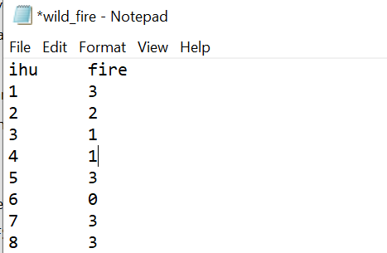You also need to have a text file named wild_fire.txt located in the SWAT folder. This is a text file needs to be tab separated with the column headers “ihu” and “fire” (see right), where:
   1. ihu is the HRU number (all HRU’s should be included).
   2. fire is a value between 0 and 3 indicating the burn severity for that HRU, where:
      1. 0 is unburned
      2. 1 is low severity
      3. 2 is moderate severity
      4. 3 is high severity
2. The modules have been modified slightly from the one used in Wampler et al. (2023), replacing the land use change with a change in LAI. To do this you will need to copy your calibrated plant parameters to the bottom of your plant.dat file.
   1. Note at present only FRSE, RNGE, RNGB, WETF, and FRSD landuses can be burned in the wildfire module.
   2. You will need to manually determine the decrease in maximum LAI for each severity level for each land use.
      1. See 8-get-lai-change.R for methods on how to do this.
   3. For the wildfire module the following land use numbers are reserved for the following land use-severity combos where the character code is the modified land use code and the number is the crop cover number.

|  |  |  |  |
| --- | --- | --- | --- |
| **Initial Land Use** | **Low Severity** | **Moderate Severity** | **High Severity** |
| FRSE | LSFE, 129 | MSFE, 130 | HSFE, 131 |
| RNGE | LSRG, 132 | MSRG, 133 | HSRG, 134 |
| RNGB | LSRB, 135 | MSRB, 136 | HSRB, 137 |
| WETF | LSWT, 138 | MSWT, 139 | HSWT, 140 |
| FRSD | LSFD, 141 | MSFD, 142 | HSFD, 143 |

* 1. To use, copy the calibrated unburned plant parameters to the appropriate line number in the plant.dat file, and manually modify the maximum LAI value (BLAI) to reflect the desired decrease in LAI. See below for an example:

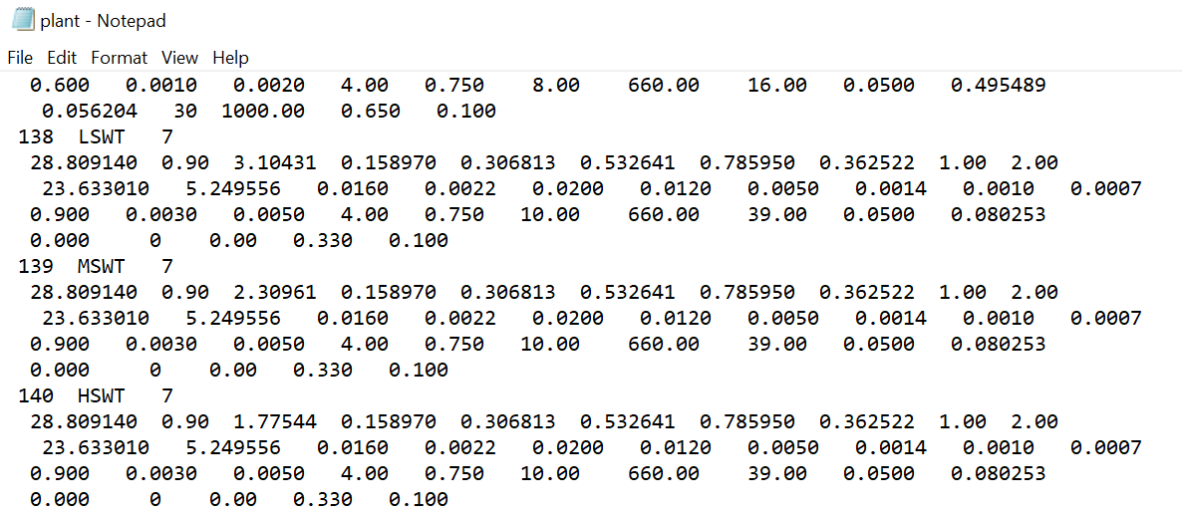

* 1. Lastly, copy the swat module into your SWAT folder, while not required, if running secondary software like SWAT-CUP (2W2E GmbH, 2019), rename the .exe file to just “swat.exe”.

**Line By Line Changes to SWAT Code**

***DOC module from Dr. Du (Du et al., 2020)***

Added subroutines and files:

* carbon_para.f90: define all the variables used in organic carbon module.
* cal_carbon.f90: facilite the calibration for organic carbon module

Modifications for orginal SWAT code version 664:

1. allocate_parms.f
   * (Line 49): use 'carbon_para' module

* (Line 51): define local flag variable 'j'
* (Line 57): modified to include 2 variables (DOC,POC) for routing in array 'varoute'
* (Line 59): modified to add 4 additional variables for carbon output in array ‘rchdy’
* (Line 1380): add 1 variables (DDOC) for calculating DOC lag in lateral flow
* (Line 1388): add 2 variables (POC,DOC) for calculating carbon lag in surface runoff
* (Line 1891-1903): allocate the size of the carbon variables defined in 'modparm.f'

1. main.f

* (Line 80): call subroutine 'cal_carbon.f90' for parameter calibration in SWAT-CUP

1. gwmod.f

* (Line 74): use 'carbon_para' module
* (Line 137-138): calculating DOC load in groundwater flow

1. rtout.f

* (Line 272) :use 'carbon_para' module
* (Line 315-320): calculate organic carbon loads in outflow to downstream reach
* (Line 445-452): set daily reach output for organic carbon module
* (Line 526-533): summarize monthly reach output for carbon module

1. !!Note:the colunms for pesticide variables in file 'output.rch' were used for outputting organic carbon variables in the reach temporarily, this can be revised later
2. rchday.f

* (Line 102 and 164-172):assign daily output values for organic carbon module

1. rchmon.f

* (Line 112 and 178-185):assign monthly output values for carbon module

1. rchyr.f

* (Line 109 and 181-188):assign yearly output values for carbon module

1. watqual.f:

* (Line 221) : use 'carbon_para' module
* (Line 234): define local variables for organic carbon processes in the reach/stream
* (Line 258-263 and 275-280): calculate DOC and POC concentratins in inflow
* (Line 305-310): calculate DOC and POC initial concentrations in the reach by mixing inflow and water stored in the reach
* (Line 616-650): calculate organic carbon reaction processes in the reach/stream
* (Line 675-680): organic carbon concentrations in the reach when no flow (flow is zero)

1. sim_initday.f:

* (Line 251 - 264) : initialize the value of new carbon transport variables to zero

***DOC Module Modification by Dr. Kang***

1. virtual.f
   * + (Line 260) use 'carbon_para' module
     + (Line 410 – 415) calculate DOC and POC amounts from HRU to subbasins (kg/ha)
     + (Line 573 – 578) calculate DOC and POC amounts subbasins for routing (kg)
     + (Line 646 – 651) calculate DOC and POC amounts in subbasin for routing (kg)
2. NCsed_leach.f90 (orgncswat2)
   * + (Line 52) use 'carbon_para' module
     + (Line 97, 130) allocate borrowed eri_POC (original SWAT parameter: erorgp_hru)
     + (Line 164) allocate borrowed kd_OC (original SWAT parameter: dep_imp_hru)
     + (Line 181) allocate borrowed peroc_DOC (original SWAT parameter: erorgn_hru)
     + (Line 195 to 237) extract and calculate total DOC and TOC from existing calculations
3. substor.f
   * + (Line 56) use 'carbon_para' module
     + (Line 73 to 77) calculate DOC lag in lateral flow
     + (Line 92 to 96) calculate DOC lag in lateral flow
     + (Line 111 to 115) calculate DOC lag in lateral flow3
4. surfstor.f
   * + (Line 138) use 'carbon_para' module
     + (Line 191 to 196) calculate sufq_doc and poc lag
     + (Line 229 to 234) calculate sufq_doc and poc lag
     + (Line 261 to 267) calculate sufq_doc and poc lag
5. subbasin.f
   * + (Line 132) use 'carbon_para' module
     + (Line 526 to 531) calculate Total DOC loads from HRU

***Wildfire Module (Wampler et al., 2023)***

Modification by Dr. Kang for wildfire module with DOC. Wildfire module (Wampler et al., 2023) was originally developed by Majid Zaremehrjardy, and Kang edited and combined it with the DOC module.

Added subroutines and files:

* Add ‘wild_fire.f90’ subroutine
* Add ‘read_fire.f90' subroutine

Modifications

1. subbasin.f
   * + - (Line 148) call 'wild_fire' subroutine

**Sources:**

Du, X., Loiselle, D., Alessi, D. S., & Faramarzi, M. (2020). Hydro-climate and biogeochemical processes control watershed organic carbon inflows: Development of an in-stream organic carbon module coupled with a process-based hydrologic model. Science of The Total Environment, 718, 137281. https://doi.org/10.1016/j.scitotenv.2020.137281

Wampler, K. A., Bladon, K. D., & Faramarzi, M. (2023). Modeling wildfire effects on streamflow in the Cascade Mountains, Oregon, USA. Journal of Hydrology, 621, 129585. <https://doi.org/10.1016/j.jhydrol.2023.129585>

2W2E GmbH. (2019). SWAT-CUP. Zürich, Switzerland: Water Weather Energy Ecosystem. Retrieved from https://www.2w2e.com/home/SwatCup