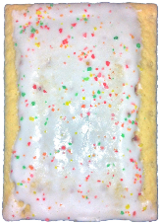special **(SP)/** pop_tart**(PT)**

grass_top_left**(GTL)** grass_top_middle**(GTM)** grass_top_right**(GTR)**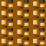grass_center**(GC)** grass_top**(GTP)** grass_float_lone**(GL)**

grass_float_left**(GFL)** grass_float_center**(GFC)** grass_float_**right(GFR)**

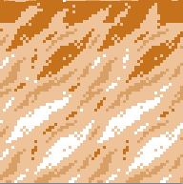sand_top_middle**(STM)**  ****sand_center**(SC)**

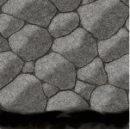rock_bottom**(RB) 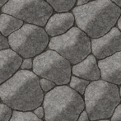**rock_center**(RC)**

 mars_top_left**(MTL) **mars_top_middle**(MTM)**mars_top_right**(MTR)**

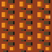 mars_center **(MC) ** mars_top **(MT) **mars_float_lone**(ML)**

****mars_float_left**(MFL) **mars_float_center**(MFC)**  mars_float_right**(MFR)**