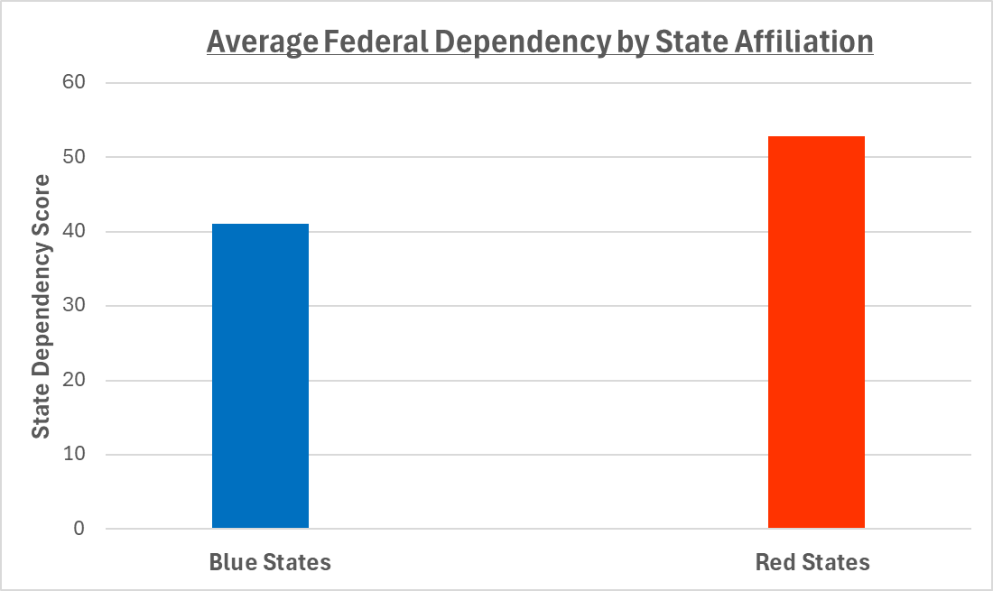

The above graphic shows the Average Federal Dependency by State Affiliation. This was calculated by categorizing each state as either Blue (Democratic Party leaning) or Red (Republican Party leaning) and then taking the average score for each group. From the graph above, it’s pretty clear that the Red States have a higher federal dependency score.