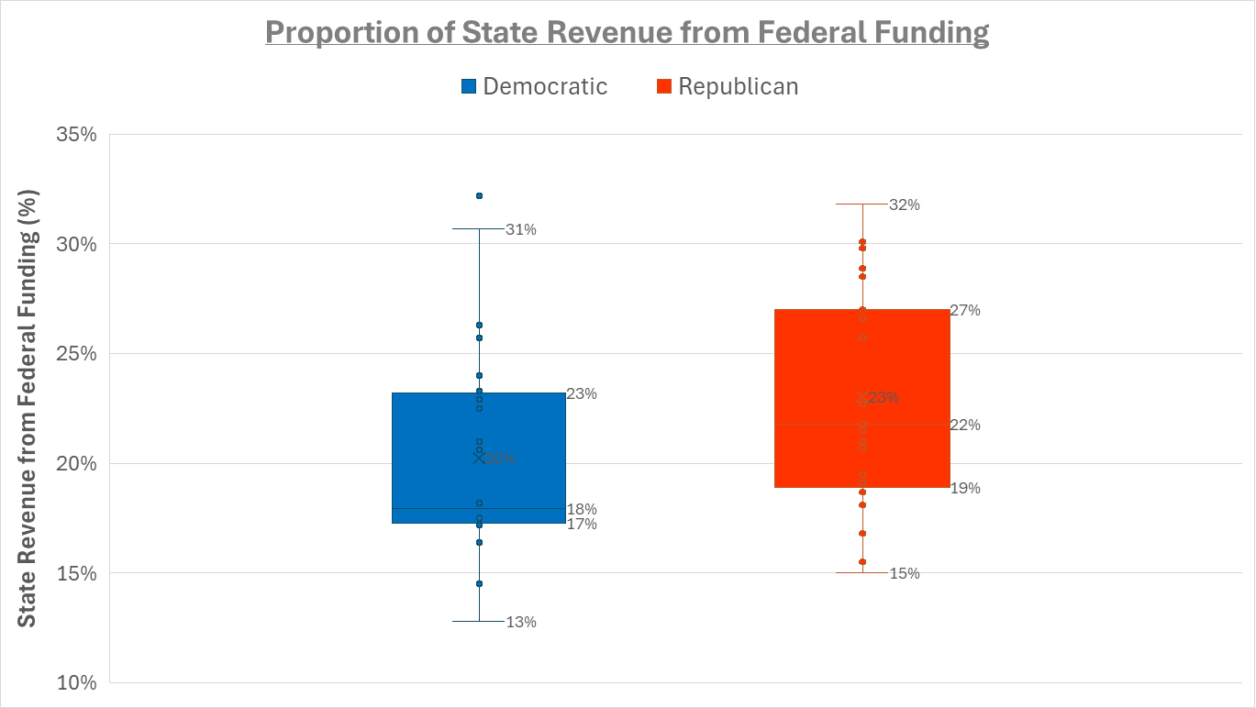

The boxplot displays the proportion of state revenue derived from federal funding, categorized by political affiliation. The median federal dependency for Democratic-leaning states is **18%**, while for Republican-leaning states, it is **22%**. The means **20**% and **22**%, respectively. However, both the medians and means fall within each other’s interquartile ranges (**17%–23%** for Democratic and **19%–27%** for Republican states), indicating significant overlap. This suggests that, while Republican-leaning states seem higher, we cannot conclude that there is a correlation between state dependency of federal aid and political affiliation.