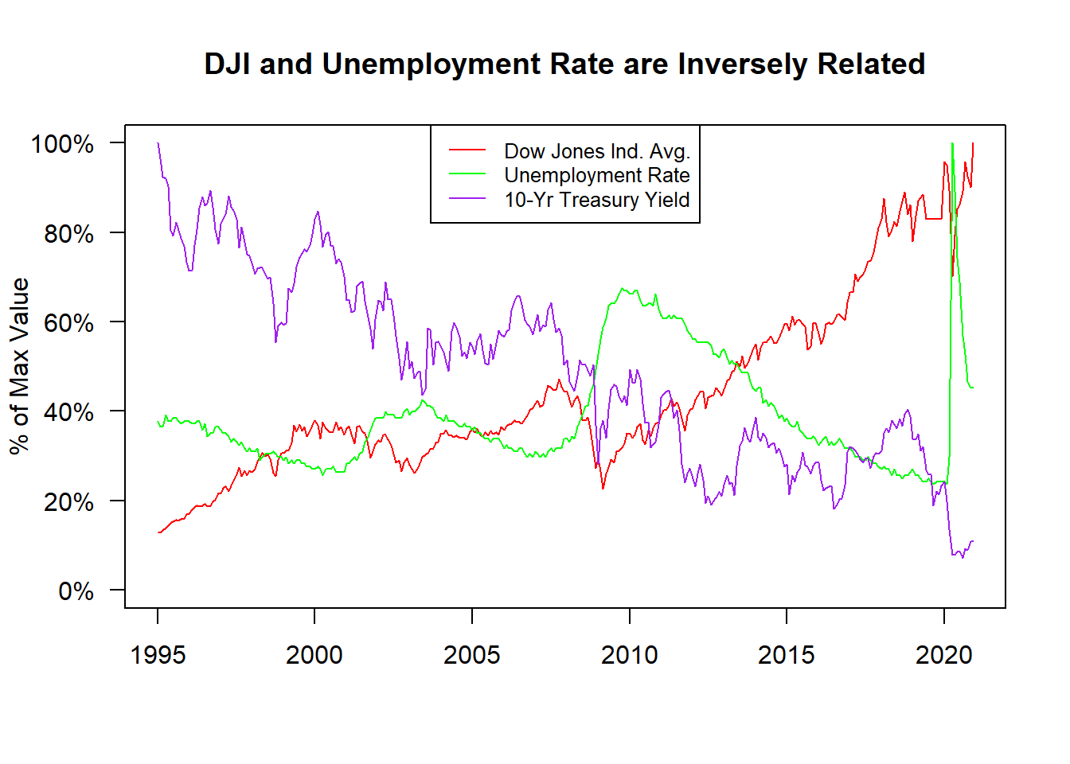

From the above graph, we can clearly see that there is an inverse relationship between the unemployment rate and the Dow Jones Industrial Average (DJIA). This makes sense as the stock market is correlated with consumer confidence and consumer confidence decreases as unemployment and other factors of uncertainty increase. Looking at the 10 Year Treasury Yield (TNX), there doesn't appear to be any visible trend between TNX and either the DJIA or the Unemployment rate.