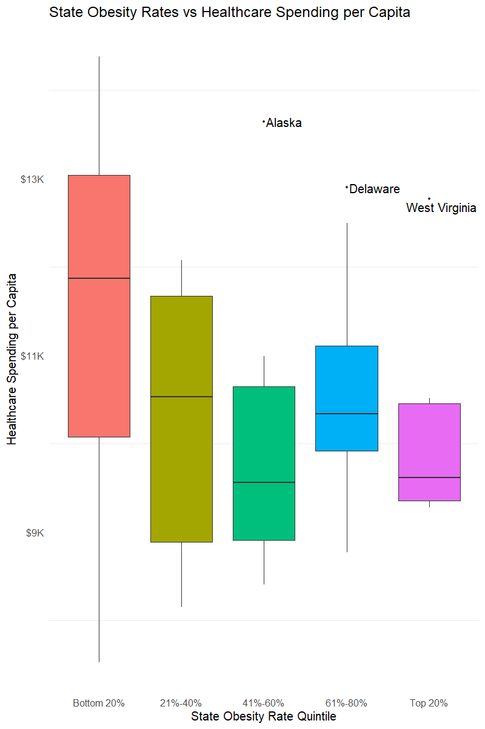

From the above graph, we can fairly easily discern that there is no significant trend between healthcare spending and obesity rates. Although the first quintile shows that the median spend is the highest median spend, there are many of examples of much lower spend in the same quintile. There are a few labeled outliers (Alaska, Delaware, and West Virginia) who have much higher spend than their peers within the same quintile.