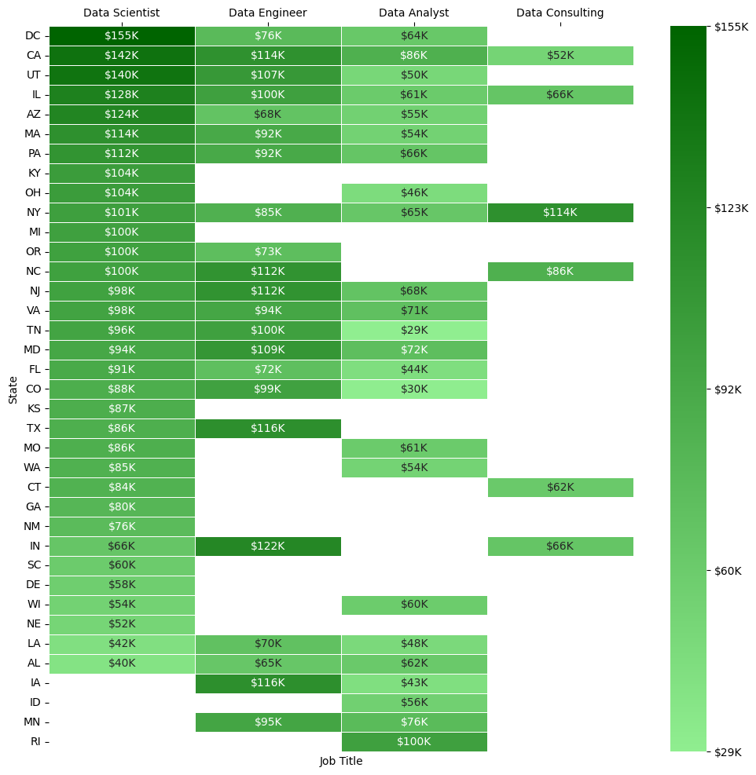

The visualization above shows the median salaries by job title and state sorted by descending order of the most represented title (Data Scientist). From the dataset used, there are gaps which represent areas where there were no posted salaries for that state and title combination. From the heatmap, Washington DC pays Data Scientists the most followed closely by California and Utah. Interestingly enough, in Indiana and Texas the median Data Engineer out earns the median Data Scientist.