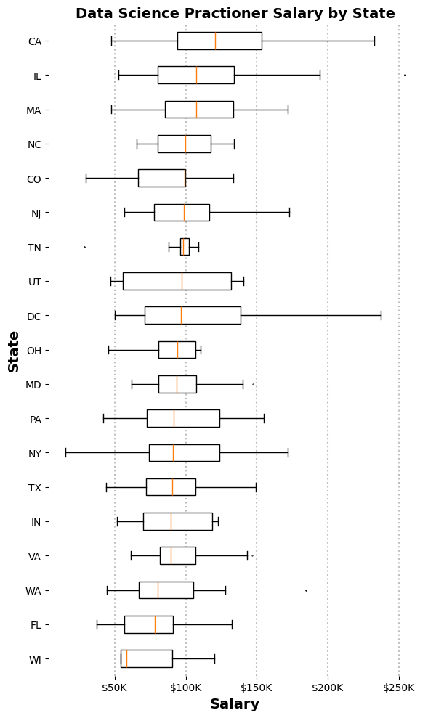

The box plot visualizes data science practitioner salaries across various U.S. states sorted in descending order by median income. California (CA) and Washington, D.C. (DC) have higher salary distributions, with DC exhibiting a particularly wide spread. States like Wisconsin (WI) and Tennessee (TN) have lower median salaries and tighter salary ranges, indicating less variability. New York’s (NY) median income was brought down greatly due to the high number of analysts that the dataset contained.