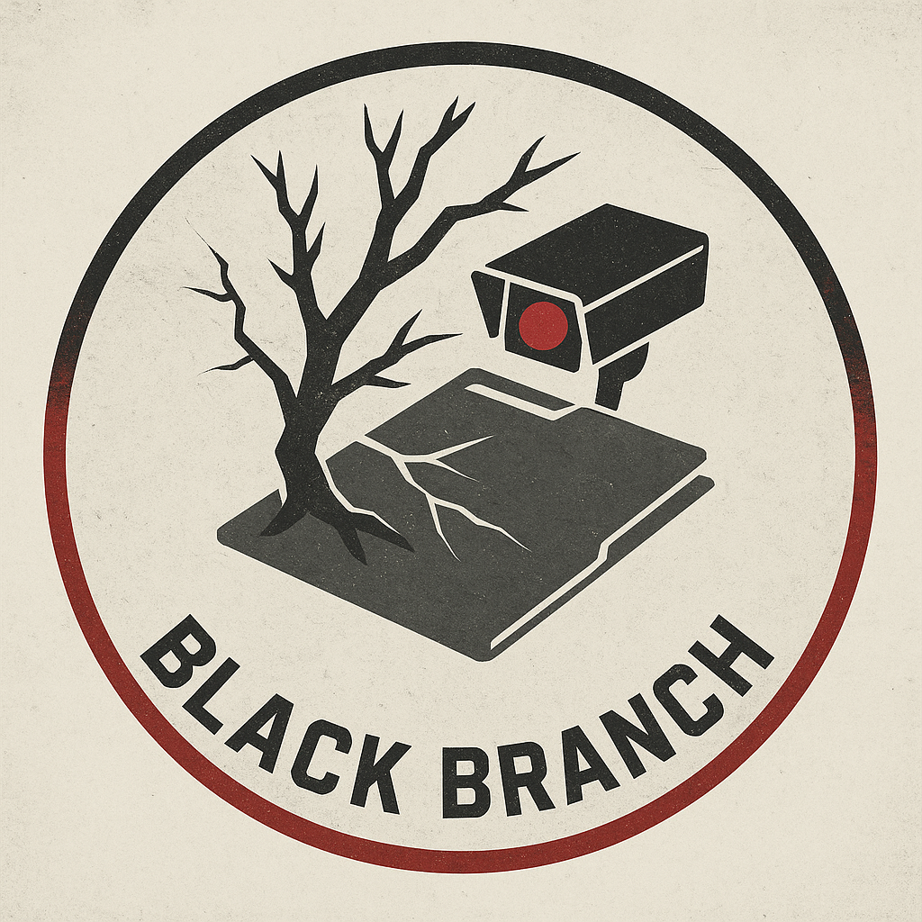

## **Black Branch**

## **🎯 Primary Objectives**

### **1. Eliminate Key Argos Command Assets**

*“Decapitate the regime. The rest will eat itself.”*

* Target Argos officers involved in Project Silencer and regional destabilization.
* Assassinate collaborators and politicians enabling the occupation (e.g., Mayor Kova Stann).

### **2. Destabilize Regional Neutrality**

*“Chaos accelerates truth.”*

* Sabotage peace between Ngata and Takula through false flag operations and arms leaks.
* Incite militia skirmishes to draw both nations into regional war, overwhelming Argos’ narrative.

### **3. Control the Flow of Truth**

*“History belongs to the last one left to write it.”*

* Intercept, alter, or destroy evidence collected by SPECTRE cells that doesn't serve Black Branch’s narrative.
* Discredit or kill any SPECTRE agent seen as a liability to their mission.

### **4. Collapse SPECTRE’s Moral Center**

*“Integrity is weakness. Victory requires control.”*

* Sow distrust within SPECTRE’s command structure.
* Recruit or force defections from active SPECTRE cells.
* Reveal SPECTRE’s role in covering up early Argos ops.

### **5. Create a Vacuum to Fill**

*“We will guide what comes next.”*

* Overthrow current power players (Argos, pirates, rebels, and foreign handlers).
* Position Black Branch as a hidden controlling force behind the new order via puppet leaders and secret influence.