Conor Donnelly

GIS 5574 – JSFiddle Assignment

11/16/2021

I had trouble getting any of my own AGOL Web Maps to load correctly into using the createMap javascript function. The error console always showed an object error of some kind, despite making these explicitly available to the public.

Eventually I found a public webmap on the UMN GIS gallery from Ryan Mattke that would load successfully.

<https://umn.maps.arcgis.com/home/item.html?id=8393f00da74e441b831dd3ecc44de9f5>

This map shows pre-settlement vegetation in the Twin Cities seven county metro area, also known as the Marschner Map.

I was having trouble understanding how to export all of this JS, HTML and CSS into one file… found this info on Stack Overflow: <https://stackoverflow.com/questions/9851878/is-there-a-download-function-in-jsfiddle#9869987>

So here’s the way to show the results of the my sandbox edits (just need to add the word /show/ to the URL):

<https://jsfiddle.net/w6snpkyz/1/show/>

In the browser, hit file “Save As” and export the entire page as an html file. Then upload all that to Google Cloud storage.

Anyways, here’s the link to the map hosted in my Google Cloud Storage and shared publicly.

<https://storage.googleapis.com/gis5574cd/webmap/index.htm>

Here’s a screenshot of what the page looks like:

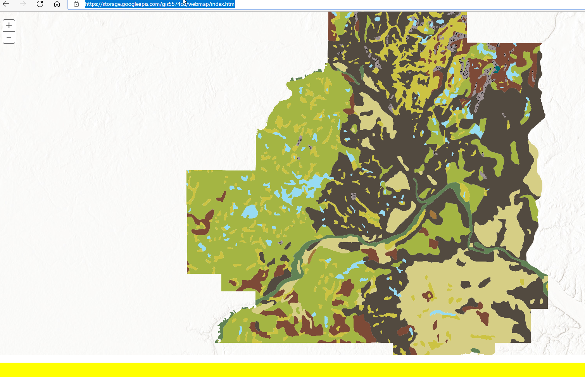

Changes made to the HTML, JS and CSS:

1. Changed HTML label on button from “Click” to “Mystery Button”
2. Changed JS createMap function to show mapID for the Marschner Map
3. Changed JS alert function to display “See important message below in yellow box.”
4. Changed JS informationArea function to display “...............................I bet you weren't expecting this message............”
5. Changed CSS to reposition the “Mystery Button”
6. Changed CSS informationArea background-color attribute to yellow

For some weird reason, the “Mystery Button” isn’t showing up in the exported HTML! Will try to continue debugging this.