Customer Confidential

**Importing additional KMs and Customer KMs to On-Prem BHOM**

**24.3.00+ Version**

6th September 2024

Version 1.0

Table of Contents

Contents

1 Table of Contents 2

2 Document Information 3

2.1 Document History 3

3 Document Reference Material 4

3.1 Document Reference Material 4

3.2 Proprietary Notice 4

4 Document Purpose 5

4.1 Purpose 5

4.2 Intended Audience 5

4.3 Objectives 5

5 How to import a KM (BMC or Custom) into BHOM repository 6

5.1 Steps given below 6

5.2 How to check on the UI. 10

# Document Information

## Document History

| Version | Contributor | Date | Description of Change |
| --- | --- | --- | --- |
| 1.0 | Steve Mundy | 6/09/2024 | Created document as clone of 24.2.x doc |
|  |  |  |  |
|  |  |  |  |

# Document Reference Material

## Document Reference Material

| Version | Description | URL Location |
| --- | --- | --- |
| 24.3 | ITOM 24.3 | [Here](https://docs.bmc.com/docs/itomdeploy242/home-1310266615.html) |
| 24.3 | BMC Helix AIOps | [Here](https://docs.bmc.com/docs/helixaiops/243/home-1362867694.html) |
| 24.3 | BMC PATROL Agent for BMC Helix Operations Management | [Here](https://docs.bmc.com/docs/PATROLAgent/233/home-1226109831.html) |
|  | Monitoring solutions in BMC Helix Operations Management | [Here](https://docs.bmc.com/docs/TrueSight/Repository/monitoring-solutions-in-bmc-helix-operations-management-955525756.html) |
|  |  |  |

## Proprietary Notice

Copyright and other Intellectual Property rights in any original programs, specifications, reports, or other items arising in the course of, or resulting from the project shall remain the property of BMC Software   Nothing in this document shall enable either party to make use of any intellectual property rights vested in the other party prior to the commencement of this assignment.

BMC Software and the BMC Software logo are registered trademarks or trademarks of BMC Software, Inc.

# Document Purpose

## Purpose

The document will serve the purpose of deploying additional KM (Knowledge Modules) or Custom KM which are not bundled out of the box.

## Intended Audience

Anyone working on BHOM and need to deploy additional Knowledge Modules not bundled out of the box.

**Note**: This document should be referred ONLY when using BHOM On Premises version 23.1 and higher.

## Objectives

The main objective is for the audience to know the steps to import custom KMs to On-Prem BHOM.

# How to import a KM (BMC or Custom) into BHOM repository

**Note.** Ensure you have downloaded from EPD the corresponding ZIP or TAR file of the KM you want to import. If you want to import a custom KM, ensure the KM has been properly created using pcig tool and has ZIP or TAR extension.

## Steps given below

1. **Optional step:** Take snapshot of your BHOM setup (the K8 cluster where BHOM is installed and also the Discovery base snapshot pre-BHOM installation).
2. Get a copy of **single-solution-import-578.tgz** template from BMC and copy it to your Controller machine of the cluster, to any location (take note of the full path where the file is copied)
3. We need to copy the custom KM .zip or .tar file inside the container. Below steps to do the same from the controller machine.
   1. Run below command on controller to get the deployment pod

**kubectl get pods -n <namespace> | grep deployment**

Example output:

deployment-repository-service-fb77c688c-kllzj 1/1 Running 0 12d

* 1. Run the kubectl copy command with this pod name

**kubectl -n <namespace> cp <km name> <deployment pod name>:/opt/bmc/bmc-repo**

Example command:

kubectl cp monitoring-studio-10.4.00-thorium.zip deployment-repository-service-fb77c688c-kllzj:/opt/bmc/bmc-repo/

Note : In customer case the KM name and pod name will be different

* 1. Please check if the custom solution KM has been copied correctly. Run below commands

**kubectl -n <namespace> exec -it <deployment pod name> -- bash**

Example command:

root@xxxxxx#kubectl exec -it deployment-repository-service-fb77c688c-kllzj – bash

deployment-repository-service-fb77c688c-kllzj:/opt/bmc/tspod/Deployment-Repository-Service-PoD/deployer/bin$ cd /opt/bmc/bmc-repo

deployment-repository-service-fb77c688c-kllzj:/opt/bmc/bmc-repo$ ls

bmc_products conf **monitoring-studio-10.4.00-thorium.zip**

deployment-repository-service-fb77c688c-kllzj:/opt/bmc/bmc-repo$ exit

* 1. This confirms we have copied the KM zip or tar to the bmc_repo inside the deployment container.

1. Run command to list running job for single-solution-import:

**kubectl get job -n <namespace> | grep single**

Ex. Output:

[root@xxxxxx configs]# kubectl get job -n <namespace> | grep single

single-solution-import-job 1/1 5m6s 28d

1. Delete the existing job (if any):

**kubectl delete job single-solution-import-job -n <namespace>**

1. Uninstall the existing helm chart (if it exists):

**helm uninstall single-solution-import -n <namespace>**

1. From the Controller machine (where helm and kubectl is installed), change to the directory where the single-solution-import-578.tgz template file is copied.
2. Compose the helm upgrade command from the same location, this will import the KM to the tenant.

Follow the below steps on how to compose the command. The command should look like below. The value will be different depending on environment. BMC confidential values are shows as xxxx.

**helm install single-solution-import single-solution-import-578.tgz --set namespace=xxxx,registryhost=xxxx,imagePullSecrets.name=xxxx,job.initContainers.containers.container1.registryhost=xxxx,job.initContainers.containers.container1.org=xxxx,job.container.org=xxxx:,job.container.tag=xxxx,job.volumes[0].persistentVolumeClaim.claimName=xxxxx,job.volumes[0].name=repo-volume,job.container.envMap.env.TENANT_NAME=xxxx,job.container.envMap.env.REPOSITORY_NAME="monitoring-studio-10.4.00-thorium.zip",job.initContainers.enabled=false,job.volumes[1].name=gcpcert1,job.volumes[1].secret.secretName=kafka-pem,job.volumes[2].name=gcpcert2,job.volumes[2].secret.secretName=kafka-pem,job.volumes[1].secret.optional=true,job.volumes[2].secret.optional=true -n xxxx,job.container.tag=6c6aa1bc-4,job.serviceAccount=helix-onprem-sa**

Values/Variables to be set in the command line:

**Note 1**: To help getting the right values for the different variables, go to the directory /helix-on-prem-deployment-manager/logs on the controller machine and search on the deployment.log files for string repo-copy-import (grep "helm upgrade repo-copy-import" deployment*).

This may return few lines. Take one from the more recent deployment log file and get the values from there.

* --namespace <namespace>
* --set namespace=<namespace>
* registryhost=<Harbor registry host>
* imagePullSecrets.name=xxxx
* job.initContainers.containers.container1.registryhost=<Harbor registry host>
* job.initContainers.containers.container1.org=xxxx
* job.container.org=xxxx:
* job.container.tag=\*\***See Note 2**
* job.volumes[0].persistentVolumeClaim.claimName=xxxxx
* job.container.envMap.env.TENANT_NAME=<your_tenant_id>
* job.container.envMap.env.REPOSITORY_NAME="<ZIP/Tar KM filename>"
* job.initContainers.enabled=false
* job.container.envMap.env.TENANT_NAME=<tenant ID> \*\***See Note 3**

**\*\*Note 2**: How to get the job.container.tag value?

**\*\*Note 3**: How to get Tenant ID.

From the main landing page

<https://Tenant FQDN/admin/#/landing> please mouse over Top Right Icon and click on “My Profile”. This will open the editUserProfile page where we can see the Tenant ID.

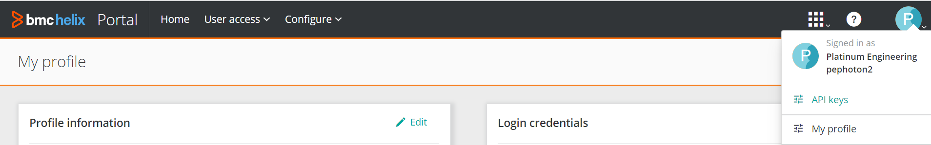

Run below command:

**kubectl get pods -n <namespace> | grep deployment**

This will list the deployment pods. Take the name of any **deployment-repository service** running and then run command:

**kubectl describe pod deployment-repository-service-67c84dc6cd-c78m4 -n <namespace> | grep Image**

This command will list something like:

*Image: phx-epddtr-prd.bmc.com/bmc/lp0mz:deployment-repository-service-2bfd0ff-9*

*Image ID: docker-pullable://phx-epddtr-prd.bmc.com/bmc/lp0mz@sha256:5ad071f435c4991f62ddd245a318fef891b71228a1ae7f079f9367fb8db6562b*

In the first line you will see a number at the end. This is the job.container.tag value

1. The output should be like:

root@xxxx# helm install single-solution-import single-solution-import-578.tgz --set namespace=broken-dreams,registryhost=phx-epddtr-prd.bmc.com,imagePullSecrets.name=bmc-dtrhub,job.initContainers.containers.container1.registryhost=phx-epddtr-prd.bmc.com,job.initContainers.containers.container1.org=bmc/lptso,job.container.org=bmc/lptso:,job.container.tag=2fb6a1ce-392,job.volumes[0].persistentVolumeClaim.claimName=poc-broken-dreams-nfs-pvc,job.volumes[0].name=repo-volume,job.container.envMap.env.TENANT_NAME=89999057,job.container.envMap.env.REPOSITORY_NAME="monitoring-studio-10.4.00-thorium.zip",job.initContainers.enabled=false,job.volumes[1].name=gcpcert1,job.volumes[1].secret.secretName=kafka-pem,job.volumes[2].name=gcpcert2,job.volumes[2].secret.secretName=kafka-pem,job.volumes[1].secret.optional=true,job.volumes[2].secret.optional=true -n broken-dreams,job.container.tag=6c6aa1bc-4,job.serviceAccount=helix-onprem-sa

NAME: single-solution-import

LAST DEPLOYED: Mon May 29 03:13:14 2023

NAMESPACE: broken-dreams

STATUS: deployed

REVISION: 1

TEST SUITE: None

**Note**: For OpenShift Cluster, please make sure to add runAsUser=1000670000 (OpenShift user ID), get this value from the infra.config file:

Example:

root@xxxx# helm install single-solution-import single-solution-import-578.tgz --set namespace=broken-dreams,registryhost=phx-epddtr-prd.bmc.com,imagePullSecrets.name=bmc-dtrhub,job.initContainers.containers.container1.registryhost=phx-epddtr-prd.bmc.com,job.initContainers.containers.container1.org=bmc/lptso,job.container.org=bmc/lptso:,job.container.tag=2fb6a1ce-392,job.volumes[0].persistentVolumeClaim.claimName=poc-broken-dreams-nfs-pvc,job.volumes[0].name=repo-volume,job.container.envMap.env.TENANT_NAME=89999057,job.container.envMap.env.REPOSITORY_NAME="monitoring-studio-10.4.00-thorium.zip",job.initContainers.enabled=false,job.volumes[1].name=gcpcert1,job.volumes[1].secret.secretName=kafka-pem,job.volumes[2].name=gcpcert2,job.volumes[2].secret.secretName=kafka-pem,job.volumes[1].secret.optional=true,job.volumes[2].secret.optional=true,**runAsUser=1000670000** -n broken-dreams,job.container.tag=6c6aa1bc-4,job.serviceAccount=helix-onprem-sa

1. We can tail the logs in the single-solution-import-job pod to check the progress of the job. First get the pod name and then get the logs:

**kubectl get pod -n <namespace> | grep single**

**kubectl logs -f <single-solution-pod name> -n <namespace>**

Example**:**

**kubectl logs -f single-solution-import-job-79mwx -n xxx**

If there is any problem, get a copy of the log by running:

**kubectl logs -f <single-solution pod name> -n <namespace> > /tmp/importjob.log**

1. There will be some error but after few minutes it should give the successful message for Single Solution Import similar to the one below:

2023-05-29 08:19:54.890 +0000 [main] [INFO ] - com.bmc.truesight.saas.drs.deployablepackage.DeployablePackageSolutionPlatform [com.bmc.truesight.saas.drs.util.Log:info:22] - Single Solution imported successfully for Tenant - 89999057, KM - X & version - 10.4.00

Single Solution imported successfully for Tenant - 89999057, KM - X & version - 10.4.00

2023-05-29 08:19:54.890 +0000 [main] [INFO ] - com.bmc.truesight.saas.drs.service.DeploymentRepositoryServiceRequestHandler [com.bmc.truesight.saas.drs.util.Log:info:22] - Response for repository import - 200

2023-05-29 08:19:54.890 +0000 [main] [INFO ] - com.bmc.truesight.saas.drs.service.DeploymentRepositoryServiceRequestHandler [com.bmc.truesight.saas.drs.util.Log:info:22] - Sending repo import success notification over Kafka - MessageType: REPO_IMPORT_NOTIFY

2023-05-29 08:19:54.891 +0000 [main] [INFO ] - DeploymentAudit [com.bmc.truesight.saas.drs.scheduler.KafkaProducer:getProperties:23] - Loading kafka producer properties for gcp.

2023-05-29 08:19:55.238 +0000 [main] [INFO ] - com.bmc.truesight.saas.drs.service.DeploymentRepositoryServiceRequestHandler [com.bmc.truesight.saas.drs.util.Log:info:22] - Finished importRepository.

Single Solution imported successfully for Tenant - 89999057, KM - X & version - 10.4.00

## How to check on the UI.

Please login to the BHOM on Premise User Console. Under Administration 🡪 Repository you should see your additional KM / Customer KM listed. Example screenshot below.

In this case imported Sentry Monitoring Studio X

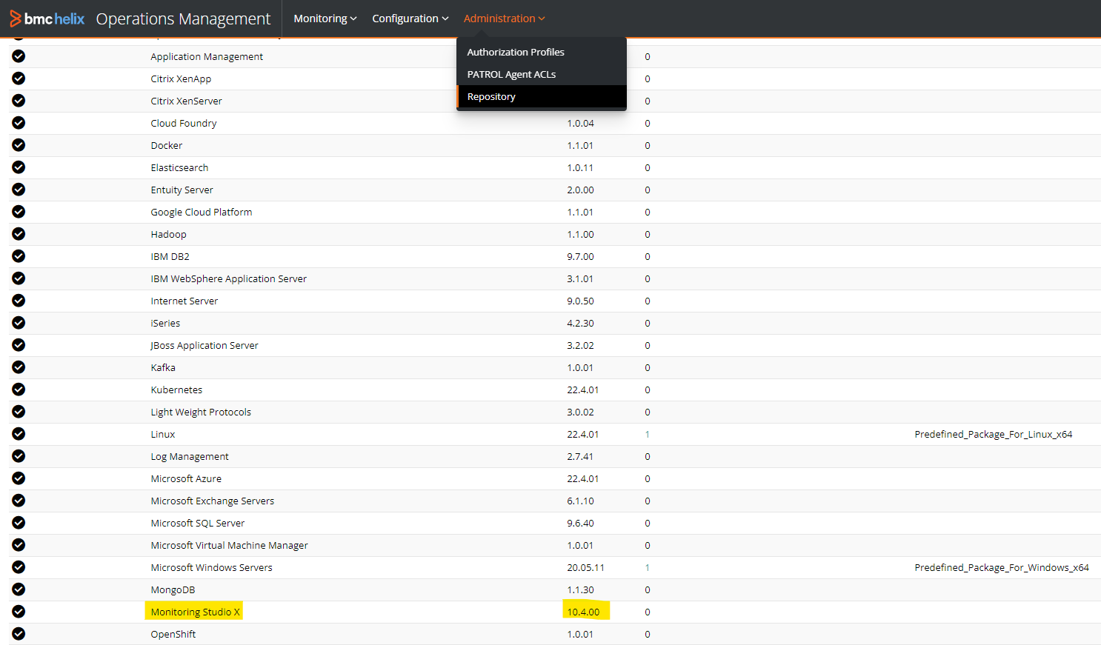

BMC delivers software solutions that help IT transform digital enterprises for the ultimate competitive business advantage. We have worked with thousands of leading companies to create and deliver powerful IT management services. From mainframe to cloud to mobile, we pair high-speed digital innovation with robust IT industrialization—allowing our customers to provide amazing user experiences with optimized IT performance, cost, compliance, and productivity. We believe that technology is the heart of every business, and that IT drives business to the digital age.

**BMC – Bring IT to Life.**