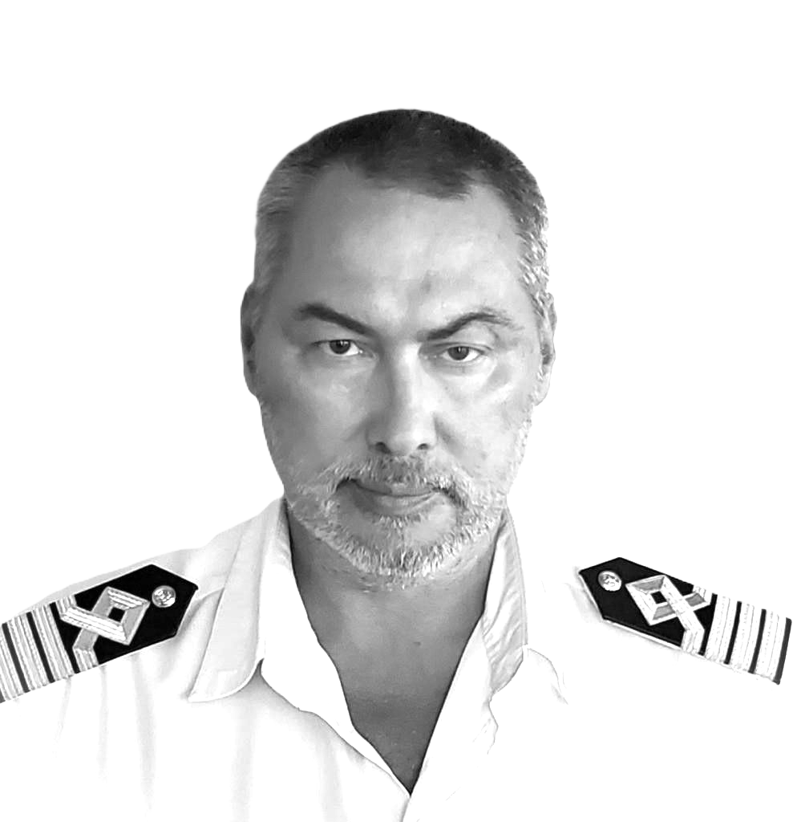
Capt. Oleksandr Shyrokov

| Deep Sea Captain | Harbour Master | Maritime Operations Expert | ISM/ISPS
Auditor | Fleet and Port Management Professional | Web Developer |
—————————————————————————————————————————
Phone: +38 067 519 4912
Email: rivervenra@gmail.com
LinkedIn: linkedin.com/in/oleksandr-shyrokov-340aa8b6
Residence: Odessa, UA
—————————————————————————————————————————

Professional Summary

Maritime professional with over 20 years of leadership in fleet operations, port management, and maritime regulatory compliance. Extensive experience commanding tankers, bulk carriers, Ro-Ro/Container vessels, and offshore ships, ensuring safety, efficiency, and strict adherence to ISM/ISPS standards.
As Harbour Master of Odessa and Illichevsk Sea Ports, directed vessel traffic and emergency response operations, ensuring efficient port operations and regulatory compliance. Led sustainability initiatives to enhance environmental responsibility and improve port logistics.
At ABC Maritime, played a role in fleet restructuring, ISM/ISPS audits, and vessel lifecycle management, achieving significant cost savings and operational efficiency. Supervised dry-docking, maintenance, and new vessel construction, ensuring compliance with international standards.
With a deep understanding of navigational safety, risk assessment, and maritime regulations, I have successfully collaborated with port authorities, regulatory bodies, and international shipping companies to enhance operational efficiency and regulatory compliance. Skilled in leveraging digital navigation tools, real-time data analysis, and performance optimization strategies, I bring a modern and proactive approach to maritime operations.
Passionate about maritime safety, crisis management, and optimizing global shipping operations. Open to leadership roles in fleet management, port operations, or maritime consultancy where expertise in risk mitigation, regulatory compliance, and operational excellence can drive success.

Experience

Harbour Master Odessa
Odessa Sea Port, Ukraine (Jan 2022 – Sep 2023)
- Led and managed all port navigation operations, ensuring full compliance with IMO and national maritime regulations.
- Supervised vessel traffic control, optimizing port logistics and reducing turnaround times.
- Developed and enforced safety protocols, enhancing incident response and minimizing operational risks.
- Implemented environmental sustainability initiatives, reducing emissions and improving waste management within port operations.
- Engaged with key stakeholders, including government agencies, shipping companies, and local authorities, to improve port efficiency and commercial attractiveness.

Harbour Master Illichevsk
Illichevsk Sea Port, Ukraine (Aug 2020 – Mar 2021)
- Managed daily port operations, overseeing vessel scheduling, cargo handling, and berth allocation.
- Strengthened safety compliance by implementing ISM/ISPS standards and conducting regular audits.
- Led operational improvements, optimizing berth utilization and streamlining pilotage services.
- Coordinated emergency response efforts, ensuring rapid and effective incident management.

Deep-Sea Captain / Fleet Operations
ABC Maritime, Switzerland (Apr 2007 – Jan 2020)
- Commanded various vessels, including tankers, Ro-Ro ships, and supply vessels, ensuring operational efficiency and safety.
- Conducted ISM/ISPS and SOLAS compliance audits, improving fleet regulatory adherence and risk management.
- Supervised dry-docking, retrofitting, and vessel maintenance projects, optimizing costs and ensuring timely completion.
- Led emergency drills and crisis management training for crews, enhancing safety preparedness.
- Spearheaded a major restructuring of the company’s tanker fleet, achieving cost reductions and operational improvements.

Vessel Operator and Fleet Operations
ABC Maritime, Switzerland (Mar 2017 – Sep 2017)
- Coordinated vessel operations, including routing, bunkering, and port entry planning to optimize performance and cost efficiency.
- Advised on cargo operations, tank cleaning, and vessel stability management during complex operations.
- Monitored and analyzed operational data, proactively identifying risks and implementing corrective actions.
- Worked closely with technical teams to enhance fleet reliability and minimize downtime.

Education
Odessa State Marine Academy – Navigator Engineer (Sep 1991 – Jun 1997)
Acquired in-depth knowledge of ship navigation, maritime safety, cargo handling, and international shipping regulations. Completed extensive training in vessel maneuvering, emergency response, and compliance with IMO standards. Developed a strong foundation in marine engineering, meteorology, and advanced navigation systems, which became the basis for a successful maritime career.

Skills

Maritime Operations
- Fleet Operations & Vessel Traffic Management
- Port Navigation & Traffic Control
- Vessel Maintenance, Dry-Docking & Retrofitting
- Cargo Handling & Stability Management

Safety & Compliance
- ISM/ISPS, SOLAS & MARPOL Regulatory Compliance
- Emergency Response & Crisis Management
- Risk Assessment & Incident Prevention
- Security Audits & Safety Training

Leadership & Strategy
- Stakeholder Engagement & Negotiation
- Team Leadership & Crew Development
- Operational Cost Optimization
- Strategic Decision-Making & Problem-Solving

Environmental & Technological Adaptation
- Environmental Sustainability in Maritime Operations
- Digital Navigation Systems & ECDIS Proficiency
- High Voltage & Safety Training
- Port & Fleet Performance Optimization

Audit & Regulatory Expertise
- ISM/ISPS Lead Auditor Certification
- Regulatory Compliance & Port State Control
- Internal Auditing & Safety Inspections
- Maritime Security Risk Assessments

Technical & Digital Proficiency
- GMDSS & Bridge Resource Management
- Radar, ARPA, ECDIS & Bridge Team Management
- Maritime Software & Fleet Monitoring Systems
- Front-End Web Development & IT Systems

Professional Highlights

Founder & CEO of ProShipRouting (2024 – Present)
I founded ProShipRouting (visit: www.proshiprouting.com), a company dedicated to providing professional hydrometeorological ship routing services. By leveraging advanced meteorological data and oceanographic insights, we help vessels optimize their routes for safety, efficiency, and cost-effectiveness. Our services assist shipowners, captains, and fleet operators in making well-informed navigational decisions while reducing fuel consumption and voyage risks.
In addition to leading the company's strategic direction, I have been actively involved in developing and refining our online platform to ensure a seamless user experience. The platform integrates real-time weather updates and voyage planning tools, making ProShipRouting a reliable partner in maritime operations. This initiative reflects my commitment to enhancing shipping efficiency through data-driven solutions and innovation.

Licenses & Certifications

Master Mariner & Tanker Training
- Certificate of Competency as Master Mariner (Unlimited)
- Advanced Oil Tanker Training (STCW V/1-1)
- Advanced Chemical Tanker Training (STCW V/1-1)

Safety & Security
- Ship Security Officer (SSO) – ISPS Code
- ISM/ISPS Lead Auditor Certification
- Basic & Advanced Firefighting (STCW A-VI/3)
- Survival Craft and Rescue Boats (STCW A-VI/2-1)

Bridge & Navigation
- Bridge Resource Management (BRM)
- Radar, ARPA, ECDIS & Bridge Team Management
- GMDSS General Operator Certificate
- Dynamic Positioning (DP) Certificate

Medical & Emergency Response
- Medical First Aid (STCW A-VI/4-1)
- Medical Care (STCW A-VI/4-2)
- High Voltage Safety Training

Hobbies & Interests

Frontend Development
I have a passion for web development and have successfully designed and built a corporate website using HTML and CSS. I also configured a domain, set up business email, and ensured a fully responsive design. Currently, I am continuously expanding my knowledge of frontend development, exploring JavaScript and modern web frameworks.

Hunting & Outdoor Skills
Hunting is not just a sport for me but a way to connect with nature. I have extensive experience in ethical hunting, tracking, and firearm safety. Additionally, I enjoy outdoor survival training, navigation, and spending time in the wilderness, refining my self-sufficiency skills in challenging environments.

Closing Statement
Excited to connect with professionals in the maritime industry! With extensive experience in fleet management, port operations, and regulatory compliance, I am passionate about advancing safety and efficiency in maritime services.
Let’s collaborate and explore opportunities! Looking forward to connecting with maritime professionals. Let’s discuss how my expertise can contribute to your operations! Contact me via email or visit my LinkedIn profile.

© 2024 Oleksandr Shyrokov | Maritime Operations & Fleet Management

