CHATBOT FOR PLACEMENT CELL

END TERM REPORT

By

Rivesh Raja, Deepak Kumar, Riya Roy, Swati
(Section: K18JF)
(Roll Number(s):18,23,06,48)


Department of Intelligent Systems
School of Computer Science Engineering
Lovely Professional University, Jalandhar
APRIL-2020
Student Declaration
This is to declare that this report has been written by me/us. No part of the report is copied from sources. All information included from other sources have been duly acknowledged. I/We aver that if any of the part of the report is found to be copied, I/we are shall take full responsibility for it.

Signature of Student
RIVESH RAJA
Roll number: 18
Signature of Student
DEEPAK KUMAR
Roll number: 23

Signature of Student
RIYA ROY
Roll number: 06

Signature of Student
SWATI
Roll number: 48

TABLE OF CONTENTS

TITLE PAGE NO.
- INTRODUCTION………………………………………………………………………...1
- CLASSIFICATION……………………………………………………………………….1
- GOALS AND OBJECTIVE…………………………........................................................2
- DESCRIPTION OF PROJECT…………………………………………………………...3
4.1 TRAINING THE DATA or DATA SET……………………………………………..3
4.2 PREREQUISITES…………………………………………………………………….4
4.3 IMPORT AND LOAD THE DATA……………………………………..……………5
4.4 PREPROCESS DATA………………………………………………………………...6
4.5 PREDICT THE RESPONSE………………………………………………………….7
5. DESCRIPTION OF WORK DIVISION IN TERMS OF ROLES
AMONG STUDENTS……………………………………………………………………20
6. SCREENSHOTS………………………………………………………………………...21
7. SWAT ANALYSIS……………………………………………………………………..23
8. SUMMARY……………………………………………………………………………..23

BONAFIDE CERTIFICATE

Certified that this project report “ CHATBOT FOR PLACEMENT CELL” is the bonafide work of “ Rivesh Raja, Deepak Kumar, Riya Roy, Swati” who carried out the project work under my supervision.

Signature of the Supervisor
Name of supervisor
Academic Designation
ID of Supervisor
Department of Supervisor

1. INTRODUCTION
Chatbot can be defined as AI based computer program that simulates human conversations. They are also known as digital assistants that understand human capabilities. Bots interpret and process the user requests and give prompt relevant answers. Bots can through voice as well as text and can be deployed across websites, applications and messaging channels such as Facebook Messenger, Twitter or WhatsApp.
Chatbots work by analysing and identifying the intent of the user’s request to extract relevant entities, which is the most important task of a chatbot. Once the analysis is done appropriate response is delivered to the user. The chatbots work by adopting three classification methods.

2. CLASSIFICATIONS
Pattern matching
Bots utilize pattern matches to group the text and it produces an appropriate response from the clients. Artificial Intelligence Markup Language (AIML) is a standard structured model of these patterns. A bot is able to get the right answer in the related pattern. The bots react to anything relating it to the correlate patterns.

Natural language understanding (NLU)
NLU is the ability of the chatbot to understand a human. It is the process of converting text into structured data for a machine to understand. NLU follows three specific concepts. They are: entities, context, and expectations.

3. GOALS AND OBJECTIVE
Chatbots boost operational efficiency and bring cost savings to businesses while offering convenience and added services for customers. They allow companies to easily resolve many types of customer queries and issues while reducing the need for human interaction.
According to Forbes, 80% of marketers plan to start using a chatbot in some way or another by 2020. This is a significant reason why brands are investing in improving the customer experience.
Let’s find out the importance of adopting the chatbot strategy in your business and how chatbot benefits to win more customers or retain the existing ones.
Reduce customer waiting time – According to Chatbot Report, 21% of consumers see chatbots as the easiest way to contact a business. Chatbots are a smarter way to ensure that customers receive the immediate response that they are looking for without making them wait in a queue.
24×7 availability – 68% of customers switch to a competitor if they don’t think you care about them. Bots are always available to engage customers with immediate answers to the common questions asked by them. The top potential benefit of using chatbots is 24-hour customer service.
Better customer engagement – Conversational bots can engage customers round the clock by starting proactive conservation and offering personalized recommendations that boost customer experience.
Easy scalability with bots – Bots can be easily scalable during the peak business hours or and manage ‘n’ number of customer conversations without additional customer service costs.
Save customer service costs – Juniper Research estimates that chatbots will help businesses save more than $8 billion per year by 2022. Chatbots help businesses to save customer service costs of hiring more support agents that require additional costs such as salary, training and infrastructure costs.
Automate lead qualification & sales – You can automate your sales funnel with chatbots to prequalify leads and directing them to the right team for further nurturing. Being able to engage customers instantly increases the number of leads and conversion rates.
Reduce customer churn rate– Engaging your visitors is arguably the single most sure-fire way of reducing bounce rates and subsequently increasing conversions. With chatbots, you can boost your engagement strategy even further and actually keep visitors hooked.

4. DESCRIPTION OF PROJECT
4.1. TRAINING THE DATA or DATA SET
The dataset is a JSON file like that contains the patterns we need to find and the responses we want to return to the user. In this program we tell train the data about the what to response again n again by using [intents.json] file it will remember the pattern used further to understand and find the pattern to response further.
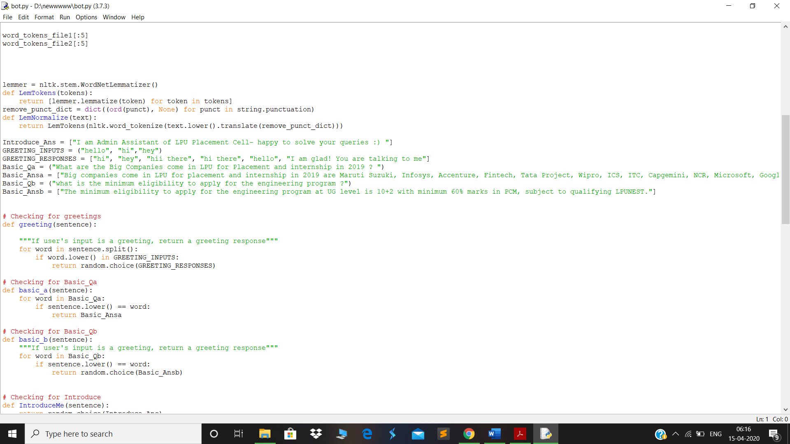

4.2. PREREQUISITES
The project requires you to have the good knowledge of Python, Natural Language Processing (NLTK), Tkinter, JSON String, Random, NUMPY, Tokenizer, Lemmatize, etc. We will use some helping modules which you can download using the -PIP command in python.

A) NLTK
NLTK stands for Natural Language Toolkit. This toolkit is one of the most powerful NLP libraries which contains packages to make machines understand human language and reply to it with an appropriate response. Tokenization, Stemming, Lemmatization, Punctuation, Character count, word count are some of these packages in this library.

Code used is
import nltk
from nltk.stem.lancaster import LancasterStemmer
stemmer = LancasterStemmer()

B) NUMPY:
Numpy is a library for the Python programming language, adding
support for large, multi-dimensional arrays and matrices, along with
a large collection of high-level mathematical functions to operate on
these arrays.
Code used is
import numpy as np

C) TENSORFLOW
TensorFlow is a rich system for managing all aspects of a machine
learning system; however, this class focuses on using a particular
TensorFlow API to develop and train machine learning models.
TensorFlow APIs are arranged hierarchically, with the high-level APIs
built on the low-level APIs. Machine learning researchers use the lowlevel
APIs to create and explore new machine learning algorithms.
Code used is
import tensorflow as tf

D) Random:
In Python, a random module implements pseudo-random number
generators for various distributions including integer, float (real).This
function of the module is used in predicting the output
Code used is
import random

4.3. IMPORT AND LOAD THE DATA

First, make a file name as BOT.py. We import the necessary packages for our chatbot and initialize the variables we will use in our Python project. As I have made two files of name COMPANY 1.txt and COMPANY 2.txt . First we read both the files and load the file to break there statements in sentence and word.
Below given picture : how to read the file.
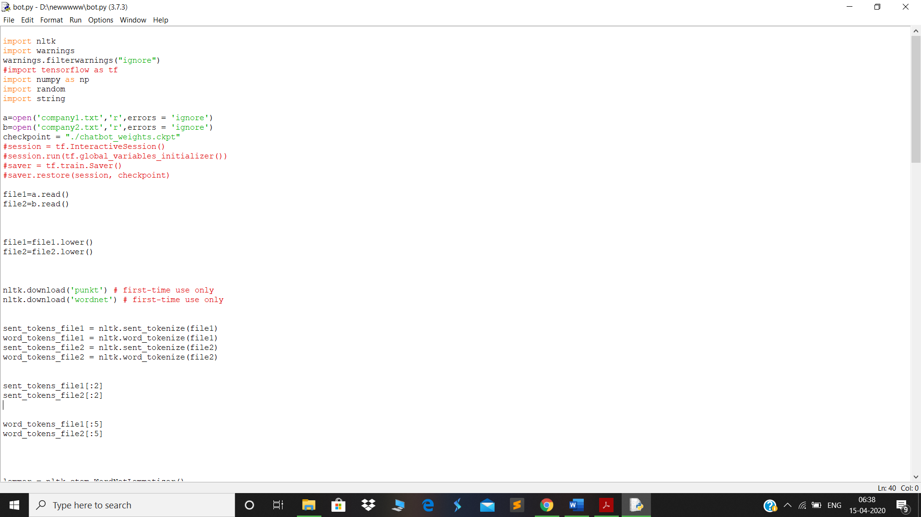

4.4. PREPROCESS DATA
When working with text data, we need to perform various preprocessing on the data before we make a machine learning or a deep learning model. Tokenizing is the most basic and first thing you can do on text data. Tokenizing is the process of breaking the whole text into small parts like words.
Here we iterate through the patterns and tokenize the sentence using nltk.word_tokenize() function and append each word in the words list. We also create a list of classes for our tags.

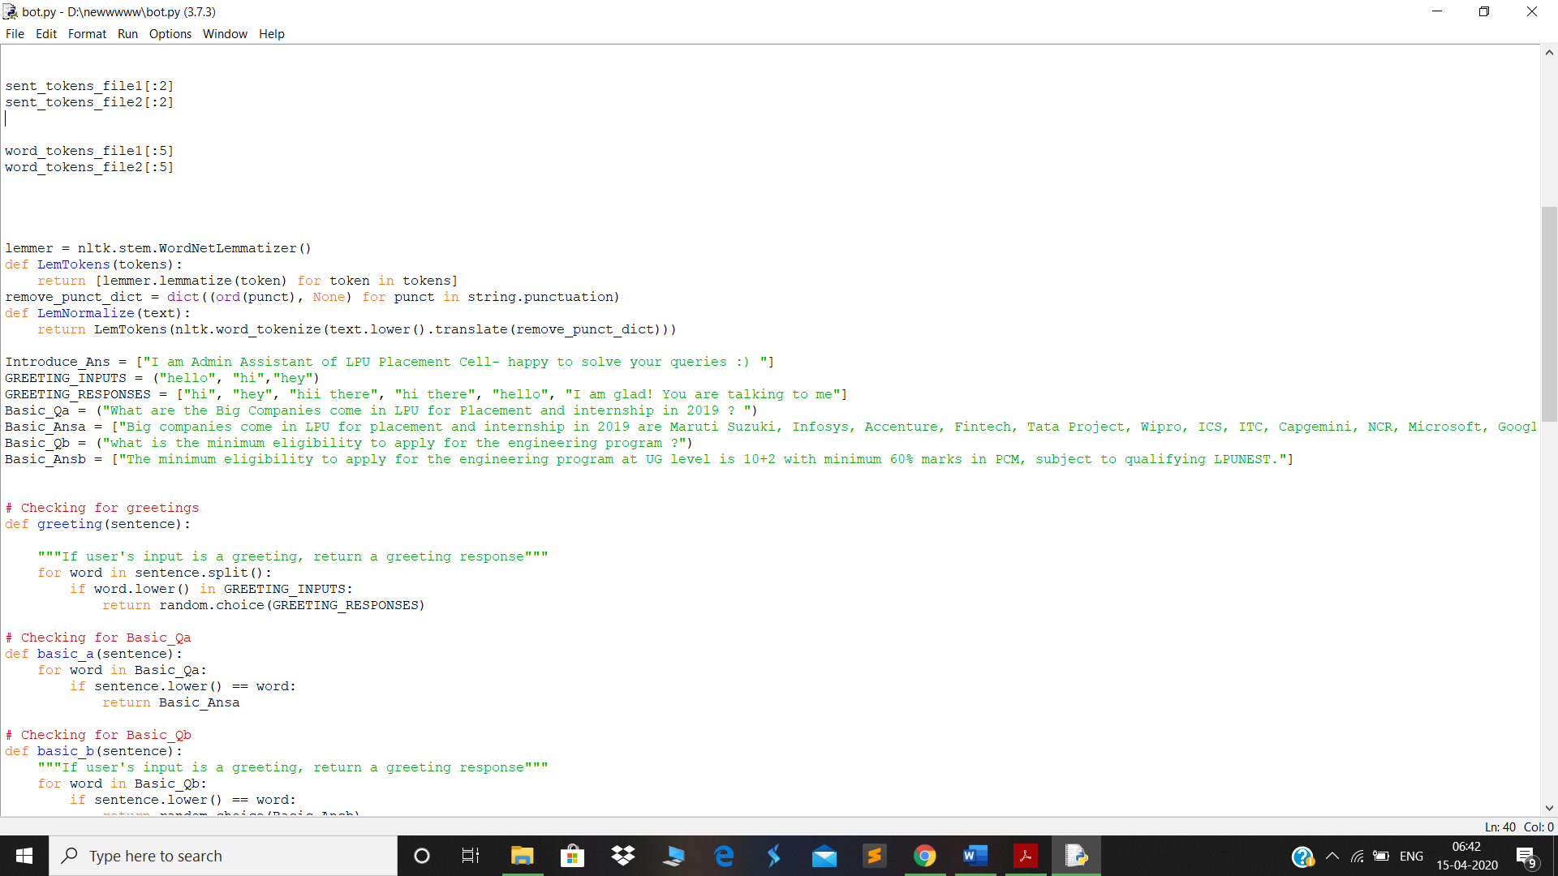

Now we will lemmatize each word and remove duplicate words from the list. Lemmatizing is the process of converting a word into its lemma form and then creating a pickle file to store the Python objects which we will use while predicting.

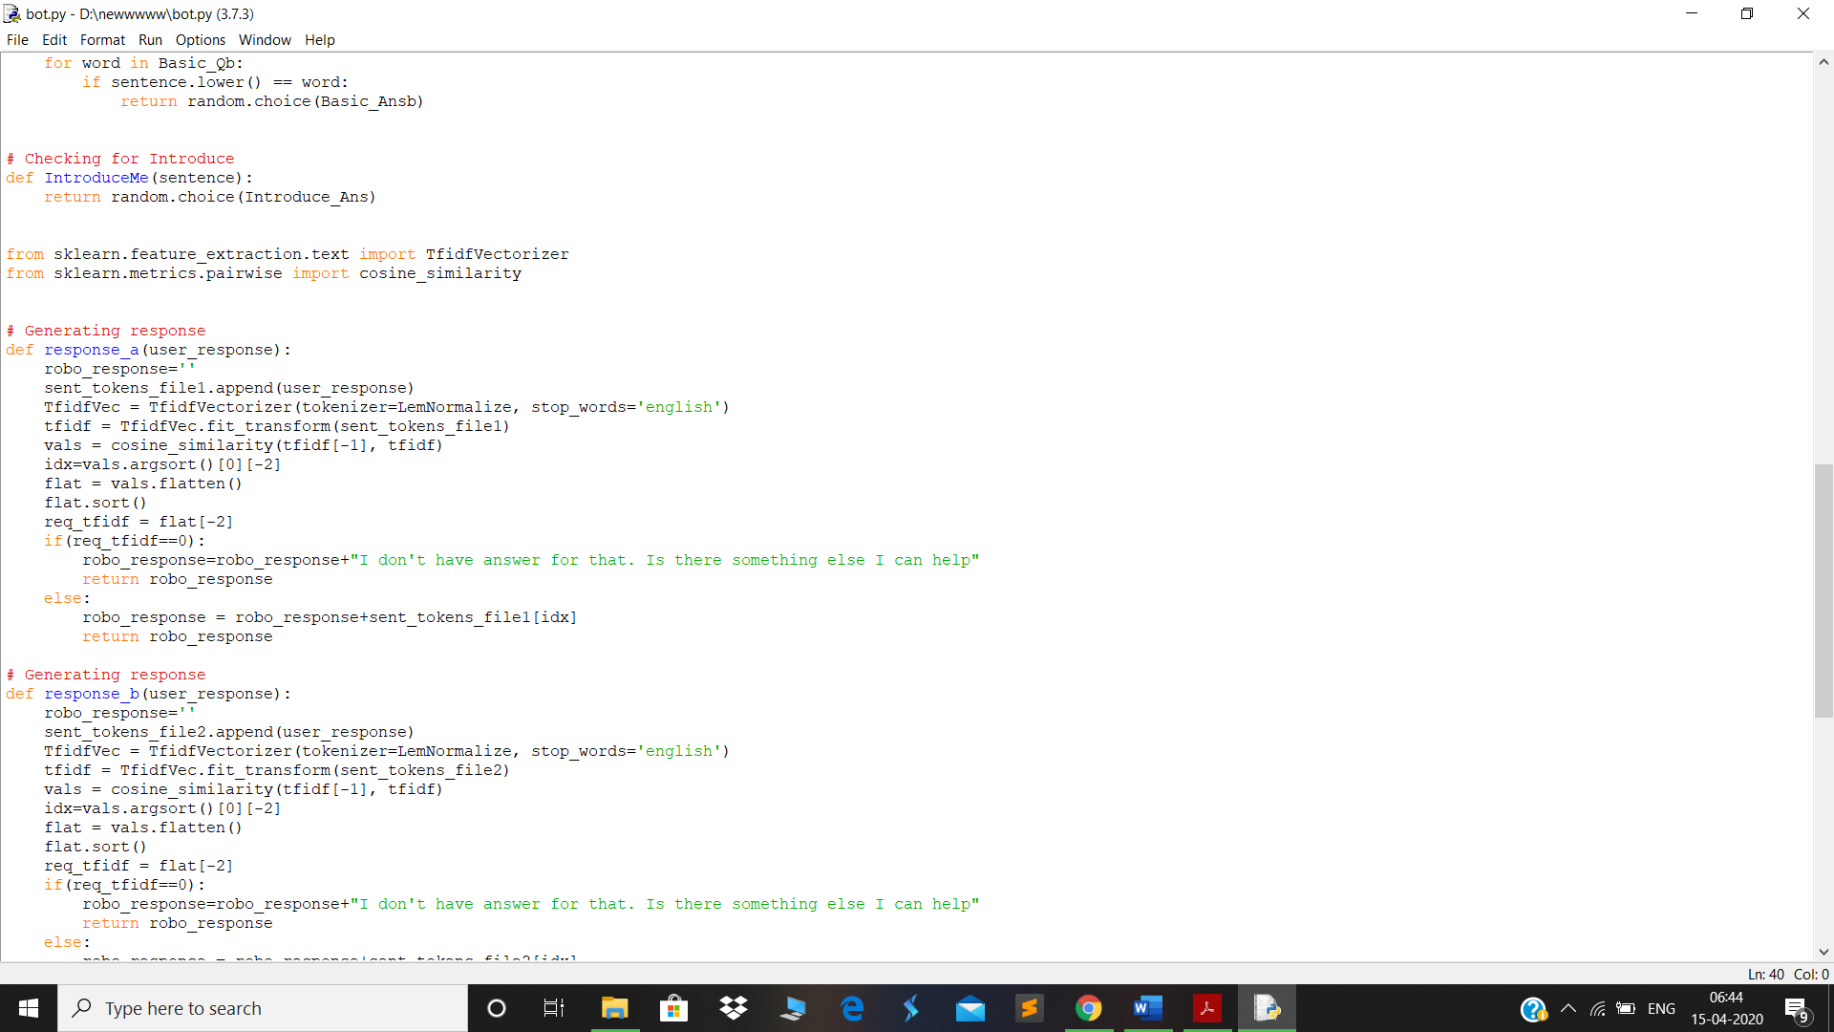
4.5. PREDICT THE RESPONSE (Graphical User Interface)

Now to predict the sentences and get a response from the user to let us create a new file ‘bot.py’.
We will load the trained model and then use a graphical user interface that will predict the response from the bot. The model will only tell us the class it belongs to, so we will implement some functions which will identify the class and then retrieve us a random response from the list of responses.
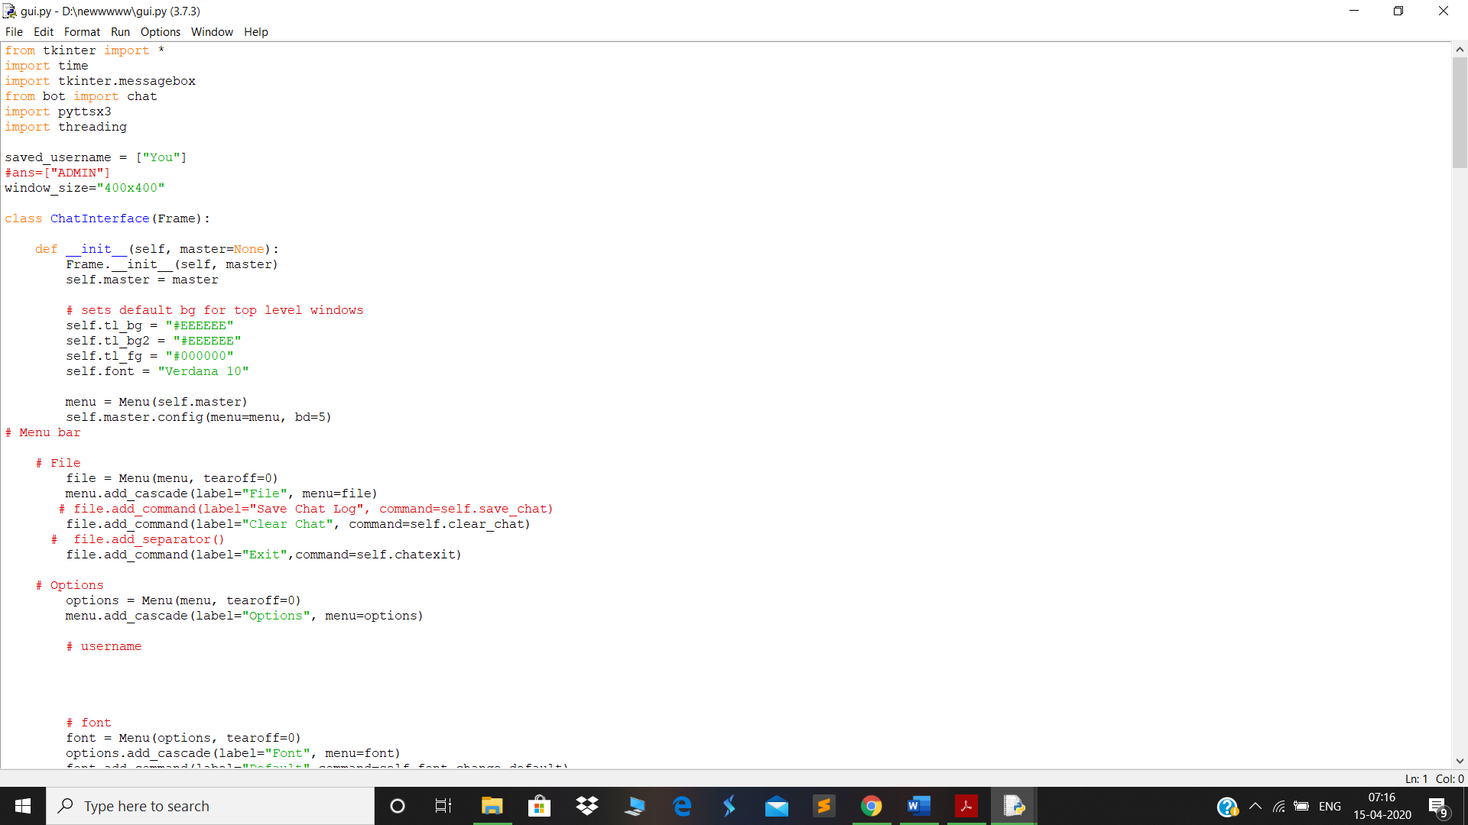

Using GUI application we created an interface so that the person can come and interact with us in this GUI we have made a window box with various option is the tab to exit the application window to clear the chats. About the developers. You can also change the colour of the text .

We have use button keyword to submit the response as tkinter message box, a scrolling window etc.

To predict the class, we will need to provide input in the same way as we did while training. So we will create some functions that will perform text pre-processing and then predict the class.

Now we will code a graphical user interface. For this, we use the Tkinter library which already comes in python. We will take the input message from the user and then use the helper functions we have created to get the response from the bot and display it on the GUI. Here is the full source code for the GUI.

Code:

from tkinter import *
import time
import tkinter.messagebox
from bot import chat
import pyttsx3
import threading
saved_username = ["You"]
#ans=["ADMIN"]
window_size="400x400"
class ChatInterface(Frame):
def __init__(self, master=None):
Frame.__init__(self, master)
self.master = master
# sets default bg for top level windows
self.tl_bg = "#EEEEEE"
self.tl_bg2 = "#EEEEEE"
self.tl_fg = "#000000"
self.font = "Verdana 10"
menu = Menu(self.master)
self.master.config(menu=menu, bd=5)
# Menu bar
# File
file = Menu(menu, tearoff=0)
menu.add_cascade(label="File", menu=file)
# file.add_command(label="Save Chat Log", command=self.save_chat)
file.add_command(label="Clear Chat", command=self.clear_chat)
# file.add_separator()
file.add_command(label="Exit",command=self.chatexit)
# Options
options = Menu(menu, tearoff=0)
menu.add_cascade(label="Options", menu=options)
# username
# font
font = Menu(options, tearoff=0)
options.add_cascade(label="Font", menu=font)
font.add_command(label="Default",command=self.font_change_default)
font.add_command(label="Times",command=self.font_change_times)
font.add_command(label="System",command=self.font_change_system)
font.add_command(label="Helvetica",command=self.font_change_helvetica)
font.add_command(label="Fixedsys",command=self.font_change_fixedsys)

# color theme
color_theme = Menu(options, tearoff=0)
options.add_cascade(label="Color Theme", menu=color_theme)
color_theme.add_command(label="Default",command=self.color_theme_default)
# color_theme.add_command(label="Night",command=self.)
color_theme.add_command(label="Grey",command=self.color_theme_grey)
color_theme.add_command(label="Blue",command=self.color_theme_dark_blue)

color_theme.add_command(label="Torque",command=self.color_theme_turquoise)
color_theme.add_command(label="Hacker",command=self.color_theme_hacker)
# color_theme.add_command(label='Mkbhd',command=self.MKBHD)
help_option = Menu(menu, tearoff=0)
menu.add_cascade(label="Help", menu=help_option)
#help_option.add_command(label="Features", command=self.features_msg)
help_option.add_command(label="About PyBot", command=self.msg)
help_option.add_command(label="Develpoers", command=self.about)

self.text_frame = Frame(self.master, bd=6)
self.text_frame.pack(expand=True, fill=BOTH)

# scrollbar for text box
self.text_box_scrollbar = Scrollbar(self.text_frame, bd=0)
self.text_box_scrollbar.pack(fill=Y, side=RIGHT)

# contains messages
self.text_box = Text(self.text_frame, yscrollcommand=self.text_box_scrollbar.set, state=DISABLED,
bd=1, padx=6, pady=6, spacing3=8, wrap=WORD, bg=None, font="Verdana 10", relief=GROOVE,width=10, height=1)
self.text_box.pack(expand=True, fill=BOTH)
self.text_box_scrollbar.config(command=self.text_box.yview)

# frame containing user entry field
self.entry_frame = Frame(self.master, bd=1)
self.entry_frame.pack(side=LEFT, fill=BOTH, expand=True)

# entry field
self.entry_field = Entry(self.entry_frame, bd=1, justify=LEFT)
self.entry_field.pack(fill=X, padx=6, pady=6, ipady=3)
# self.users_message = self.entry_field.get()

# frame containing send button and emoji button
self.send_button_frame = Frame(self.master, bd=0)
self.send_button_frame.pack(fill=BOTH)

# send button
self.send_button = Button(self.send_button_frame, text="Send", width=5, relief=GROOVE, bg='white',
bd=1, command=lambda: self.send_message_insert(None), activebackground="#FFFFFF",
activeforeground="#000000")
self.send_button.pack(side=LEFT, ipady=8)
self.master.bind("<Return>", self.send_message_insert)

self.last_sent_label(date="No messages sent.")
#t2 = threading.Thread(target=self.send_message_insert(, name='t1')
#t2.start()

def playResponce(self,responce):
x=pyttsx3.init()
#print(responce)
li = []
if len(responce) > 100:
if responce.find('--') == -1:
b = responce.split('--')
#print(b)

x.setProperty('rate',120)
x.setProperty('volume',100)
x.say(responce)
x.runAndWait()
#print("Played Successfully......")
def last_sent_label(self, date):

try:
self.sent_label.destroy()
except AttributeError:
pass

self.sent_label = Label(self.entry_frame, font="Verdana 7", text=date, bg=self.tl_bg2, fg=self.tl_fg)
self.sent_label.pack(side=LEFT, fill=X, padx=3)

def clear_chat(self):
self.text_box.config(state=NORMAL)
self.last_sent_label(date="No messages sent.")
self.text_box.delete(1.0, END)
self.text_box.delete(1.0, END)
self.text_box.config(state=DISABLED)

def chatexit(self):
exit()

def msg(self):
tkinter.messagebox.showinfo("CHATBOT v1.0",'CHATBOT is a chatbot for answering python queries\nIt is based on retrival-based NLP using pythons NLTK tool-kit module\nGUI is based on Tkinter\nIt can answer questions regarding python language for new learners')

def about(self):
tkinter.messagebox.showinfo("CHATBOT Developers","1.Rivesh Raja\n2.Deepak Kumar\n3.Riya Roy\n4.Swati")

def send_message_insert(self, message):
user_input = self.entry_field.get()
pr1 = "You : " + user_input + "\n"
self.text_box.configure(state=NORMAL)
self.text_box.insert(END, pr1)
self.text_box.configure(state=DISABLED)
self.text_box.see(END)
#t1 = threading.Thread(target=self.playResponce, args=(user_input,))
#t1.start()
#time.sleep(1)
ob=chat(user_input)
pr="ADMIN : " + ob + "\n"
self.text_box.configure(state=NORMAL)
self.text_box.insert(END, pr)
self.text_box.configure(state=DISABLED)
self.text_box.see(END)
self.last_sent_label(str(time.strftime( "Last message sent: " + '%B %d, %Y' + ' at ' + '%I:%M %p')))
self.entry_field.delete(0,END)
time.sleep(0)
t2 = threading.Thread(target=self.playResponce, args=(ob,))
t2.start()
#return ob

def font_change_default(self):
self.text_box.config(font="Verdana 10")
self.entry_field.config(font="Verdana 10")
self.font = "Verdana 10"

def font_change_times(self):
self.text_box.config(font="Times")
self.entry_field.config(font="Times")
self.font = "Times"

def font_change_system(self):
self.text_box.config(font="System")
self.entry_field.config(font="System")
self.font = "System"

def font_change_helvetica(self):
self.text_box.config(font="helvetica 10")
self.entry_field.config(font="helvetica 10")
self.font = "helvetica 10"

def font_change_fixedsys(self):
self.text_box.config(font="fixedsys")
self.entry_field.config(font="fixedsys")
self.font = "fixedsys"

def color_theme_default(self):
self.master.config(bg="#EEEEEE")
self.text_frame.config(bg="#EEEEEE")
self.entry_frame.config(bg="#EEEEEE")
self.text_box.config(bg="#FFFFFF", fg="#000000")
self.entry_field.config(bg="#FFFFFF", fg="#000000", insertbackground="#000000")
self.send_button_frame.config(bg="#EEEEEE")
self.send_button.config(bg="#FFFFFF", fg="#000000", activebackground="#FFFFFF", activeforeground="#000000")
#self.emoji_button.config(bg="#FFFFFF", fg="#000000", activebackground="#FFFFFF", activeforeground="#000000")
self.sent_label.config(bg="#EEEEEE", fg="#000000")

self.tl_bg = "#FFFFFF"
self.tl_bg2 = "#EEEEEE"
self.tl_fg = "#000000"

# Dark
def color_theme_dark(self):
self.master.config(bg="#2a2b2d")
self.text_frame.config(bg="#2a2b2d")
self.text_box.config(bg="#212121", fg="#FFFFFF")
self.entry_frame.config(bg="#2a2b2d")
self.entry_field.config(bg="#212121", fg="#FFFFFF", insertbackground="#FFFFFF")
self.send_button_frame.config(bg="#2a2b2d")
self.send_button.config(bg="#212121", fg="#FFFFFF", activebackground="#212121", activeforeground="#FFFFFF")
# self.emoji_button.config(bg="#212121", fg="#FFFFFF", activebackground="#212121", activeforeground="#FFFFFF")
self.sent_label.config(bg="#2a2b2d", fg="#FFFFFF")

self.tl_bg = "#212121"
self.tl_bg2 = "#2a2b2d"
self.tl_fg = "#FFFFFF"

# Grey
def color_theme_grey(self):
self.master.config(bg="#444444")
self.text_frame.config(bg="#444444")
self.text_box.config(bg="#4f4f4f", fg="#ffffff")
self.entry_frame.config(bg="#444444")
self.entry_field.config(bg="#4f4f4f", fg="#ffffff", insertbackground="#ffffff")
self.send_button_frame.config(bg="#444444")
self.send_button.config(bg="#4f4f4f", fg="#ffffff", activebackground="#4f4f4f", activeforeground="#ffffff")
#self.emoji_button.config(bg="#4f4f4f", fg="#ffffff", activebackground="#4f4f4f", activeforeground="#ffffff")
self.sent_label.config(bg="#444444", fg="#ffffff")
self.tl_bg = "#4f4f4f"
self.tl_bg2 = "#444444"
self.tl_fg = "#ffffff"

def color_theme_turquoise(self):
self.master.config(bg="#003333")
self.text_frame.config(bg="#003333")
self.text_box.config(bg="#669999", fg="#FFFFFF")
self.entry_frame.config(bg="#003333")
self.entry_field.config(bg="#669999", fg="#FFFFFF", insertbackground="#FFFFFF")
self.send_button_frame.config(bg="#003333")
self.send_button.config(bg="#669999", fg="#FFFFFF", activebackground="#669999", activeforeground="#FFFFFF")
#self.emoji_button.config(bg="#669999", fg="#FFFFFF", activebackground="#669999", activeforeground="#FFFFFF")
self.sent_label.config(bg="#003333", fg="#FFFFFF")

self.tl_bg = "#669999"
self.tl_bg2 = "#003333"
self.tl_fg = "#FFFFFF"

# Blue
def color_theme_dark_blue(self):
self.master.config(bg="#263b54")
self.text_frame.config(bg="#263b54")
self.text_box.config(bg="#1c2e44", fg="#FFFFFF")
self.entry_frame.config(bg="#263b54")
self.entry_field.config(bg="#1c2e44", fg="#FFFFFF", insertbackground="#FFFFFF")
self.send_button_frame.config(bg="#263b54")
self.send_button.config(bg="#1c2e44", fg="#FFFFFF", activebackground="#1c2e44", activeforeground="#FFFFFF")
#self.emoji_button.config(bg="#1c2e44", fg="#FFFFFF", activebackground="#1c2e44", activeforeground="#FFFFFF")
self.sent_label.config(bg="#263b54", fg="#FFFFFF")

self.tl_bg = "#1c2e44"
self.tl_bg2 = "#263b54"
self.tl_fg = "#FFFFFF"
# Torque
def color_theme_turquoise(self):
self.master.config(bg="#003333")
self.text_frame.config(bg="#003333")
self.text_box.config(bg="#669999", fg="#FFFFFF")
self.entry_frame.config(bg="#003333")
self.entry_field.config(bg="#669999", fg="#FFFFFF", insertbackground="#FFFFFF")
self.send_button_frame.config(bg="#003333")
self.send_button.config(bg="#669999", fg="#FFFFFF", activebackground="#669999", activeforeground="#FFFFFF")
#self.emoji_button.config(bg="#669999", fg="#FFFFFF", activebackground="#669999", activeforeground="#FFFFFF")
self.sent_label.config(bg="#003333", fg="#FFFFFF")

self.tl_bg = "#669999"
self.tl_bg2 = "#003333"
self.tl_fg = "#FFFFFF"

# Hacker
def color_theme_hacker(self):
self.master.config(bg="#0F0F0F")
self.text_frame.config(bg="#0F0F0F")
self.entry_frame.config(bg="#0F0F0F")
self.text_box.config(bg="#0F0F0F", fg="#33FF33")
self.entry_field.config(bg="#0F0F0F", fg="#33FF33", insertbackground="#33FF33")
self.send_button_frame.config(bg="#0F0F0F")
self.send_button.config(bg="#0F0F0F", fg="#FFFFFF", activebackground="#0F0F0F", activeforeground="#FFFFFF")
#self.emoji_button.config(bg="#0F0F0F", fg="#FFFFFF", activebackground="#0F0F0F", activeforeground="#FFFFFF")
self.sent_label.config(bg="#0F0F0F", fg="#33FF33")

self.tl_bg = "#0F0F0F"
self.tl_bg2 = "#0F0F0F"
self.tl_fg = "#33FF33"

# Default font and color theme
def default_format(self):
self.font_change_default()
self.color_theme_default()
root=Tk()
a = ChatInterface(root)
root.geometry(window_size)
root.title("LPU PLACEMENT CELL QUERIES CHATBOT")
root.iconbitmap('i.ico')
root.mainloop()

5. DESCRIPTION OF WORK DIVISION IN TERMS OF ROLES AMONG STUDENTS.

1) Name: Rivesh Raja
Work : write the code to collect information and make the chatbot implementation and together with Riya Roy, Deepak Kumar, and Swati worked on GUI.
2) Name: Deepak Kumar
Work : Helped in writing the chatbot codes implementation and GUI.
3) Name: Riya Roy
Work : write code for GUI and implementation of tkinter
4) name : Swati
Work : helped in GUI and in finding the data information about the Placement cell.

Together we make the Report file.

Reference -www.geeksforgeeks.com
Reference 2- https://www.revechat.com/blog/what-is-a-chatbot/

RUN THE CHATBOT
To run the chatbot, we have two main files; bot.py and gui.py.

6. SCREENSHOTS
1) initial window
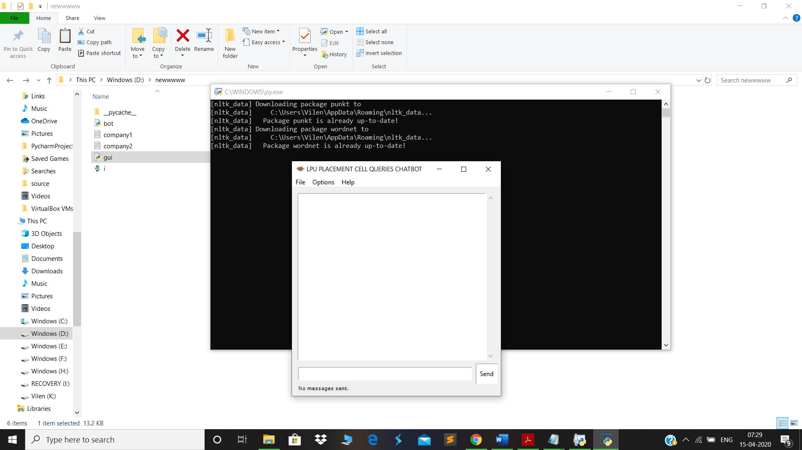
2)writing hello
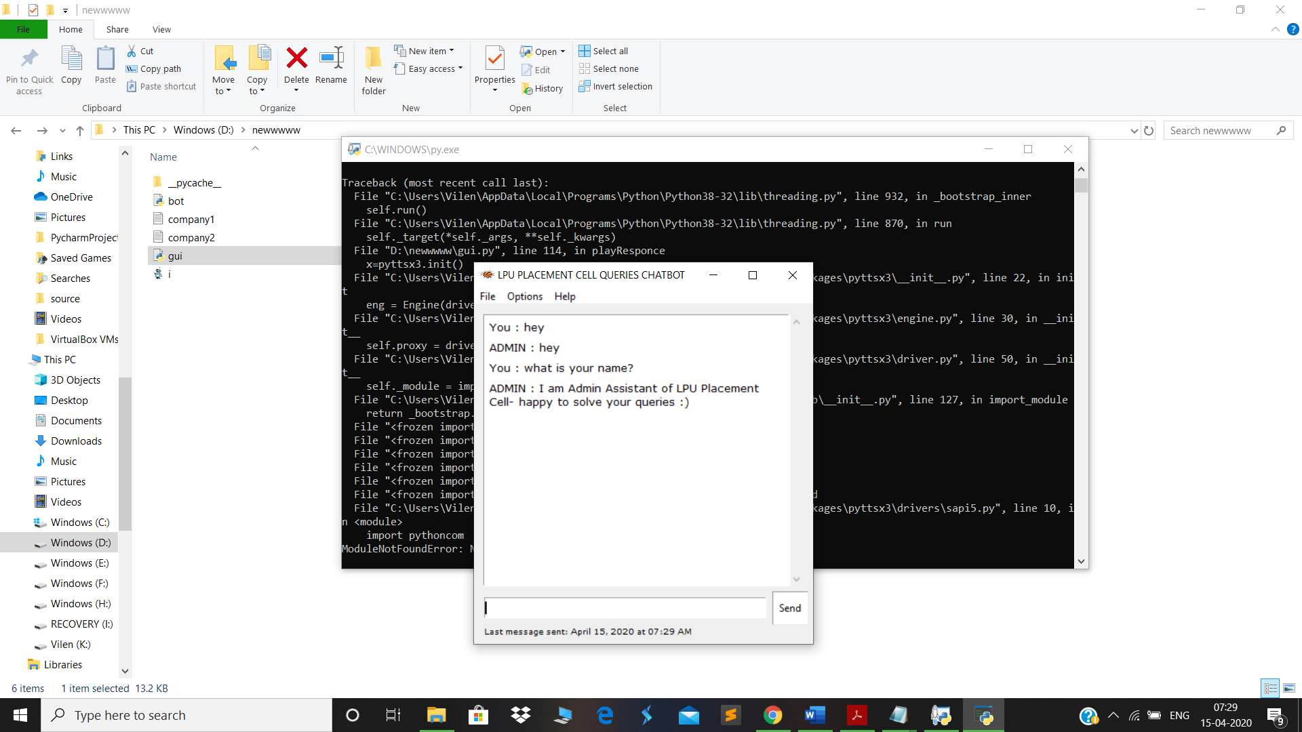

3)Asking some random Questions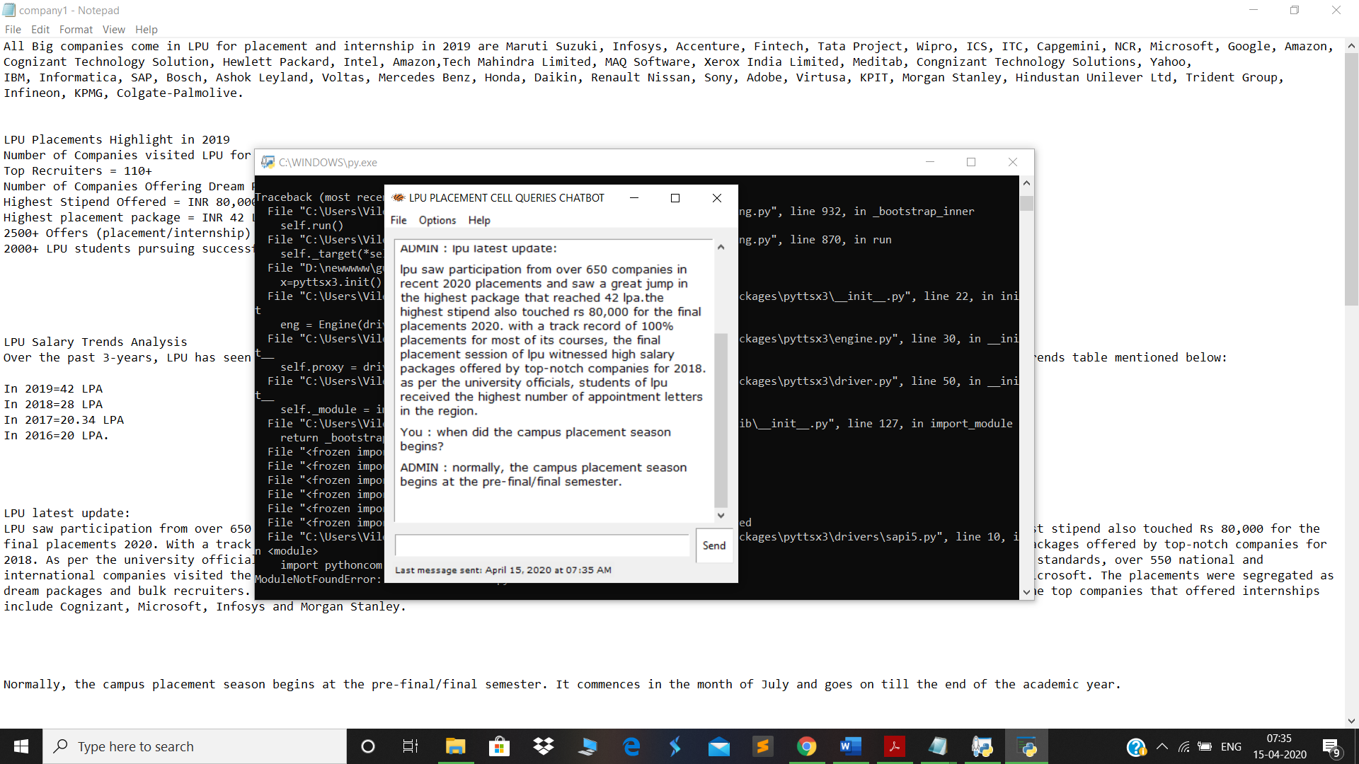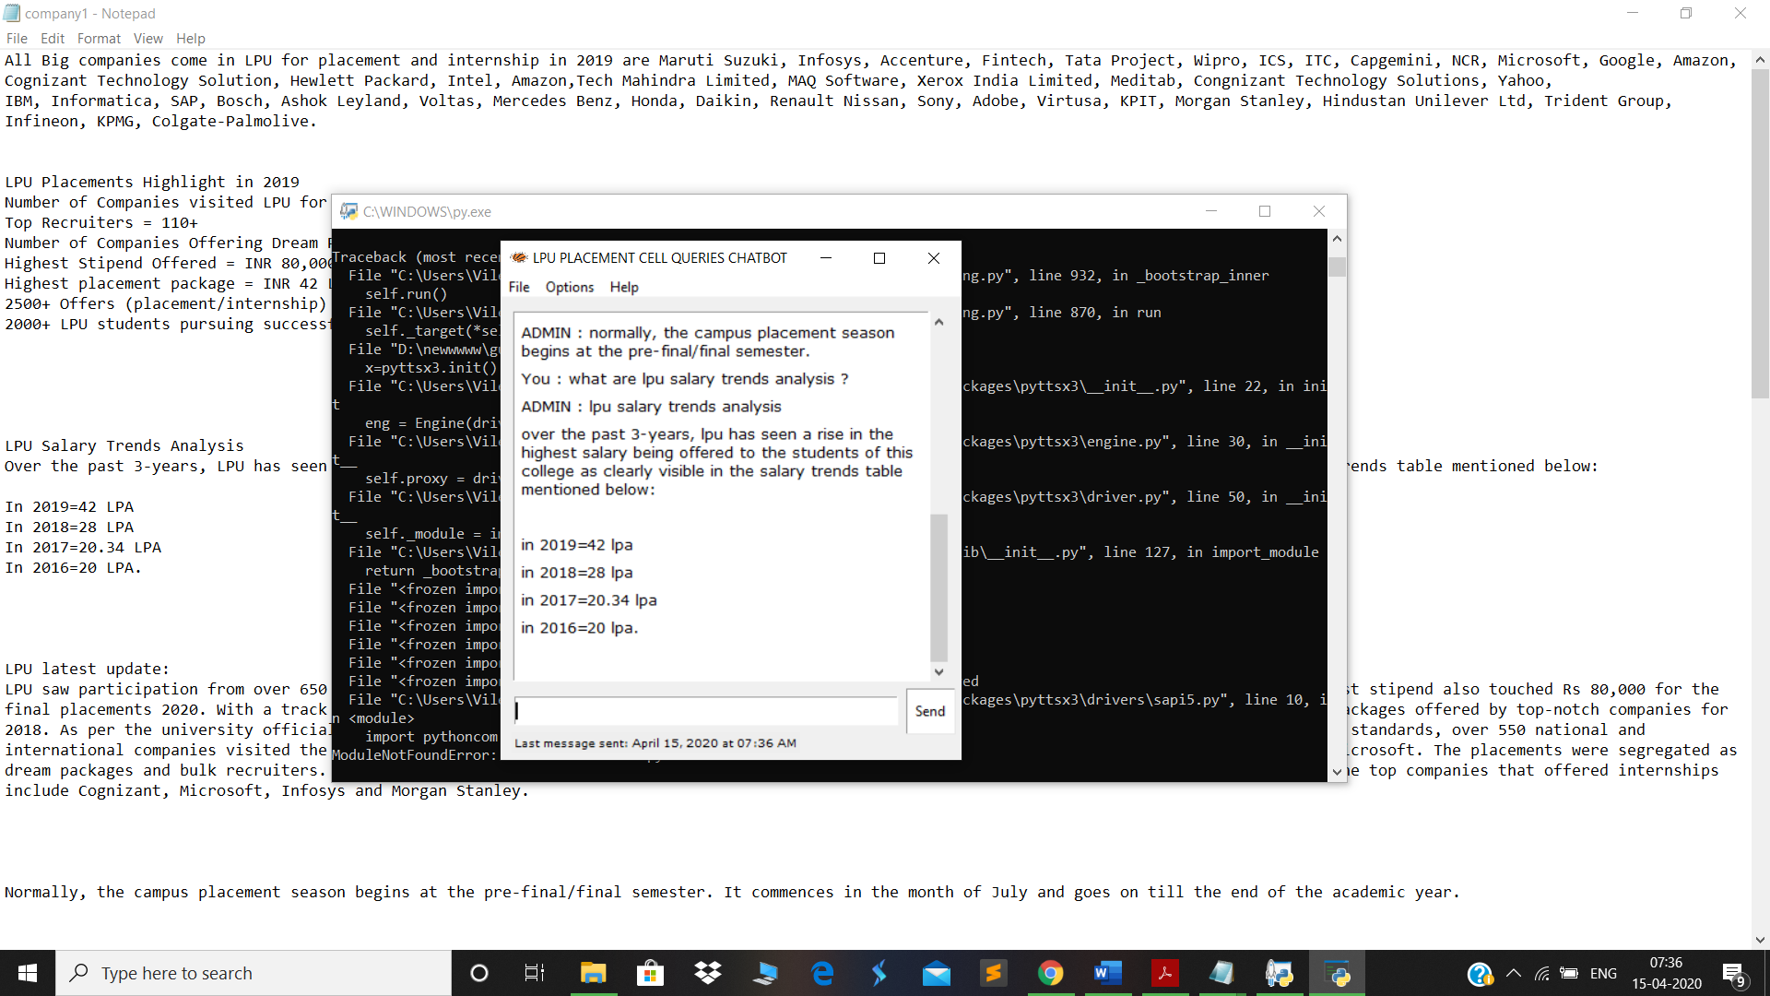

7. SWOT Analysis
Strength
- Code is precise and short
- Code is easy to understand
- Complexity of code is lesser than other methods used.
- Good interface

Weakness
- Can’t recognize little similar question precisely

Opportunities
- Can use this software at Placement Query
- Can be used as to reply general question without human interection.
- Augmented reality.
Threats
- This can be get confused
- This AI simply works on database, cannot learn (for example it can’t)
- Not easy to manage the database.
So, basically this particular type of chatbot can be used at smaller level where only human entry is needed and there’s small data. But it can exchange the person from computer bot to answer random question and help to do multitasking and save efforts of person to reply all the logic static message to share information to user.
8. SUMMARY
In this Python data science project, we understood about chatbots and implemented a deep learning version of a chatbot in Python which is accurate. You can customize the data according to business requirements and train the chatbot with great accuracy. Chatbots are used everywhere and all businesses is looking forward to implementing bot in their workflow.

