**Athul Test**

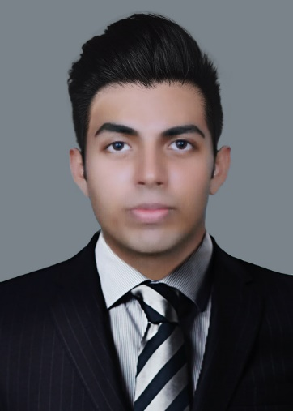

**file: {{ filename }}**

**Company: {{** **company_full_name }}**

**Company: {{ company_full_name }}**

**ciso: {{ ciso_name }}**

**HR: {{ hrman_name }}**

**Itsec: {{ itsec_name }}**

**It help: {{ ithelp_name }}**

**Ref: {{ doc_ref }}**