Faculty of Information Technology

Horizon Campus

2019

Rivindi Kaushini K. Ekanayake

IT2018020

Mrs Yasanthika Mathotaarachchi

IT20132

SOFTWARE DESIGN AND IMPLEMENTATION

ASSIGNMENT 01

# **Introduction**

# 

This report is makes for fulfill the purpose of identifying functionalities of a Library Management System and represent the proposed system interfaces for the requirements in the system as a system solution. In here I am clearly identifying and mentioned what are the main functionalities in the Library and what will be the system requirements for fulfill these functional activities.

I am providing the facilities through our system solution for main functionalities in the library such as login, member registration, book lending, returning books and searching books etc. I am describing deeply these functionalities and our system solutions for achieve these requirements through this report.

This report will give you a proper idea about my system and you can clearly identify whether this system give the proper solution for manage the library system in a good and required manner or not.

The front-end of the system will develop by using HTML and CSS markup languages and back-ends will develop by using php, C# and java. Developer is adding the figure explanations about all these front-end designs for this Library management system in this report and when you go through with this report deeply you will have the idea regarding system interface due to your required functionalities.

This Library Management System will be use to manage the Matara Public Library and all bellow functionalities identified by looking at the all activities done by the Library staff to conduct and manage the library. I hope that this system might be the best solution to maintain the all functionalities in the library without any doubt.

# **Main Functionalities in Library Management system.**

* Login to system
* Member registration
* Lending Books
* Returning Books
* Reserve books
* Search books
* Book registration.
* Book deletion.
* Remove a member.
* Edit member details.
* Search member.
* Inventory Management of books.
* Fine payment calculation.
* History of activity

## **Login to system**

In a library Management System there are can be many functionalities. As I identified Member login system is much efficient way to manage privileges of all users in the system.

Once we registered one member to the management system they will receive a Username and password. That username and password must be a unique one and it is need to login to the system. To do all the activities in the system each user must be log in to the system.

In this system there are three main roles Staff, VIP members and members because this is the main public library which used all the civilians in matara district. Most of professionals, School children and university students also use this library for their educational purposes. So this system must has ability to control all their activities and must to give privileges under control of the library staff. For success all these targets introducing a login system is the most efficient way. Because of that we had introduce that login system and after they log their accounts they will have their own account and through it they can do their own activities and they can check their past activities also.

Bellow figure display you the login interface which we introduced and by giving their own username and the password each user can log in to the system. If some person tries to log system without registration, he or she will receive a message as register first. For all registrations members should meet the librarian. Because member registration can only do library staff.

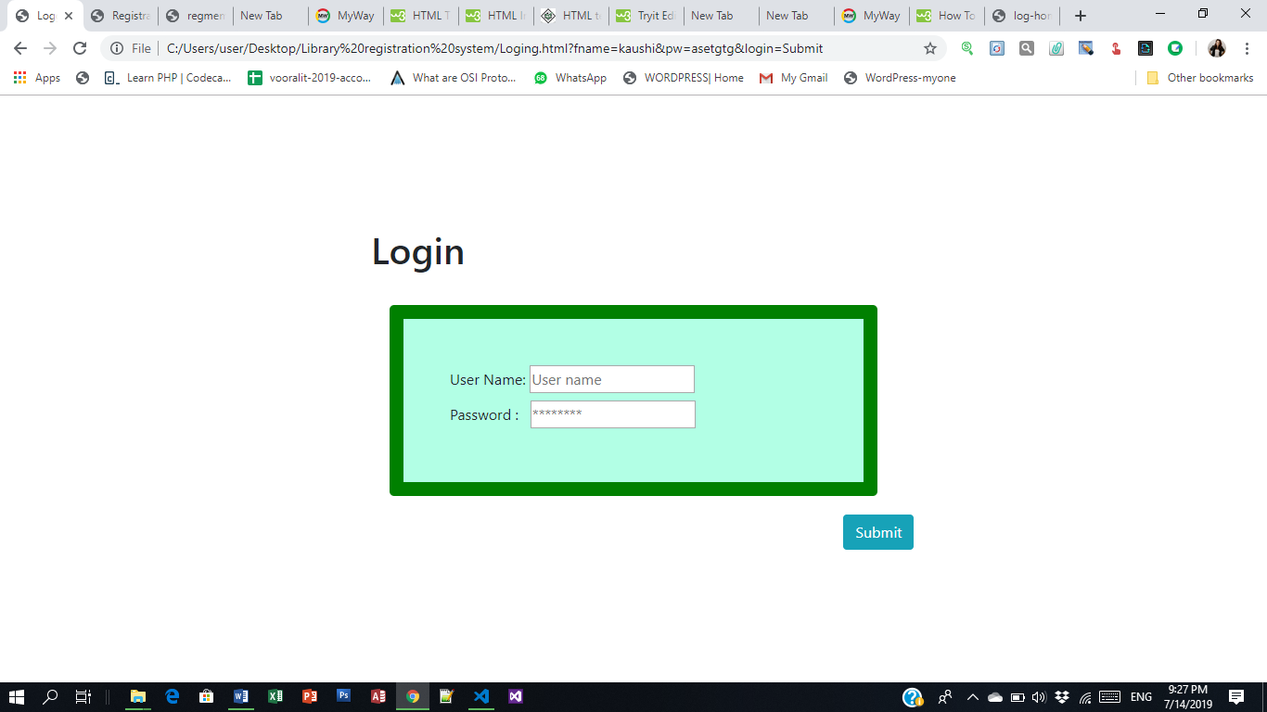

Figure 1-Login form interface