# **How Segment Works ( segment.com )**

**We can add Segment In our application to collect Customers data. Segment Collect Data According to the Segmentation Features for Email Marketing, Push Notifications, Advertising, Analytics and also it store all data in data warehouse.**

**In Here they Use 4 Main Apis To capture customers data.**

1. **Identify ( Who is the customer )**
2. **Track What customers are doing.**
3. **What Web Page they are on.**
4. **What app screen they are On.**

* **By Using this Segmentation We can Do Specific Campaign.**

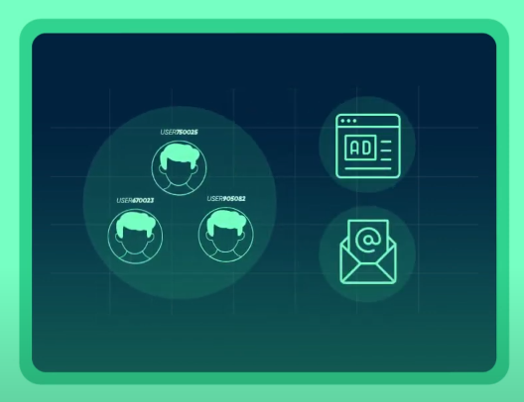

* **And also there is a feature to Record Screen Calls. We can Enable or disable Features Record in particular Screen. also we can track all customer actions on that enabled Screen.**

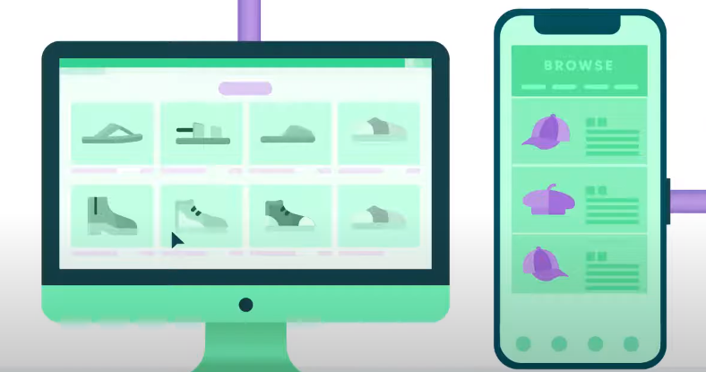

* **Other main Thing they use is Creating Personas. They Use a unique keys to identify each Customers. If some one update the profile they Update it using customers key.**

**Example: Below You can see All Customers are in California.**

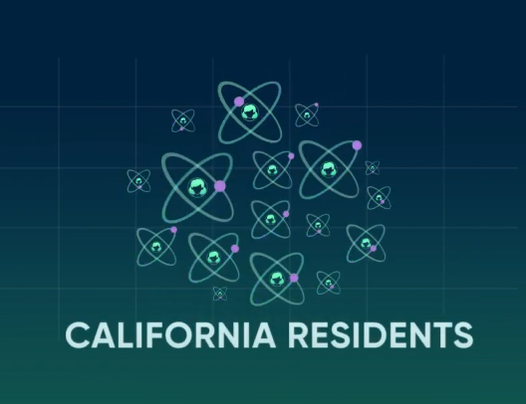

**If Someone visit a Product Page It Will Store in the segment.**

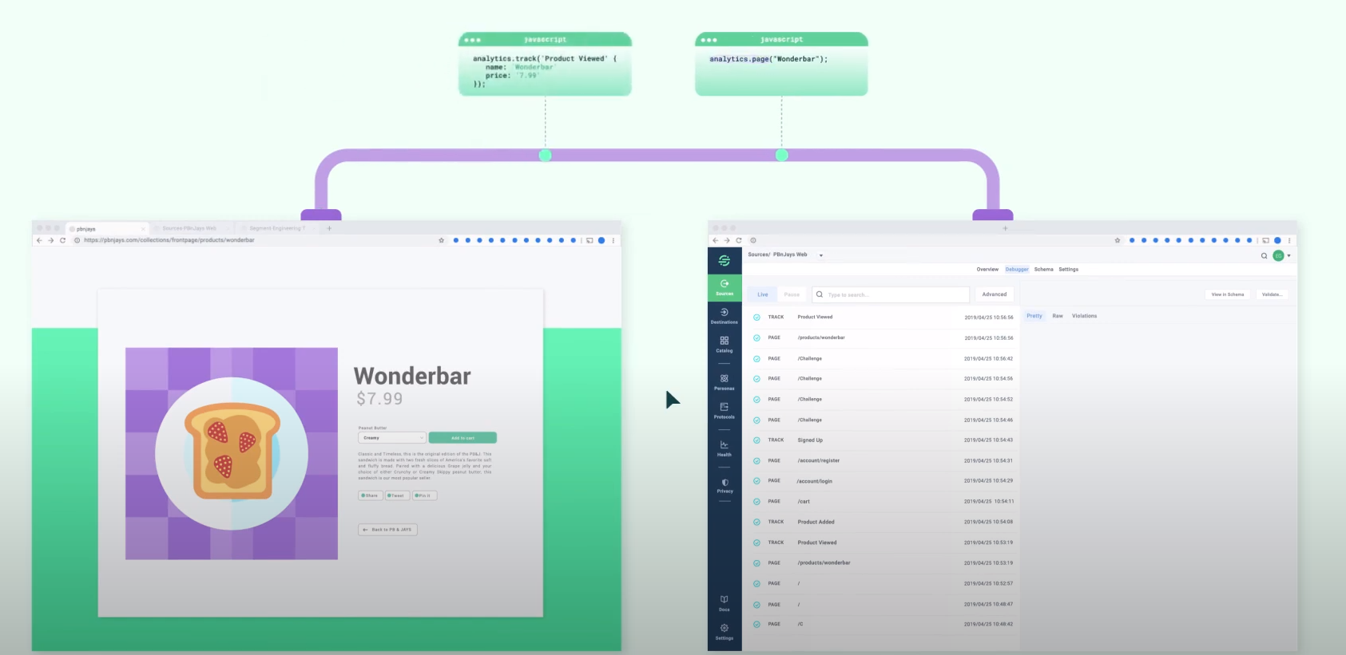

**Here All Records are store under that customer.**

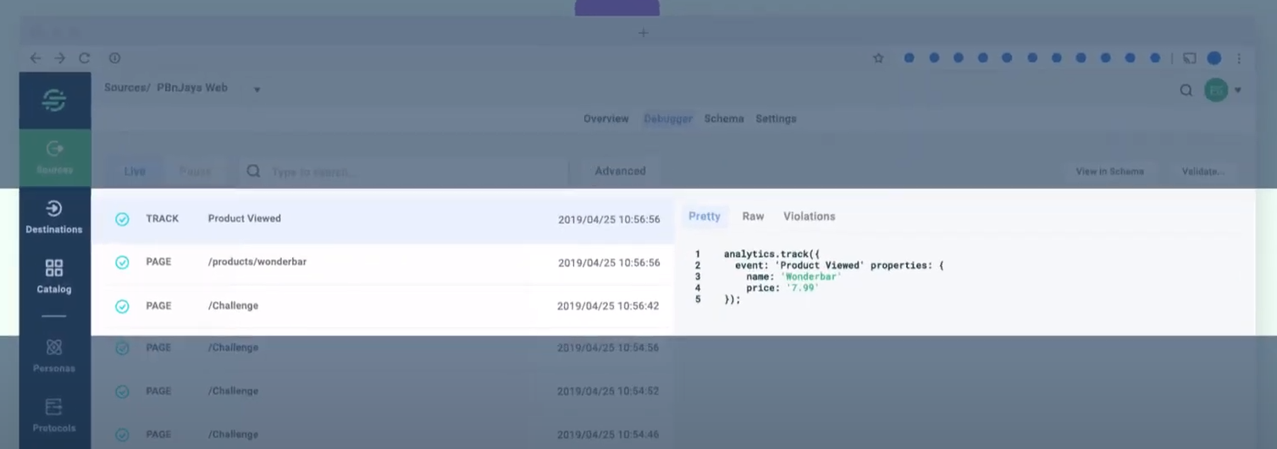

**They Provide a Dashboard To see All the Tasks Customers did.**

