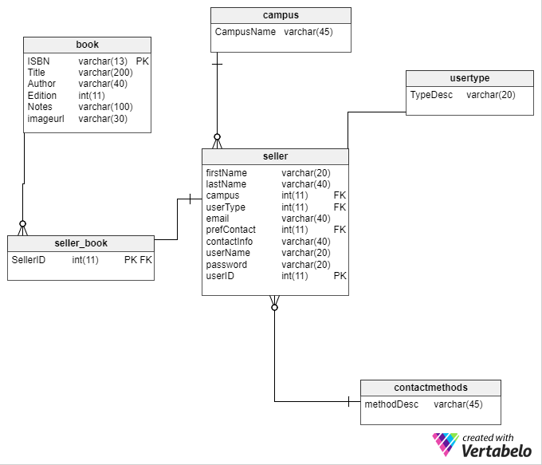

ISBN varchar(13) pk fk

1

4

6

5

3

2

As an introductory database, this database includes sellers and books. A book (1) has an isbn stored as a varchar because some isbns have an X char as their last digit. (representing 10). Although ISBNs are 10 or 13 characters, I allow for up to 13 characters in the database. The imageurl stores the location of the image in my website.

A seller includes a name, email and chosen contact method in lookup table. Email is used as a secondary pk. (Two users can’t use the same email address). Contact info stores information for the pref contact method.