Outline:

* **Filters** – Changing the way you see things
  + built in filters
  + Custom filters
* **ControllerAs** – how to use it and why (to get ready for angular2)
* **Services** – Five recipe flavors
* **Directives** – Extending HTML
* **ng-src**
* **scope**
  + $destroy
  + digest cycle
    - dirty check example
    - 10 times check
    - scope.$apply
    - stopWatch
    - Performance:

1. ::
2. $watch options
3. Try not to use watch value
4. $httpProvider.useApplyAsync(true); // default value is false
   * $emit <http://jsfiddle.net/shushanthp/zp6v0rut/>
   * $broadcast <https://docs.angularjs.org/guide/scope>
   * rootScope vs scope

* performance document attached

$watch:

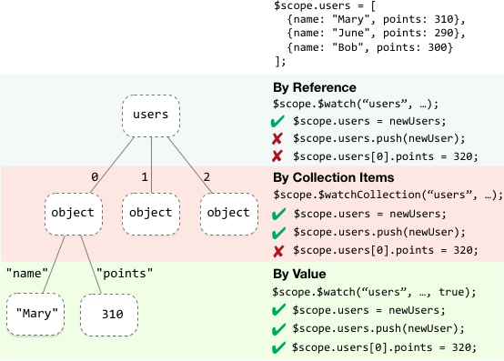

digest cycle:

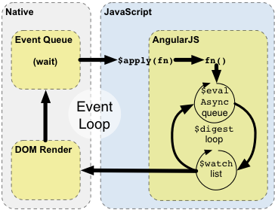

$emit:, $broadcast

