Structural Calculations

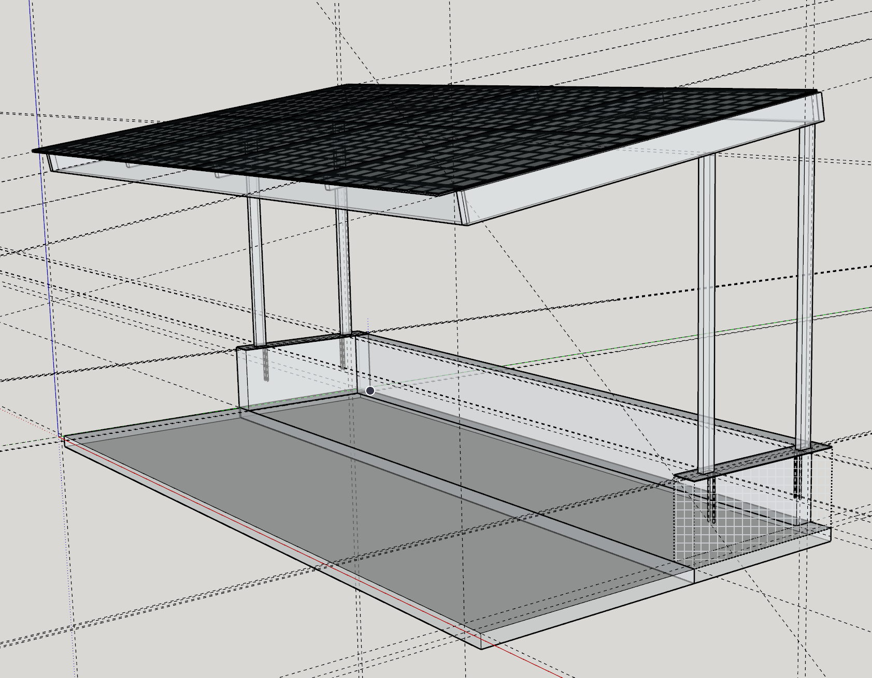
April 24, 2023
Solar Canopy  55 Loring Avenue, Mill Valley, CA 94901  Attn: Aaron Kahn  re: Building Permit |  | 
Rodney H. Holland MS, PE
15 Blanca Drive, Novato, California 94947 415-320-6017 rod.h.holland@gmail.com

