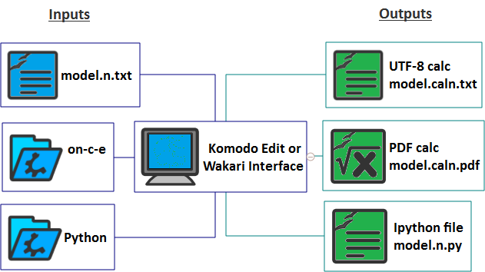
Komodo Edit or Wakari Interface
- UTF-8 calc model.caln.txt
- PDF calc model.caln.pdf
- Ipython file model.n.py
- Python
- on-c-e
- model.n.txt
- Inputs
- Outputs

