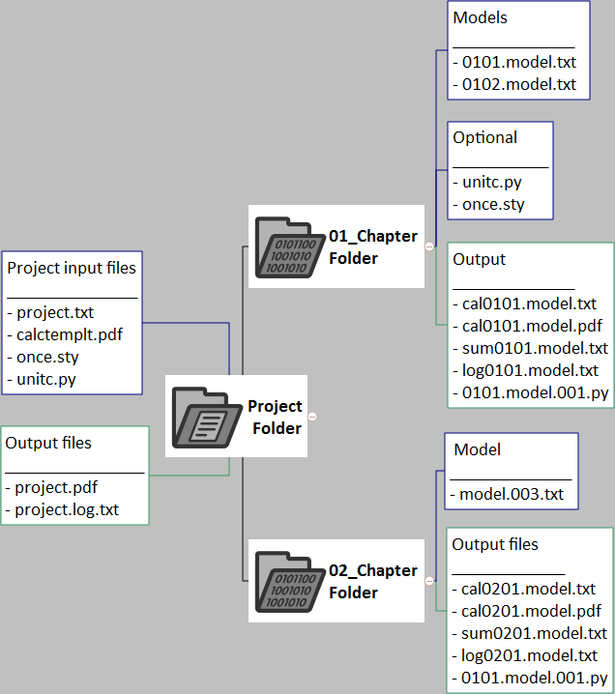
Project Folder
- 01_Chapter Folder
  - Models ______________ - 0101.model.txt - 0102.model.txt
  - Optional ___________ - unitc.py - once.sty
  - Output ______________ - cal0101.model.txt - cal0101.model.pdf - sum0101.model.txt - log0101.model.txt - 0101.model.001.py
- 02_Chapter Folder
  - Model ______________ - model.003.txt
  - Output files _____________ - cal0201.model.txt - cal0201.model.pdf - sum0201.model.txt - log0201.model.txt - 0101.model.001.py
- Output files ________________ - project.pdf - project.log.txt
- Project input files _______________ - project.txt - calctemplt.pdf - once.sty - unitc.py

