Main page html:

Main Page output:

CSS Code:

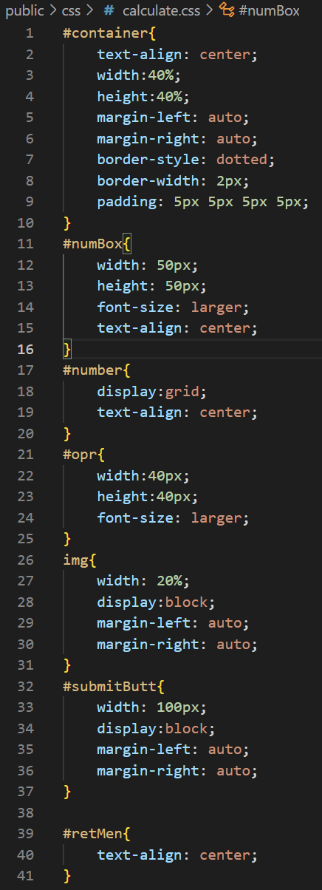

Calculator JS Code:

Result page HTML (I know this was not required but I added this route as well for practice):

Result page output:

