**Eldeler - Personalized e-butler for elderly**

**Overview and Problem:**

With Singapore’s growing aging population, its impact is already being felt. From diverting more resources to healthcare to having working adults support both the young (children) and the old (elderly), there is a pressing need for us to address the problems faced by an aging population.

We have recognized several issues that an elderly faces as they get older. Firstly, everyday activities can be cumbersome for them. A visit to the grocery store or a trip to the hospital can take significantly longer time than most of us. Secondly, most elderly are not tech savvy and it is difficult for them to discover find activities or like-minded individuals to socialise with. This may impact their mental health adversely since most of them spend their time alone at home. A local study published in June 2015 found that loneliness is associated with a higher mortality risk among the elderly in Singapore.[1]

Recognizing that elderly need more support from the society and that an active lifestyle is essential to their physical and mental health, we propose the Elderler software.

**Proposed solution:**

Our Elderler software is designed as an e-butler for elderly by seamlessly matching their needs to 3rd-party service providers. From groceries delivery, transport and medical assistance to discovering activities and like-minded people, Elderler helps elderly manage their day-to-day activities while allowing them to enrich their lives through various activities organized around Singapore.

Elderler can be used through a mobile application or a call to the call centre. Each elderly is assigned an account which can also be accessed by the caregiver or children of the elderly. The services are outsourced to the various service providers (including Accenture’s clients) who will handle the various services available on Elderler system. For instance, honestbee can deliver grocery while Grab/ Uber can assist with transportation. Partnerships can be formed to provide discounts to elderly who use Elderler. Also, through our “Discover” feature, elderly can discover various activities in the neighbourhood and sign up for it through us. We can partner with community clubs and travel agencies to organize activities suitable for elderly.

We acknowledge that the elderly may not be receptive to our Elderler software as it is difficult to overcome the inertia to make changes to their daily arrangements. Their reluctance to adopt Elderler despite the benefits it can bring will hamper the progress of Elderler. In view of that, we suggest having a mobile team of volunteers to assist the elderly during the early phase when Elderler is rolled out. By providing free door-to-door services to educate the elderly as well as their caregiver and/or next-of-kin, we would have a higher chance of getting the elderly to adopt Elderler, hence providing them with greater ease and convenience in the long run. Nonetheless, it is also crucial that the caregivers and/or next-of-kin are adept at using the software since they could be involved in the day-to-day activities of the elderly.

**Schematic diagram:**

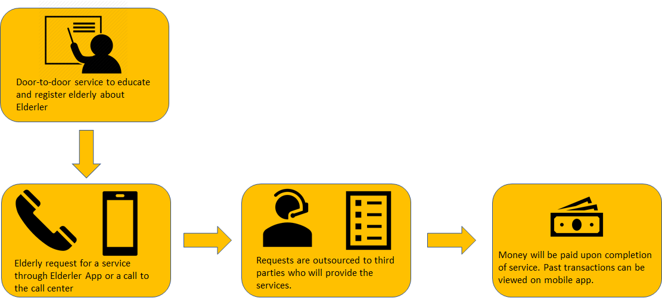

**Elderler software:**

|  |  |
| --- | --- |
| **Services provided under Elderler system:** | |
| Grocery and food delivery | Transport |
| General repair and maintenance of home | Medical assistance |
| Sign up for classes and activities in the neighbourhood | Laundry service |

Transactions will be made through our mobile app (escrowed until completion of service) or cash. Also, Elderler will adopt machine-learning technology to analyze past transactions and recommend future transactions (e.g purchase of certain item) or activities (e.g suggest cooking classes in the neighbourhood). This form of personalization ensures optimisation so that every elderly is well-taken care of under Elderler.

**Revenue:**

Our Elderler system adopts a commission-based revenue model, charging a fixed commission with our partnered service providers. By outsourcing these services instead of handling it ourselves, we are able to connect Accenture’s clients to a new customer segment, reduce our operating cost and ensure that the elderly will have their needs met professionally.

With the number of Singaporeans aged 65 and above projected to hit 900,000 by 2030[2] ( 1 in every 4 Singaporeans), we expect a nonlinear increase in demand for services provided by Elderler in the foreseeable future. Hence, we expect our revenue to increase in the long run in tandem with the growing elderly population. Furthermore, our low operating cost ensures that we are able to turn profitable in the first few years of operation.

**Social impact:**

By having an e-butler for every elderly, we hope to reduce reliance on their working children. While we acknowledge that all these services will incur additional expenses, the costs are relatively low and we believe that the benefits would outweigh the costs incurred.

Furthermore, through the “Discovery” feature in Elderler, the elderly are encouraged to sign up for activities and have more opportunities to meet like-minded individuals in the community. By promoting an active lifestyle, this would lead to an improvement in experienced well-being and life satisfaction for the elderly.

All in all, we believe that Elderler is a viable solution to the problems faced by an aging population given its ease of integration into the senior citizens’ life and that it will improve their quality of living while reducing their reliance on their working children.

Start:

· Stats about elderly (How many elderly living alone, With the number of Singaporeans aged 65 and above projected to hit 900,000 by 2030 ( 1 in every 4 Singaporeans),)

· Or make a connection with judges (e.g I’m sure some of us face it, having someone to buy grocery for your elderly parents or taking leave to take your parents to the clinic/hospital for checkup)

· Also, mention that a lot of elderly are alone and find it difficult to discover activities in Singapore or simply find like-minded individuals to hang out with.

This is when Elderler steps into play. Serving as a e-butler for elderly, we are a software/mobile app that helps elderly to be independent while allowing them to find friends and organize/join meetup groups. We aim to bridge the gap between elderly and service providers by matching their needs to the services provided. Some of the services included are grocery shopping, transport, laundry, medical assistance as well as general maintenance. Furthermore, Elderler allows elderly to discover activities happening around Singapore while allowing them to organize meetups.

- Elderler can be accessed through a mobile application or simply a call to the call centre where our team will help you arrange all the services.

- Machine learning can be adopted to understand elderly preference and provide personalization.

-

An active lifestyle is essential to their physical and mental health, and we believe that Elderler is the key to it.

QnA.

**Wouldn’t a maid replace the elderler, which is the norm in today’s society**

A: Yes, we agree that a maid helps to solve almost everything. But are you willing to pay over $1k for her salary, levy and her living expenses? And imagine that a maid has to push a wheelchair around the NTUC or wet market and carry home bags of stuff. Furthermore, a maid has off-days.

However we agree that a maid is essential for elderly who are unable to live on their own. Who we are targeting are elderly who are able to live independently but require assistance on certain household chores. Furthermore, since these activities are provided on a ad-hoc basis, the total cost are significantly lower than hiring a maid. Furthermore, we should be able to secure a discount for these elderly since we are opening up a new market segment for these service providers.

**How do you market these software or product. Many elderly are not receptive to technologies.**

A: At the early stage, we understand that there is resistance to such a software. What we plan to do is to hire volunteers, or part-timers to visit elderly home and educate them on such a service. As we build up our customer base, we believe that the word of mouth will help tremendously in increasing take-up rate. Furthermore, we can target working adults to manage the account for their elderly parents. The potential is limitless.

1. https://www.demographic-research.org/volumes/vol32/49/32-49.pdf
2. https://population.sg/articles/older-singaporeans-to-double-by-2030