Mutation-process priors calibrate protein language models for genotype-phenotype evolutionary forecasting
Hyoseok Jang,1, 2, * Sangchul Lee,1, * David S. Yang,3, * Haneol Cho,4 Cherlhyun Jeong,3, 5, † and Chansoo Kim1, 2, ‡
1 Computational Science Research Center, Korea Institute of Science and Technology (KIST), Seoul 02792, Republic of Korea
2 AI-Robot Department, University of Science and Technology (UST), Seoul 02792, Republic of Korea
3 Chemical and Biological Integrative Research Center, Korea Institute of Science and Technology, Seoul 02792, Republic of Korea
4 Computer Science and Engineering, Sejong University, Seoul 05006, Republic of Korea
5 Division of Bio-Medical Science & Technology, University of Science and Technology, Seoul 02792, Republic of Korea
(Dated: June 18, 2026)
Protein language models rank amino-acid substitutions by learned constraints on protein sequence and function, but natural variation first arises through stochastic nucleotide changes before selection acts on protein phenotypes. This genotype-phenotype mismatch can distort evolutionary forecasts when a predictor scores amino-acid outcomes but ignores the mutational process that makes those outcomes accessible. We introduce codon-aware constrained semantic change (CAC), a post-hoc calibration that augments protein-level semantic-change and grammaticality scores with a codon-transition prior inferred from mutation spectra. The prior is implemented as a continuous-time Markov process on nucleotides and requires no retraining or access to model internals. In a retrospective SARS-CoV-2 Spike benchmark used as a public, annotated evolutionary case study, CAC improves the ranking of published deep-mutational-scanning antibody-escape annotations across a specialized model and general-purpose ESM-2 protein language models, reducing the ESM-2-3B mean rank from 9130 to 5037 among 24,187 candidates. Varying the dimensionless Markov horizon reveals a crossover from local mutation-accessibility effects to broader protein-level constraints. These results frame mutation-process priors as an evolutionary calibration layer for learned protein representations, not as a procedure for designing or experimentally generating variants.

Introduction.- The last few years have made protein language models (PLMs) useful predictors of mutation effects, protein fitness, and annotated immune-escape phenotypes [1-5]. In this representation-centered view, a protein sequence is embedded in a learned space. A mutation is assigned a semantic-change score when it moves the sequence to a different region of that space, a proxy for altered phenotype or antigenic recognition, and a grammaticality score when the mutant sequence remains probable under the model, a proxy for protein viability. Constrained semantic change search (CSCS), for example, prioritizes substitutions that have large embedding displacement while retaining high model likelihood [4].
This amino-acid view is incomplete for evolutionary forecasting. Mutations arise stochastically in nucleotide space, are translated through the genetic code, and are then filtered by selection on protein-level phenotypes. Consequently, the likelihoods of protein substitutions are not uniform: two amino-acid changes with comparable semantic effects can have very different evolutionary accessibility because they require different codon transitions or exploit different nucleotide mutation biases [6-8]. Ignoring this mutational accessibility creates a model-process mismatch: the model evaluates phenotypes in amino-acid space, whereas evolution supplies variation in genotype space. The issue is general to genotype-phenotype forecasting and to other settings in which a learned representation scores possible outcomes while a biased stochastic process determines which outcomes are sampled first.
Here we convert that observation into a calibration rule. We add to PLM scores a codon-transition prior inferred from observed single-base substitution spectra [9]. The resulting score, codon-aware constrained semantic change (CAC), is post-hoc and model agnostic. It does not introduce a new evolutionary mechanism; rather, it places learned protein scores inside the long-standing mutation-selection view of coding-sequence evolution [6,7]. Because CAC only reweights an existing candidate list, it can be applied to a specialized PLM or to a frozen general-purpose foundation model without retraining, fine-tuning, or access to internal parameters. The central question is whether a codon-level accessibility prior improves retrospective phenotype ranking, and whether its importance changes as the transition kernel is widened from a local mutational neighborhood to a broader one.
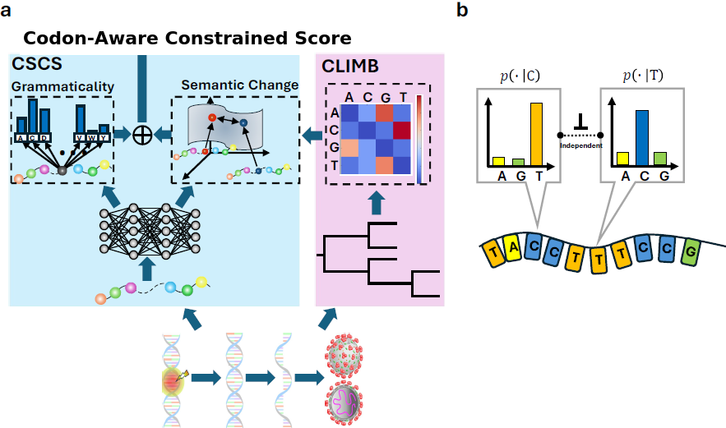
FIG. 1. Process-aware calibration of protein language models. A PLM scores candidate amino-acid substitutions by semantic change s_s, measured from distances between learned sequence embeddings, and grammaticality s_g, measured from model probability or pseudolikelihood. CAC augments this amino-acid objective with a codon-accessibility term s_p = log p_T computed from a nucleotide continuous-time Markov process. Empirical substitution spectra estimate the nucleotide generator Q; the genetic code maps this process to unequal probabilities for amino-acid substitutions. The calibration therefore reweights PLM rankings toward substitutions that are both protein-compatible and genetically accessible.
Codon-transition prior.- Our prior follows the same basic object used in classical codon-substitution and mutation-selection models: a nucleotide transition process projected through the genetic code [6,7]. Let B = {A, C, G, U} be the RNA alphabet and let a nucleotide evolve as a continuous-time Markov process with generator Q = (q_uv)_{u,v in B}. The transition probability from base u to base v over dimensionless Markov horizon T is [exp(TQ)]_uv. Here T is not calibrated calendar time; it controls the breadth of the mutational neighborhood represented by the prior. Assuming independent evolution of the three bases in a codon, the probability that a wild-type codon c = (c_1, c_2, c_3) produces amino acid a~ after horizon T is
p_T(a~ | c) = Σ_{c~: g(c~)=a~} Π_{k=1}^3 [exp(TQ)]_{c_k c~_k}, (1)
where g maps codons to amino acids. We estimate Q from published SARS-CoV-2 substitution counts by normalizing the empirical transition fluxes with base frequencies; details, the estimated matrix, and a context-dependence check are provided in the Supplemental Material. This case study uses a data-rich public sequence record, but the mathematical prior is a generic genotype-to-phenotype accessibility model.
For a candidate substitution at residue i, we combine this codon-likelihood Markov-bias accessibility term (CLIMB) with the PLM semantic-change and grammaticality scores,
S_CAC = α z(s_s) + β z(log s_g) + γ z(log p_T), α + β + γ = 1, (2)
where z(.) denotes standardization over all nonsynonymous single-nucleotide substitutions of the reference Spike sequence. Setting gamma = 0 recovers the amino-acid-only CSCS objective. Positive gamma adds the accessibility prior (with weight gamma) to the same candidate set, so CAC changes only the ranking, not the candidate space.
Retrospective phenotype ranking.- We evaluated CAC on all 24,187 nonsynonymous single-nucleotide substitutions of the SARS-CoV-2 Wuhan-Hu-1 Spike protein as a public genotype-phenotype benchmark. Protein-level scores were computed using the original Hie-BiLSTM model [4] and three ESM-2 backbones, ESM-2-150M, ESM-2-650M, and ESM-2-3B [5]. Validation sets were drawn from published deep mutational scanning (DMS) antibody-escape measurements [10] and from characteristic substitutions observed in major lineages. Performance was measured by the mean rank of these published annotations, with lower values corresponding to earlier retrospective recovery.
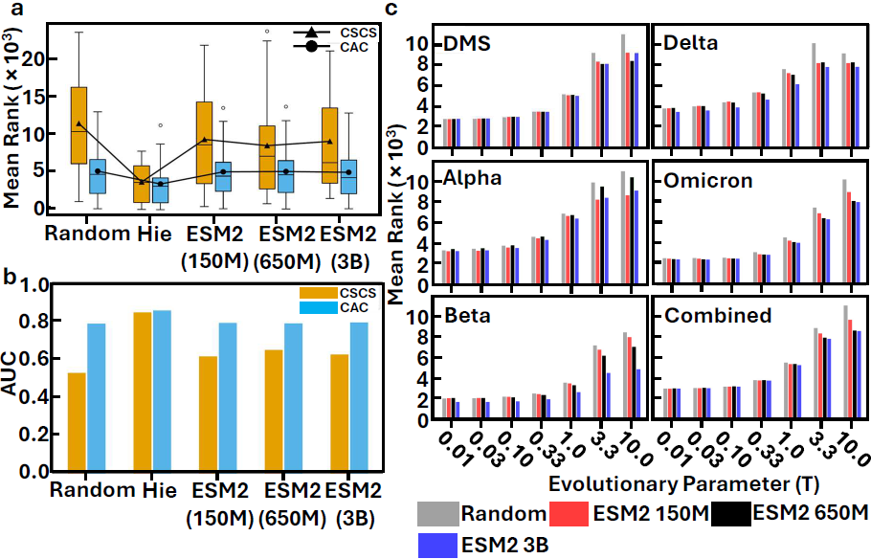
FIG. 2. Codon-aware calibration improves retrospective phenotype ranking. CAC is compared with the amino-acid-only CSCS baseline, a CLIMB-only ablation in which protein scores are randomized, and a random baseline. (a) On the DMS antibody-escape annotation set, CAC substantially lowers ranks for general-purpose ESM-2 models. (b) CAC also improves AUC across model backbones. (c) The dependence on dimensionless Markov horizon T shows that local-neighborhood rankings benefit most from the mutation-accessibility prior.
The codon-transition prior consistently improved retrospective ranking across PLM backbones and validation sets (Fig. 2). On the DMS set, CAC reduced the ESM-2-3B mean annotation rank from 9130 +/- 6500 to 5037 +/- 3586 (mean +/- s.d.; one-sided Wilcoxon signed-rank test, p = 0.0031). The same calibration improved ESM-2-150M from 9387 +/- 6127 to 5098 +/- 3667 and ESM-2-650M from 8562 +/- 6870 to 5143 +/- 3701. The specialized Hie-BiLSTM backbone showed a smaller change on DMS, 3757 +/- 2574 to 3493 +/- 2974, consistent with the possibility that a model trained on related evolutionary data already encodes part of the short-horizon mutational structure. Biologically, these shifts mean that published phenotype annotations are enriched among substitutions that are reachable by common nucleotide transitions; they should not be read as forecasts that any particular substitution will arise or spread.
The combined set of 60 DMS and lineage-associated substitutions gave the same qualitative result. CAC lowered the mean rank for Hie-BiLSTM from 6260 to 3841, for ESM-2-150M from 9816 to 5309, for ESM-2-650M from 8857 to 5327, and for ESM-2-3B from 8736 to 5204. The larger gain for Hie-BiLSTM on the combined set than on DMS alone is consistent with a simple distinction between assay-defined protein phenotypes and substitutions that also passed through real evolutionary sampling. Full tables, AUC values, and validation-set definitions are given in the Supplemental Material. The CLIMB-only ablation was also informative: on DMS it achieved a mean rank of 5100 +/- 184 across 100 randomizations of the PLM-derived terms, far below the random baseline of 12012 +/- 1588. This does not imply that nucleotide accessibility replaces protein constraints. Instead, it shows that the benchmark annotations are already strongly structured by the genotype-space process, while amino-acid PLM scores can miss that short-horizon structure unless it is supplied explicitly.
Horizon-dependent crossover.- The Markov horizon T in Eq. (1) controls how narrowly the prior favors locally reachable codon changes. At small T, high-probability single-base paths dominate; as T grows, probability mass spreads across more codons and the accessibility prior becomes less restrictive. Because T is not fitted to calendar time, the result should be interpreted as a comparison of local versus broadened mutational neighborhoods, not as a time-resolved epidemiological forecast. Optimizing the simplex weights in Eq. (2) revealed a systematic crossover between these regimes (Fig. 3). For the Hie-BiLSTM backbone on the DMS set, the optimal CLIMB weight was gamma = 0.5372 at T = 0.1 but dropped to gamma = 0.0652 at T = 3. Across backbones, small-T rankings were driven primarily by codon accessibility, whereas broader-horizon rankings shifted toward semantic change and grammaticality.
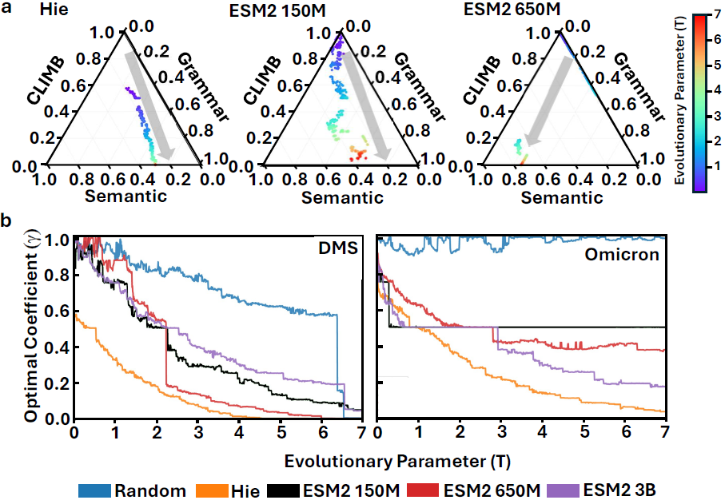
FIG. 3. Evolutionary horizon controls the mixture of process and protein information. Optimized weights (alpha, beta, gamma) shift systematically with dimensionless Markov horizon T. At small T, the CLIMB weight gamma is large, indicating strong local mutational accessibility. As T increases, gamma decreases and the PLM-derived semantic and grammatical terms carry more weight, although the accessibility prior remains part of the model.
This behavior has a natural evolutionary interpretation. In a local mutational neighborhood, the variants available to selection are strongly shaped by the nucleotide mutation process. As the neighborhood broadens, more codon paths become accessible and protein compatibility or antigenic change increasingly determines which substitutions remain plausible. The crossover also suggests how short-horizon accessibility can bias longer trajectories: readily accessible substitutions may populate local regions of genotype space before more distant, high-scoring phenotypes become reachable through multi-step paths. CAC makes this accessibility-constraint tradeoff explicit through an interpretable weight rather than burying it in a black-box predictor.
Discussion.- The main result is a simple evolutionary calibration: when a representation model scores outcomes in one space, forecasting should also account for the stochastic process that supplies variation in another. Amino-acid PLMs evaluate phenotypic consequences, whereas codon transitions define an unequal accessibility distribution over substitutions. Adding the latter as a post-hoc prior improved retrospective ranking of published phenotype annotations, especially for general-purpose PLMs that were not trained to encode short-horizon nucleotide biases. The contribution is not the idea that mutation and selection are coupled, which is foundational in evolutionary biology, but a practical way to couple that idea to black-box protein representations.
This framing also clarifies why a genomic or temporal model is a complement rather than an automatic replacement. A sequence-level evolutionary model could learn mutation process, sampling history, and selection jointly when sufficient aligned genomes and timestamps are available. CAC addresses a different use case: a protein model has already supplied phenotype-oriented scores, and a lightweight codon prior is needed to make those scores consistent with genotype-space accessibility. This separation makes the method portable across PLM backbones and testable against future genomic baselines.
Several limitations remain. The present benchmarks are retrospective and use published phenotype annotations or lineage-associated substitutions; strict held-out time-split evaluations would be needed for any prospective scientific claim. The current prior is also intentionally minimal: it assumes independent sites and uses a context-averaged substitution process. Context-dependent nucleotide models, lineage-specific spectra, multi-step paths, and epistatic protein constraints can all be incorporated into the same modular form. We also do not provide experimental procedures, recommend construction of candidate variants, or claim operational prediction of future variants. The broader lesson is sharper than a restatement of mutation-selection theory: learned protein representations become more interpretable and biologically faithful when their scores are explicitly calibrated to the stochastic evolutionary process that generates the genotypes on which selection acts.
This work is supported by grant Nos. 2023-00262155 (AIDE), 2024-00460980 (deFAI), and 2025-02304717 ((AI)2) from IITP; 2025R1A5A1031234 and 2021R1A2C1095046 from NRF; and RS-2023-00266133 from the Korea Health Technology R&D Project, all funded by the Korean government. We also acknowledge institutional support from KIST.
DATA AND CODE AVAILABILITY
Source code and data are available at https://github.com/sos440/climb and archived on Zenodo at https://doi.org/10.5281/zenodo.15744443.
* These authors contributed equally.
† che.jeong@kist.re.kr
‡ eau@ust.ac.kr
[1] A. J. Riesselman, J. B. Ingraham, and D. S. Marks, Deep generative models of genetic variation capture the effects of mutations, Nat. Methods 15, 816 (2018).
[2] A. Rives, J. Meier, T. Sercu, S. Goyal, Z. Lin, and J. e. a. Liu, Biological structure and function emerge from scaling unsupervised learning to 250 million protein sequences, Proc. Natl. Acad. Sci. U. S. A. 118, e2016239118 (2021).
[3] J. Meier, R. M. Rao, R. Verkuil, and T. Sercu, Language models enable zero-shot prediction of the effects of mutations on protein function, Nat. Biotechnol. 40, 1024 (2022).
[4] B. Hie, E. D. Zhong, B. Berger, and B. Bryson, Learning the language of viral evolution and escape, Science 371, 284 (2021).
[5] Z. Lin, H. Akin, R. Rao, B. Hie, Z. Zhu, W. Lu, N. Smetanin, R. Verkuil, O. Kabeli, Y. Shmueli, et al., Evolutionary-scale prediction of atomic-level protein structure with a language model, Science 379, 1123 (2023).
[6] A. L. Halpern and W. J. Bruno, Evolutionary distances for protein-coding sequences: modeling site-specific residue frequencies, Mol. Biol. Evol. 15, 910 (1998).
[7] N. Rodrigue, H. Philippe, and N. Lartillot, Mutation-selection models of coding sequence evolution with site-heterogeneous amino acid fitness profiles, Proc. Natl. Acad. Sci. U. S. A. 107, 4629 (2010).
[8] S. Duffy, Why are RNA virus mutation rates so damn high?, PLOS Biology 16, 1 (2018).
[9] K. Yi, S. Y. Kim, T. Bleazard, T. Kim, J. Youk, and Y. S. Ju, Mutational spectrum of SARS-CoV-2 during the global pandemic, Experimental & Molecular Medicine 53, 1229 (2021).
[10] A. Baum, B. O. Fulton, E. Wloga, R. Copin, K. E. Pascal, V. Russo, S. Giordano, K. Lanza, N. Negron, M. Ni, et al., Antibody cocktail to SARS-CoV-2 spike protein prevents rapid mutational escape seen with individual antibodies, Science 369, 1014 (2020).

