AI Marketing Assistant for Startup Founders
System Architecture Document
Incubation Internship Project

Prepared by: Riya Shende & Team
Version: 1.0
Date: August 2, 2026
Companion to: Software Requirements Specification v1.0

Table of Contents

1. Introduction and Purpose
This document describes the technical architecture of the AI Marketing Assistant's Marketing AI Module: how the client, backend, AI agents, and external providers fit together, how data flows between them, and the key design decisions the team should hold to during the 20-day build. It complements the SRS by answering "how," not "what."

2. Architectural Goals and Constraints
- Modularity: each agent is a single-responsibility unit with its own prompt, independently testable and replaceable.
- Provider independence: no agent should hard-code a specific LLM or video vendor.
- 20-day feasibility: architecture favours boring, fast-to-implement choices over ambitious infrastructure.
- Small-team friendliness: a 2–3 person team must be able to build, debug, and deploy this without a dedicated DevOps engineer.

3. High-Level Architecture
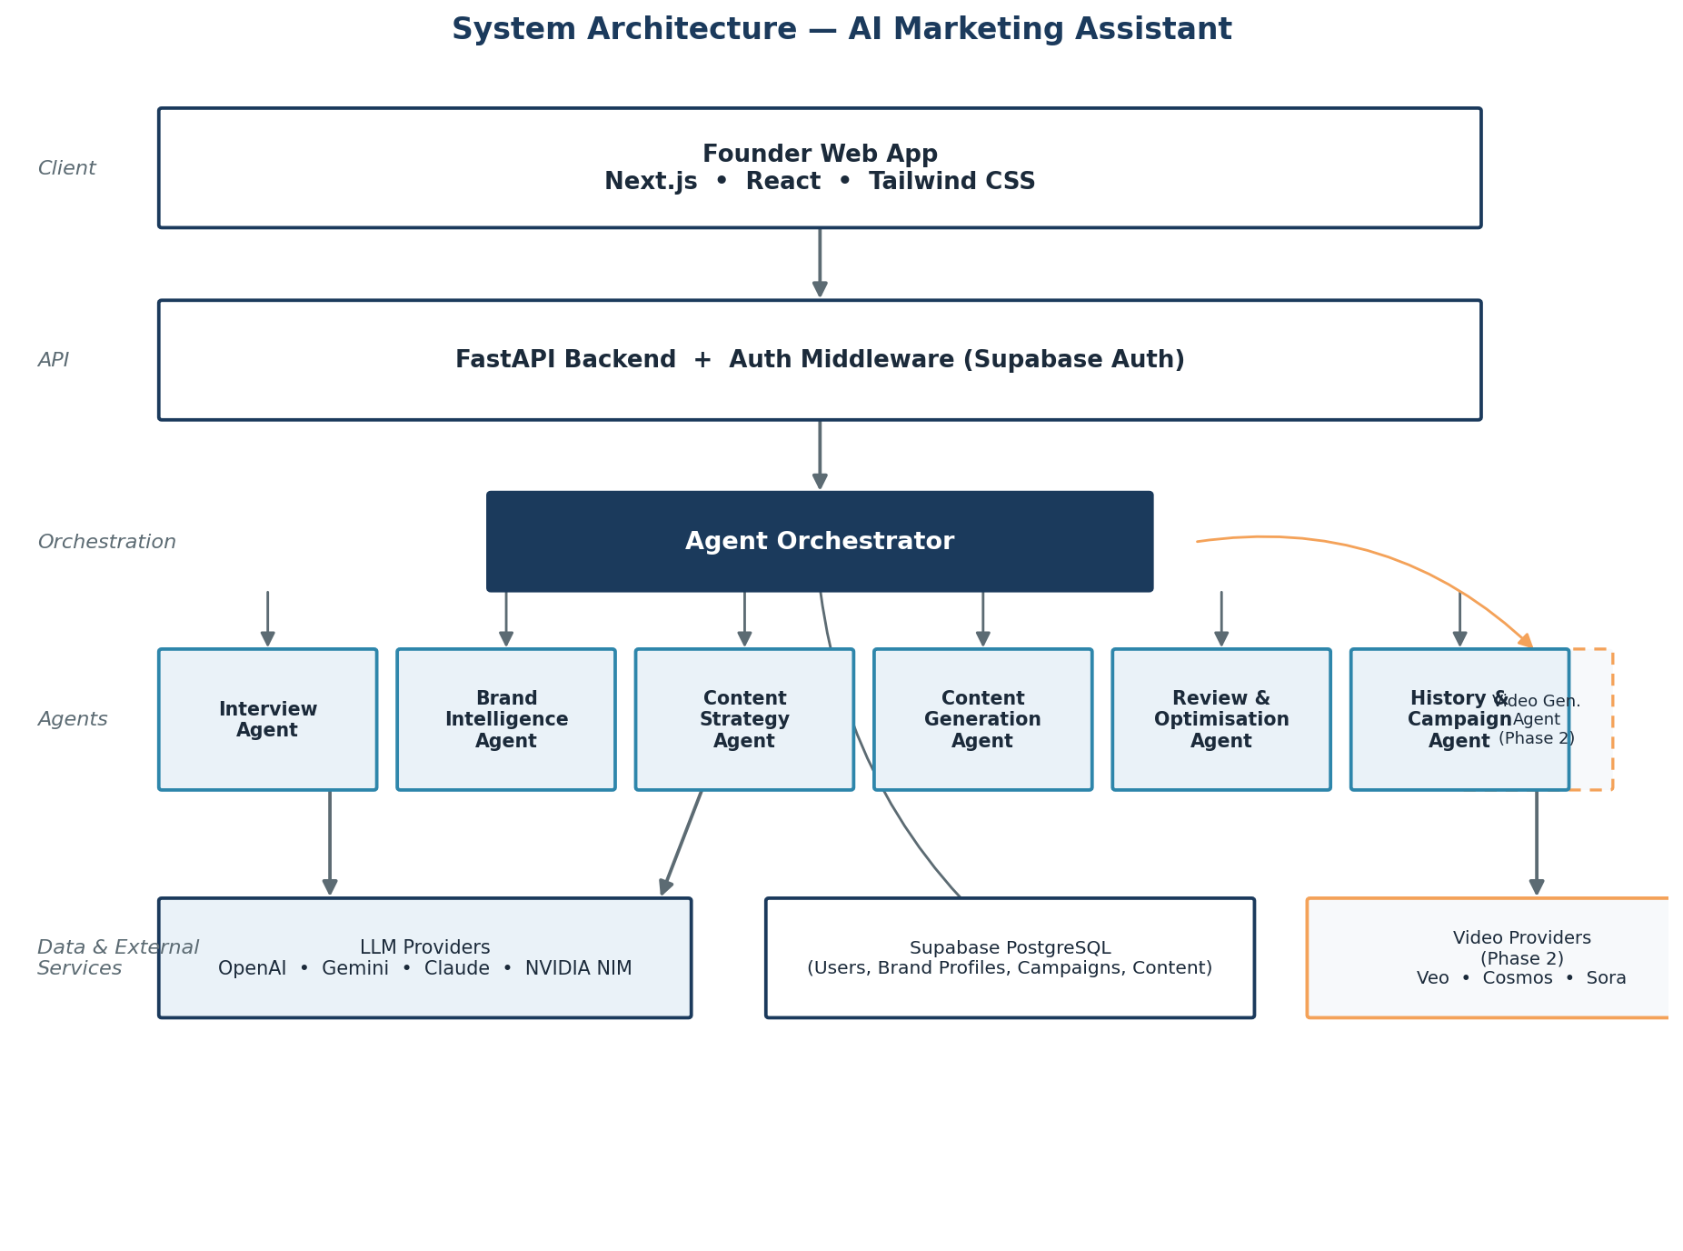
Figure 1: System architecture — client, API, agent orchestration, external providers, and data layer.
The Next.js frontend talks only to the FastAPI backend, never directly to LLM or video providers — this keeps API keys server-side and lets the team change providers without touching the client. The FastAPI layer authenticates every request via Supabase Auth middleware, then routes it to an Agent Orchestrator, which is simply the backend logic that calls each agent in sequence and passes state between them. Agents call out to LLM providers through a shared internal wrapper. All persistent data lives in Supabase PostgreSQL.

4. Agent Architecture
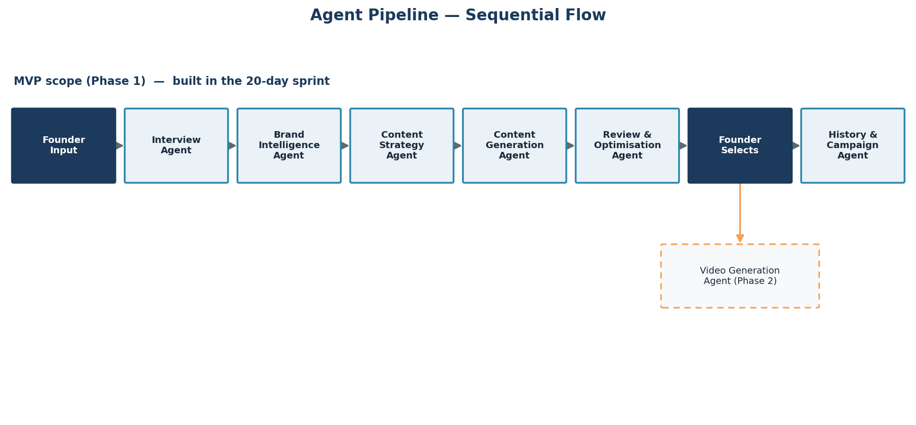
Figure 2: Sequential agent pipeline for the Phase 1 (MVP) flow, with the Phase 2 video branch shown for context.
Agent | Input | Output | Phase
Interview | Founder chat responses | Structured founder/startup data | 1
Brand Intelligence | Structured founder data | Brand Profile (voice, tone, USP, keywords) | 1
Content Strategy | Brand Profile + founder goal | Chosen content type + angle | 1
Content Generation | Content type + Brand Profile | 3–5 content variations per platform | 1
Review & Optimisation | Selected content variation | Quality/consistency notes | 1
History & Campaign | Finalised content | Stored campaign record | 1
Video Generation | Selected content + video preferences | Storyboard, script, provider video output | 2

5. Orchestration Strategy

5.1 Recommendation for the 20-Day Sprint
Use plain sequential orchestration inside FastAPI: each agent is a Python function (or small class) with its own system prompt, called in order by a single orchestrator function, with intermediate state passed as typed objects and persisted to the database between steps. This is deliberately simple.

5.2 Why Not a Full Agent Framework Yet
- Frameworks like LangGraph or CrewAI add real value once agents need dynamic branching, retries, or parallel tool use — the Phase 1 flow is a straight line, so that value is limited today
- A new framework is another thing to learn and debug inside a 20-day window
- Plain function calls are easier for a small team to trace and fix when an LLM response goes wrong
Forward-compatible, not a dead end
Keep each agent's interface narrow (typed input in, typed output out). If Phase 2 introduces branching — e.g., choosing between video providers, retrying failed generations — the same agent functions can be dropped into LangGraph or CrewAI later with minimal rewrite.

6. Data Flow
A founder's first session flows: sign up → Interview Agent collects structured data → Brand Intelligence Agent produces a Brand Profile, stored once and reused thereafter → on each content request, Content Strategy Agent picks a content type → Content Generation Agent produces variations using the stored Brand Profile as context → Review & Optimisation Agent checks the founder's selected variation → History & Campaign Agent persists the final content under a campaign record. Every step after the Brand Profile is generated reads that profile rather than re-deriving it, which keeps generation fast and consistent.

7. Technology Stack
Layer | Technology | Rationale
Frontend | Next.js, React, Tailwind CSS | Fast to build responsive UI; large ecosystem; matches original plan
Backend | FastAPI (Python) | Async-friendly, quick to wire to LLM SDKs, minimal boilerplate
Auth | Supabase Auth | Managed auth with Row-Level Security integration, no custom auth server needed
Database | Supabase PostgreSQL | Managed Postgres with built-in RLS, generous free tier for an MVP
LLM providers | OpenAI / Gemini / Claude / NVIDIA NIM (behind a wrapper) | Provider-agnostic; NIM useful for free/open-source models during development
Video providers (Phase 2) | Google Veo, NVIDIA Cosmos, Sora (if available) | Modular, swappable, allows side-by-side comparison
Automation (optional) | n8n | Orchestrates notifications/emails around the app; does not replace backend logic

8. API Design (Key Endpoints)
Method | Path | Purpose
POST | /auth/signup | Create a founder account
POST | /auth/login | Authenticate and issue a session
POST | /interview/message | Send/receive one turn of the interview chat
GET | /interview/session/{id} | Resume an in-progress interview
POST | /brand-profile/generate | Generate a Brand Profile from interview data
GET/PUT | /brand-profile/{id} | Fetch or edit a Brand Profile
POST | /content/strategy | Get a suggested content type
POST | /content/generate | Generate content variations
POST | /content/select | Mark a variation as selected and trigger review
GET | /campaigns | List a founder's campaigns
GET | /campaigns/{id} | Fetch one campaign's content
POST | /video/generate | (Phase 2) Request a video for a content piece

9. Third-Party Integrations
Both LLM and video providers sit behind a thin internal interface (e.g., a generate_text(prompt, config) and generate_video(prompt, config) function) so the concrete vendor is a configuration choice, not a code path. This directly supports FR requirements around provider independence and lets the team start on NVIDIA NIM or another free-tier LLM during development, then switch providers for production without touching agent code.

10. Security and Privacy Considerations
- All traffic served over HTTPS
- LLM/video provider API keys stored as backend environment variables, never exposed to the client
- Supabase Row-Level Security policies scope every table so a founder can only read/write their own rows
- Basic input sanitisation before content is inserted into LLM prompts, to reduce prompt-injection risk from pasted founder text
- Rate limiting on generation endpoints to control cost and abuse

11. Scalability and Future Considerations
- Brand Profile data can be cached per founder to cut redundant LLM calls
- Video generation (Phase 2) is a natural candidate for an async job queue, since providers can take longer than a typical request timeout
- FastAPI services are stateless and can scale horizontally behind a load balancer if usage grows across the incubation cohort
- An analytics pipeline (Phase 2) can be added as a separate read-only service over the same database without touching the agent pipeline

