AI Marketing Assistant for Startup Founders
Database Design Document
Incubation Internship Project

Prepared by: Riya Shende & Team
Version: 1.0
Date: August 2, 2026
Companion to: System Architecture Document v1.0

Table of Contents

1. Introduction
This document defines the persistent data model for the Marketing AI Module: the tables, their fields, and the relationships between them. It is the reference the backend team should build migrations from, and it should stay in sync with the actual Supabase schema as the build progresses.

2. Design Principles
- Every table that holds founder data carries a user_id foreign key so Supabase Row-Level Security can restrict access to the owning founder
- One Brand Profile can back many campaigns; one campaign can hold many content pieces — a straightforward one-to-many chain that mirrors the agent pipeline
- Feedback is logged at the content-piece level so future prompts can adapt to a founder's preferred style without training a new model (see SRS §2.6 and the original planning document's reinforcement-learning discussion)
- Phase 2 tables (video_requests) are included now so the schema does not need breaking changes later

3. Entity-Relationship Diagram
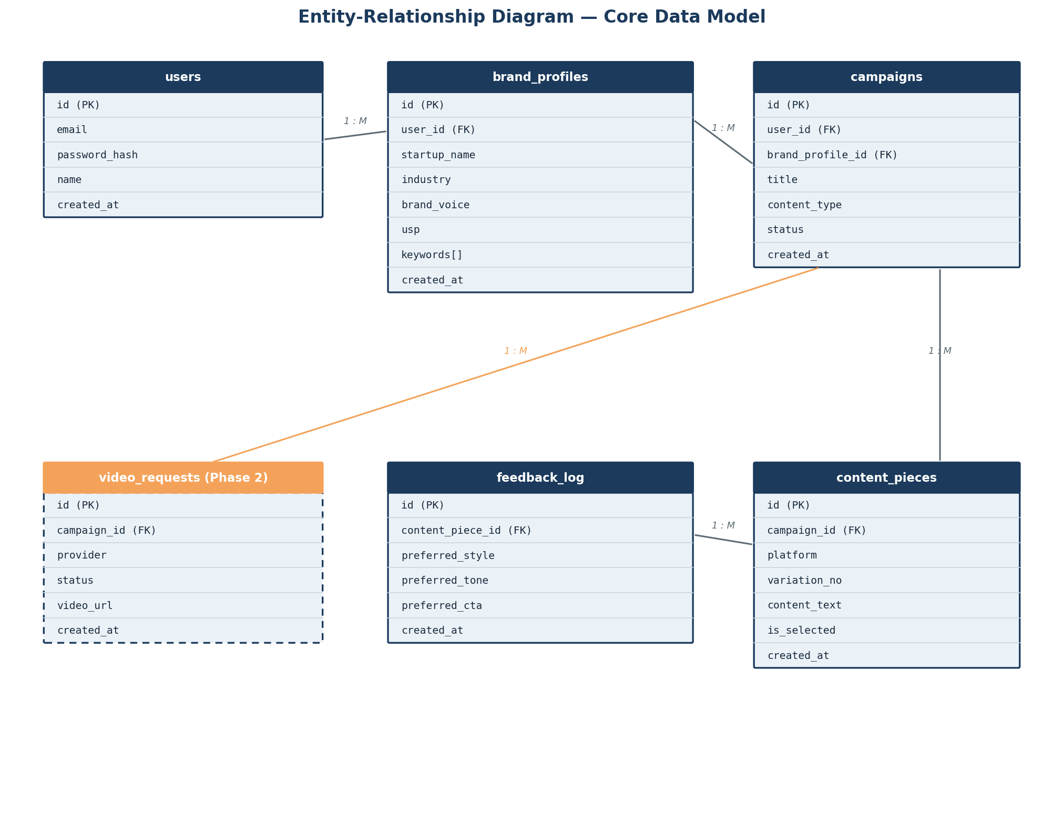
Figure 1: Core data model. Dashed box = Phase 2 table.

4. Table Definitions

4.1 users
Column | Type | Constraints | Description
id | uuid | PK, default gen_random_uuid() | Managed by Supabase Auth
email | text | unique, not null | Founder login email
password_hash | text | managed by Supabase Auth | Never accessed directly by app code
name | text | nullable | Display name
created_at | timestamptz | default now() | Account creation time

4.2 brand_profiles
Column | Type | Constraints | Description
id | uuid | PK | Unique profile id
user_id | uuid | FK → users.id, not null | Owning founder
startup_name | text | not null | Name of the startup
industry | text | nullable | Startup's industry/sector
brand_voice | text | nullable | e.g. "Friendly, Professional, Innovative"
tone | text | nullable | Preferred communication tone
core_values | text | nullable | Free-text summary of values
usp | text | nullable | Unique selling proposition
keywords | text[] | nullable | Array of brand keywords
avoid_list | text[] | nullable | Words/phrases to avoid
created_at | timestamptz | default now() | First generated
updated_at | timestamptz | default now() | Last edited/regenerated

4.3 campaigns
Column | Type | Constraints | Description
id | uuid | PK | Unique campaign id
user_id | uuid | FK → users.id, not null | Owning founder
brand_profile_id | uuid | FK → brand_profiles.id, not null | Brand context used
title | text | nullable | Founder-facing campaign label
content_type | text | not null | e.g. Product Launch, Founder Story
status | text | default 'draft' | draft | finalised
created_at | timestamptz | default now() | Creation time

4.4 content_pieces
Column | Type | Constraints | Description
id | uuid | PK | Unique content id
campaign_id | uuid | FK → campaigns.id, not null | Parent campaign
platform | text | not null | linkedin | instagram | x
variation_no | int | not null | 1–5, which generated variation
content_text | text | not null | Generated copy
cta | text | nullable | Call to action used
is_selected | boolean | default false | Founder's chosen variation
created_at | timestamptz | default now() | Generation time

4.5 feedback_log
Column | Type | Constraints | Description
id | uuid | PK | Unique feedback id
user_id | uuid | FK → users.id, not null | Founder whose preference is logged
content_piece_id | uuid | FK → content_pieces.id, not null | Which piece was preferred
preferred_style | text | nullable | Style signal for future prompts
preferred_tone | text | nullable | Tone signal for future prompts
preferred_cta | text | nullable | CTA signal for future prompts
created_at | timestamptz | default now() | Logged time

4.6 video_requests (Phase 2)
Column | Type | Constraints | Description
id | uuid | PK | Unique request id
campaign_id | uuid | FK → campaigns.id, not null | Source campaign/content
provider | text | not null | veo | cosmos | sora
status | text | default 'pending' | pending | processing | done | failed
storyboard | jsonb | nullable | Scene descriptions, voice-over script
video_url | text | nullable | Final rendered video location
created_at | timestamptz | default now() | Request time

5. Relationships Summary
Parent | Child | Cardinality | On Delete
users | brand_profiles | 1 : M | cascade
brand_profiles | campaigns | 1 : M | restrict
users | campaigns | 1 : M | cascade
campaigns | content_pieces | 1 : M | cascade
content_pieces | feedback_log | 1 : M | cascade
campaigns | video_requests (Phase 2) | 1 : M | cascade

6. Indexing and Performance Notes
- Index every foreign key column (user_id, brand_profile_id, campaign_id, content_piece_id) — these back nearly every query
- Composite index on campaigns(user_id, created_at desc) to make the History screen's default sort fast
- content_pieces(campaign_id, is_selected) speeds up fetching a campaign's chosen content

7. Data Retention and Privacy Notes
- Founders can delete a Brand Profile or campaign; cascading deletes remove dependent content and feedback rows automatically
- No table stores raw LLM/video provider API keys — those live only in backend environment configuration
- Row-Level Security policies should be written and tested before any real founder data is entered, not added later

