AI Marketing Assistant for Startup Founders
UI/UX Design Document
Incubation Internship Project

Prepared by: Riya Shende & Team
Version: 1.0
Date: August 2, 2026
Companion to: System Architecture Document v1.0

Table of Contents

1. Introduction and Design Principles
This document describes the founder-facing experience: the overall flow, each key screen, navigation, and the visual system that ties them together. It is meant to guide frontend build decisions, not to replace high-fidelity mockups — screens are described in enough structural detail (layout, key elements, states) that they can be built directly in Tailwind, or first sketched in Figma if the team prefers.
- Conversation-first: the interview replaces long forms; founders talk, the system structures.
- Minimal friction: no screen should require more than a few taps/fields before showing progress.
- Brand-aware: once a Brand Profile exists, its voice and keywords should visibly shape what the founder sees generated.
- Mobile-responsive: many founders will check content on their phone between meetings.

2. User Flow
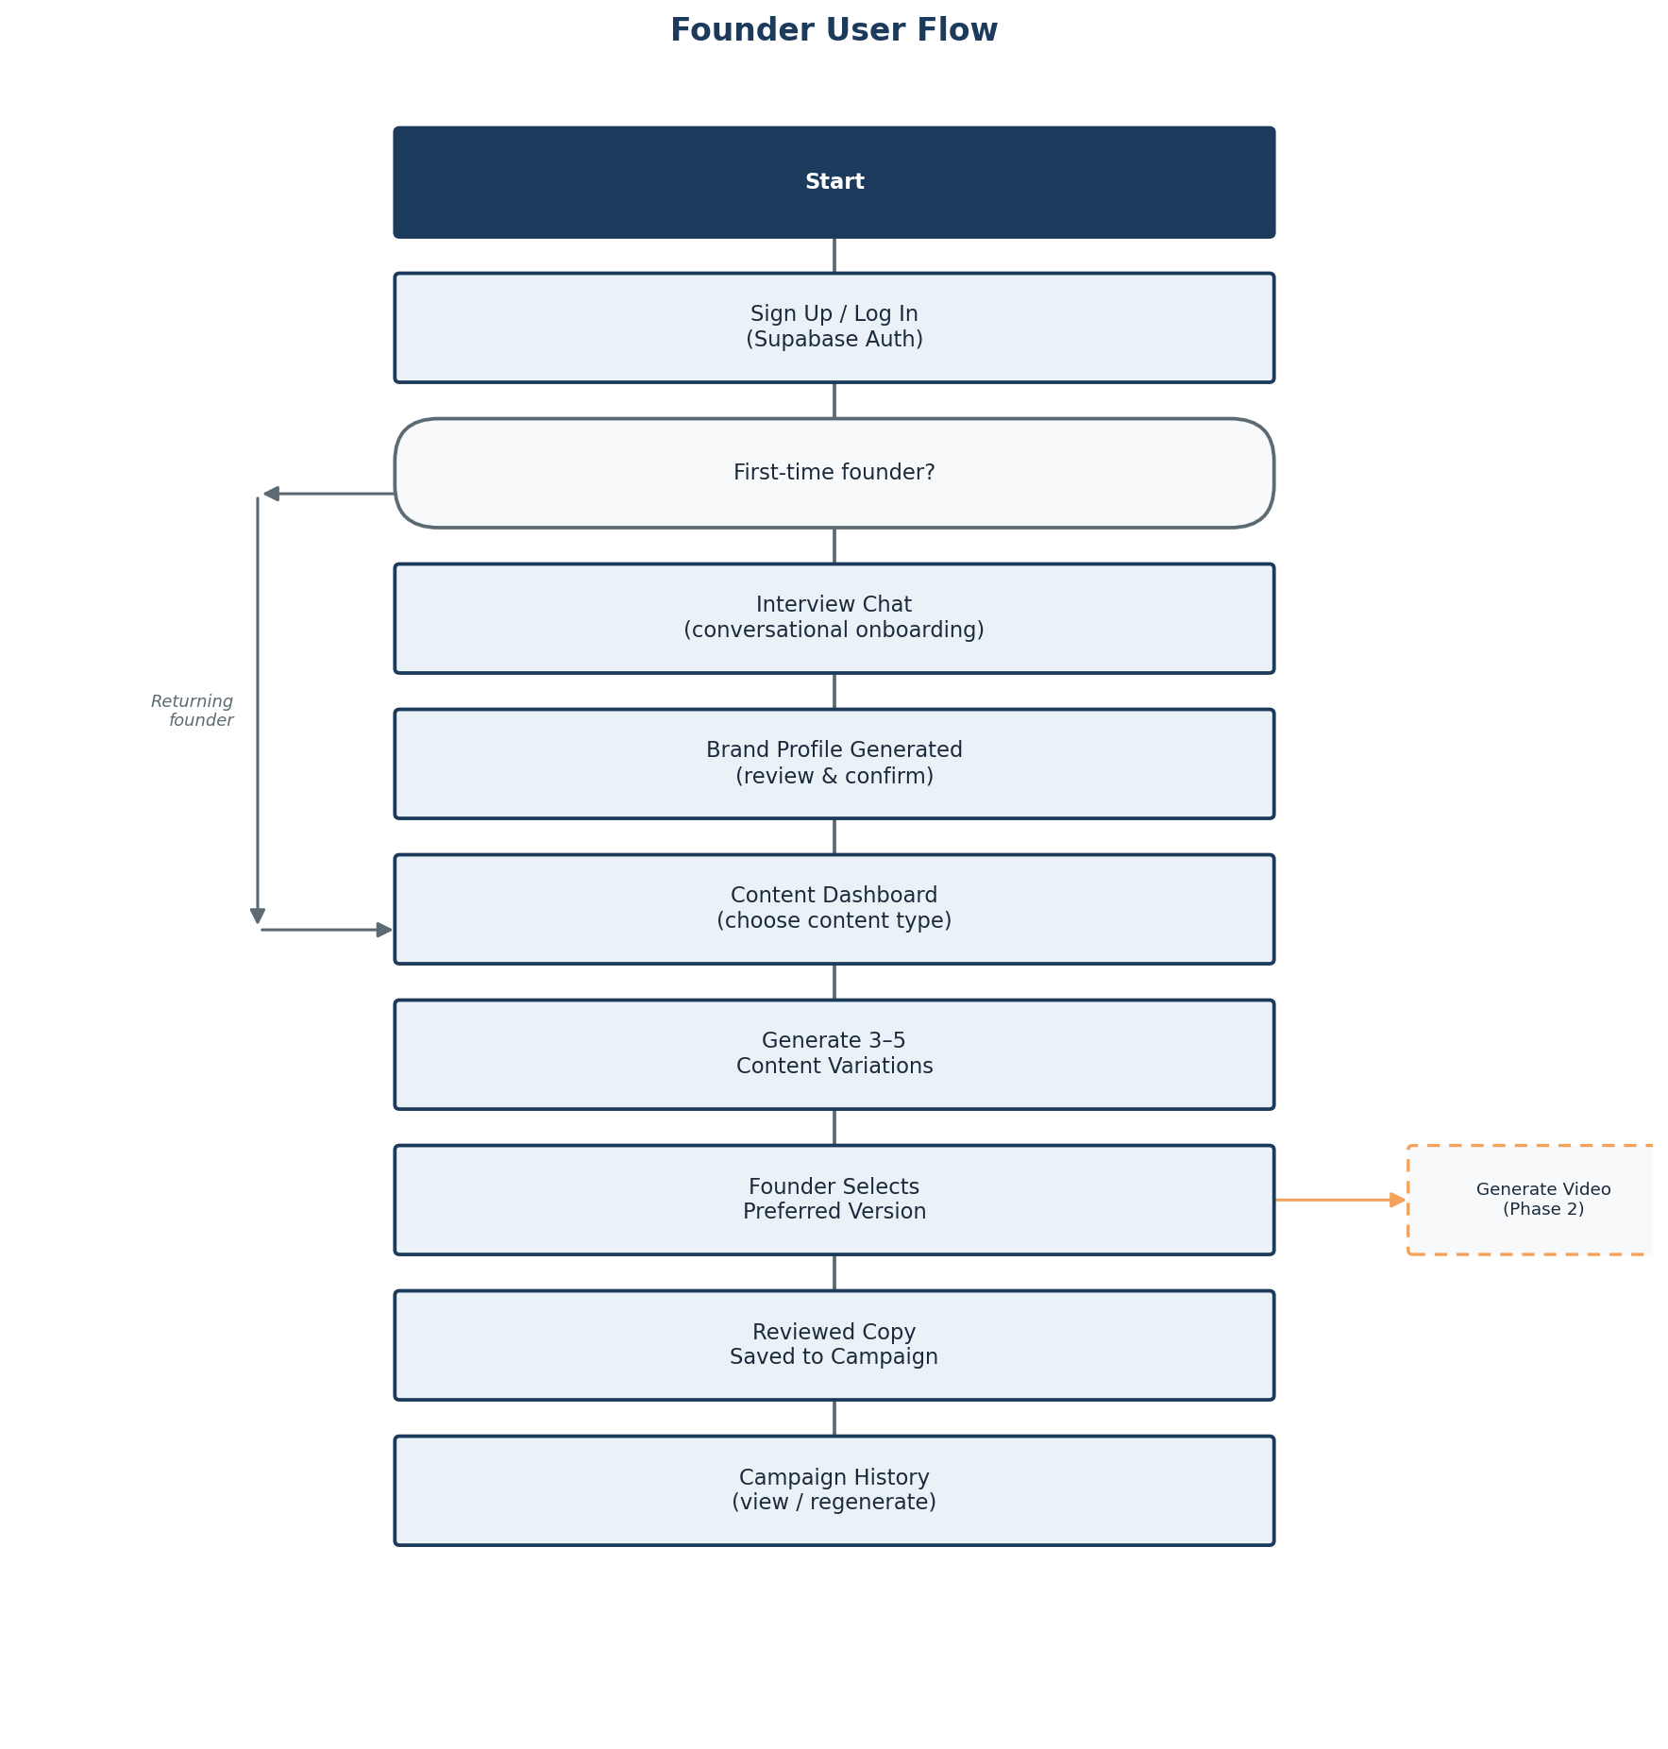
Figure 1: Founder journey from first login to campaign history, with the returning-founder shortcut and the Phase 2 video branch.
A first-time founder is routed through the full interview before reaching the Content Dashboard. A returning founder with an existing Brand Profile skips straight to the dashboard, which is what makes the assistant feel less like "filling another form" and more like an assistant that already knows the business.

3. Screen-by-Screen Breakdown

3.1 Login / Sign Up
Purpose: Get the founder into the app quickly with minimal friction.
Layout: Centered single-column card on a plain background; incubation-centre logo above the form; toggle link between Login and Sign Up below the fields.

Key elements
- Email and password fields
- Primary CTA button ("Log In" / "Create Account")
- Optional "Continue with Google" button below a divider
- Link to toggle between login and signup modes

States to design for
- Empty/validation error state
- Loading state on submit
- Wrong-credentials error banner

3.2 Onboarding / Interview Chat
Purpose: Collect structured startup information conversationally instead of via a form.
Layout: Full-height chat interface: AI messages left-aligned with a small avatar, founder replies right-aligned; a slim progress bar or step indicator sits at the top (e.g., "Step 4 of 10"); message input pinned to the bottom.

Key elements
- Chat bubbles for AI questions and founder answers
- Progress indicator tied to the fields still needed (FR-INT-1)
- "Save & exit" option so the founder can resume later (FR-INT-2)
- Typing/loading indicator while the Interview Agent processes a reply

States to design for
- First message / empty chat
- Resuming a paused interview
- Final "generating your brand profile" transition state

3.3 Brand Profile Summary
Purpose: Let the founder see and approve what the system understood about their brand before it's used everywhere else.
Layout: A set of labelled cards in a responsive grid: Brand Voice, Tone, Core Values, USP, Keywords, Avoid List — each independently editable inline.

Key elements
- Editable text/tag fields per card
- "Regenerate this section" icon on each card (FR-BRAND-3)
- Primary CTA: "Confirm & Continue" at the bottom
- Subtle brand-accent color pulled from the generated profile, previewed live on this screen

States to design for
- First-generation state
- Editing state per card
- Regenerating (loading) state

3.4 Content Dashboard
Purpose: Let the founder start a new content request quickly.
Layout: Top area shows suggested content types as tappable chips (Content Strategy Agent output); below, a manual content-type picker and platform tabs (LinkedIn / Instagram / X); a single prominent "Generate" button.

Key elements
- Suggested content-type chips with short descriptions
- Manual override dropdown/list of all content types
- Platform selector tabs
- Generate button, disabled until a type + platform are chosen

States to design for
- No campaigns yet (empty state with a friendly prompt)
- Generating (loading, ~15s target per NFR)

3.5 Content Variations View
Purpose: Let the founder compare 3–5 generated variations and pick one.
Layout: Horizontally scrollable cards (or stacked on mobile), each styled to preview how it will look on the target platform, with the CTA visually highlighted and a short style label (e.g., "Bold & direct", "Warm & story-led").

Key elements
- 3–5 variation cards with platform-accurate preview styling
- "Select this one" button per card
- Inline edit option before finalising
- Review & Optimisation notes shown once a variation is selected (FR-REV-4)

States to design for
- Loading/generating
- Review notes present vs. clean
- Post-selection confirmation

3.6 Campaign History
Purpose: Let the founder find, reuse, or revisit past content.
Layout: Grid or list of campaign cards, each showing content type, platform icon, date, and a text snippet; filter bar at the top for platform and content type.

Key elements
- Filterable/sortable campaign list
- Snippet preview per card
- "Regenerate" and "Download/Copy" actions per card (FR-HIST-3, FR-HIST-4)

States to design for
- Empty state (no campaigns yet)
- Filtered-to-empty state

3.7 Video Generation (Phase 2)
Purpose: Let the founder turn a chosen content piece into a short video, comparing providers.
Layout: Two-column layout: left side is a short preference form (duration, style, aspect ratio, voice); right side shows generated options side by side once ready (e.g., "Option A — Veo" vs. "Option B — Cosmos").

Key elements
- Preference form with sensible defaults
- Side-by-side video comparison once generated
- "Use this version" selection button per option

States to design for
- Form state
- Generating (likely a longer async wait — show a queued/processing state)
- Comparison-ready state

4. Navigation Map
During onboarding (Login → Interview → Brand Profile) there is no persistent navigation bar, to keep the founder's attention on completing setup. Once a Brand Profile is confirmed, a simple top navigation bar appears with: Dashboard, History, Brand Profile, and Logout — accessible from every subsequent screen.

5. Design System Notes
Aspect | Guidance
Typography | A single clean sans-serif (e.g., Inter or the system UI font) across the app; larger, friendlier sizing in the chat interview than in dense screens like History
Color | Neutral base (white/light gray) with a single accent color; once a Brand Profile exists, accent tone can shift subtly toward the founder's own brand color if one is captured, reinforcing "this understands my brand"
Spacing & grid | Tailwind's default spacing scale is sufficient; keep consistent card padding across Dashboard, Variations, and History for visual rhythm
Components | Rounded corners (cards, buttons), soft shadows over hard borders, generous white space over dense layouts

6. Accessibility and Responsiveness
- Maintain WCAG AA color contrast, especially once brand-accent colors are introduced dynamically
- Chat interview must be fully keyboard-navigable (send on Enter, focus management between turns)
- Design mobile-first for the Interview, Dashboard, and Variations screens, since founders are likely to use these between meetings on a phone
- History and Video Comparison (Phase 2) can be desktop-optimised first, given their denser layouts

