AI Marketing Assistant for Startup Founders
20-Day Execution Roadmap
Incubation Internship Project

Prepared by: Riya Shende & Team
Version: 1.0
Date: August 2, 2026
Team size: 2–3 members

Table of Contents

1. Scope Summary
This roadmap targets a working, demoable MVP in 20 days. It deliberately defers the highest-risk, highest-effort item — multi-provider video generation — to Phase 2, so the team spends the sprint on the core loop that proves the product's value: talk to the assistant once, get on-brand content repeatedly. Full detail on what is and isn't in Phase 1 is in the SRS, Section 5.
Ships in 20 days (Phase 1) | Deferred (Phase 2)
Auth, DB schema, Interview → Brand → Strategy → Generation → Review agents, campaign history, working frontend for all of it | Video Generation Agent, multi-provider comparison, analytics, content scheduling

2. Team Structure and Role Split
The workstreams below are designed to flex whether the team is 2 or 3 people. With 3, each workstream has a clear owner. With 2, combine Data/Infra & QA into whichever of the other two roles has more slack that week — don't leave it fully unowned, since auth/schema setup blocks everything else.
Workstream | Owns
Frontend & UX | Next.js screens, Tailwind styling, wiring to the API, all of Section 3 in the UI/UX Design Document
Backend & Agents | FastAPI endpoints, all six Phase-1 agents and their prompts, LLM provider wrapper
Data/Infra & QA | Supabase project setup, DB schema/migrations, RLS policies, deployment, end-to-end testing

3. 20-Day Timeline
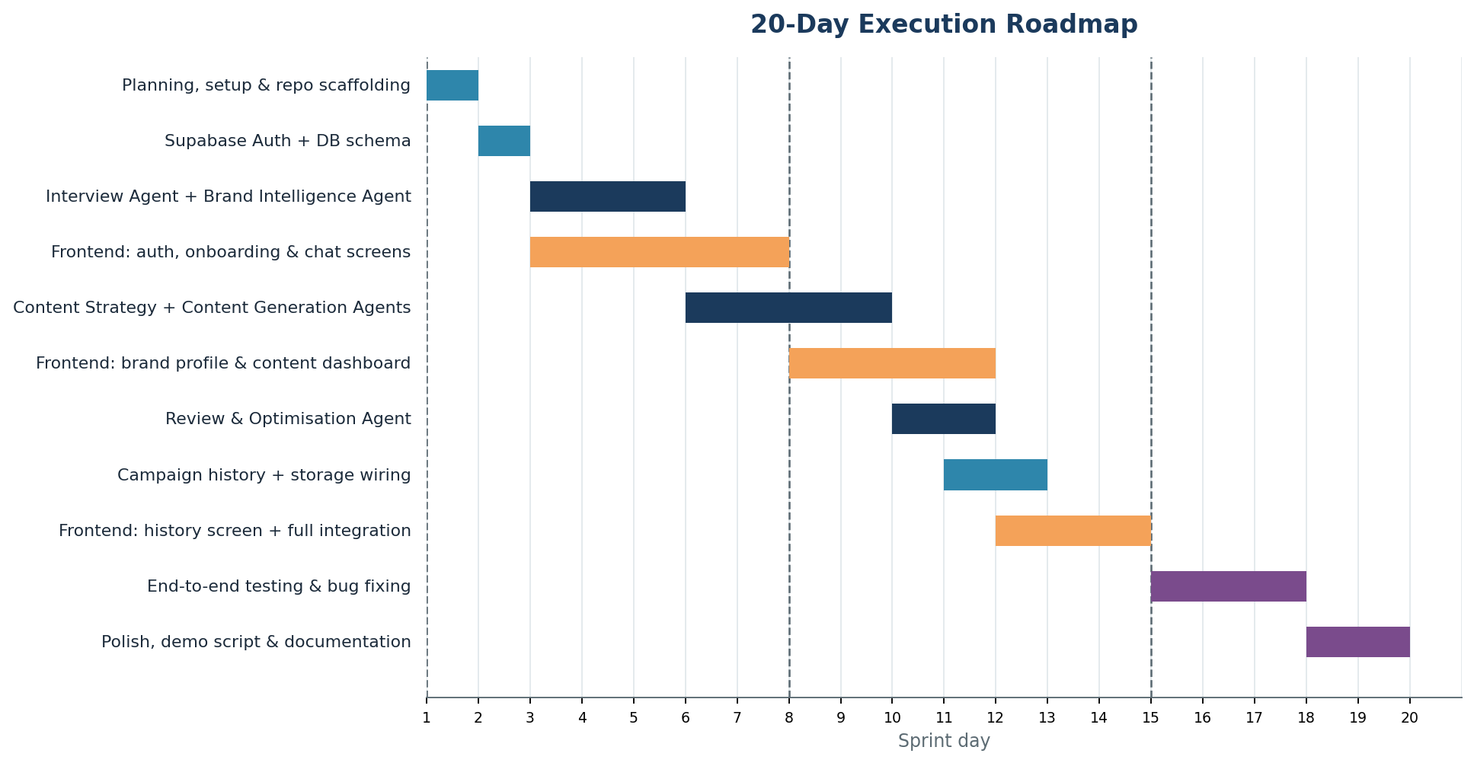
Figure 1: Workstream timeline across the 20-day sprint. Dashed week markers fall on Day 1, Day 8, and Day 15.

Week 1 (Days 1–7) — Foundation
- Finalise this documentation set with the mentor; lock the Phase 1/2 scope line
- Provision Supabase project; implement Auth and the core DB schema (Section 4 of the Database Design Document)
- Build the Interview Agent and Brand Intelligence Agent prompts and endpoints
- In parallel, build the Login, Sign Up, and Interview Chat screens against a mocked API

Week 2 (Days 8–14) — Core Loop
- Build Content Strategy and Content Generation agents; connect to a real LLM provider
- Build the Brand Profile Summary and Content Dashboard screens against the real API
- Start the Review & Optimisation Agent once generation output is stable

Week 3 (Days 15–20) — Integration, Testing, Polish
- Finish History & Campaign storage and the History screen
- Full end-to-end integration across all screens and agents
- Testing pass and bug fixing against the Definition of Done (Section 6)
- Polish, prepare the demo script, and finalise documentation for submission

4. Milestones and Deliverables
Day | Milestone
Day 2 | Supabase Auth + schema live; team aligned with mentor on locked scope
Day 6 | Interview → Brand Profile flow works end-to-end for one test founder
Day 10 | Content generation returns 3–5 on-brand variations for a real request
Day 13 | Review & Optimisation Agent flags at least grammar and brand-consistency issues
Day 15 | Campaign history stores and displays finalised content
Day 18 | Full user journey (signup → interview → content → history) works without manual intervention
Day 20 | Demo-ready build, walkthrough script, and documentation finalised

5. Risk Register
Risk | Likelihood | Impact | Mitigation
LLM API cost/rate limits slow testing | Medium | Medium | Start on a free/open-source model via NVIDIA NIM; add basic request throttling early
Video generation scope creep | High | High | Explicitly deferred to Phase 2 in this roadmap; do not start it before Day 18 even if ahead of schedule
Integration slips because frontend and backend built in parallel | Medium | Medium | Agree on API contracts (Section 8 of the System Architecture Document) before Week 1 ends; use a mocked API on the frontend until endpoints are live
A teammate becomes unavailable mid-sprint | Low–Medium | High | Keep workstream ownership documented (Section 2) so another teammate can pick up context quickly
Generated content drifts from the Brand Profile | Medium | Medium | Review & Optimisation Agent explicitly checks brand-consistency (FR-REV-2); spot-check outputs during Week 2

6. Definition of Done / Demo Success Criteria
By Day 20, the demo should show, without any manual database edits or hard-coded fixtures:
- A new founder signs up and completes the conversational interview
- A Brand Profile is generated, edited, and confirmed
- A content request returns 3–5 genuinely different variations
- A selected variation passes through the Review & Optimisation Agent and is saved
- The founder can see it afterward in Campaign History and download/copy it
- The whole loop can be repeated for a second content request using the same Brand Profile
What "done" deliberately excludes
No video generation, no analytics, no multi-provider comparison. If the team is ahead of schedule by Day 15–16, prefer polishing the core loop and demo narrative over starting Phase 2 features — a smaller, reliable demo outperforms a bigger, half-working one.

