**Project 8 Part 2 Rotating a platonic solid with OpenCV (perspective)**

Name: _Riya Dev__________________ Period: _5__________ Date: _5/28/2022_______________

Did you name your file l082.cpp (Lower case L, then 082)? _yes___

Does your file compile & run on terminals? _yes___

Did you use a rotation matrix? _yes__________

Did you start from the coordinates I provided for the cube?? _yes___

Describe here in words all the transformations you applied to vertices, for each describe how you implemented it in your code (by multiplying with a matrix, what was the matrix, or by adding a matrix, what was that matrix… be specific):

Multiplied by X rotation matrix and Y rotation matrix.

From <https://www.brainvoyager.com/bv/doc/UsersGuide/CoordsAndTransforms/SpatialTransformationMatrices.html#:~:text=The%204%20by%204%20transformation,in%20the%20first%20three%20columns>:

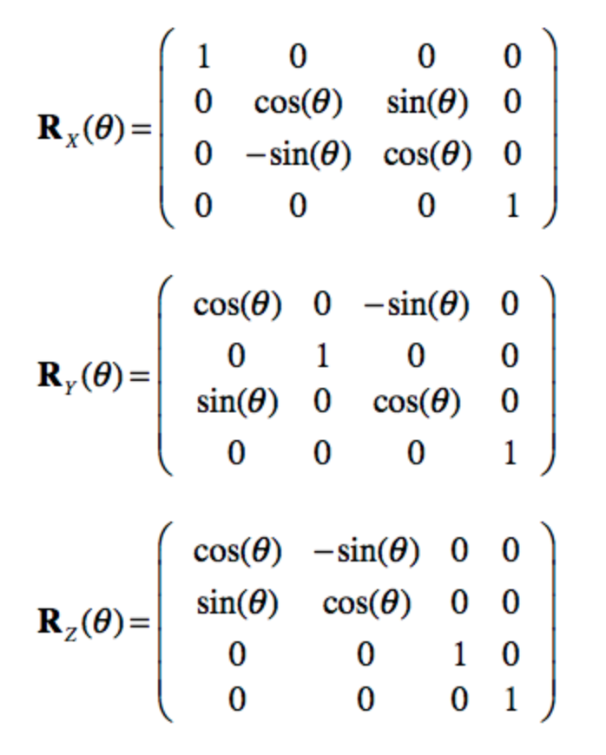

Describe in words the rotation you did:

I multiplied my matrix by the x and y rotation matrices.

Did you use homogenous coordinates? _yes___

(that allows you to combine all transformations into one matrix?

Did you combine all those transformations into one single matrix? _no___

If you used only one transformation matrix, what was it?

What functions/methods from OpenCV did you use?

cv2.circle(image, center_coordinates, radius, color, thickness)

cv2.line(image, start_point, end_point, color, thickness)

What functions/methods from OpenCV did you experiment with but ended not using?

Did you do a perspective rendering? _yes__________

What is the position of the eye you used? _700__________

What is the plane of the screen you projected on? _500__________

Did you name your video rotation.avi? _yes__________

What functions/methods from OpenCV did you use?

cv2.circle(image, center_coordinates, radius, color, thickness)

cv2.line(image, start_point, end_point, color, thickness)

What functions/methods from OpenCV did you experiment with but ended not using?

Obs.: feel free to rotate any platonic solid, around any line, and you may put the position of the screen/viewing window in any place as long as the rotating platonic solid can be seen reasonably.