**Artificial Intelligence   
& Expert Systems   
Project report on**

***“Real And fake News Detection”***

*Members:-*

## **MANASI MALI** Roll No - PD37 PRN - 1032222216

## **RIYA KONDAWAR** Roll No - PD43 PRN - 1032222227

## **SUHANI CHOUDHARY** Roll No - PD45 PRN - 1032222231

*Guided by:-*

## **Prof. Vandana Jagtap**

School of Computer Engineering and Technology   
MIT World Peace University

***Abstract***

*News is information about current events provided through many different media platforms and consumed by people who wish to know and analyze it. But nowadays following the latest news can lead to unreliable information, low quality data, and less accuracy thus increasing the scope of fake news consumption. This project has the main goal to mitigate the mishaps occurring due to spreading fake news among masses. In this project dataset is separated into two files: Fake.csv and True.csv which consists of data of contrasting aspects i.e real and relevant news and other is fake and irrelevant news. The methodology in this project is processed as data loading -> data preprocessing -> (“eda”)exploratory data analysis. The algorithm used is (Tfidf)Term Frequency Inverse Document Frequency where the text is converted into numerical format. Coming up with the accuracy of the project, it possesses up to* ***99%****.*

*Keywords: Fake.csv, Real.csv, eda(exploratory data analysis), Tfidf(Term Frequency Inverse Document Frequency )*

***[1] Introduction***

In today’s fast growing and highly computing world , providing fake news is a very easy , cheap and quick way to mislead people’s opinions, manipulate their views , seek attention and create chaos. Thus demanding of a correction system which will provide the masses the correct , relevant, and real time updated of news in the current world becomes one of the most important necessity today.Percentage of fake news data reaching people in India specifically through social media platforms is given below:

* Whatsapp - 60-80%
* Facebook - 50-60%
* Twitter - 20-30%
* Youtube - 30-40%

To address these drastic and concerning issues ML i.e machine learning plays a crucial part . It has following ways to solve this issue:-

1. NLP i.e natural language processing
2. Deep learning
3. Sentiment analysis
4. Social media context analysis
5. Real time detection

One of the main challenge here can be using or creating the correct dataset and thus we have solved this problem by dividing the dataset into two subdivisions namely:

***Fake.csv*** *and* ***Real.csv***. There are various Fact Checking websites on the internet used by consumers but the drawback here is that it only provides information related to one area of field.

However, fact-checking websites are typically limited to a single area of interest, like politics. They necessitate human experience, making it challenging to find datasets that offer some level of generalization across several disciplines

Results generated by this fake news detection system are based on text based features, currently this is not very accurate to evaluate sentiment analysis, social network behavior, and combating misinformation on digital platforms.

Our Contributions. In the current fake news corpus,there have been multiple instances where both supervised and unsupervised learning algorithms are used to classify text . However, most of the literature focuses onspeciﬁc datasets or domains, most prominently the politics domain therefore, the algorithm trained works2 Complexity best on a particular type of article’s domain and does not achieve optimal results when exposed to articles from other domains.

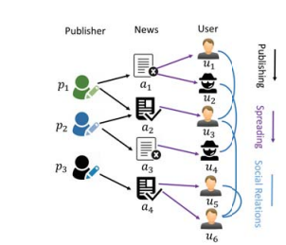

***Figure 1:*** *An illustration of tri-relationship among publishers, news pieces, and users, during the news dissemination process.*

For example,

an edge (p → a) demonstrates that publisher p publishes news item a,

an edge (a → u) represents news item a is spread by user u, and

an edge (u1 ↔ u2) indicates the social relation between user u1 and u2.

***[2] Literature Survey***

2.1. In [1] “Fake News Detection Using Machine Learning Ensemble Method ”

In the proposed framework, as illustrated in Figure 1, we are expanding on the current literature by introducing ensemble techniques with various linguistic feature sets to classify news articles from multiple domains as true or fake. The ensemble techniques along with the Linguistic Inquiry and Word Count (LIWC) feature set used in this research are the novelty of our proposed approach.

The learning algorithms are trained with diﬀerent hy -perparameters to achieve maximum accuracy for a given dataset, with an optimal balance between variance and bias.Each model is trained multiple times with a set of diﬀerentparameters using a grid search to optimize the model for the best outcome.

Algorithms , used the following learning algorithms in conjunction with our proposed methodology to evaluate the performance of fake news detection classiﬁers.

*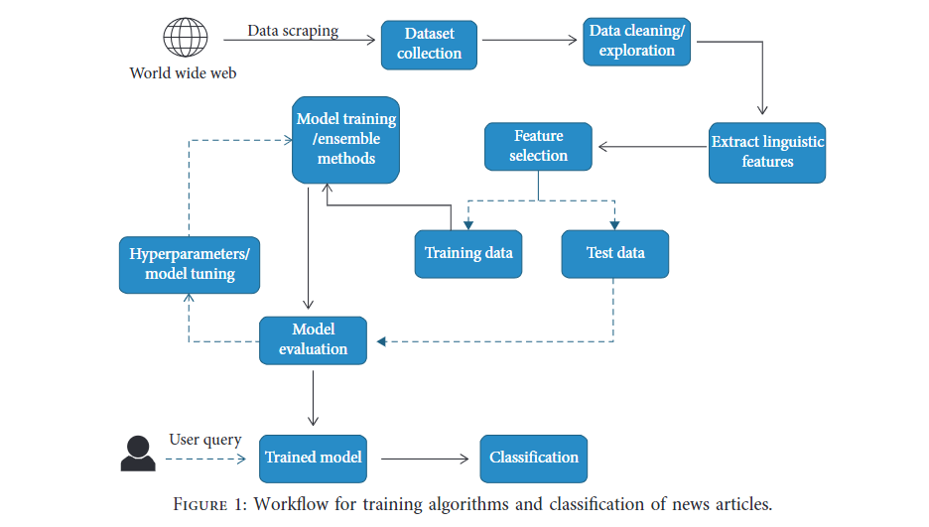****Figure 2:*** *Workflow of training algorithms and classification of news articles*

2.2 In[2] “Fake News Detection on Social Media: A Data Mining Perspective”

To facilitate research in fake news detection on social media, in this survey we will review two aspects of the fake news detection problem: characterization and detection. As shown in Figure 2, we will first describe the background of the fake news detection problem using theories and properties from psychology and social studies; then we present the detection approaches. Our major contributions of this survey are summarized as follows:

* We discuss the narrow and broad definitions of fake news that cover most existing definitions in the literature and further present the unique characteristics of fake news on social media and its implications compared with the traditional media;
* We give an overview of existing fake news detection methods with a principled way to group representative methods into different categories; and
* We discuss several open issues and provide future directions of fake news detection in social media.

Algorithm used : NLP (natural language processing) is one of the many algorithms used here.

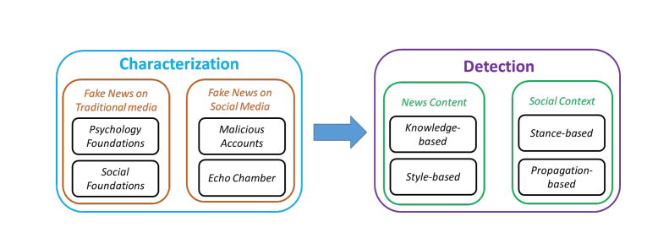

***Figure 3:*** *Fake news on social media: from characterization to detection.*

2.3 In[3] “The Role of User Profiles for Fake News Detection”

In this work, we aim to answer questions regarding the nature and extent of the correlation between user profiles on social media and fake news and provide a solution to utilize user profiles to detect fake news. This work opens up the doors for many areas of research. First, we will investigate the potential and foundation of other types of user features in a similar way, such as content features and social network features, for fake news detection. Second, we will further investigate the correlations between malicious accounts and fake news to jointly detect malicious accounts and fake news pieces. Third, we will explore various user engagement behaviors such as reposts, likes, comments, to further understand their utilities for fake news detection.

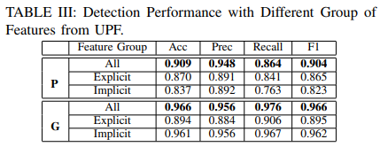

***Figure 4:*** *Performance comparison for fake news detection with different feature representations*

2.4 In[4] “The Role of Social Context for Fake News Detection”

The model is the user-news interactions by considering the relationships between user features and the labels of news items. Its shown (see Section 1) that users with low credibilities are more likely to spread fake news, while users with high credibilities are less likely to spread fake news.The basic idea in [1] is that less credible users are more likely to coordinate with each other and form big clusters, while more credible users are likely to from small clusters. Specifically, the credibility scores are measured through the following major steps: 1) detect and cluster coordinate users based on user similarities; 2) weight each cluster based on the cluster size. Note that for our fake news detection task, we do not assume that credibility scores are directly provided, but inferred from widely available data, such as user-generated contents.

2.5 In[5]: “A Tool for Fake News Detection”

It implemented the application using Python (https://www. python.org) since it supports a large number of efficient packages helping to deal with any type of data (images, text, audio, etc.) and to achieve any target he wants (machine learning, deep learning, web development, etc.).

To implement our application we used the following libraries:

(1) Scikit-learn (http://scikit-learn.org),

(2) Pandas (https://pandas.pydata. org),

(3) Beautiful Soup 4 (https://www.crummy.com/ software/BeautifulSoup/bs4/doc/),

(4)PyQT5 (https://www.riverbankcomputing.com/software/pyqt/intro), (used for implementing the application’s graphical user interface); and

two external APIs:

(1) Google Cloud Natural Language Processing API (<https://cloud.google.com/natural-language/> ),

(2) News API (<https://newsapi.org> ).

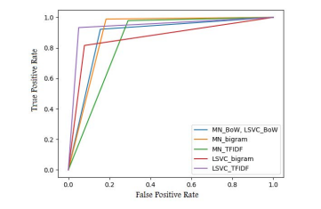

***Figure 5:*** *ROC Curve Representation for Content Detection*

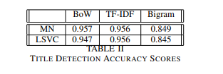

***Figure 6***

***[3] Proposed Methodology***

In this project we have used a deep learning process -> data cleaning -> data mining -> data extraction -> preprocessing -> analysis. Used linguistic features, convolutional neural network(CNN), ml algorithms, nlp techniques etc.

***[4] Results And Discussion***

The problems of fake news and disinformation play an important role in nowadays life. This is because, the advanced level of technology and communication methods we have enabled information spreading among people without any verification. This is a reason why researchers started searching for solutions to stop fake news and disinformation from spreading easily. However, it is well known that controlling the flow of information online is impossible. In this paper, we performed an attempt to verify the news articles credibility depending on their characteristics. At this aim, we implemented an algorithm combining several classification methods with text models. It performed well, and the accuracy results were relatively satisfying. As future work, we plan to better study the combination between the feature extraction methods and the classifiers as we will be able to choose the text representation model that performs best with the classifier. Moreover, to achieve a higher accuracy, we will have to implement a more sophisticated algorithm which may use data mining technologies with big data, because creating a big dataset including more types of news articles with more class variables (labels) will help raise the accuracy score.

***[5] Conclusion***

The task of classifying news manually requires in-depth knowledge of the domain and expertise to identify anomalies in the text. In this research, we discussed the problem of classifying fake news articles using machine learning models and ensemble techniques. )e data we used in our work is collected from the World Wide Web and contains news articles from various domains to cover most of the news rather than specifically classifying political news. The primary aim of the research is to identify patterns in text that differentiate fake articles from true news. We extracted different textual features from the articles using an LIWC tool and used the feature set as an input to the models. learning models were trained and parameter-tuned to obtain optimal accuracy. Some models have achieved comparatively higher accuracy than others. We used multiple performance metrics to compare the results for each algorithm. ensemble learners have shown an overall better score on all performance metrics as compared to the individual learners. Real time fake news identification in videos can be another possible future direction.

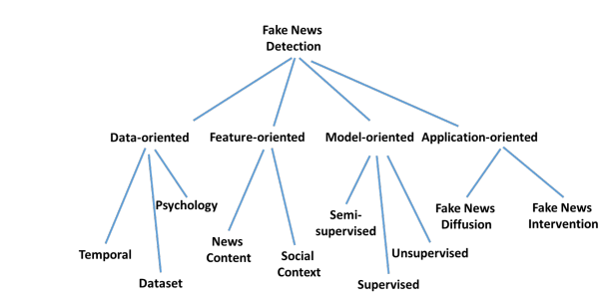

***Figure 7:*** *Future directions and open issues for fake news detection on social media.*

Working Images:-

*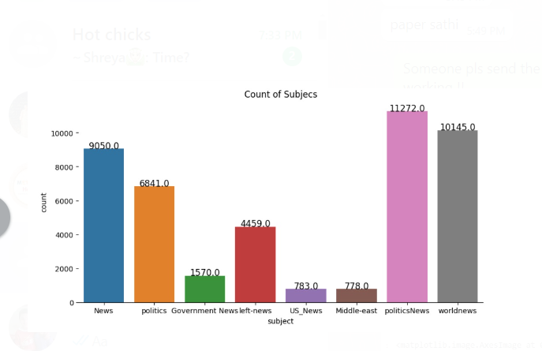****Figure 8:*** *Count of subjects*

*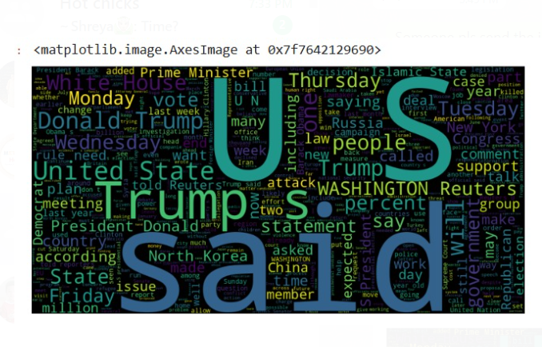****Figure 9:*** *Image Generated*

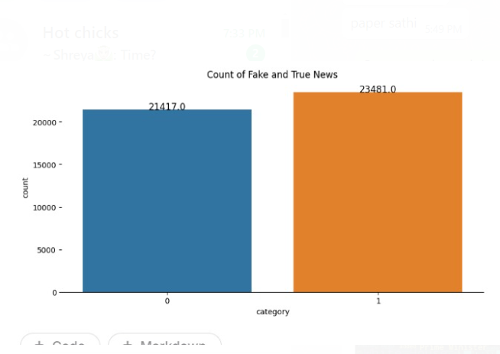

***Figure 10:*** *The count of Fake and Real News*

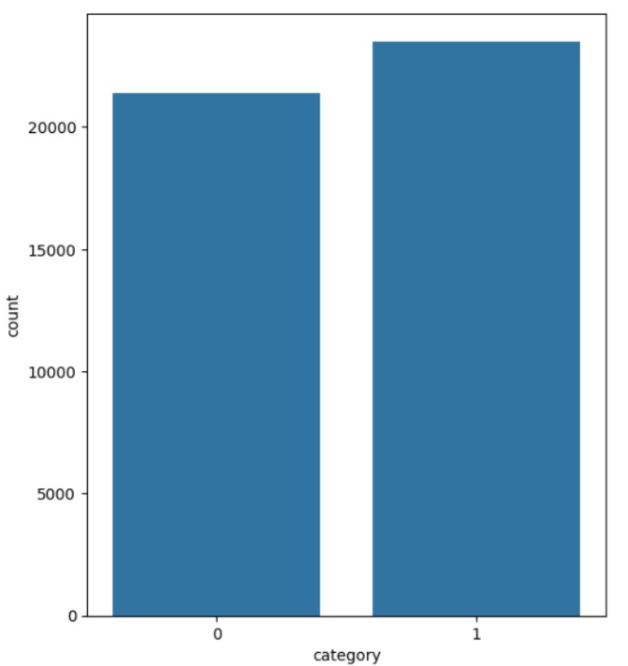

*Figure 11: Category of News*

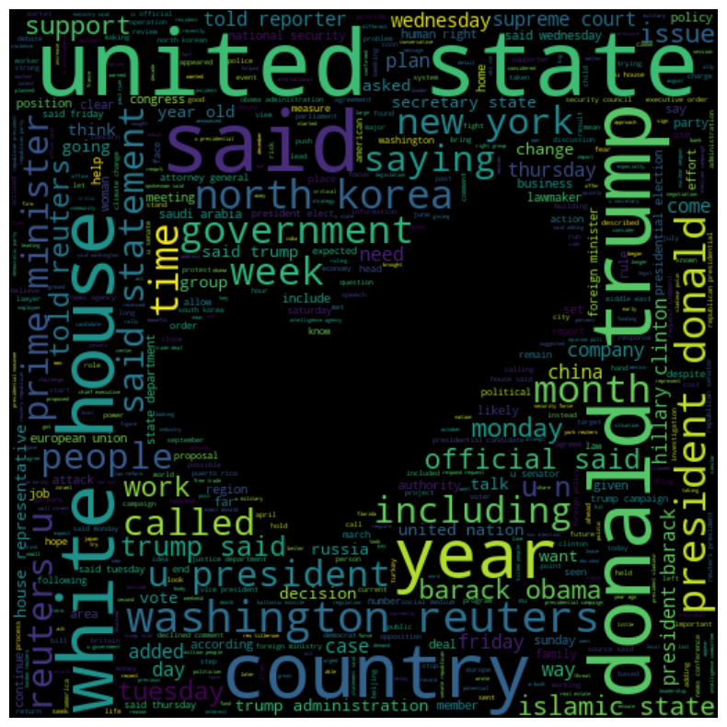

***Figure 12:*** *Real News Verification*

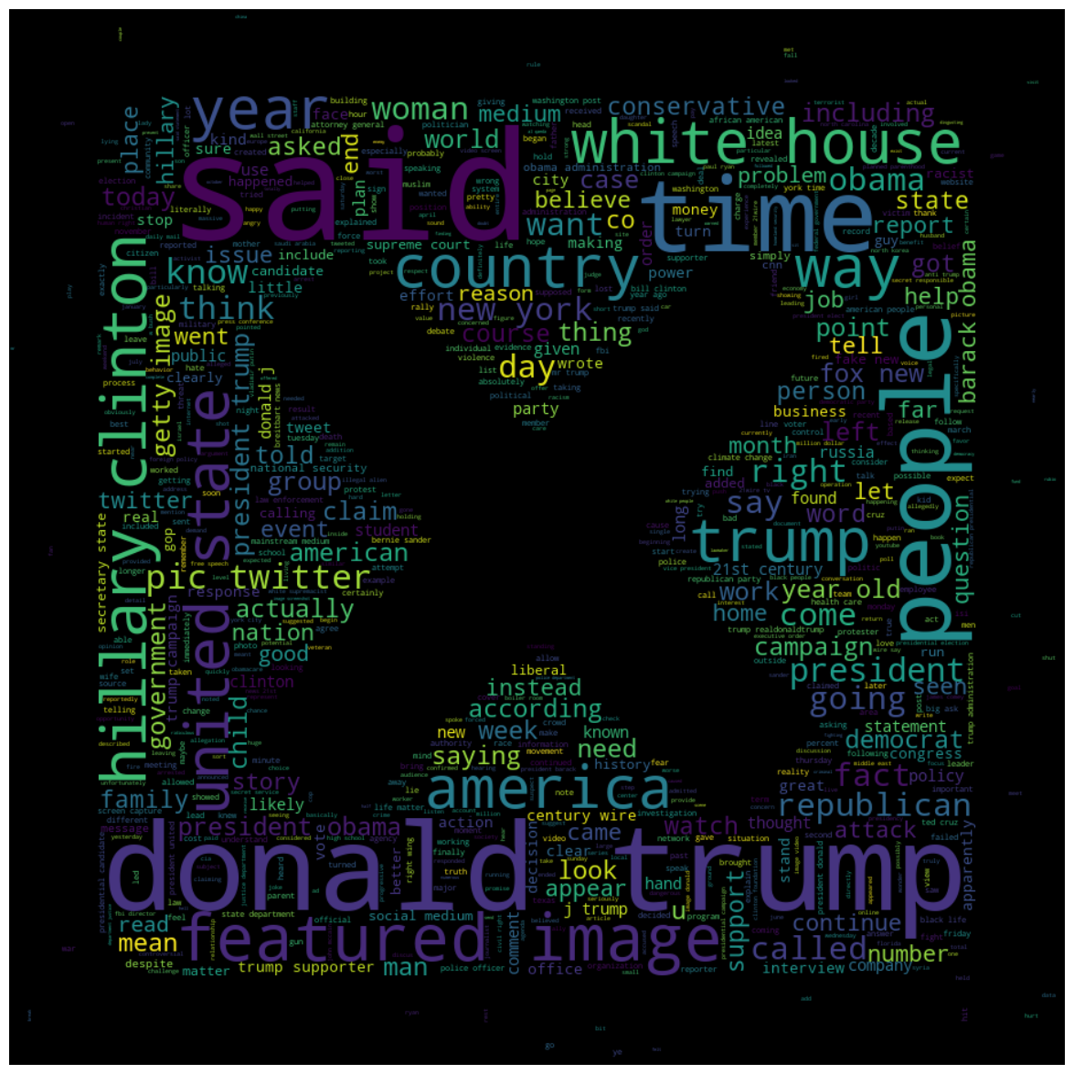

***Figure 13:*** *Fake News Verification*

***[6] Tools Used***

1. Term Frequency (TF):

Term frequency or frequency of term, basically it is a count of how many times a term is appearing in the document. The intuitive part behind term frequency is that words being used repeatedly throughout a document carry more weight and thus receive a higher score. However, this also counts frequent words like "the" or "and," which are nondescript and don't deserve a high score.

1. Inverse Document Frequency (IDF)

Inverse Document Frequency (IDF) reduces the variance of terms that occur quite often in many documents. The goal is to make more prominent those terms that are more specific to a particular document. Common words among many documents result in lower scores.

1. TF-IDF

TF-IDF score is defined as the product of TF and IDF scores. It highlights how important a term is in a document compared to the same term appearing in any other document.

1. Text Tokenization   
   It divides text into tokenization, words.

Vocabulary Building: It builds the dictionary for all unique words or tokens occurring in the dataset.

1. TF-IDF Calculation   
   It computes the TF-IDF score for every word occurring for each and every document.

Parameters in TfidfVectorizer

1. Lemmatization   
   It is a natural language processing technique that reduces words to their base or root form, the so-called lemma, that represents the meaning. Example, Running -> Run

It differs from stemming as stemming removes the last word endings without checking if what is left constitutes a valid word. For example, although add and adding end with the lettering, what is left after removing the ending does not constitute a valid word. Lemmatization, on the other hand, considers the context and the part of speech of the word.

1. Stopwords

A very typical subset of words within a language, mostly filtered out in text processing processes within NLP tasks, are *stopwords*. This set of words carries little meaning from the content standpoint and is of use for the most part in carrying out the task to understand or analyze the content. Examples of stopwords for the language English include "the," "is," "in," "and," "on," "at," etc.

1. NLP & NLTK

Two of the most used Python libraries for NLP are NLTK (Natural Language Toolkit) and ***spaCy***. Both packages offer tools to process and analyze textual data; they can be distinguished, however, by design philosophy, performance, and specific use cases.

A *corpus* is "a large, structured set of texts for use in NLP applications, for example, in the analysis and training of models for specific linguistic or NLP tasks. Corpora are essentially collections of documents, sentences, or words and thus form a basis of study for languages and construction of language models.

***[7] References***

[1] Iftikhar Ahmad , Muhammad Yousaf, Suhail Yousaf , and Muhammad Ovais Ahmad ,Fake News Detection Using Machine Learning Ensemble Methods 2020

[2] Kai Shu† , Amy Sliva , Suhang Wang , Jiliang Tang , and Huan Liu, Fake News Detection on Social Media: A Data Mining Perspective 2019

[3] Kai Shu∗ , Xinyi Zhou† Suhang Wang‡ , Reza Zafarani† , and Huan Liu∗ ,The Role of User Profiles for Fake News Detection 2019

[4] Kai Shu Suhang ,Wang Penn ,Liu Arizona State University, Beyond News Contents: The Role of Social Context for Fake News Detection 2019

[5] ZAINAB A. JAWAD *, AHMED J. OBAID ,The Combination Neural Networks And Deep Neural Networks And Deep Neural Networks For Fake News Detection 2022

[6] Bashar Al Asaad, Mad˘ alina Eras , A Tool for Fake News Detection 2019