**“SkillShark – An Instant Education, Infinite Possibilities”**



This Project Report Is Submitted To

Rajiv Gandhi Proudyogiki Vishwavidyalaya

In The Partial Fulfillment For The Award of the Degree of

**BACHELOR OF TECHNOLOGY**

(Computer Science and Engineering)

**Submitted By:**

Riya vishwakarma

(0228CS211046)

Under the Guidance of:

**Prof. NITIN SHUKLA**

Head of Department

Computer Science

Shri Ram Group Of Institutions(SRGI)

**Prof. PRIYANKA NEMA**

Asst. Prof. Department Of Computer Science

Shri Ram Group Of Institution(SRGI)

  **SHRI RAM GROUP OF INSTITUTIONS (SRGI)**

**JABALPUR**

APPROVED BY AICTE NEW DELHI AND GOVT. OF M.P.

(Affiliated TO RGPV-University of Technology Madhya Pradesh)

**CERTIFICATE**

This is to certify that the project title **“SkillShark – An Instant Education, Infinite Possibilities”** is being submitted by **“Riya Vishwakarma”** in partial fulfillment of the requirement for the award of Degree of Bachelor of Technology in Computer Science and Engineering Rajiv Gandhi Proudyogiki Vishwavidyalaya, Bhopal [M.P.] and has been carried out under my guidance and supervision.

These are the students of 6th semester, Computer Science and Engineering at Shri Ram Group of Institutions (SRGI), Jabalpur. This is the original work of these students and is based on their own innovative idea. We, hereby certify this project to be an authentic work by these young minds.

**PROF. Priyanka Nema Mam PROF. Nitin Shukla Sir**

Asst. Professor-Computer Science Department Head Of Computer Science Dep.

SRGI SRGI

**ACKNOWLEDGEMENTS**

We would like to extend our gratitude to all those who gave us the possibility to complete this project. We would like to thank the Department of Computer Science of Shri Ram Group Of Institutions(SRGI) for giving us permission to commence this project in the first instance, to do the necessary research and to use department accessories.

We are deeply indebted to our supervisor **Prof. Priyanka Nema Mam** [Asst. Prof.- Computer Science Dept] whose help , simulating suggestions and encouragement helped us at all the time in completing this project.

We are bound to our honourable head of the department **Mr. Nitin Shukla Sir** his simulating support. We have further more to thank the Faculty of our college who helped us in providing the necessary data.

Our former colleagues in the department also supported us in our project. We want to thank them for all their help, support, interest and valuable hints.

**Place :** Jabalpur **Student Name :**

**Date :** Riya Vishwakarma

**CERTIFICATE OF APPROVAL**

The foregoing minor project title **“SkillShark – An Instant Education, Infinite Possibilities”** is hereby approved as a creditable study of an engineering subject carried out and presented in a mannner satisfactory to warrant its acceptance as a prerequisite to the degree for which it has been submitted. It is understood that by this approval the undersigned do not necessarily endorse approve any statement made, opinion expressed or conclusion drawn there in, but approve the project only for the purpose for which it has been submitted.

**(Internal Examiner) (External Examinar)**

------------------------------------ ---------------------------------------

**DECLARATION**

Here we declare that the project entitled which is being submitted in partial fulfillment of the requirement for the award of the degree of Bachelor of Technology in Computer Science and Engineering “Rajiv Gandhi Proudyogiki , Bhopal [M.P.]” is the authentic record of my own work done under the guidance of **Prof. Priyanka Nema Mam** [Asst. Professor Computer Science Department]. The matter reported in this project has not been submitted earlier for the award of degree.

**Name :** Riya Vishwakarma **Roll No. :** 0228CS211046

**FORWARD**

I hereby forward project title “**SkillShark – An Instant Education, Infinite Possibilities**” which is being submitted by **Riya Vishwakarma** in partial fulfillment of the requirement for the award of degree of Bachelor of Technology in Computer Science and Engineering “Rajiv Gandhi Proudyogiki Vishwavidyalaya, Bhopal [M.P.]”.

**Prof. Priyanka Nema Prof. Nitin Shukla**

[Asst. Prof. of Computer Science Department] Head of Department, SRGI

**INDEX**

**1: Introduction**

* 1. Objective
  2. Intended Audience
  3. Proposed System

**2: Software Model**

**3: Analysis**

3.1 Output Requirements

3.2 System Requirements

3.2.1 Hardware Requirements

3.2.2 Software Requirements

3.3 Feasibility Study

**4: Design**

4.1 Modules Used

4.2 Data Flow Diagram

4.3 ER Diagram

**5: Tools Used**

**6: Expected Output**

**7: SWOT Analysis**

**8: Bibliography**

1. **Introduction**

The " **SkillShark – An Instant Education, Infinite Possibilities** " project, aims to create a userfriendly and versatile online education platform that operates entirely within a web browser. This project leverages the power of web technologies, including HTML, CSS, and JavaScript. SnapLearn aim is to provide an accessible, engaging, and effective online education platform that empowers learners to achieve their learning goals. SnapLearn aims to break down barriers to education by offering a user-friendly interface, a wide range of courses, interactive content, and flexible learning options. Ultimately, SnapLearn strives to make learning enjoyable, convenient, and rewarding for individuals of all ages and backgrounds, fostering a culture of lifelong learning and personal growth.

**1.1 Objective**

SnapLearn aims to democratize education by offering personalized and interactive learning experiences that cater to diverse learner needs. Through tailored learning paths and continuous quality assurance, SnapLearn ensures high-quality education accessible to all. By fostering lifelong learning, the platform empowers individuals to continually grow personally and professionally.

**1.2 Intended Audience**

SnapLearn caters to a diverse audience, including students, professionals, and lifelong learners. Whether you're seeking academic support, career advancement, or personal enrichment, SnapLearn offers tailored learning experiences. With its accessible platform and flexible approach, SnapLearn accommodates learners of all ages and backgrounds. Whether you're a student striving for academic success, a professional aiming to enhance your skills, or a lifelong learner pursuing personal interests, SnapLearn provides the resources you need to achieve your learning goals.

**1.3 Proposed System**

The proposed system of SnapLearn encompasses a comprehensive online education platform featuring personalized learning paths, interactive content, and community engagement tools. Quality assurance measures will ensure up-to-date and high-standard course content. Accessibility and user-friendliness are prioritized, allowing seamless navigation and access from any device. Overall, the system aims to create an engaging and empowering learning environment for individuals to achieve their educational objectives effectively.

1. **Software Model**

* **Scrum Framework:** The development process will follow the Scrum framework, which divides the project into time-bound iterations called sprints. Each sprint typically lasts 2-4 weeks and results in a potentially shippable product increment. Scrum promotes regular collaboration, adaptability, and the ability to respond to changing requirements.
* **Cross-Functional Teams:** The project team will be cross-functional, including developers, designers, and testers, working collaboratively to deliver user stories and features. This approach ensures a well-rounded perspective and diverse skill sets.
* **User-Centric Design:** User stories and features will be developed based on user feedback and needs. Regular user testing and feedback loops will be incorporated to refine the user experience.
* **Continuous Integration and Testing:** Continuous integration practices will be adopted to ensure that code is integrated, built, and tested continuously. Automated testing will be used to maintain software quality.
* **Product Backlog:** A product backlog will be maintained to prioritize and organize feature requests and improvements. This backlog will evolve as the project progresses and as new insights are gained.
* **Iterative Development**: The project will evolve through iterations. At the end of each sprint, a potentially shippable increment of the application will be available for testing and feedback.
* **Regular Stand-Up Meetings**: Daily stand-up meetings will be conducted to facilitate communication, collaboration, and issue resolution within the team.

# **Analysis**

* 1. **Output Requirements**
* Personalized Learning Experiences
* High-Quality Course Content
* Certification and Accreditation
* Virtual Classroom Features
* Cross Browser compatibility
* Career Guidance and Support
  1. **System Requirements**

**3.2.1 Hardware Requirements**

* A computer or mobile with a modern web browser.
* A stable internet connection to access online resources without interruptions.
* Headphones or Speakers for better audio clarity.
* Ram : Min. 4GB.

**3.2.2 Software Requirements**

* HTML, CSS, Javascript.
* A web browser (e.g. Google, Chrome, Firefox, Mozilla).
* Text editor or Integrated Development Environment (IDE) for coding.
* Server technology (if required for advance feature).
  1. **Feasibility Study**
     1. **Technical Feasibility:**
* The tech stack used here are HTML, CSS, Javascript.
* Dataset of lectures is taken from Open Eduction Resources.
  + 1. **Economical Feasibility:**
* Cost-Effective Development.
* Diverse Revenue Streams.

1. **Design**

**4.1 Modules Used:**

* **User Authentication and Management Module:**

1. Responsible for user registration, login, and profile management.
2. Ensures secure access to platform features through authentication processes.

* **Course Management Module:**

1. Facilitates course creation, organization, and administration.
2. Allows instructors to upload course materials, set assessments, and monitor student progress.

* **Content Delivery Module:**

1. Manages the delivery of course content, including videos, documents, quizzes, and assignments.
2. Ensures seamless access and playback across various devices.

* **Learning Management System (LMS):**

1. Serves as the central hub for course enrollment, progress tracking, and communication.
2. Provides instructors and learners with tools for managing and accessing course materials.

* **Discussion Forums and Community Engagement Module:**

1. Enables learners to participate in discussions, share resources, and collaborate with peers and instructors.
2. Fosters a sense of community and facilitates peer-to-peer learning experiences.

* **Analytics and Reporting Module:**

1. Collects and analyzes data on user interactions, course performance, and engagement metrics.
2. Provides administrators and instructors with insights to optimize course content and delivery.

* **Payment Gateway Integration Module:**

1. Facilitates secure online transactions for course enrollment fees and subscription payments.
2. Ensures a seamless and convenient payment experience for users.

* **Administrative Tools Module:**

1. Equips administrators with tools for managing user accounts, course catalogs, permissions, and administrative tasks.
2. Enables efficient platform administration and oversight.

**4.2 Data Flow Diagram**

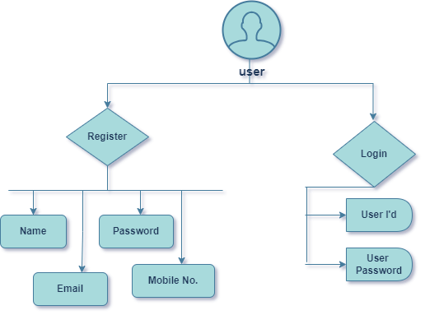

**ER Diagram**

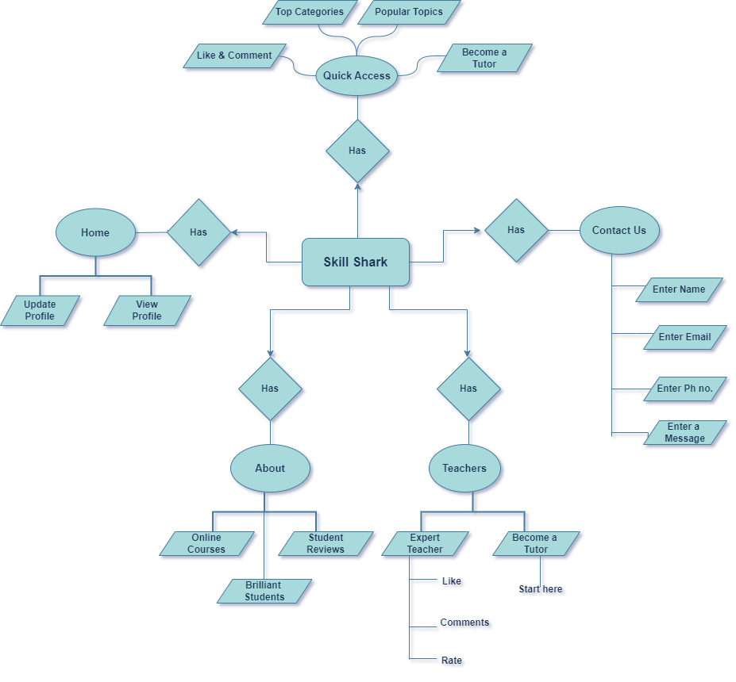

1. **Tool Used**

**Front-End:** HTML for structure, CSS for styling, and JavaScript for functionality.

**Open Educational Resources**: A OEd is utilized for education resources platforms like Khan Academy, Coursera, OpenStax.

**Version Control:** Git for collaborative development and source code management.

**Text Editor/IDE:** A text editor or integrated development environment, such as Visual Studio Code, is used for coding.

**Browser Dev Tools:** Browsers' developer tools for debugging and testing.

1. **Expected Output**

* **User Registration and Authentication**: Users can create accounts and log in securely.
* **Courses and Modules**: Users can browse through the available courses and modules covering various subjects and topics.
* **Responsive Design**: The application is designed to work seamlessly on different devices and screen sizes.
* **Browsing SkillShark Catalog**: Users can search, browse, and explore a vast education catalog with filtering and sorting options.
* **Personalized Learning Paths**: Users receive personalized recommendations for learning paths based on their interests, goals, and learning preferences
* **Lesson Plans**: Each course typically includes a structured lesson plan outlining the topics covered and the sequence of learning activities.
* **User Library:** Users can save their lectures to watch later and playlists in their library.
* **SkillShark Management:** Users can create, edit, and delete custom playlists, as well as reorder lectures within them.

# **SWOT Analysis**

**Strengths:**

1. User Experience

2. Customization

3. Responsive Design

4. **Personalized Learning Experience**

**Weaknesses:**

1. Competition

2. Resource Intensive

3. Backend Complexity

4. **Limited Course Offerings**

**Opportunities:**

1. **Expansion of Course Offerings**

2. Partnerships

3. Monetization

4. **Global Reach**

**Threats:**

1. Licensing and Legal Issues

2. Changing Market Trends

3. Cybersecurity and Data Privacy

4. Competitor Responses

1. **Bibliography**

* **W3Schools** Online Web Tutorials.
* GitHub Guides.
* utilized AI assistance from ChatGPT, developed by OpenAI.