# **Building an Event-Driven Architecture on AWS: S3, Lambda, and SNS Integration**

**Project Goal:**   
Create a system that automatically notifies users when an image is uploaded to a specific location with AWS.  
  
**Technologies:**   
We'll use Amazon Web Services (AWS) tools like S3(Simple Storage Service), Lambda, and SNS(Simple Notification Service) to achieve this.  
  
HOW IT WORKS  
**Project Architecture**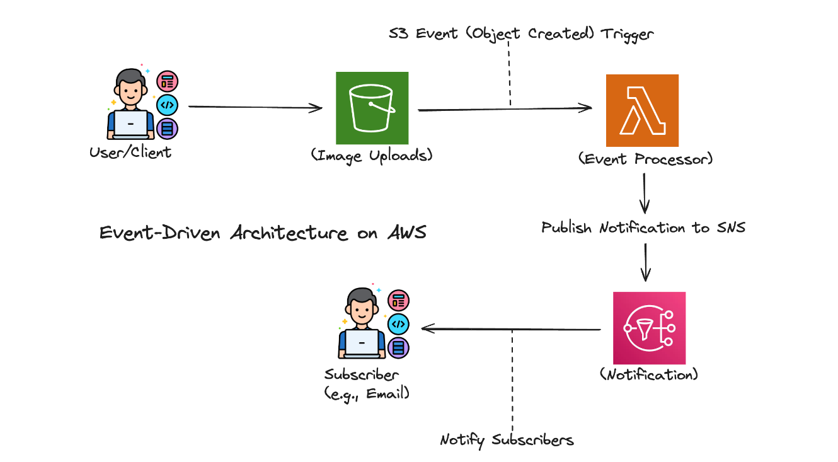

### Steps to Build the Project:

* **Step 1: Set Up an AWS Account (if already have sign in)**
* **Step 2: Create an S3 Bucket (S3 Bucket Name(for eg):my-eda)** · Click the "Create bucket" button.

· Enter a **unique bucket name**. Bucket names must be globally unique.

· Choose a **region** for your bucket. The region you choose affects the latency and costs associated with accessing your bucket.

· Click the "Create bucket" button again to confirm.

* **Step 3: Create an SNS Topic (SNS Topic Name: ImageUploadNotification)** · Click on "Create Topic".  
   · Give your topic a **name** and select a **platform**. The platform determines the type of subscribers that can subscribe to the topic (e.g., Amazon SQS queues, email addresses, HTTP endpoints, etc.).  
   · Click "Create topic".
* **Step 4: Create a Subscription**  
  · Click on the "Create subscription" button.  
  · Select the protocol for your endpoint (e.g., email, SQS, Lambda, HTTP).  
  · Enter the endpoint details (e.g., email address, SQS queue URL, Lambda function ARN, HTTP endpoint URL).  
  · Choose a protocol version (e.g., email, SQS, Lambda, HTTP).  
  · Click "Create subscription".
* **Step 5: Create a Lambda Function (Lambda Function Name:** ImageUploadProcessor)  
  · Click on "Create function".  
  · Choose a **name** for your function.  
  · Select a **runtime** (e.g., Node.js, Python, Java).  
  · Choose a **role** that grants your function the necessary permissions (you can create a new role or use an existing one).  
  · Click "Create function".
* **Step 6: Add S3 trigger**  
  · In the "Triggers" section, click the "Add trigger" button.  
  · Select "S3" as the event source.  
  · Choose the **S3 bucket** you want to monitor.  
  · Select the **event type** (e.g., "Object Created", "Object Modified").  
  · Configure any **additional settings** (e.g., prefixes or suffixes).  
  · Click "Add".
* **Step 7: Write Lambda Function Code**
* **Step 8: Test the System**

**EXPECTED OUTCOME:**Following this guide will result in a simple event-driven application on AWS, illustrating the key principles of EDA