ASSIGNMENT 1 — Web Development Fundamentals
1. Difference between Frontend, Backend, and Full-Stack Development
Frontend Development
Frontend development deals with the visual part of a website that users interact with directly. It includes designing layouts, buttons, forms, animations, and user interfaces.
Technologies used:
- HTML → Structure of web pages
- CSS → Styling and design
- JavaScript → Interactivity
Example:
The login page of Instagram where users enter their username and password is frontend development.

Backend Development
Backend development deals with the server-side logic of a website. It manages databases, authentication, business logic, and communication between the server and frontend.
Technologies used:
- Java, Python, Node.js, PHP
- Databases like MySQL, MongoDB
Example:
When you log into Instagram, the backend verifies your username and password from the database.

Full-Stack Development
Full-stack development involves working on both frontend and backend parts of a website.
Example:
A full-stack developer can create an entire e-commerce website including:
- Product pages (frontend)
- Payment processing (backend)
- Product database (database)

2. Client-Server Model Diagram
Client
(Browser/User)
|
| HTTP Request
↓
Web Server
|
| Process Request
↓
Application Server
|
| Query Data
↓
Database
|
| Response
↓
Client
(Web Page Displayed)
Explanation:
The client sends requests to the server. The server processes the request, communicates with the database if required, and sends the response back to the client.

3. How a Browser Requests and Displays a Web Page
- User enters a website URL in the browser.
- Browser finds the IP address of the website using DNS.
- Browser sends an HTTP/HTTPS request to the web server.
- The server processes the request and sends HTML, CSS, and JavaScript files.
- Browser downloads these files.
- The rendering engine converts the code into a visual webpage.
- The webpage is displayed to the user.
Example:
When entering www.google.com, the browser requests Google’s server and displays the search page.

4. Tools Required for Web Development Environment
Tool | Purpose
VS Code | Code editor used for writing HTML, CSS, and JavaScript
Web Browser | Used for testing and viewing websites
Git | Version control system to track code changes
Node.js | Allows running JavaScript outside the browser
npm | Package manager for installing libraries
Database System | Stores and manages application data
Developer Tools | Helps debug and inspect webpages

5. What is a Web Server? Examples
A web server is software or hardware that stores website files and delivers them to users when requested through a browser.
Functions:
- Receives client requests
- Processes requests
- Sends webpages to users
Examples:
- Apache HTTP Server
- Nginx
- Microsoft IIS
- LiteSpeed
- Node.js Server

6. Roles of Frontend Developer, Backend Developer, and Database Administrator
Frontend Developer
Responsibilities:
- Creates user interfaces
- Designs webpage layouts
- Implements animations and interactions
- Ensures responsive design

Backend Developer
Responsibilities:
- Creates server-side logic
- Develops APIs
- Handles authentication
- Connects applications with databases

Database Administrator (DBA)
Responsibilities:
- Manages databases
- Ensures data security
- Performs backups
- Maintains database performance

7. VS Code Setup for HTML, CSS, and JavaScript Development
Steps:
- Download and install VS Code.
- Install useful extensions:
  - Live Server
  - HTML CSS Support
  - JavaScript Extension Pack
- Create project folder.
- Create files:
  - index.html
  - style.css
  - script.js
- Open the folder in VS Code.
- Run using Live Server extension.
Screenshot:
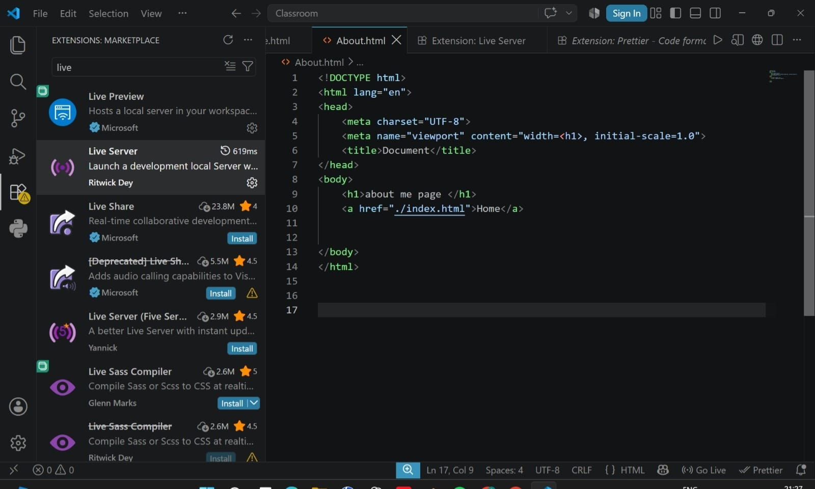

8. Difference Between Static and Dynamic Websites
Static Website | Dynamic Website
Content remains the same | Content changes based on user interaction
Uses HTML and CSS | Uses backend languages and databases
Faster and simpler | More complex
No database required | Usually requires database
Example of Static Website:
Portfolio website containing fixed information.
Example of Dynamic Website:
Amazon website where products and recommendations change for every user.

9. Five Web Browsers and Their Rendering Engines
Browser | Rendering Engine
Google Chrome | Blink
Microsoft Edge | Blink
Mozilla Firefox | Gecko
Safari | WebKit
Opera | Blink
Difference Between Rendering Engines:
A rendering engine converts HTML, CSS, and JavaScript into a webpage.
- Blink: Used by Chrome and Edge; fast and optimized.
- Gecko: Used by Firefox; focuses on standards and customization.
- WebKit: Used by Safari; optimized for Apple devices.

10. Basic Web Architecture Flow Diagram
User
|
↓
Client Browser
|
HTTP Request/API Call
|
↓
Server
|
----------------
| |
↓ ↓
Application APIs
Logic |
| |
↓ ↓
Database
|
|
Data Response
|
↓
Client Browser
(Web Page)
Components:
- Client: User's browser that sends requests.
- Server: Processes requests and sends responses.
- Database: Stores application data.
- API: Allows communication between different software components.

