Data Technician
Week 2 Workbook
Tableau

Name: Riya Mahajan
Course Date: 21/09/2026
Table of contents
Day 1: Task 1 3
Day 1: Task 2 (Optional) 3
Day 1: Task 3 4
Day 2: Task 1 4
Day 2: Task 2 8
Course Notes 17
Additional Resources to learn and Practice 18

Day 1: Task 1

Please research the different versions of Tableau, compare them below and explain the limited functionality on ‘Tableau Public’.

Different Tableau versions | Tableau version | Main purpose | Key features
 | Tableau Desktop | Creating and analysing visualisations | Connects to many data sources, data preparation, interactive dashboards and analysis. It can work offline.
 | Tableau Cloud | Sharing and managing Tableau content online | Fully hosted cloud platform for securely publishing, sharing and managing dashboards and data without maintaining servers.
 | Tableau Server | Organisation-controlled Tableau environment | Self-hosted solution that can be deployed on an organisation's infrastructure or cloud, giving organisations greater control over their data and analytics environment.
 | Tableau Public | Learning, portfolios and sharing public data | Free platform for creating and publicly sharing interactive visualisations. It is intended for data that can be made public.

Day 1: Task 2 (Optional)
Please access and complete the DataCamp course.
Introduction to Tableau - DataCamp Learn

Paste your XP here. | I already have a previous work experience with tableau and also had a good refresh during the week 2 sessions, hence skipping this :)

Day 1: Task 3

Please attach the screenshot and link to your EMSI Job Change (GB Employment) dashboard below.

Paste your print screen here | 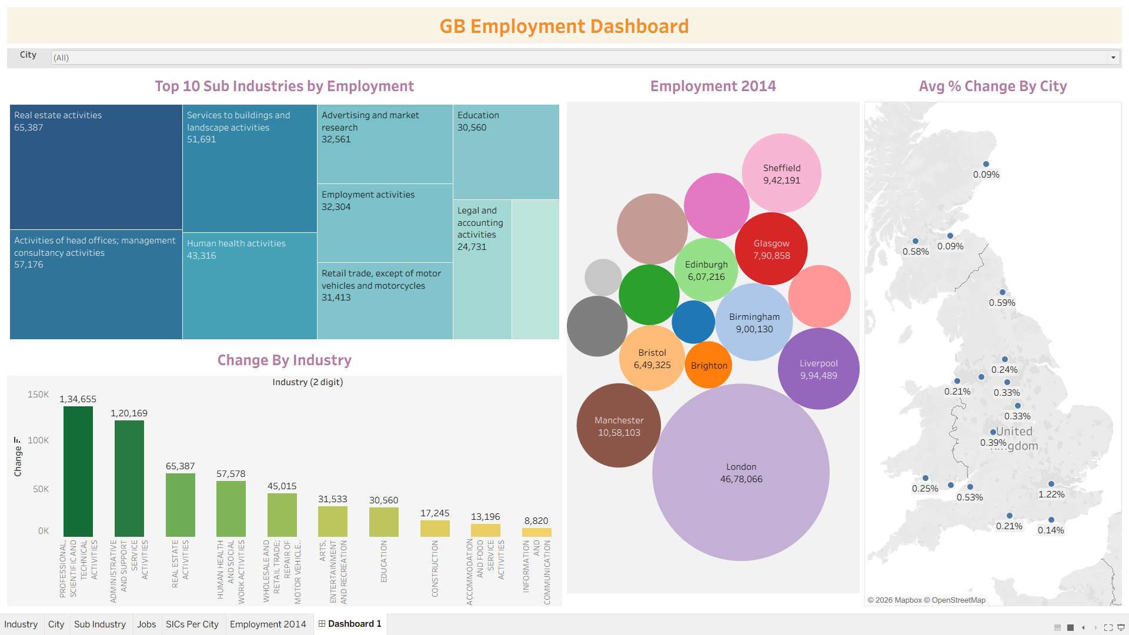
Link to your dashboard | https://public.tableau.com/app/profile/riya.mahajan3088/viz/GBEmploymentData_17900033303860/Dashboard1

Day 2: Task 1
Start new Tableau page.
Download GapminderHealth.xlsx dataset.
Using the Health GapminderHealth dataset, conduct an analysis to find trends and key information that could be used by an organisation for future support.

Column Name | Description | Data Type | Example
Continent | Continent where the country is located. | Text | Asia
Country | Name of the country. | Geographic | Afghanistan
Year | Year of observation or measurement. | Numeric | 1990
Life Expectancy | Average number of years a person is expected to live at birth. | Numeric | 48.9
Gender | Gender group for which the metrics are reported. | Text | Women
BMI | Average Body Mass Index of the population. | Numeric | 20.7
Blood Pressure | Average blood pressure measurement of the population. | Numeric | 124
Cholesterol | Average cholesterol level of the population. | Numeric | 4.55
Lung Cancer | Lung cancer incidence | Numeric | 194
Liver Cancer | Liver cancer incidence | Numeric | 107
Stomach Cancer | Stomach cancer incidence | Numeric | 406
Population | Total population of the country for the specified year. | Numeric | 6,067,694
Population Growth | Annual population growth rate expressed as a percentage. | Decimal (%) | 6.75

Scenario:
You are a data analyst working for a global health organization. Your team needs to quickly understand key health trends and disparities across different countries and continents. They are particularly interested in seeing how health metrics vary and how life expectancy has changed over time.
Your Task:
Using the GapminderHealth dataset in Tableau, create a series of visualizations to answer the following questions. Focus on using basic chart types and features.

Instructions & Deliverables:
- Life Expectancy by Continent (Most Recent Year):
  - Create a bar chart showing the average Life Expectancy for each Continent.
  - Filter the data to show only the most recent year available in the dataset.
  - Sort the continents by Life Expectancy in ascending or descending order.
  - Deliverable: A worksheet named "Life Expectancy by Continent".

- Life Expectancy Trend Over Time (Top 5 Countries):
  - Create a line chart to show the trend of Average Life Expectancy over Year.
  - Filter the data to display only the top 5 countries with the highest average Life Expectancy across all years. (Hint: Use a Top N filter on Country based on Average Life Expectancy).
  - Use Country on Colour to differentiate the lines.
  - Deliverable: A worksheet named "Life Expectancy Trend".

- Population Distribution by Gender (Latest Year for a Selected Country):
  - Create a pie chart showing the Population distribution by Gender.
  - Add a Country filter to the worksheet (e.g., set it to 'United States' or a country of your choice initially, but ensure the filter is available for interaction). Change filter type to Single Value (dropdown).
  - Filter the data to show only the most recent year available in the dataset.
  - Add Population to Labels. Right click on sum (Population) under marks card and change Quick table calculation to Percentage of Total.
  - Deliverable: A worksheet named "Population by Gender".

- Health Metric Comparison (Scatter Plot):
  - Create a scatter plot to explore the relationship between Average Life Expectancy and Average BMI.
  - Place Life Expectancy on one axis and BMI on the other.
  - Use Country on Detail to represent individual countries as points.
  - Use Continent on Colour to differentiate points by continent.
  - Add Continent to filters and show filter.
  - Deliverable: A worksheet named "Life Expectancy vs BMI".
- Viz of your Choice
  - Use any other fields or chart types to add another visual.

- Dashboard Creation:
  - Combine all worksheets (Life Expectancy by Continent, Life Expectancy Trend, Population by Gender, Life Expectancy vs BMI, Viz of your Choice) into a single dashboard.
  - Ensure the "Country" filter on the "Population by Gender" worksheet applies to the "Life Expectancy Trend" worksheet as well (if applicable or make it a global filter if you prefer the user to select one country to see all relevant details for it). Self-correction: Given it's basic, let's keep the filters simple. Just place the filter on the dashboard and ensure it's applied to the relevant sheet(s) where it makes sense.
  - Add a Title to your dashboard, e.g., "Global Health Insights".
  - Publish your dashboard to Tableau Public Website
  - Deliverable: A dashboard named "Global Health Dashboard".

Paste your dashboard screens here | 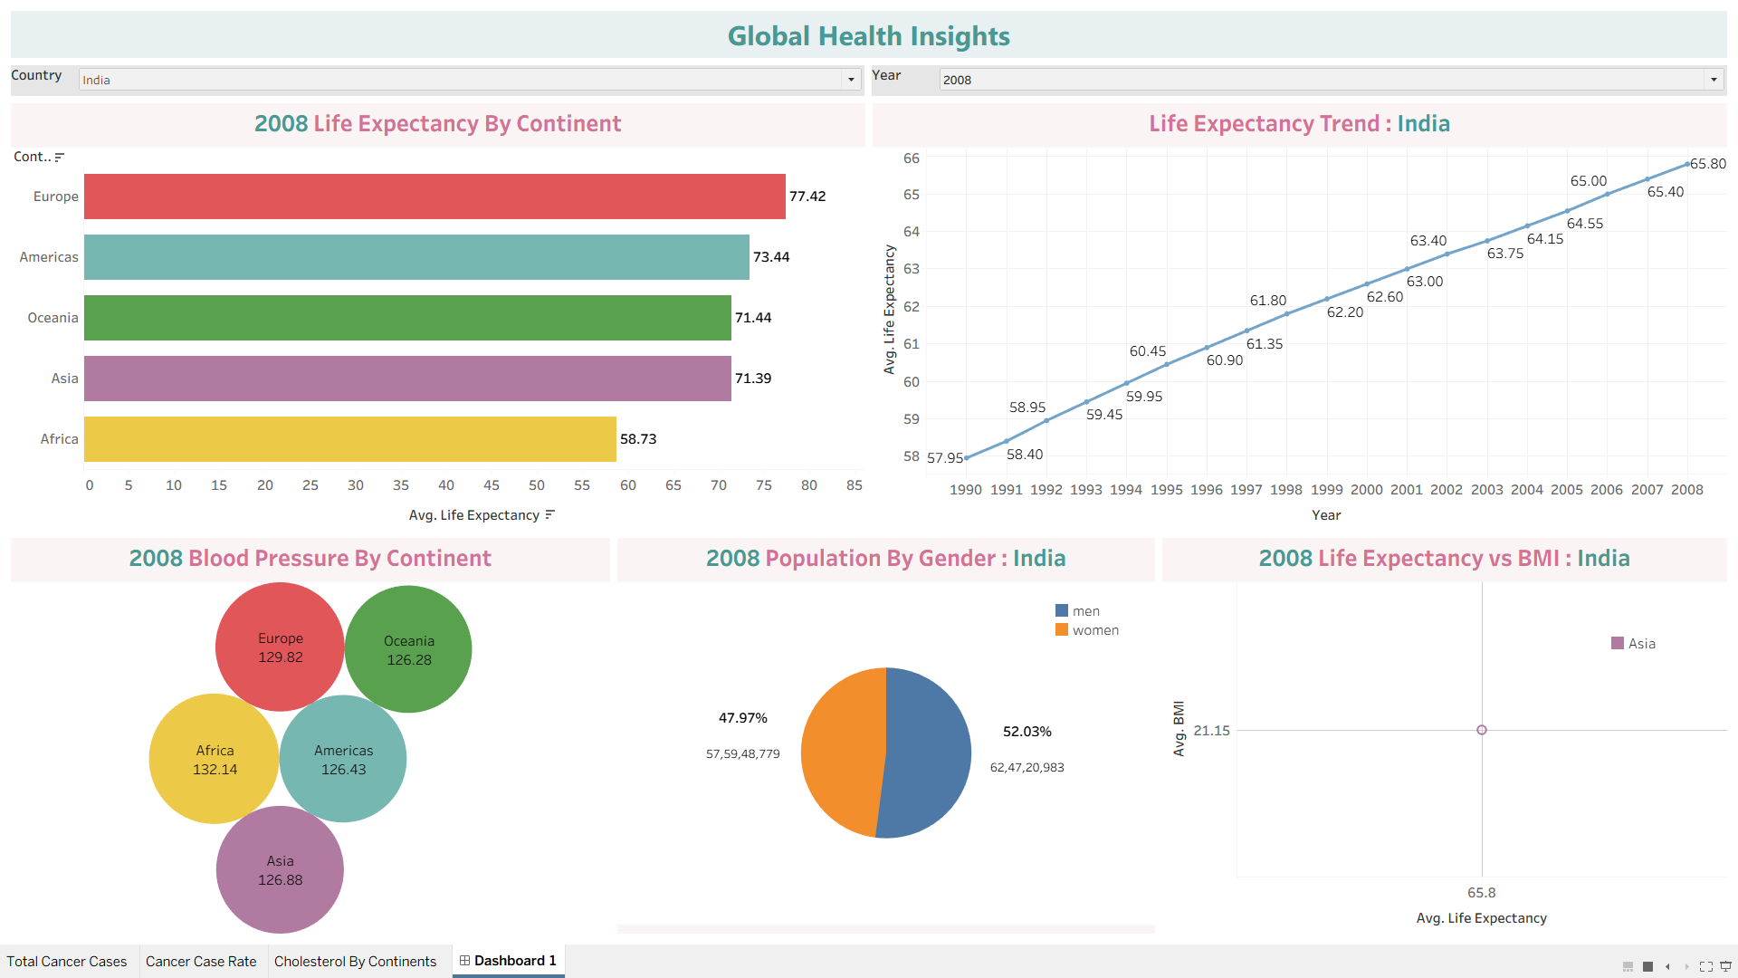
What did you find and any reflections on how the NHS could use this? | Key Findings:  - Europe had the highest life expectancy in 2008 at 77.42 years, while Africa had the lowest at 58.73 years.  - Africa had the highest average blood pressure at 132.14  - India’s life expectancy steadily increased from 57.95 years in 1990 to 65.80 years in 2008.  Reflections:  The NHS could use insights like these to spot health trends, identify areas that may need more attention, and better target prevention and healthcare programmes. Combining this data with demographic and socioeconomic information would give a fuller picture and support better-informed decisions.
Link to your dashboard | https://public.tableau.com/app/profile/riya.mahajan3088/viz/GlobalHealthDashboard_17900837368200/Dashboard1

Once you finish this task save and close Tableau.

Day 2: Task 2
Start Tableau Public Desktop and import the Spotify dataset SpotifyFeatures.xlsx, conduct an analysis to find trends and key information that could be used by an organisation for future projects.
Column Description
- genre: The genre in which the track belongs
- artist_name: The artists' names who performed the track.
If there is more than one artist, they are separated by a;
- track_name: Name of the track
- track_id: The Spotify ID for the track
- popularity: The popularity of a track is a value between 0 and 100, with 100 being the most popular. The popularity is calculated by algorithm and is based, in the most part, on the total number of plays the track has had and how recent those plays are. Songs that are being played a lot now will have a higher popularity than songs that were played a lot in the past. Duplicate tracks (e.g. the same track from a single and an album) are rated independently. Artist and album popularity is derived mathematically from track popularity.
- acousticness: A confidence measure from 0.0 to 1.0 of whether the track is acoustic. 1.0 represents high confidence the track is acoustic
- danceability: Danceability describes how suitable a track is for dancing based on a combination of musical elements including tempo, rhythm stability, beat strength, and overall regularity. A value of 0.0 is least danceable and 1.0 is most danceable
- duration_ms: The track length in milliseconds
- energy: Energy is a measure from 0.0 to 1.0 and represents a perceptual measure of intensity and activity. Typically, energetic tracks feel fast, loud, and noisy. For example, death metal has high energy, while a Bach prelude scores low on the scale
- instrumentalness: Predicts whether a track contains no vocals. "Ooh" and "aah" sounds are treated as instrumental in this context. Rap or spoken word tracks are clearly "vocal". The closer the instrumentalness value is to 1.0, the greater likelihood the track contains no vocal content
- key: The key the track is in. Integers map to pitches using standard Pitch Class notation. E.g. 0 = C, 1 = C♯/D♭, 2 = D, and so on. If no key was detected, the value is -1
- liveness: Detects the presence of an audience in the recording. Higher liveness values represent an increased probability that the track was performed live. A value above 0.8 provides strong likelihood that the track is live
- loudness: The overall loudness of a track in decibels (dB)
- mode: Mode indicates the modality (major or minor) of a track, the type of scale from which its melodic content is derived. Major is represented by 1 and minor is 0
- speechiness: Speechiness detects the presence of spoken words in a track. The more exclusively speech-like the recording (e.g. talk show, audio book, poetry), the closer to 1.0 the attribute value. Values above 0.66 describe tracks that are probably made entirely of spoken words. Values between 0.33 and 0.66 describe tracks that may contain both music and speech, either in sections or layered, including such cases as rap music. Values below 0.33 most likely represent music and other non-speech-like tracks
- tempo: The overall estimated tempo of a track in beats per minute (BPM). In musical terminology, tempo is the speed or pace of a given piece and derives directly from the average beat duration
- time_signature: An estimated time signature. The time signature (meter) is a notational convention to specify how many beats are in each bar (or measure). The time signature ranges from 3 to 7 indicating time signatures of 3/4, to 7/4.
- valence: A measure from 0.0 to 1.0 describing the musical positiveness conveyed by a track. Tracks with high valence sound more positive (e.g. happy, cheerful, euphoric), while tracks with low valence sound more negative (e.g. sad, depressed, angry)

There is no set scope for the analysis, simply to find trends and document them below:

Paste your print screens here | 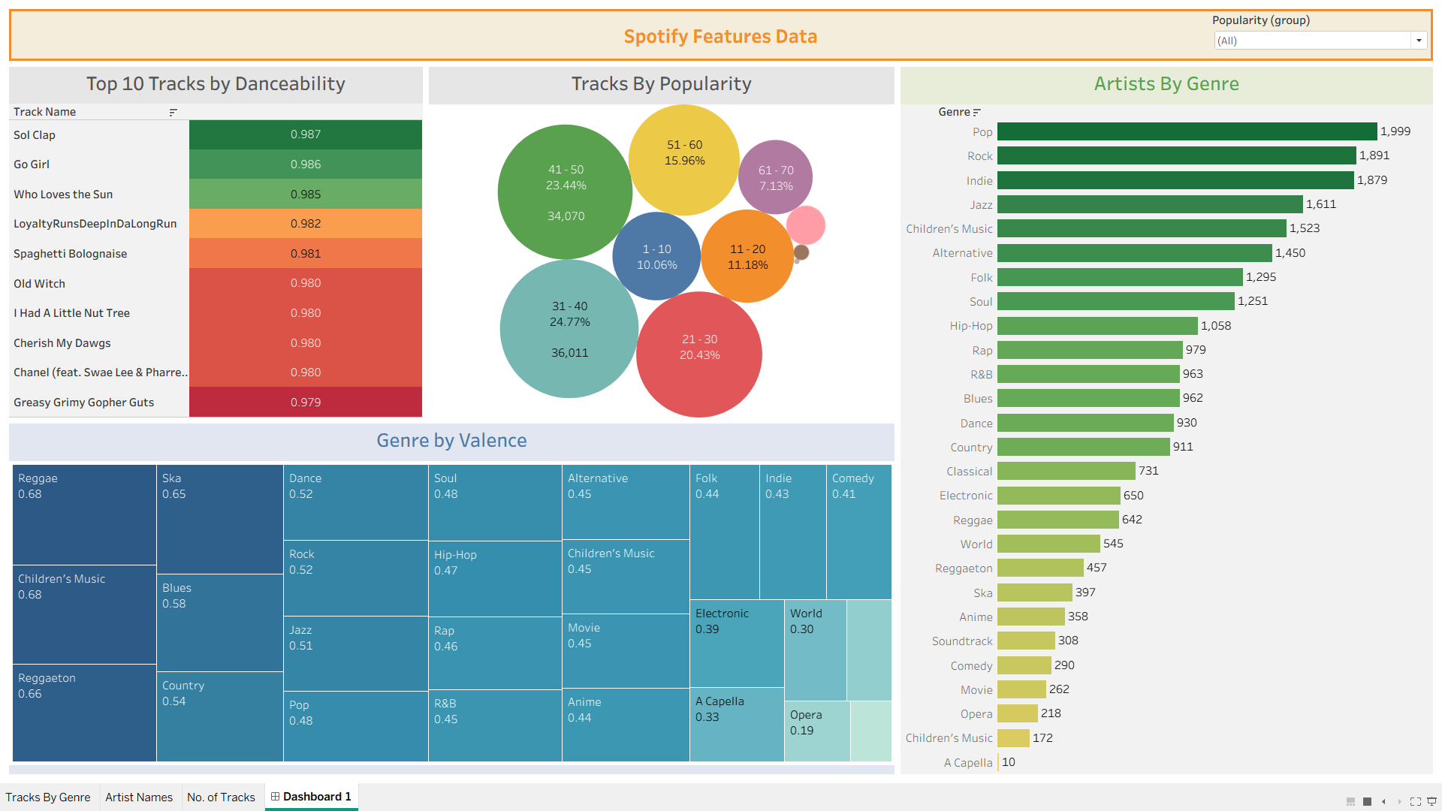

What did you find? | Key Findings  - The top tracks by danceability are extremely high, with the highest reaching 0.987, showing that some tracks are particularly suited to dance-focused listening.  - Most tracks fall into the 31–50 popularity range, together making up almost half of the tracks shown.  - Pop is the most represented genre, with around 2,000 artists, followed by Rock and Indie.  - Reggae and Children’s Music have the highest average valence (0.68), suggesting these genres tend to have a more positive or upbeat feel.  Overall: The dashboard shows that Spotify’s music catalogue is heavily represented by genres like Pop and Rock, while mood and danceability vary considerably across genres.
Link to your dashboard | https://public.tableau.com/app/profile/riya.mahajan3088

Course Notes

It is recommended to take notes from the course, use the space below to do so, or use the revision guide shared with the class:

Additional Resources to learn and Practice

- Full Beginner Project in Tableau | Tableau Tutorials for Beginners
- Learn Tableau Basic Calculations (Calculated Fields) in Tableau (with 10+ examples) | Part 1
- Tableau Hands-on Challenges Trailmix | Salesforce Trailhead
- Introduction to Tableau - DataCamp Learn
- Creating Dashboards in Tableau - DataCamp Learn
- Sample Data | Tableau Public
- How-To Videos | Tableau Public
- Analyzing Data in Tableau - DataCamp Learn
- Creating Dashboards in Tableau - DataCamp Learn

END OF WORKBOOK

Please check through your work thoroughly before submitting and update the table of contents if required.

Please send your completed work booklet to your trainer.

