A

Project Report on

**Expense Tracker**

**(Elective Module: 3)**

Submitted in partial fulfillment of completion of the course

Advanced Diploma in IT, Networking and Cloud Computing

Submitted by:

**HENA DHAWA**

**NISHAT PERWEZ**

**SK RAJESH**

**RIYA SHARMA**

Under Guidance of:

**ARPITA ROY (Edunet)**

**SAYANTI MANNA (Edunet)**



Year 2024

**PROJECT OVERVIEW**

Abstract

Acknowledgement

Team Composition and Workload Division

Table of Contents

1. Introduction to Problem

2. Proposed Solution

3. Requirements

4.1 Technology Stack

4.2 Hardware

4.3 Software

4.4 Deployment Environment

5. User Requirements

6. Implementation Details

7. Testing

8. Deployment

9. ER Diagram

10. Future Scope

11. Conclusion

Appendix A Screenshot of Project

References

**ABSTRACT**

The Expense Tracker project based on the MEAN (MongoDB, Express.js, Angular, Node.js) stack aims to provide users with a comprehensive platform for managing their expenses efficiently. The application facilitates users in tracking their spending habits, categorizing expenses, and generating insightful reports for better financial management. Users can securely log in, add, edit, and delete expenses, as well as set budget limits and receive notifications when nearing or exceeding these limits. The platform leverages MongoDB as the database to store expense data, Express.js for server-side routing and handling requests, Angular for building a dynamic and interactive user interface, and Node.js to power the backend server. By harnessing the power of the MEAN stack, the Expense Tracker project offers a seamless and intuitive experience for users to gain insights into their spending patterns and make informed decisions to achieve financial goals.

**ACKNOWLEDGEMENT**

We would like to express our sincere gratitude to all those who have supported and contributed to the successful completion of this project. Your assistance and encouragement have been invaluable throughout this journey.

First and foremost, we want to thank my project supervisors, Arpita Roy(Edunet) and Sayanti Manna(Edunet), for their guidance, expertise, and unwavering support. Their insights and feedback have been instrumental in shaping the direction of this project.

We would also like to extend my appreciation to my fellow classmates who provided valuable input, shared resources, and engaged in stimulating discussions that enriched the project. Your collaborative spirit was a driving force behind our achievements.

Furthermore, we want to acknowledge our friends and family for their patience, understanding, and encouragement throughout this endeavour. Your support provided the motivation we needed to see this project through to its completion.

Last but not least, we are grateful to the entire faculty and staff of NSTI Howrah for providing a conducive learning environment and the necessary resources to undertake this project.

This project has been a rewarding learning experience, and we are thankful for the collective efforts of everyone involved. Your support has been instrumental in making this project a reality.

Thank you all for being a part of this journey.

Hena Dhawa, Nishat Perwez, Riya Sharma, SK Rajesh

NSTI Howrah

27/03/2024

**TEAM COMPOSITION AND WORKLOAD DIVISION**

The team composition for the "Expense Tracker Project on MEAN stack" can vary depending on the project's complexity, goals, and scope. This is the team composition:

1. Riya Sharma (Project Leader): Responsible for overseeing the entire project, coordinating tasks, managing timelines, and ensuring communication within the team and stakeholders.

2. Hena Dhawa (Web Developer): Responsible for building the user interface and ensuring a seamless user experience. Responsible for developing the server-side logic, handling data storage, and ensuring the smooth functioning of the application's backend.

3.Nishat Perwez (Web Developer): Responsible for building the user interface and ensuring a seamless user experience. Responsible for developing the server-side logic, handling data storage, and ensuring the smooth functioning of the application's backend.

4.SK Rajesh (Quality Assurance (QA) Tester):  Responsible for testing the application to identify bugs, usability issues, and performance bottlenecks.

**WORKLOAD DIVISION:**

The successful execution of this project was made possible by the collaborative efforts of each team member, who contributed their unique skills and insights.

All team members participated in designing various scenarios, conducting simulations, and evaluating system responsiveness.

Documentation and Report Writing:

Lead the documentation process, with contributions from all team members for their respective areas of expertise.

**INTRODUCTION TO PROBLEM**

**The Expense Tracker application is a full-stack web application built using the MEAN stack, which includes MongoDB, Express.js, AngularJS, and Node.js. This application allows users to create an account, log in and log out, and track their expenses by creating, reading, updating, and deleting them. The back-end provides a RESTful API with JSON Web Token (JWT) based authentication and authorization, while the front-end is a single-page application that interacts with the server. The application is built using Mongoose, a MongoDB mapper for Node.js, and provides an interface agnostic to any particular front-end client implementation. The project also includes features for generating reports of spending over time and supports two types of users: regular users and admins. Regular users can only CRUD expenses they own, while admins can read all saved expenses, including those they do not own. The project is optimized for cloud hosting and can be easily scaled to accommodate temporary usage spikes.**

Our Expense Tracker Project utilizes the capabilities of each component in the MEAN stack to create a seamless and intuitive user experience. Users can register and log in securely to access their personalized dashboard, where they can add, categorize, and manage their expenses effortlessly. The application offers features such as real-time data updates, customizable expense categories.

**PROPOSED SOLUTION**

The proposed solution for the Expense Tracker project involves the development of a web application using the MEAN stack (MongoDB, Express.js, Angular, Node.js). Here's an outline of the solution:

1. **User Authentication**: Implement user authentication to allow users to securely register and log in to their accounts. This can be achieved using technologies like JWT (JSON Web Tokens) for authentication and authorization.
2. **Expense Management**: Create functionalities for users to add, edit, and delete expenses. Each expense entry should include details such as date, amount, category, description, and any relevant tags. Users should also be able to categorize expenses for better organization and analysis.
3. **Budget Tracking**: Enable users to set budget limits for different expense categories or overall spending. The application should provide real-time updates and notifications to users when they are approaching or exceeding their budget limits.
4. **Reporting and Analysis**: Develop features to generate insightful reports and visualizations based on users' expense data. Users should be able to view summaries, charts, and graphs depicting their spending patterns over time, by category, or any custom criteria.
5. **Reminder and Notification**: Implement reminder features to prompt users about upcoming bills, payments, or deadlines. Notifications can also be sent when users exceed predefined spending thresholds or when certain expense patterns are detected.
6. **Data Security and Privacy**: Ensure robust security measures to protect users' sensitive financial data. Utilize encryption techniques to secure data storage, implement secure communication protocols, and follow best practices for user privacy.

**REQUIREMENTS ANALYSIS**

Requirements Analysis for the Expense Tracker Project includes:-

**4.1 Technology stack:-**

The expense tracker project, built on the MEAN stack, combines MongoDB, Express.js, Angular, and Node.js to deliver a robust solution for efficient expense management. MongoDB serves as the database, offering flexibility in storing various expense data. Express.js streamlines backend development by facilitating the creation of RESTful APIs for seamless interaction with the database. Angular powers the frontend, providing dynamic interfaces and enhancing user experience. Node.js enables real-time updates and scalability on the server side.

**4.2 Hardware Requirement:-**

The hardware requirements for a MEAN stack-based expense tracker project are generally moderate, with the emphasis primarily on software development and deployment. A moderately powered server or virtual machine (VM) can adequately host the application, requiring a CPU capable of efficiently handling concurrent requests, a minimum of 4GB of RAM for smooth operation, and SSD storage preferred over HDD for faster read/write operations. A stable internet connection with sufficient bandwidth is necessary for hosting the application and handling incoming requests. MongoDB, the NoSQL database utilized in the project, can run on the same server as the application or on a separate server, depending on workload and scalability needs. Developers' machines should meet minimum requirements for running development tools and IDEs, and a reliable internet connection is crucial for accessing resources and collaboration.

**4.3 Software Requirement:-**

The software requirements for a MEAN stack-based expense tracker project are essential for smooth development, deployment, and operation. The project requires Node.js and npm (Node Package Manager) for server-side JavaScript execution and dependency management, respectively. MongoDB serves as the database system, providing flexible storage for expense data. Express.js facilitates backend development by simplifying the creation of RESTful APIs for communication between the server and client. Angular is essential for building dynamic and interactive user interfaces on the frontend, ensuring a seamless user experience. Additionally, developers may use code editors or Integrated Development Environments (IDEs) such as Visual Studio Code, Sublime Text, or Atom for writing and debugging code. Version control systems like Git are vital for collaborative development, enabling multiple developers to work on the project concurrently.

**4.4 Deployment Environment:-**

The deployment environment for a MEAN stack-based expense tracker project is crucial for ensuring the application's availability, scalability, and performance. Typically, deployment environments can vary based on factors like project requirements, budget, and operational preferences. Here's an overview of deployment options:

* **Self-hosted Servers**: This option provides full control over hardware resources and network configurations but requires expertise in server management, maintenance, and security.
* **Cloud-based Platforms:** Leveraging cloud services provides scalability, flexibility, and cost-efficiency, as resources can be scaled up or down based on demand.

**User Requirement:-**

User requirements for an expense tracker application can vary depending on the target audience and specific use cases. Here's a list of common user requirements that may be relevant for such an application:

1. **User Authentication and Authorization**:

* Users should be able to register and log in securely to access the application.
* Different user roles (e.g., regular user, admin) may require varying levels of access to features and data.

**2. Expense Management:**

* Users should be able to add, edit, delete, and categorize expenses.
* The application should support various types of expenses (e.g., one-time expenses, recurring expenses, income).

**3. Data Security and Privacy:**

* Users expect their personal and financial information to be secure and protected from unauthorized access.

**IMPLEMENTATION DETAILS**

**1. Technical Specifications:**

* Frontend: Angular framework for the client-side development, utilizing TypeScript for coding.
* Backend: Node.js with Express.js framework for server-side development, utilizing JavaScript for coding.
* Database: MongoDB for storing user data, with Mongoose as the Object-Document Mapper (ODM).

**2. Coding Standards:**

* Follow Angular Style Guide and TypeScript best practices for frontend development.
* Adhere to Node.js and Express.js style guides for backend development.
* Use consistent naming conventions for variables, functions, and classes.
* Maintain code readability and consistency through proper indentation, commenting, and documentation.
* Follow SOLID principles and design patterns to ensure clean, modular, and maintainable code.

**3. Frameworks and Libraries:**

* Angular Material or Bootstrap for UI components and styling.
* Express.js middleware for handling routing, request processing, and error handling.
* Mongoose for interacting with MongoDB database, providing schema validation and data modeling.

**4. Development Environment Setup:**

* Install Node.js and npm (Node Package Manager) for backend development.
* Set up Angular CLI for frontend development.
* Install MongoDB and set up a local or cloud-based database instance.
* Set up a code editor or Integrated Development Environment (IDE) such as Visual Studio Code or WebStorm.
* Configure Git for version control and create a repository for the project.

**TESTING**

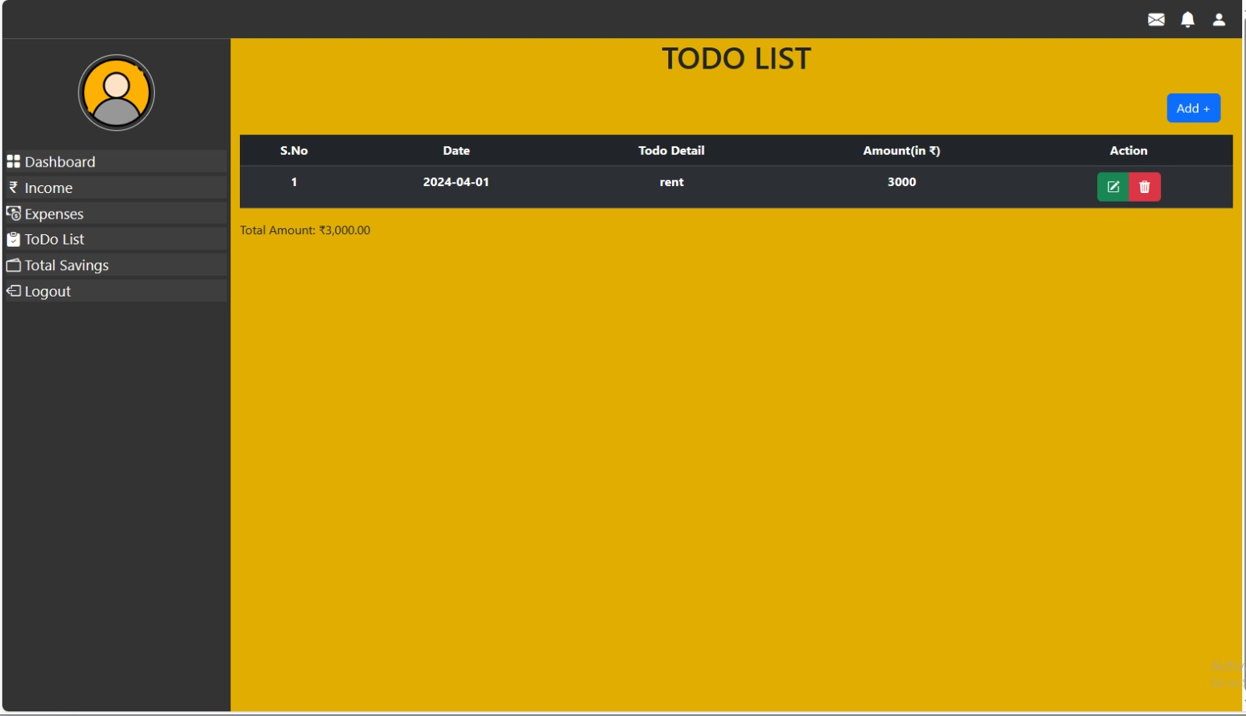

**image 1: Testing the crud operation**

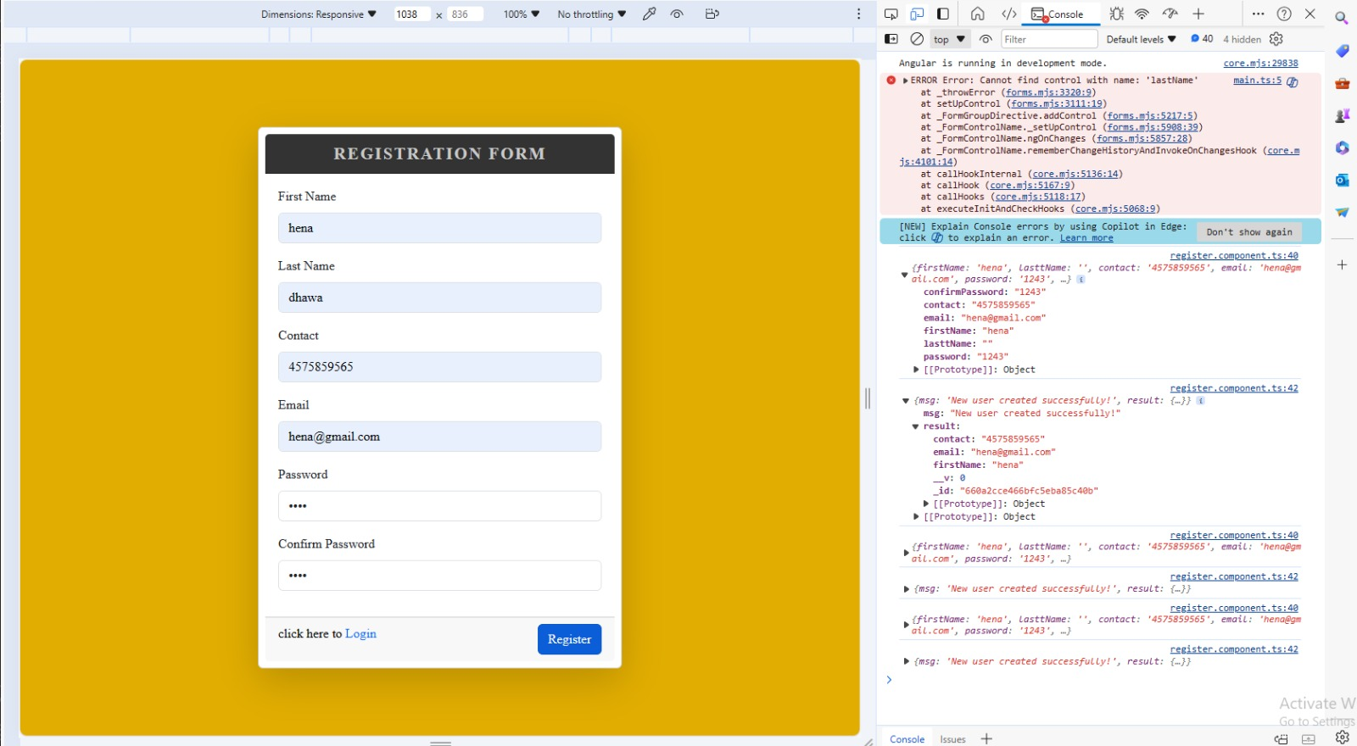

**image 2: Testing for the data storing and retrieving.**

**DEPLOYMENT**

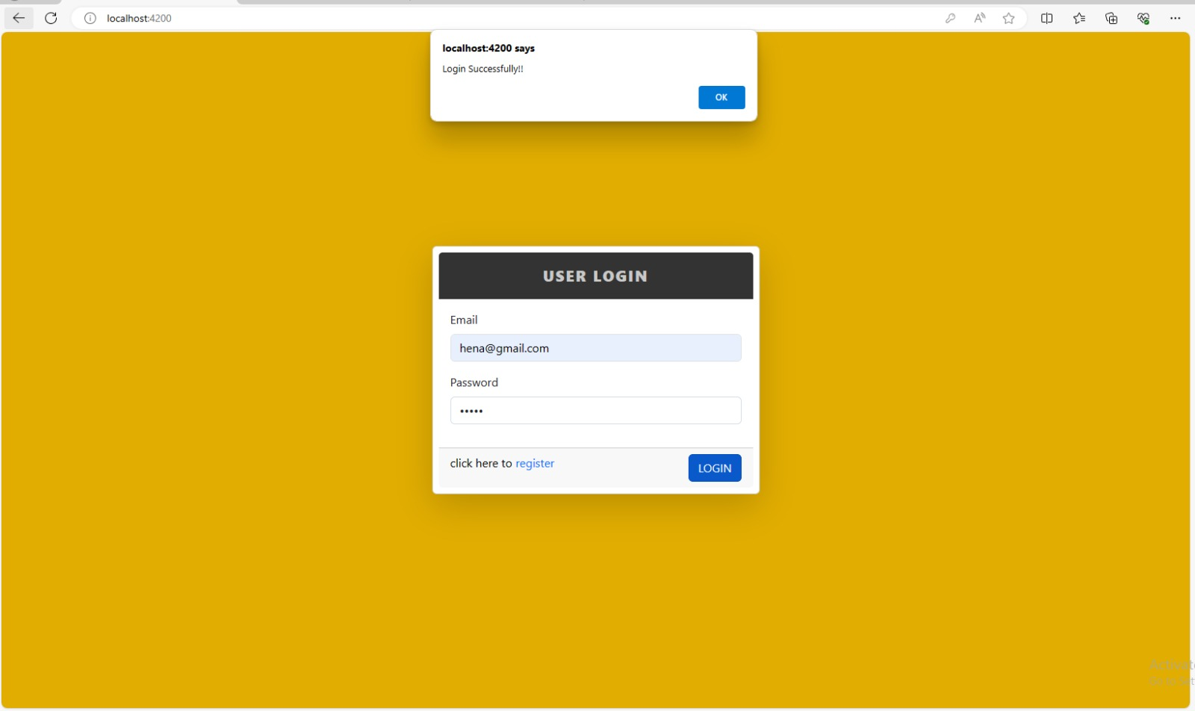

**image 3: Login page of expense tracker.**

**ER DIAGRAM**

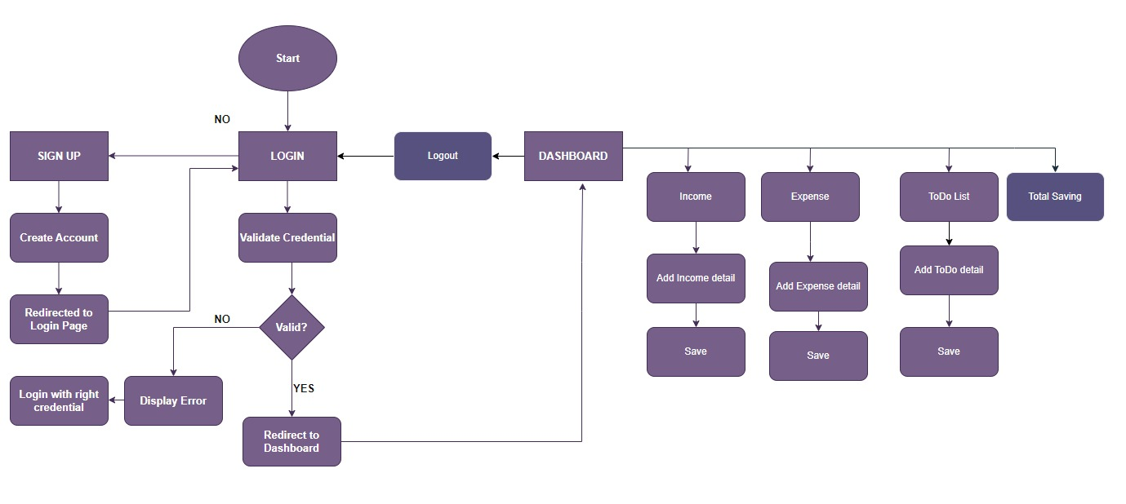

**image 4: Flow chart of expense tracker.**

**FUTURE SCOPE**

The future scope for an expense tracker project built on the MEAN stack is promising, offering avenues for substantial enhancements and expansion. Potential developments include advanced reporting and analytics capabilities, allowing users to gain deeper insights into their spending patterns and budget management. Integration with mobile platforms can extend the application's accessibility, while security enhancements ensure user data remains protected. Collaborative features enable shared expense tracking, and integration with financial institutions streamlines transaction importing. Localization and performance optimization further enhance the user experience, while CI/CD pipelines ensure efficient updates and deployment. By continuously iterating and incorporating user feedback, the project can evolve into a comprehensive financial management platform with broad market appeal.

**CONCLUSION**

In conclusion, the expense tracker project built on the MEAN stack presents a compelling solution for individuals and businesses seeking efficient and intuitive financial management tools. Through continuous refinement and enhancement, the project stands poised to address evolving user needs and market demands. By integrating advanced features such as reporting, budgeting, and collaboration, alongside robust security measures and seamless integration with financial institutions, the application offers a comprehensive solution for tracking and optimizing expenses. With a focus on user experience, performance optimization, and adherence to industry standards, the project holds significant potential to become a trusted and widely adopted platform for effective expense management. Through ongoing development and responsive iteration based on user feedback, the project is positioned for sustained growth and success in the realm of financial technology.

**APPENDIX A SCREENSHOT OF PROJECT**

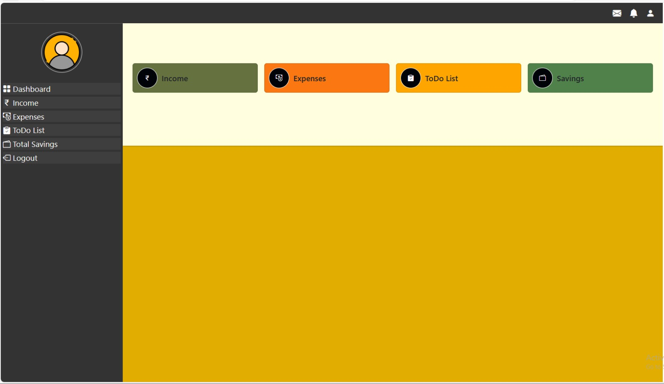

**image 5: Dashboard of expense tracker.**

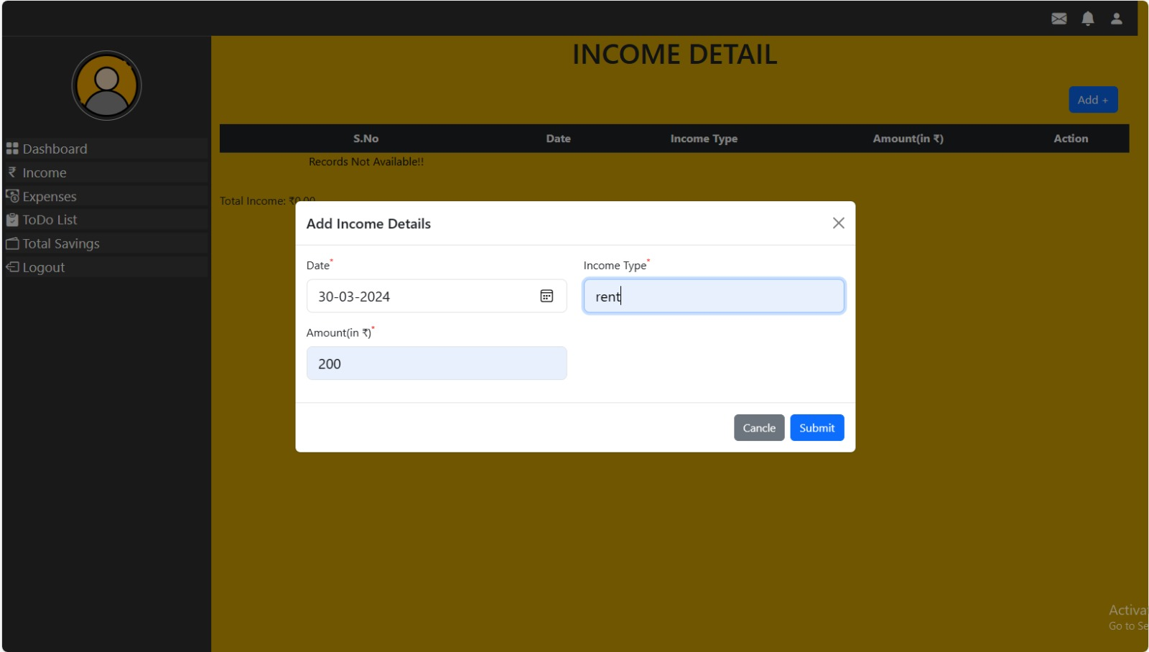

**image 6: Income detail form of expense tracker.**

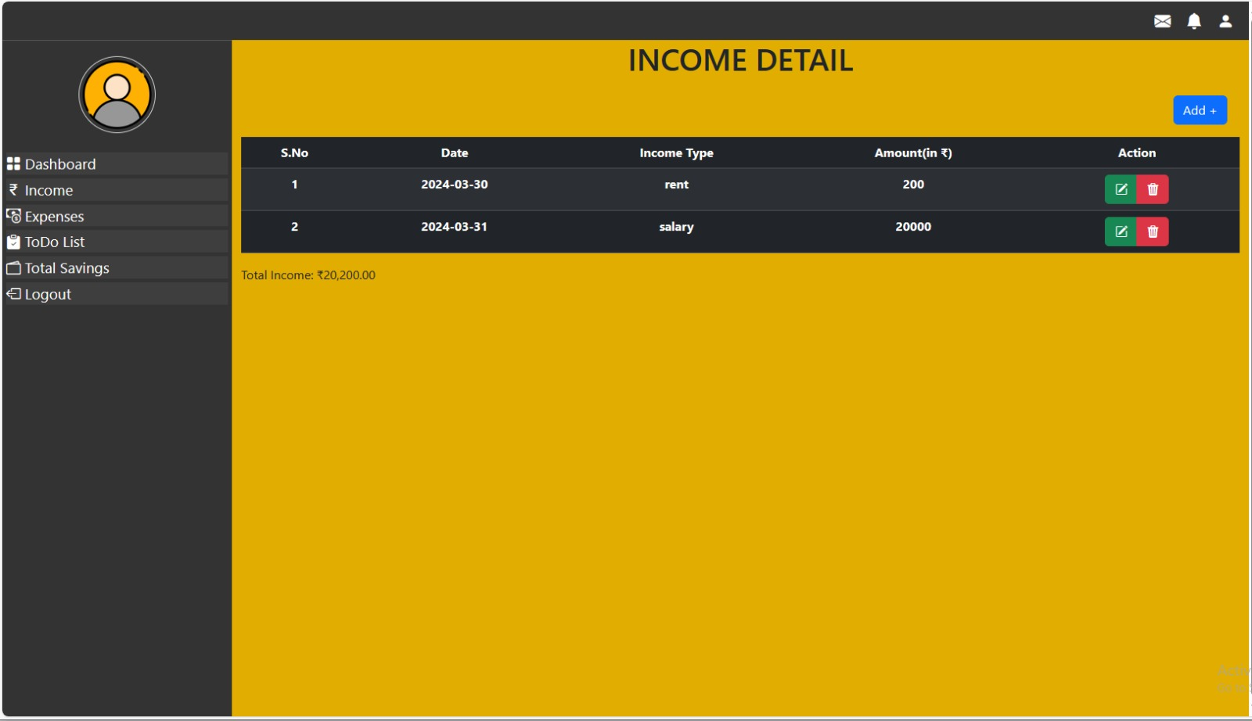

**image 7: Income detail page of expense tracker.**

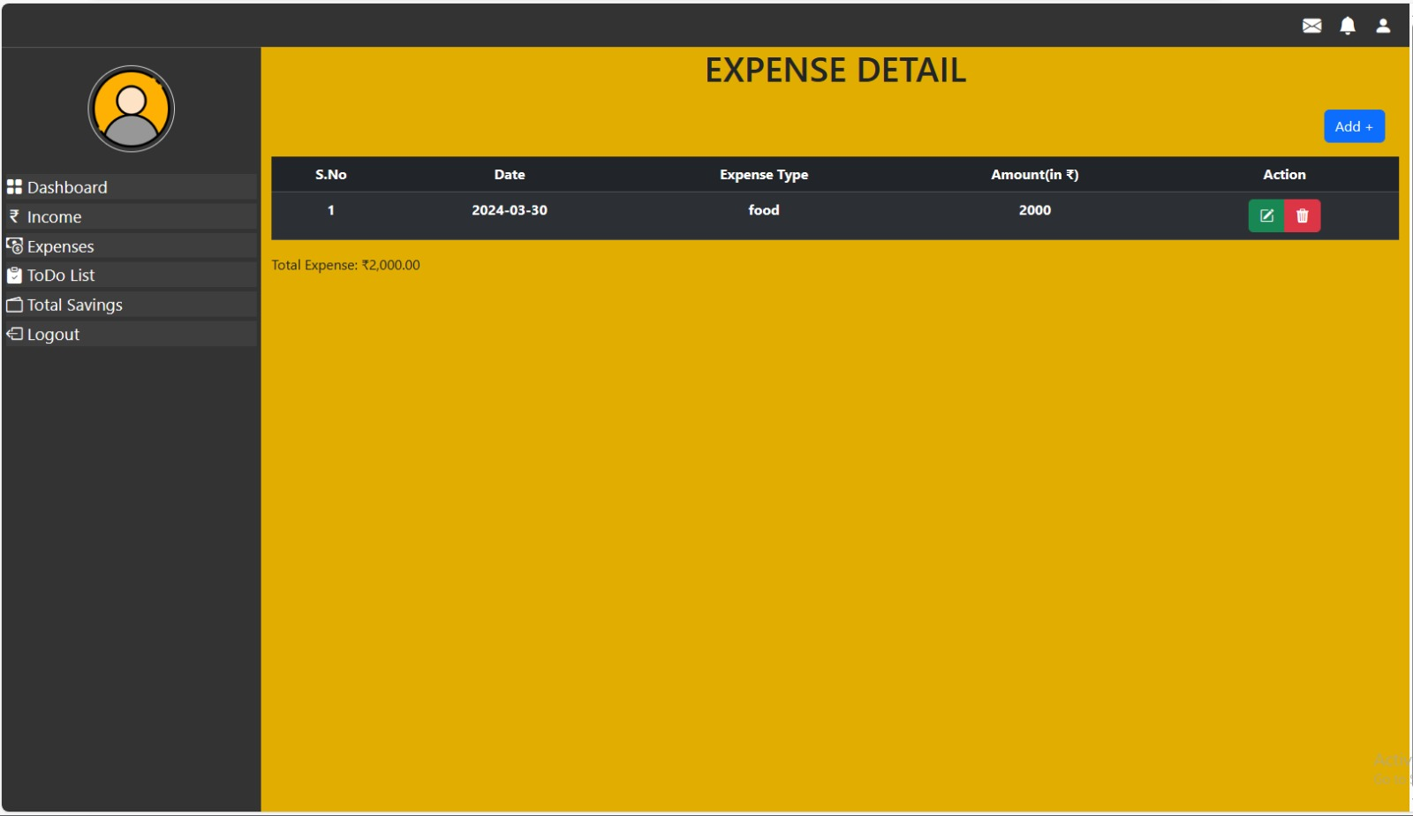

**image 8: Expense detail page of expense tracker.**



**image 9: Todo List page of expense tracker.**

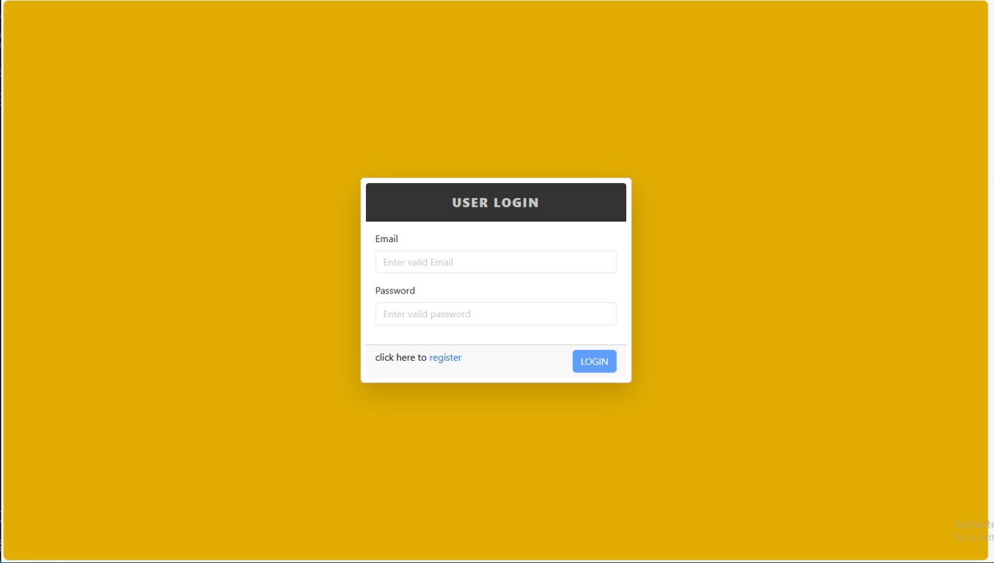

**image 10: Login page of expense tracker.**

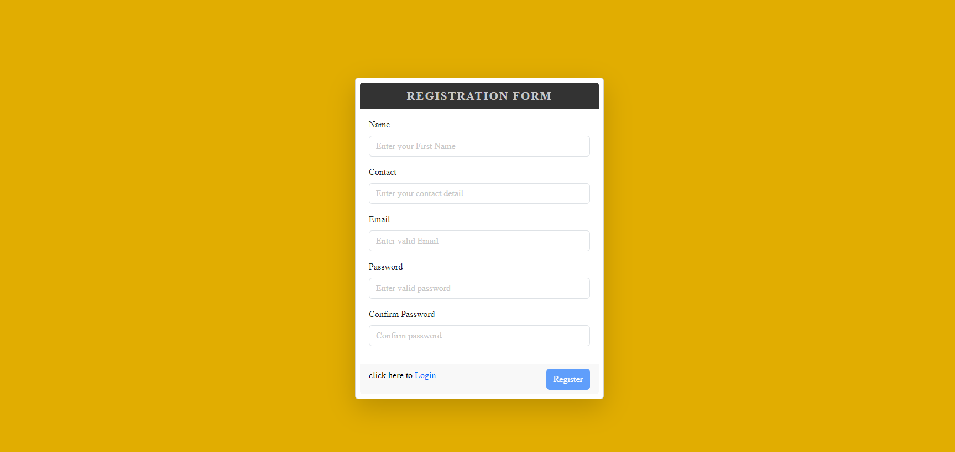

**image 11: Registration page of expense tracker.**

REFRENCES

* [www.geeksforgeeks.org](https://r.search.yahoo.com/_ylt=AwrKBX3Pyv9lY6w8EQq7HAx.;_ylu=Y29sbwNzZzMEcG9zAzEEdnRpZAMEc2VjA3Ny/RV=2/RE=1711291215/RO=10/RU=https%3a%2f%2fwww.geeksforgeeks.org%2fexpense-tracker-budget-management-using-mern%2f/RK=2/RS=uwxVw7hlAuMClV.DJOqslPVX0NA-)
* <https://docs.mongodb.com/>
* <https://expressjs.com/>
* <https://angular.io/docs>
* <https://nodejs.org/en/docs/>