**AXON CAR RETAIL ANALYSIS**

I conducted a comprehensive analysis for Axon Company, leveraging the powerful combination of Power BI and MySQL Workbench to extract invaluable insights. Through meticulous data examination, I have presented a detailed overview of the company's operations, shedding light on crucial aspects that can guide strategic decision-making.

The analysis offers a nuanced understanding of the company's dynamics, providing actionable intelligence for optimizing resource allocation. By delving into the data, we identified opportunities for expanding office locations strategically, optimizing stock quantities to meet demand efficiently, and formulating targeted customer engagement strategies.

This data-driven approach empowers Axon to navigate its business landscape with precision, making informed decisions that align with the company's growth objectives. The insights derived from the analysis serve as a compass, guiding Axon towards areas of potential expansion, efficient inventory management, and enhanced customer satisfaction.

In conclusion, this data analysis not only illuminates the current state of the company but also serves as a roadmap for future success. By harnessing the power of data, Axon can confidently steer its course towards increased operational efficacy, sustainable growth, and a more profound understanding of its market landscape.

In my Power BI analysis, I've unearthed a wealth of valuable insights that encapsulate the operational dynamics of the company. These key findings not only provide a snapshot of the current state but also illuminate strategic pathways for optimization and growth:

1. Total Employees Overview:

A comprehensive view of the total workforce within the company, serving as a foundational metric for understanding organizational scale.

1. Product Inventory Analysis:

Quantity metrics revealing the availability of various products, laying the groundwork for efficient inventory management.

1. Customer Order Landscape:

A detailed breakdown of total orders placed by customers, offering insights into demand patterns and customer engagement.

1. Geographical Employee Distribution:

An exploration of total employees in each country, providing a geographical perspective on workforce distribution.

1. Job Title Contribution:

Aggregated summaries showcasing the sum of employees categorized by job titles, aiding in understanding the organizational structure.

1. Credit Limit Allocation by Country:

Insights into credit limits allocated across different countries, offering a nuanced perspective on financial strategies

1. Product Order Analysis:

A detailed breakdown showcasing the count of product names, considering both quantity ordered and product line, offering insights into product popularity and category preferences.

1. Stock Quantity Breakdown:

A comprehensive view of stock quantities by product name and product line, facilitating efficient inventory management and strategic stock replenishment.

1. Inventory Flow Analysis:

A holistic examination, combining the sum of quantity in stock with the sum of quantity ordered, providing a comprehensive overview of inventory dynamics and demand fulfillment.

1. Annual Revenue Summary:

Aggregated data revealing the sum of amounts generated annually, empowering stakeholders with a clear understanding of revenue trends over time.

These insights collectively provide a multifaceted view of the company's operational landscape, enabling informed decision-making. The data-driven narrative not only enhances internal understanding but also sets the stage for targeted interventions in employee distribution, inventory management, and customer engagement strategies, thereby propelling the company towards sustained success and growth.

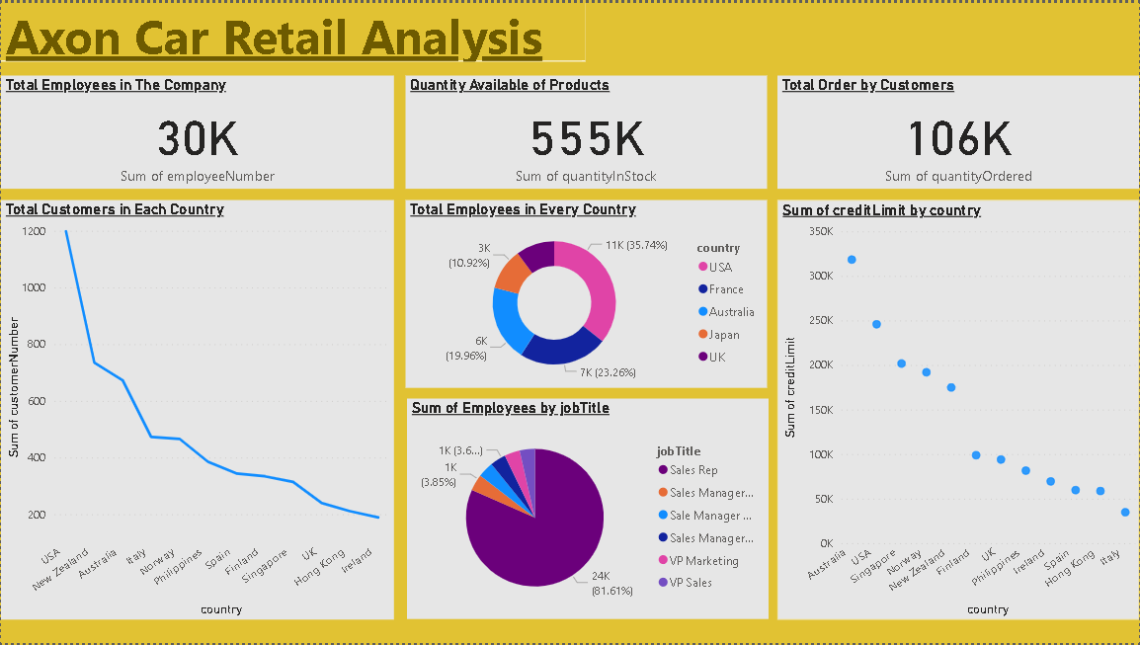

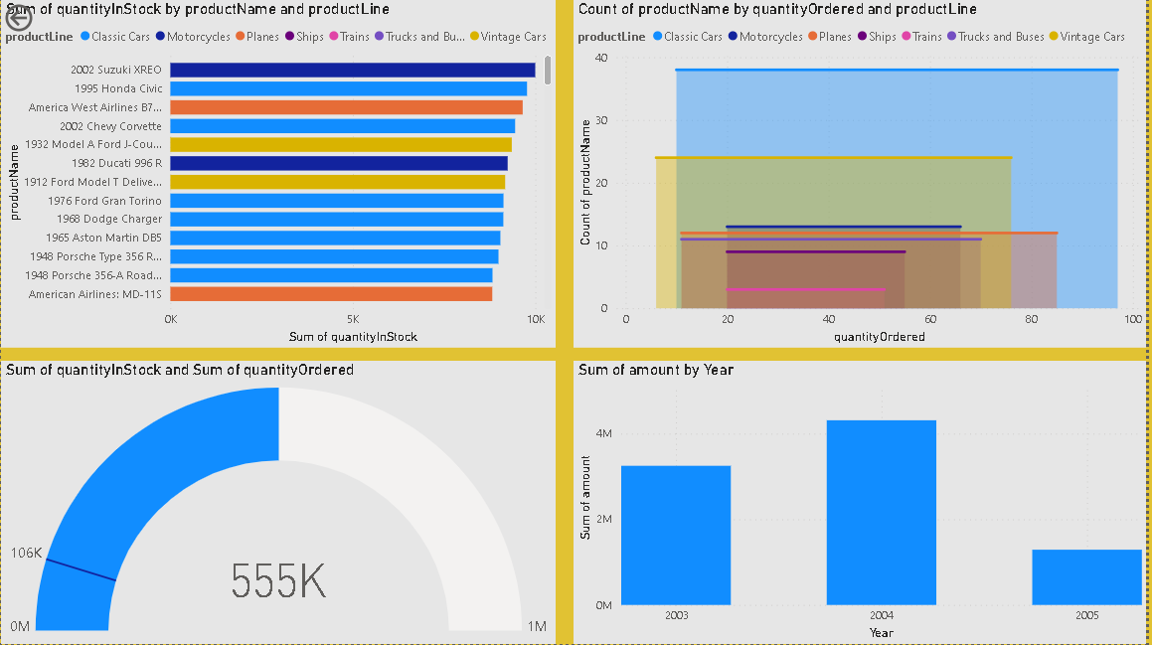

Upon careful analysis of the visually compelling graphs presented in the dashboard, a wealth of insightful information has been gleaned, shedding light on critical aspects of the company's operations. Here are some key findings distilled from the data analytics:

1. Customer and Employee Dynamics in the USA:

The USA emerges as the focal point with the highest customer count, boasting 1199 customers. A robust workforce of 10619 employees in the region underscores the company's commitment to customer engagement and support.

1. Dominance of Sales Rep Job Title:

A prevalent job title within the company is 'Sales Rep,' with a staggering count of 24247 employees. This distribution suggests a strategic focus on sales-driven roles, reflecting the company's sales-centric organizational structure.

1. Credit Limit Insights in Australia:

Australia stands out with the highest aggregate credit limit, reaching an impressive sum of 318400. This strategic allocation of credit underscores the company's financial acumen and targeted investment in key markets.

1. Motorcycle Stock and Popular Product Lines:

The company's inventory reveals a substantial stock of motorcycles, prominently featuring the 2002 Suzuki XREO. Meanwhile, the graph indicates that Classic Cars are the most frequently ordered, offering valuable insights into product popularity and customer preferences.

1. Inventory Fulfillment Assurance:

The Gauge Chart provides a reassuring visual representation, indicating that the company maintains sufficient stock levels to fulfill customer orders. This suggests a robust supply chain and inventory management system in place.

1. Annual Revenue Peaks in 2005:

The graph depicting the sum of amounts generated annually points to a notable peak in the year 2005. This insight into historical revenue patterns aids in understanding the company's financial performance over time, guiding strategic planning and forecasting.

These data-driven revelations serve as a compass for strategic decision-making, empowering the company to capitalize on strengths, address challenges, and optimize operations for sustained growth and success in the competitive landscape of the automotive industry.

To gain deeper insights into our data, I conducted additional analyses using SQL in MySQL Workbench. These queries provide valuable perspectives on our customers, employees, offices, and orders, offering a clearer understanding of our business dynamics. The results reveal meaningful patterns and trends within our dataset, facilitating informed decision-making and strategic planning for our company's growth and optimization.

In this analysis, we've covered the following key points:

1. Extracted valuable details about customers, including their order and shipment dates, along with the corresponding amounts spent.

2. Explored comprehensive information about employees as provided in the 'Employees' table.

3. Conducted an analysis of the distribution of customers across various cities, presenting the total count for each city.

4. Implemented a stored procedure capable of delivering specific customer information based on the customer number.

5. Introduced a view named 'ProductLineSales' that consolidates data from 'productlines,' 'products,' and 'orderdetails' tables to provide a summary of total sales for each product line.

6. Formulated a query to ascertain the count of employees in each office, accounting for offices with zero employees, and presented the results in a grouped format based on office code and city.

These insights offer a well-rounded understanding of customer interactions, employee details, geographical customer distribution, and specific customer information retrieval. The creation of stored procedures, views, and queries enhances the analytical capabilities, providing actionable intelligence for strategic decision-making within the company."

**Conclusion:** In conclusion, the Power BI insights and SQL analysis have proven instrumental in addressing the challenges faced by the company in managing and analyzing their sales data. By harnessing Power BI's visualization capabilities and SQL's analytical tools, we've gained valuable insights into customer behaviors, employee dynamics, and overall sales performance. The identification of specific customer details, creation of stored procedures for targeted data retrieval, and formulation of views and queries have significantly streamlined data management and decision-making processes.

These tools not only offer a clearer understanding of the company's sales landscape but also pave the way for strategic interventions, allowing the company to overcome obstacles, optimize resources, and navigate toward sustained growth and success in the competitive market.