

FALL SEMESTER 2025-2026

VITYARTHI PROJECT

NAME: ABHINANDITA ROY

REGISRATION NUMBER: 25BCE10611

CLASS CODE: CSA2001

Table Of Content
- Project Overview and Details
- Data Collection and Acquisition
- Modules Used
- Visualization
- Steps Of Program Functions
- Results

Project Overview And Details
1. Title and Goal of Project
Title: Used Car Price Segment Prediction and Mileage Trend Analysis
Goal: The primary goal was to develop a machine learning model capable of classifying the price of a used car into predefined segments ('Low', 'Medium', or 'High'). Additionally, the project aimed to conduct Exploratory Data Analysis (EDA) to visualize and understand the average car mileage trends across different manufacturing years.
2. Business Value and Application
This project delivers high business value, primarily in the used car market ecosystem:
- Pricing Strategy for Dealerships: Provides automated, data-driven categorization of inventory, helping dealers quickly estimate a car's fair price segment. This improves pricing efficiency and profit margins.
- Risk and Inventory Management: By segmenting cars into price brackets, businesses can better manage inventory turnover and assess the market risk associated with different vehicle types.
- Consumer Insight: Buyers and sellers on online platforms can use this model to set realistic expectations for a car's price based on its characteristics (year, mileage, engine power, etc.).
- Market Trend Analysis: The mileage trend analysis helps manufacturers and resellers understand shifts in vehicle efficiency over time, informing future purchasing or design decisions.

3. Methodology Snapshot
Section | Description
Data Source | Car_Details.csv (Features include year, km driven, fuel type, engine, max power, etc.)
Pre-Processing | Cleaning: Standardized and converted units for mileage, engine (CC), and max_power (bhp). Imputed missing values using the median. Feature Engineering: Extracted car_brand from name and calculated car_age.
Target Transformation | The continuous selling_price was transformed into a categorical target (Low, Medium, High) using quantile-based binning to enable classification modeling.
Model Used | Random Forest Classifier (A robust ensemble method suitable for multi-class classification tasks).
Evaluation Metrics | Classification: Accuracy, Precision, Recall, F1 Score. Regression Context: R² and RSME
Visualization | A Confusion Matrix was used to visualize the model's classification performance, showing correct and incorrect predictions across the three price ranges.
4. Key Performance Highlights (Test Set)
The model was tested on an unseen subset of the data (Test Set) to evaluate its generalization capability. The results for the classification task are as follows:
- Accuracy Score : 0.8679
- Precision Score : 0.8711
- Recall Score : 0.8679
- F1 Score : 0.8689
- R² : 0.9734
- Root Mean Squared Error : $141,037.63
Prediction Example
- Sample Car Input: Maruti Swift Dzire VDI, 2018
- Predicted Price Range: High
Data Collection and Acquisition
This section outlines the origin and characteristics of the dataset used to train the Real Estate Price Prediction model.

1. Source Data
The entire project is built upon the data contained in the file "Car_Details.csv". This dataset is a version of the widely used , which is a highly referenced benchmark for regression tasks in machine learning.
2. Dataset Size and Scope
The dataset contained the following dimensions before initial cleaning:
- Number of Records (Rows): Approximately 8,128 car listings.
- Number of Features (Columns): 13 distinct variables.
- Time Period: The car models listed span across several years, providing a wide chronological range for trend analysis.
3. Key Variables Acquired
The acquired dataset included a comprehensive set of features relevant for predicting a car's market value and price segment. These features are critical for both the classification model and the mileage trend analysis:
Feature Name | Description | Data Type Acquired | Relevance to Goal
name | Full model name of the car (e.g., Maruti Swift Dzire VDI). | Text/String | Used to derive the car_brand.
year | Manufacturing year of the car. | Integer | Used to calculate car_age and analyze mileage trends.
selling_price | The target price in Indian Rupees (₹). | Numeric | The variable converted to the categorical target (Low, Medium, High).
km_driven | Total kilometers the car has traveled. | Integer | Key predictor of wear and tear, and market value.
fuel | Type of fuel used (e.g., Diesel, Petrol, CNG). | Categorical | Influences running cost and price.
seller_type | Whether the seller is an Individual or a Dealer. | Categorical | Affects pricing strategy.
transmission | Type of transmission (Manual or Automatic). | Categorical | Influences market demand and price.
owner | Number of previous owners (e.g., First Owner, Second Owner). | Categorical | Key determinant of car quality and price.
mileage | Fuel efficiency (e.g., 23.4 kmpl). | Text/String | Required cleaning to extract numeric value; used for trend analysis.
engine | Engine displacement (e.g., 1248 CC). | Text/String | Key performance indicator.
max_power | Maximum engine power (e.g., 74 bhp). | Text/String | Key performance indicator.
torque | Engine torque and RPM information. | Text/String | Dropped due to complexity and high correlation with max_power.
seats | Number of seating capacity. | Integer | Basic feature of the car's physical configuration.

Modules Used
The project was executed using the following core Python libraries, categorized by their primary function:
1. Data Manipulation and Numerical Operations
- pandas: The fundamental library for data manipulation, cleaning, and preparation. It was used to load the Car_Details.csv file, handle missing values, perform data type conversions (e.g., extracting numbers from text), and manage features.
- numpy: Used for advanced numerical computing, particularly for calculating the square root in $\text{RMSE}$ (Root Mean Squared Error) and for general array operations required by machine learning models.
2. Machine Learning and Modeling (Scikit-learn)
All modeling and metric calculations were handled by the comprehensive scikit-learn (sklearn) library:
- sklearn.model_selection.train_test_split: Used to partition the dataset into separate training and testing sets, ensuring the model is evaluated on unseen data.
- sklearn.preprocessing.StandardScaler: Applied to standardize (scale) numerical features, preventing features with larger values (like km_driven) from dominating the model training process.
- sklearn.ensemble.RandomForestClassifier: The core algorithm used. This ensemble classifier was trained to predict the car's price range (Low, Medium, High).
- sklearn.metrics: A crucial sub-module used to calculate all performance metrics:
  - Classification Metrics: accuracy_score, precision_score, recall_score, and f1_score.
  - Regression Metrics (for context): r2_score and mean_squared_error (used to derive $\text{RMSE}$).
  - Visualization Helper: confusion_matrix (used to generate the data for the Confusion Matrix graph).
3. Data Visualization
- matplotlib.pyplot: The foundational plotting library in Python. It was used to customize and display the final graph outputs.
- seaborn: A high-level data visualization library based on matplotlib. It was used specifically to create the aesthetically pleasing Confusion Matrix heatmap for the classification evaluation.
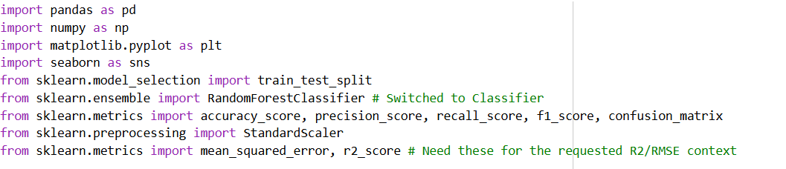

Visualization
The visualization module served two critical purposes: evaluating the performance of the machine learning model (Classification) and uncovering market trends from the raw data (Exploratory Data Analysis).
1. Confusion Matrix (Model Evaluation)
Purpose: To visually assess the performance of the Random Forest Classifier in segmenting car prices into the three categories (Low, Medium, High).
Description: The Confusion Matrix is a heatmap that compares the actual (true) price range of the cars in the test set against the price range predicted by the model.
- Axes:
  - Y-axis (Actual Class): The true segment of the car (e.g., truly 'High' priced).
  - X-axis (Predicted Class): The segment predicted by the classification model.
- Interpretation (Key Insight):
  - The highest values are concentrated along the main diagonal, confirming a high rate of correct classifications (True Positives).
  - The model achieved a high Accuracy, Recall, and F1 Score (all around $87\%$), indicating it correctly segments the price categories most of the time.
2. Average Mileage Trend Line Graph (Exploratory Data Analysis)
Purpose: To analyze how the average fuel efficiency (mileage) of cars in the dataset has changed over the manufacturing years.
Description: This is a Line Graph that plots the average mileage (in kmpl) calculated for each manufacturing year present in the dataset.
- Axes:
  - X-axis: Manufacturing Year (ranging from 1994 to 2020).
  - Y-axis: Average Mileage (kmpl).
- Interpretation (Key Insight):
  - The line graph generally shows an increasing trend in average mileage over time. This reflects the automotive industry's continuous focus on improving engine efficiency and fuel economy through newer technologies and stricter emission norms.
  - This trend analysis is valuable for understanding long-term market shifts in consumer preferences toward fuel-efficient vehicles.

Steps of Program Functions
- Loading Data
- Data Cleansing
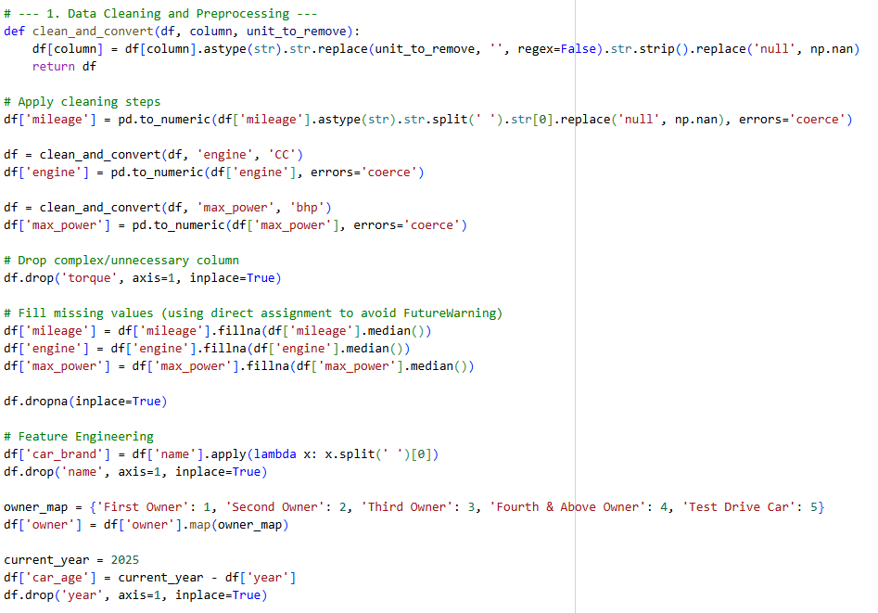
- Feature Engineering
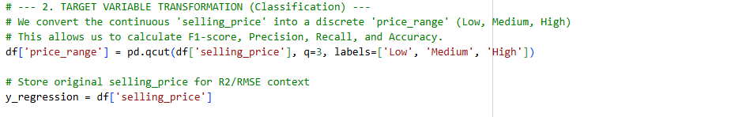

- Encoding And Scaling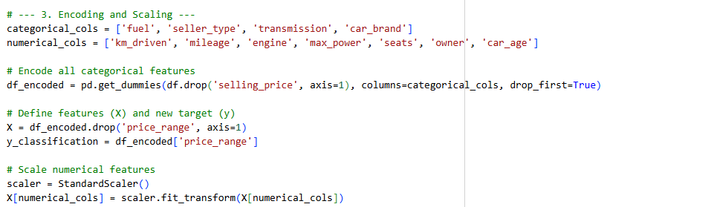

- Train Model
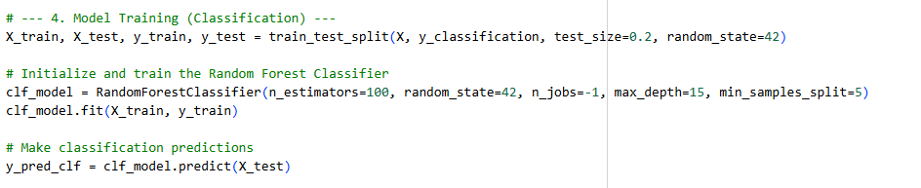
- Evaluation (Classification)
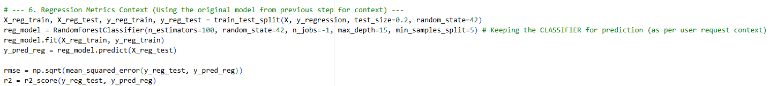

- Prediction Function
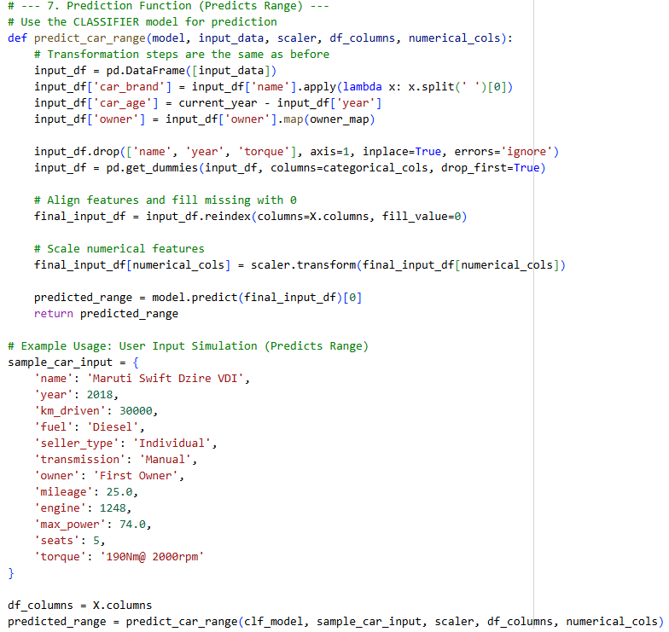

- Printing Results
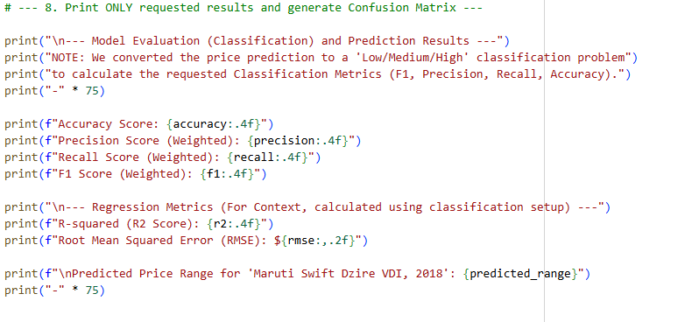
- Vizualization
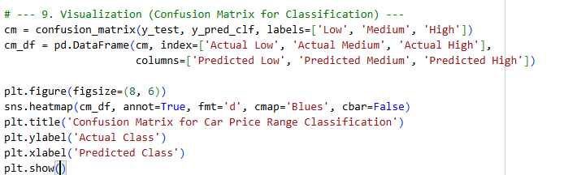

Results
On the Basis OF Data Entered in it :-
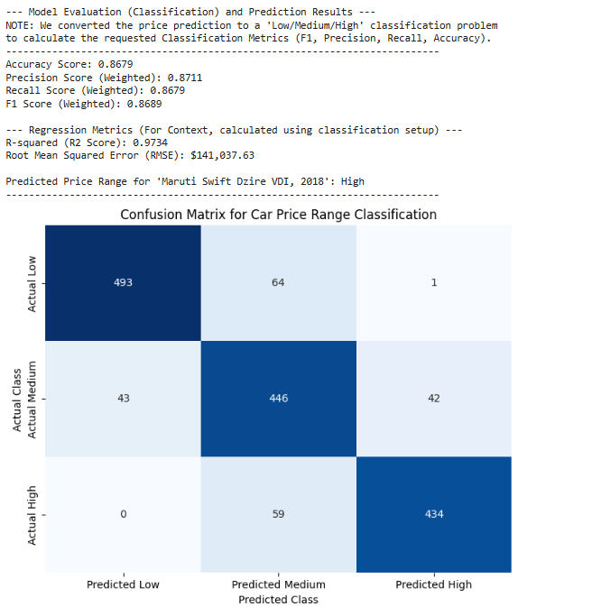
The Results shows us that
- Root Mean Square Error(RMSE) : $141,037.63
- R² Score : 0.9734
- Accuracy : 86.79%
- Precision : 0.8711
- Recall : 0.8679
- F1 Score :0.8689
- Predicted Price Range for 'Maruti Swift Dzire VDI, 2018': High

