**INSTITUTE OF TECHNOLOGY AND MANAGEMENT** 

**SKILLS UNIVERSITY,**

**KHARGHAR, NAVI MUMBAI**

**HTML LAB MANUAL**



**Prepared by:**

Name of Student :Riya Singh

Roll No: 26

Batch: 2023-27

Dept. of CSE

**DEPARTMENT OF COMPUTER SCIENCE & ENGINEERING**

**INSTITUTE OF TECHNOLOGY AND MANAGEMENT** 

**SKILLS UNIVERSITY,**

**KHARGHAR, NAVI MUMBAI**

**CERTIFICATE**

This is to certify that Mr. / Ms. _________________________________________ Roll No. _____________ of _____ Semester of B.Tech Computer Science & Engineering of ITM Skills University, Kharghar, Navi Mumbai , has completed the term work satisfactorily in subject _____________________________________ for the academic year 20___ - 20___ as prescribed in the curriculum.

Place: _____________

Date: ______________

**Subject I/C HOD**

**INDEX**

| **Exp. No** | **List of Experiment** | **Date of**  **Submission** | **Sign** |
| --- | --- | --- | --- |
| 1 | Design a page having suitable background colour and text colour with title “My First Web Page” using all the attributes of the Font tag. |  |  |
| 2 | Create a HTML document giving details of your [Name, Age], [Address, Phone] and [Register Number, Class] aligned in proper order using alignment attributes of Paragraph tag. |  |  |
| 3 | Create a web page with an appropriate image towards the left hand side of the page, when user clicks on the image another web page should open. |  |  |
| 4 | Create a web page for internal links; when the user clicks on different links on the web page it should go to the appropriate  locations/sections in the same page. |  |  |
| 5 | Create a HTML document containing a nested list showing a content page of any book. |  |  |
| 6 | Create a web page, showing an unordered list of names of all he PG Diploma Programmes (Branches) in your institution. |  |  |
| 7 | Create the following table in HTML with following Data for your batch:  **Reg**. **Number Student Name Year/Semester Date of**  **Admission** |  |  |

|  | 8. Create a web page which divides the page in two equal frames and place the audio and video clips in frame-1 and frame-2 respectively. | | | |  |  |
| --- | --- | --- | --- | --- | --- | --- |
|  |  | **FRAME-1** | **FRAME-2** |  |  |  |
|  |  |
| 9 | 1. Use frames such that page is divided into 3 frames 20% on left to show contents of pages, 60% in center to show body of page, remaining on right to show remarks. | | | |  |  |
| 10 | Create an HTML page that contains a selection box with a list of 5 countries, when the user selects a country, its capital should be printed next to the list; Add CSS to customize the properties of the font of the capital (color, bold and font size). | | | |  |  |
|  |  | | | |  |  |
|  |  | | | |  |  |
|  |  | | | |  |  |
|  |  | | | |  |  |
|  |  | | | |  |  |
|  |  | | | |  |  |
|  |  | | | |  |  |
|  |  | | | |  |  |

**Name of Student: Riya Singh**

**Roll Number: __26_______________ Experiment No: 1**

**Title: Design a page having suitable background colour and text colour with title “My First Web Page” using all the attributes of the Font tag.**

**Theory: This HTML code demonstrates basic webpage structure, including**

**the use of elements like <html>, <head>, <title>, <body>, <h1>,**

**and <p>. Styles are applied inline using the style attribute to**

**set properties like font-family, color, font-size, font-weight,**

**and margin.**

**Code: <!-- Design a page having suitable background colour and text colour with title “My**

**First Web Page” using all the attributes of the Font tag. -->**

**<!DOCTYPE html>**

**<html lang="en">**

**<head>**

**<meta charset="UTF-8">**

**<meta name="viewport" content="width=device-width, initial-scale=1.0">**

**<title>My First Web Page</title>**

**</head>**

**<body style="background-color:darksalmon">**

**<h1 style="color:darkslategray"><i>My first web page.</i></h1>**

**<p><font face="Arial" size="4">Welcome to my first web page.</font></p>**

**<p><font face="Georgia" size="4" color="blue">This page demonstrates the use of various font attributes using the font tags.</font></p>**

**<p><font face="Courier New" size="6" color="aqua" >Feel free to customize and experiment with different font styles and colors!</font></p>**

**<p><font face="Courier New" size="8" color="black"><i><u>Thank You</u></i></font></p>**

**</body>**

**</html>**

**Output: (screenshot)** 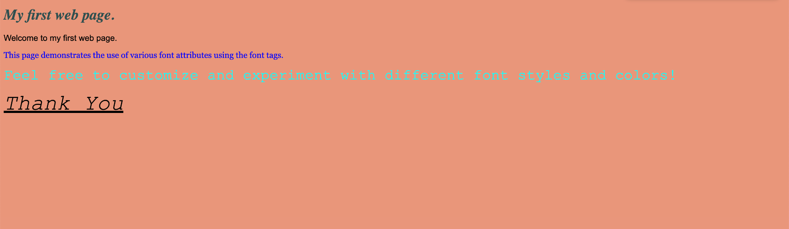

**Test Case: Any two (screenshot)**

**Same as above**

**Conclusion:**

**This code showcases how to create a simple webpage with styled**

**text and background using HTML and inline CSS.**

**Experiment No: 2**

**Title:**Create a HTML document giving details of your [Name, Age], [Address, Phone] and [Register Number, Class] aligned in proper order using alignment attributes of Paragraph tag.

**Theory:This HTML code structures a webpage presenting personal details.**

**It utilises elements such as <html>, <head>, <title>, <body>, <h1>,**

**and <p>. Inline CSS is employed for text alignment (text-align)**

**and indentation (text-indent).**

**Code:<!--Create a HTML document giving details of your [Name, Age],[Address, Phone] and**

**[Register Number, Class] aligned in proper order using alignment attributes of Paragraph tag. -->**

**<!DOCTYPE html>**

**<html lang="en">**

**<head>**

**<meta charset="UTF-8">**

**<meta name="viewport" content="width=device-width, initial-scale=1.0">**

**<title>My Details</title>**

**</head>**

**<body>**

**<h1>My Details</h1>**

**<p align="left">**

**<strong>Name:</strong>Riya Singh<br>**

**<strong>Age:</strong>18</p>**

**<p align="left">**

**<strong>Address:</strong>Ghansoli ,Sec-6 ,Plot-12<br>**

**<strong>Phone:</strong>+8108907297</p>**

**<p align="left">**

**<strong>Register Number:</strong>150096723026<br>**

**<strong>Class:</strong>B.tech CSE - First Year</p>**

**</body>**

**</html>**

**Output: (screenshot)** 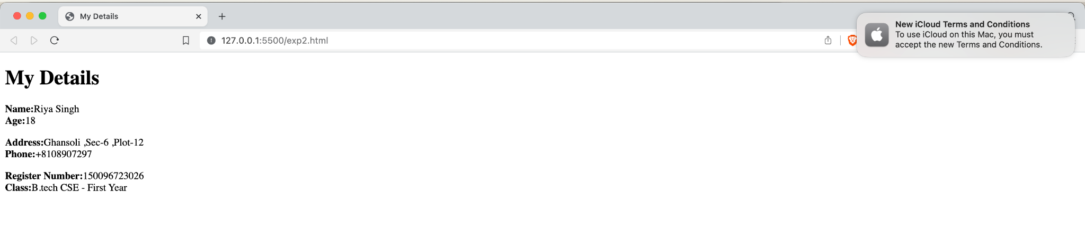

**Test Case: Any two (screenshot)**

**Same as above.**

**Conclusion:**

**The code provides a straightforward example of how to structure**

**a webpage presenting personal details using HTML. It demonstrates**

**the use of inline CSS to control text alignment and indentation for**

**improved readability.**

**Experiment No:3**

**Title:Create a web page with an appropriate image towards the left hand side of the page, when user clicks on the image another web page should open.**

**Theory:This HTML code integrates an image into a webpage, utilizing the**

**<img> tag and inline CSS to adjust its width. A hyperlink is created**

**around the image with the <a> tag, targeting a specified URL.**

**Code:<!-- Create a web page with an appropriate image towards the left hand side of the**

**page, when user clicks on the image another web page should open. -->**

**<!DOCTYPE html>**

**<html lang="en">**

**<head>**

**<meta charset="UTF-8">**

**<meta name="viewport" content="width=device-width, initial-scale=1.0">**

**<title>Image</title>**

**</head>**

**<body>**

**<a href="https://www.youtube.com/" target="_blank">**

**<img src="youtube.jpg" alt="Click Me" style="width: 250px; height: auto;">**

**<p>Click on the image to open another web page.</p>**

**</body>**

**</html>**

**Output: (screenshot)**

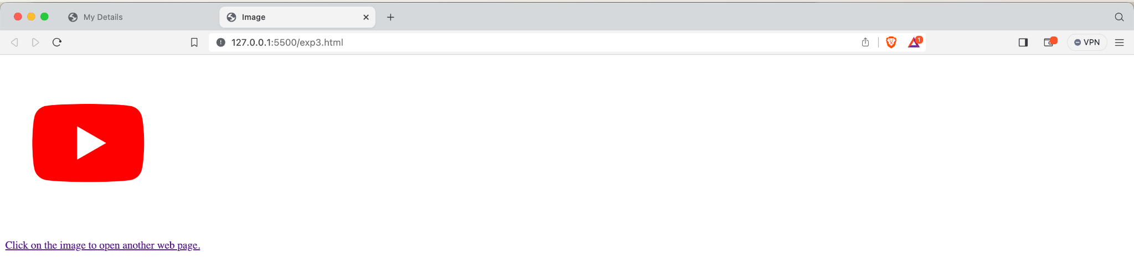

**Test Case: Any two (screenshot): Same as above**

**Conclusion:The code demonstrates how to incorporate an image with a hyperlink**

**in an HTML webpage, showcasing basic usage of image tags and inline**

**styling for layout adjustment.**

**Experiment No:4**

**Title:Create a web page for internal links; when the user clicks on different links on the web page it should go to the appropriate locations/sections in the same page.**

**Theory:This HTML code demonstrates the implementation of internal**

**links within a webpage using anchor tags (<a>). Each link is assigned**

**an href attribute with the ID of the target section, allowing users**

**to navigate seamlessly within the same page.**

**Code:<!-- Create a web page for internal links; when the user clicks on different**

**links on the web page it should go to the appropriate locations/sections in the same page. -->**

**<!DOCTYPE html>**

**<html lang="en">**

**<head>**

**<meta charset="UTF-8">**

**<meta name="viewport" content="width=device-width, initial-scale=1.0">**

**<title>Internal Links</title>**

**</head>**

**<body>**

**<h1>Internal Links Example</h1>**

**<ul>**

**<li><a href="https://www.netflix.com/in/">Section 1</a></li>**

**<li><a href="https://www.netflix.com/in/">Section 2</a></li>**

**<li><a href="https://www.google.co.in/">Section 3</a></li>**

**</ul>**

**</body>**

**</html>**

**Output: (screenshot)**

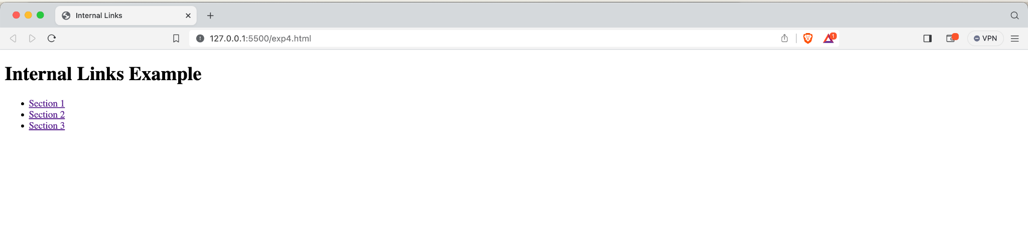

**Test Case: Any two (screenshot):Same as Above**

**Conclusion:By incorporating internal links, this webpage enhances user experience**

**by providing easy navigation to different sections of content within**

**the page, improving accessibility and readability.**

**Experiment No:5**

**Title:Create a HTML document containing a nested list showing a content page of any book.**

**Theory:This HTML code constructs a table of contents for a content page**

**titled "Do Epic Shit," organizing various topics into parts and**

**subsections using nested lists (<ul> and <li>). Each list item**

**represents a section or sub-section with a brief description**

**Code:<!-- Create a HTML document containing a nested list showing a content page of any book. -->**

**<!DOCTYPE html>**

**<html lang="en">**

**<head>**

**<meta charset="UTF-8">**

**<meta name="viewport" content="width=device-width, initial-scale=1.0">**

**<title>Book Content Page</title>**

**</head>**

**<body>**

**<h1>Content Page</h1>**

**<ul>**

**<li>Chapter 1: Introduction</li>**

**<li>Chapter 2: Main Concepts**

**<ul>**

**<li>Section 2.1: Basics</li>**

**<li>Section 2.2: Advanced Topics</li>**

**<li>Section 2.3: Case Studies</li>**

**</ul>**

**</li>**

**<li>**

**Chapter 3: Application**

**<ul>**

**<li>Section 3.1: Practical Examples</li>**

**<li>Section 3.2: Implementation</li>**

**</ul>**

**</li>**

**<li>Chapter 4: Conclusion</li>**

**</ul>**

**</body>**

**</html>**

**Output: (screenshot)**

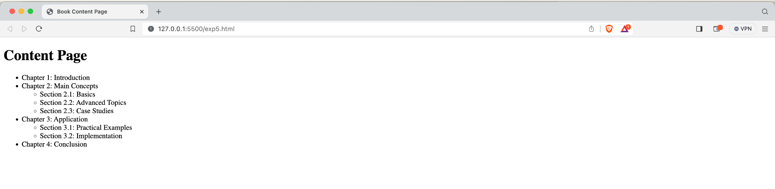

**Test Case: Any two (screenshot):Same as Above**

**Conclusion:By structuring the content into a hierarchical table of contents,**

**this webpage facilitates easy navigation and comprehension for**

**readers, enabling them to quickly locate and access specific topics**

**of interest within the document.**

**Experiment No:6**

**Title:Create a web page, showing an unordered list of names of all he PG**

**Diploma Programmes (Branches) in your institution.**

**Theory:Utilizing HTML elements such as headings (<h2> and <h3>) and an**

**unordered list (<ul>), the webpage efficiently structures information**

**about various PG Diploma programmes, enhancing readability and**

**accessibility for users seeking program details.**

**Code:<!-- Create a web page, showing an unordered list of names of all he PG Diploma Programmes (Branches) in your institution. -->**

**<!DOCTYPE html>**

**<html lang="en">**

**<head>**

**<meta charset="UTF-8">**

**<meta name="viewport" content="width=device-width, initial-scale=1.0">**

**<title>PG Diploma Programmes</title>**

**</head>**

**<body>**

**<h1>PG Diploma Programmes</h1>**

**<ul>**

**<li>Executive MBA</li>**

**<li>Executive MBA in Financial Services</li>**

**<li>Executive MBA in e-Commerce & Digital Marketing</li>**

**<li>Executive MBA in Business Analytics</li>**

**<li>BBA Financial Services</li>**

**<li>BBA International Travel & Tourism Management</li>**

**<li>MBA Hospitality Management</li>**

**</ul>**

**</body>**

**</html>**

**Output: (screenshot)**

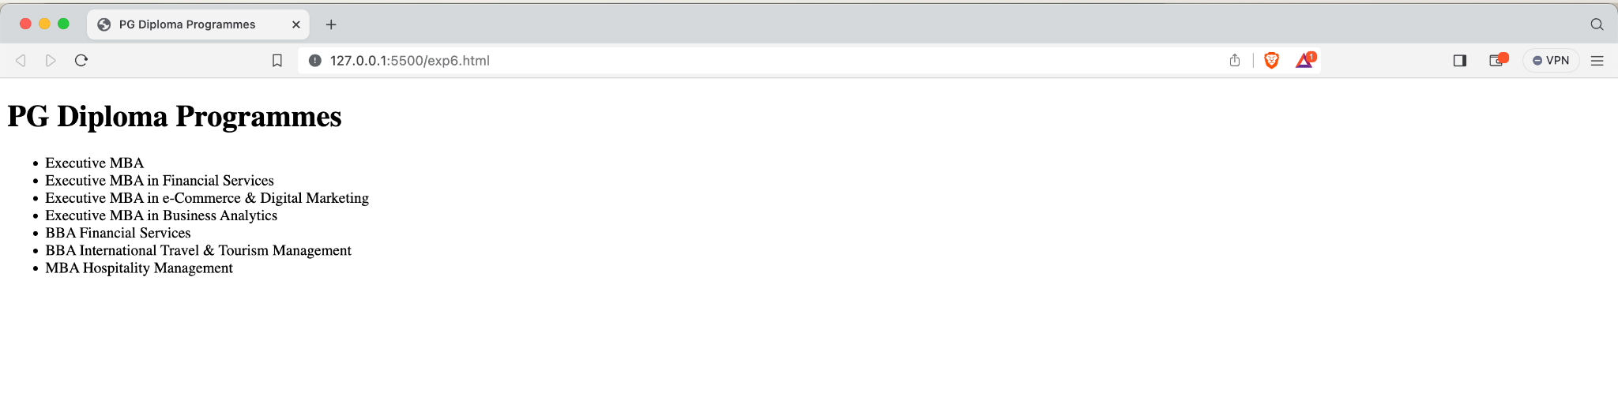

**Test Case: Any two (screenshot):Same as above**

**Conclusion:This webpage succinctly showcases the array of Post Graduate**

**Diploma programmes offered by ITM SKILLS UNIVERSITY, aiding**

**prospective students in their academic choices with a straightforward**

**list format.**

**Experiment No:7**

**Title:Create the following table in HTML with following Data for your batch:**

**Theory:Employing HTML's <table> element, this code efficiently organizes**

**student data into rows and columns, with inline CSS used to style**

**headers (<th>) and table cells (<td>), providing a visually appealing**

**and easy-to-read format for presenting student information.**

**Code:<!-- Create the following table in HTML with following Data for your batch:table and its properties-->**

**<!DOCTYPE html>**

**<html>**

**<head>**

**<style>**

**table , th ,td {**

**border: 1px solid black;**

**border-collapse:collapse**

**}**

**th , td{**

**padding:15px;**

**}**

**th{**

**text-align: left;**

**background-color:dimgrey;**

**color:black;**

**}**

**table{**

**border-spacing: 5px;**

**}**

**table#t01 tr:nth-child(even) {**

**background-color:lightgray ;**

**}**

**table#t01 tr:nth-child(odd) {**

**background-color: #fff;**

**}**

**</style>**

**</head>**

**<body>**

**<table id="t01" ; style="width:100%">**

**<tr>**

**<th>Reg. Number</th>**

**<th>Student Name</th>**

**<th>Year/Semester</th>**

**<th>Date of Admission</th>**

**</tr>**

**<tr>**

**<td style="background-color:darkgray ">150096723026</td>**

**<td>Riya Singh</td>**

**<td>First Year</td>**

**<td>28th July 2023</td>**

**</tr>**

**<tr>**

**<td style="background-color:darkgray">150096723011</td>**

**<td>Ashlin Lee George</td>**

**<td>First Year</td>**

**<td>22nd July 2023</td>**

**</tr>**

**<tr>**

**<td style="background-color:darkgray">150096723030</td>**

**<td>Akriti Kesarwani</td>**

**<td>First Year</td>**

**<td>30th July 2023</td>**

**</tr>**

**<tr>**

**<td style="background-color:darkgray">150096723034</td>**

**<td>Bhagyashree Bhagat</td>**

**<td>First Year</td>**

**<td>2nd August 2023</td>**

**</tr>**

**</table>**

**</body>**

**</html>**

**Output: (screenshot)**

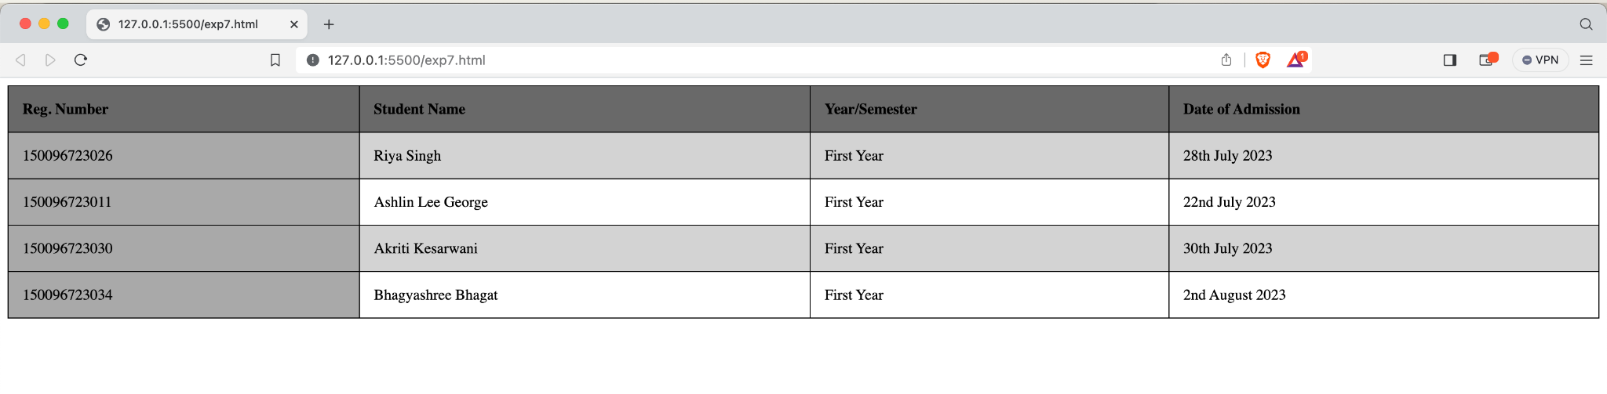

**Test Case: Any two (screenshot):Same as Above**

**Conclusion:This HTML code generates a structured table displaying student**

**information, including registration numbers, names, academic**

**years/semesters, and dates of admission, enhancing data organization**

**and readability for administrative purposes.**

**Experiment No:8**

**Title:Create a web page which divides the page in two equal frames and**

**place the audio and video clips in frame-1 and frame-2 respectively.**

**FRAME-1 FRAME-2**

**Theory:By utilizing the <frameset> element with the cols attribute to divide**

**the webpage horizontally, this code embeds two frames (frame1 and**

**frame2) with distinct sources (audio.html and video.html),**

**facilitating simultaneous playback of audio and video content within**

**a single webpage for enhanced user experience.**

**Code:<!-- Create a web page which divides the page in two equal frames and place the audio and video clips in frame-1 and frame-2 respectively. -->**

**<!DOCTYPE html>**

**<html>**

**<head>**

**<title>Audio and Video in Frames</title>**

**</head>**

**<frameset rows="50%, 50%">**

**<frame src="frame1.html" name="frame1">**

**<frame src="frame2.html" name="frame2">**

**</frameset>**

**</html>**

**<!DOCTYPE html>**

**<html lang="en">**

**<head>**

**<meta charset="UTF-8">**

**<meta name="viewport" content="width=device-width, initial-scale=1.0">**

**</head>**

**<body>**

**<audio controls>**

**<source src="epic.mp3" type="audio/mpeg">**

**</audio>**

**</body>**

**</html>**

**<!DOCTYPE html>**

**<html lang="en">**

**<head>**

**<meta charset="UTF-8">**

**<meta name="viewport" content="width=device-width, initial-scale=1.0">**

**</head>**

**<body>**

**<video controls width="450" height="330">**

**<source src="video.mp4" type="video/mp4">**

**Your browser does not support the video tag.**

**</video>**

**</body>**

**</html>**

**Output: (screenshot)**

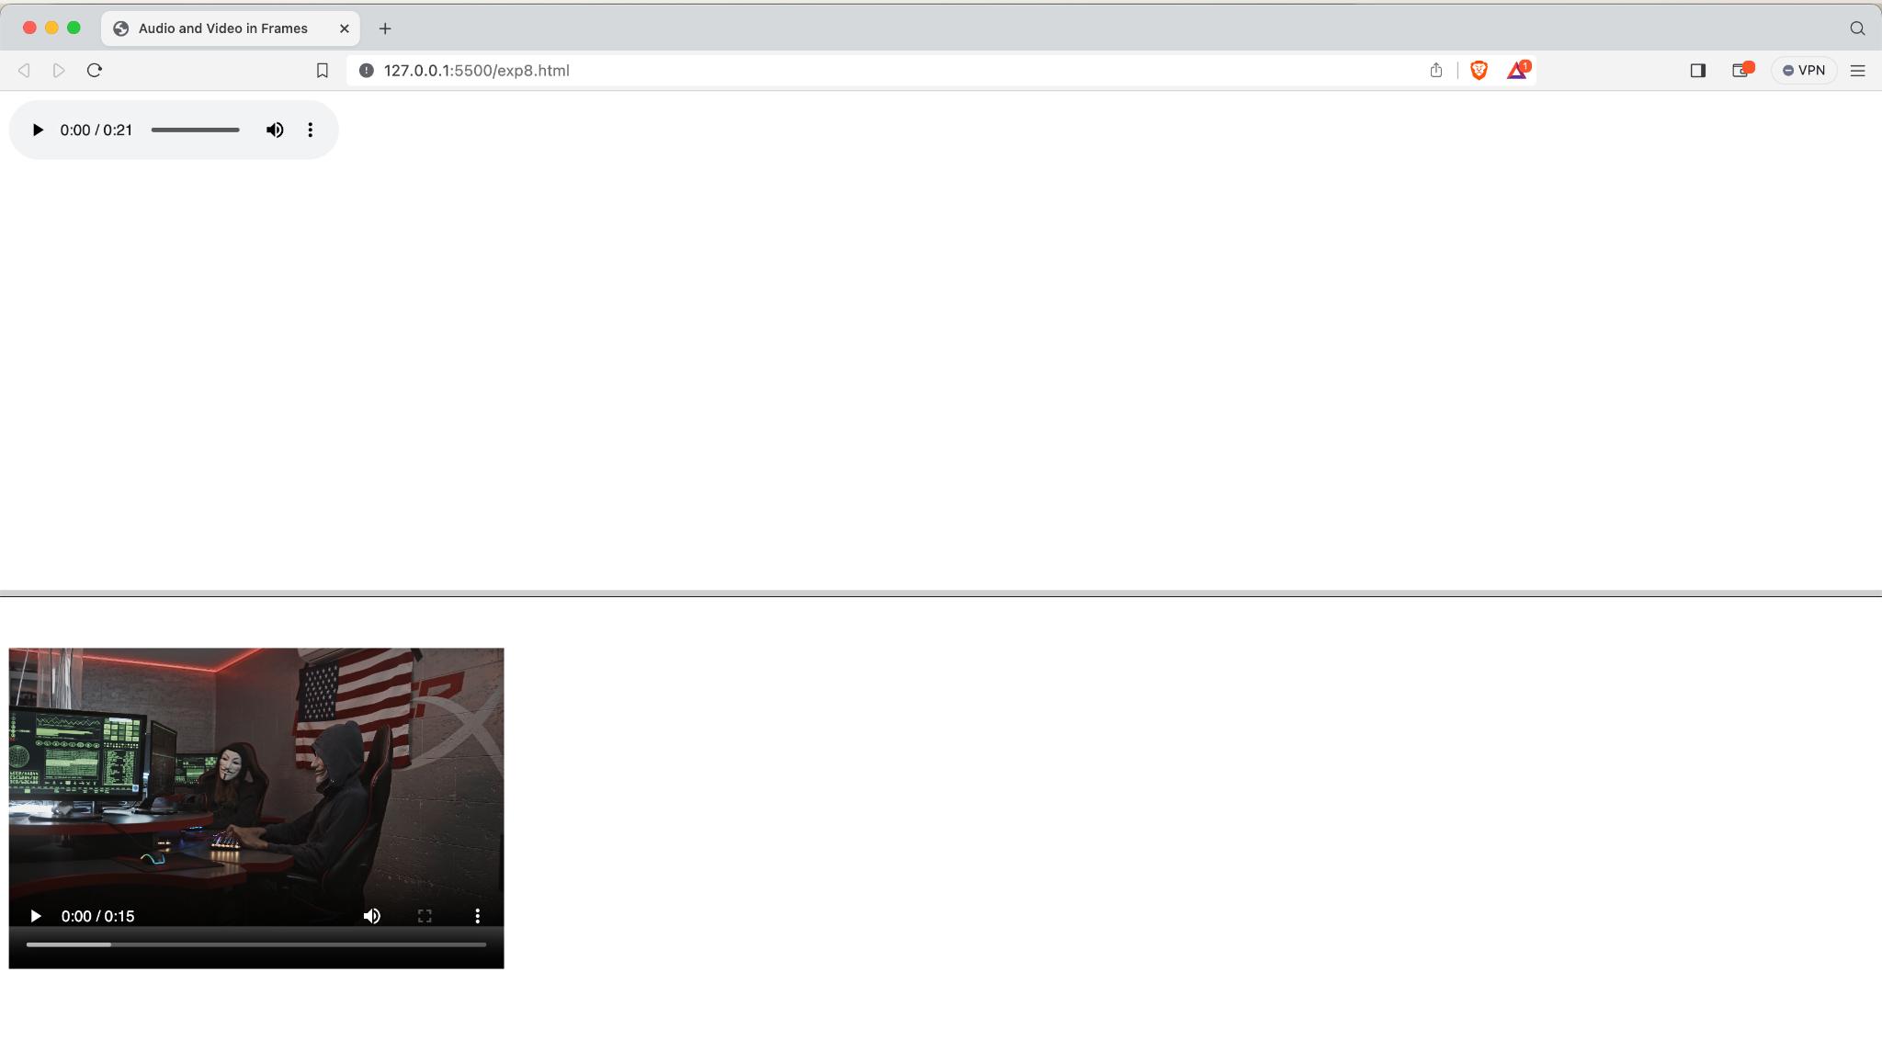

**Test Case: Any two (screenshot):Same as Above**

**Conclusion:This HTML code sets up a frameset with two frames, each loading**

**separate HTML documents (audio.html and video.html) to display audio**

**and video content side by side, enabling efficient multimedia**

**presentation within a webpage.**

**Experiment No:9**

**Title:1. Use frames such that page is divided into 3 frames 20% on left to**

**show contents of pages, 60% in center to show body of page,**

**remaining on right to show remarks.**

**Theory:By utilizing the <frameset> element with the cols attribute to**

**partition the webpage horizontally, and embedding separate <frame>**

**elements with distinct source documents, this code creates a framed**

**layout, facilitating the simultaneous presentation of multiple**

**webpages for improved content organization and navigation.**

**Code:<!-- Use frames such that page is divided into 3 frames 20% on left to show contents of**

**pages, 60% in center to show body of page,remaining on right to show remarks. -->**

**<!DOCTYPE html>**

**<html>**

**<frameset cols="20%,60%,*">**

**<frame src="frame_a.html">**

**<frame src="frame_b.html">**

**<frame src="frame_c.html">**

**</frameset>**

**</html>**

**Frame_a.html**

**<!DOCTYPE html>**

**<html>**

**<head>**

**<title>Contents</title>**

**</head>**

**<body>**

**<h1>Contents</h1>**

**<ul>**

**<li><a href="page1.html" target="centerFrame">Page 1</a></li>**

**<li><a href="page2.html" target="centerFrame">Page 2</a></li>**

**<li><a href="page3.html" target="centerFrame">Page 3</a></li>**

**</ul>**

**</body>**

**</html>**

**Frame_b.html**

**<!DOCTYPE html>**

**<html>**

**<head>**

**<title>Body</title>**

**</head>**

**<body>**

**<h1>Body</h1>**

**<p>This is the main content area.</p>**

**</body>**

**</html>**

**Frame_c.html**

**<!DOCTYPE html>**

**<html>**

**<head>**

**<title>Remarks</title>**

**</head>**

**<body>**

**<h1>Remarks</h1>**

**<p>This is the remarks area.</p>**

**</body>**

**</html>**

**Output: (screenshot)**

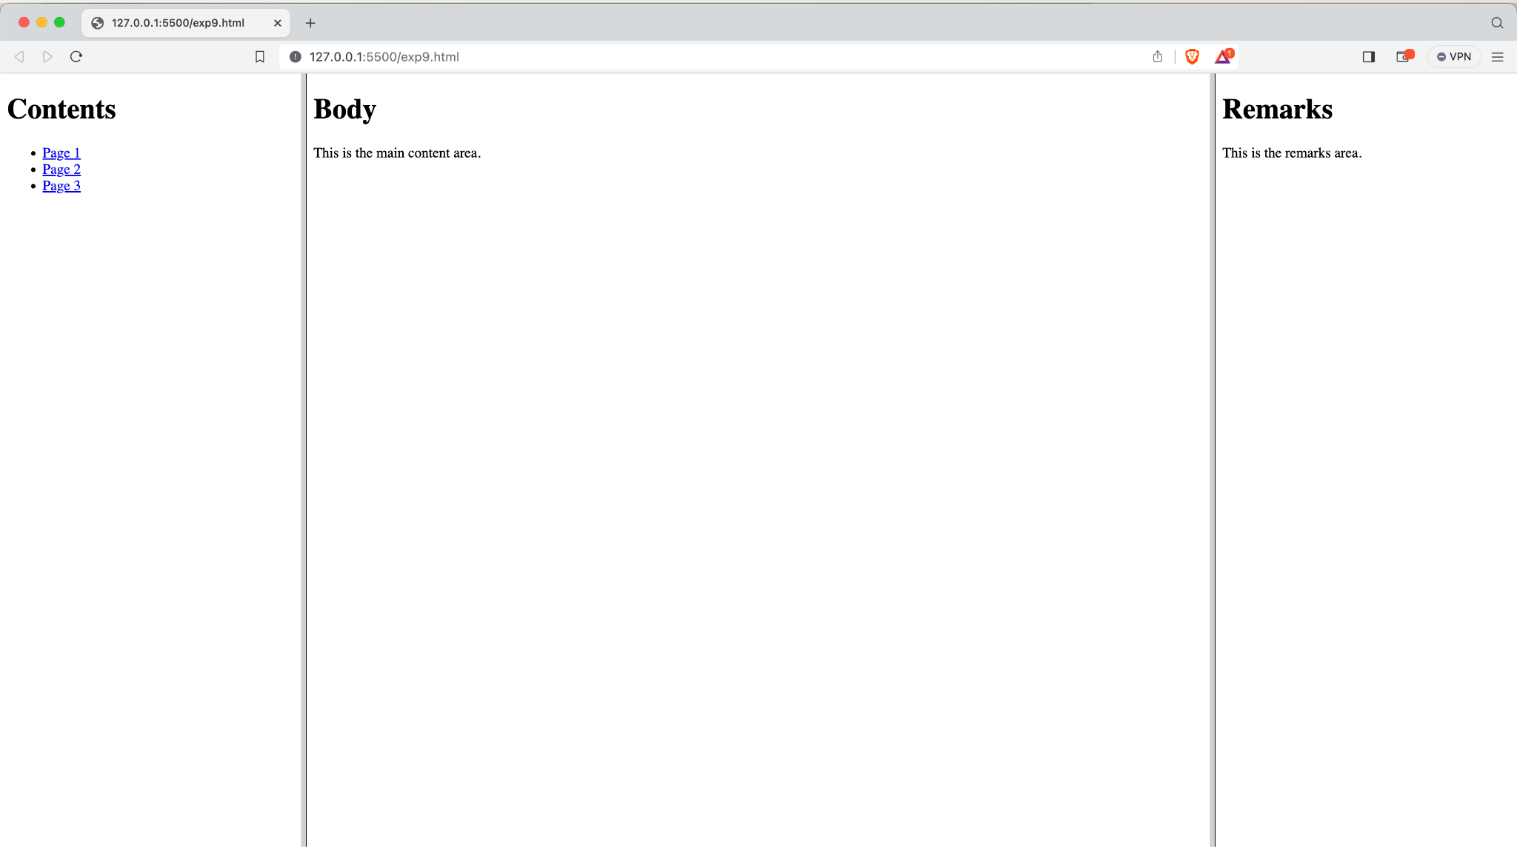

**Test Case: Any two (screenshot):Same as Above**

**Conclusion:This HTML code defines a frameset divided into three columns, each**

**containing a separate HTML document loaded into frames named "frame1,"**

**"frame2," and "frame3," enabling the display of multiple webpages**

**simultaneously within a single browser window.**

**Experiment No:10**

**Title:Create an HTML page that contains a selection box with a list of 5**

**countries, when the user selects a country, its capital should be**

**printed next to the list; Add CSS to customize the properties of the**

**font of the capital (color, bold and font size).**

**Theory:This HTML code creates a user-friendly interface for selecting**

**countries and displaying their capitals. Centered within the page,**

**it features a dropdown menu with five country options. Upon selection,**

**the chosen country's capital is promptly shown.**

**Code:<!-- Create an HTML page that contains a selection box with a list of 5 countries, when**

**the user selects a country, its capital should be printed next to the list; Add CSS to**

**customize the properties of the font of the capital (color, bold and font size). -->**

**<!DOCTYPE html>**

**<html>**

**<head>**

**<title>Country Capitals</title>**

**</head>**

**<body align="center">**

**<select id="country-select">**

**<option value="default">Select a country</option>**

**<option value="usa">USA</option>**

**<option value="uk">UK</option>**

**<option value="france">France</option>**

**<option value="germany">Germany</option>**

**<option value="japan">Japan</option>**

**</select>**

**<p id="capital">Capital: </p>**

**</body>**

**</html>**

**Output: (screenshot)**

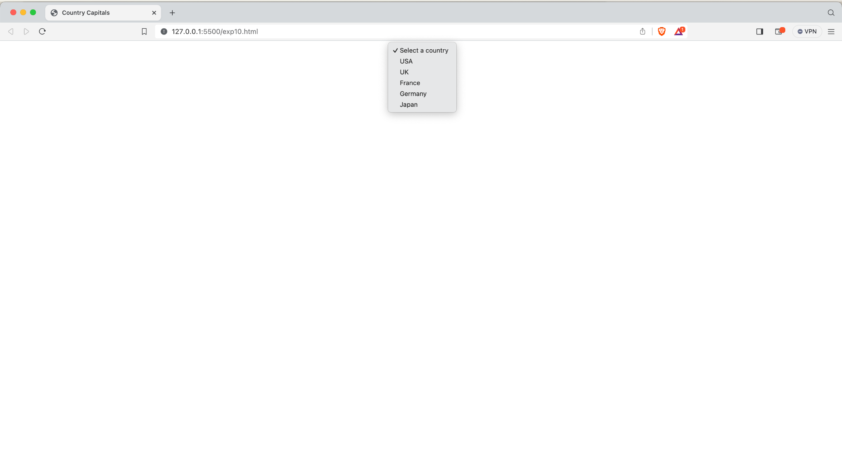

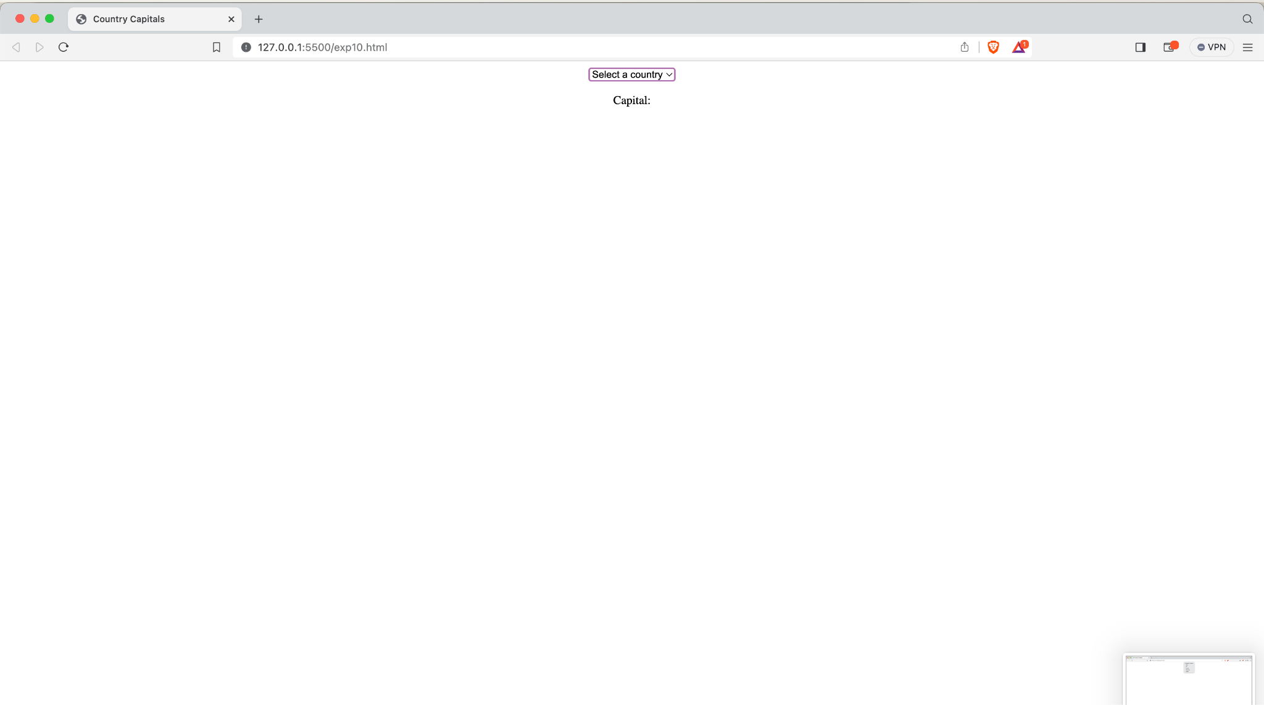

**Test Case: Any two (screenshot):Same as Above**

**Conclusion:With its straightforward design and functionality, this HTML document**

**offers an accessible means for users to explore and learn about**

**different countries and their capitals.**